Art Department Curriculum

Handbook

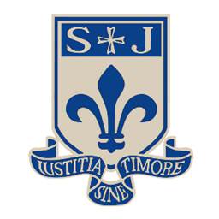

**Art Department Statement of Intent**

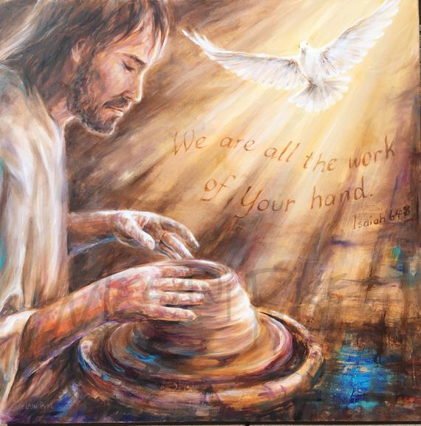

**“We are God’s work of art, created in Christ Jesus for the good works which God has already designated to make up our way of life.” Ephesians 2:10**

Art, craft and design embody some of the highest forms of human creativity.

A high-quality art and design education should engage, inspire and challenge pupils, equipping them with the knowledge and skills to experiment, invent and create their own works of art, craft and design.

As students’ progress, they should be able to think critically and develop a more rigorous understanding of art and design. They should also know how art and design both reflect and shape our history and contribute to the culture, creativity and wealth of our nation.

**Aims of the Art Department**

The Art department aims to make art and creativity accessible for all. We aim to encourage students to extend, explore and expand their creative thinking and problem-solving skills.

We aim to inspire students by introducing them to artists, craftspeople, designers and movements in art, alongside a variety of art made across different time periods, cultures, and countries.

We aim to expand student knowledge and understanding by putting into context different periods of art history.

We aim to expand student thinking and challenge preconceived ideas, encouraging them to develop their own opinions, be able to justify these and broaden their own cultural capital.

We aim to enhance skills, both physical and analytical; to communicate concepts, experiences and ideas across a wide range of media.

We aim to develop knowledge, inspire and enthuse, creating ‘awe and wonder’, encouraging students to question, query and analyse.

We aim to enhance and enrich students’ educational experience by encouraging them to express themselves creatively, to feel confident exploring media, and to be able to express their own feelings and opinions fluently, whether in the written or visual form.

**Art Department Overview of Intent**

**By the end of Year 7 our Artists will**

* improve and develop fine-motor skills e.g. hand-eye coordination.
* develop skills using a range of media and materials.
* learn about some of the key periods in Art.
* learn about traditional and modern artists’ and designers.
* have an ability to analyse the work of different artists and produce a personal response.

**By the end of Year 8 our Artists will**

* develop skills using a range of media and materials.
* learn about some of the key periods in Art.
* learn about traditional and modern artists’ and designers.
* have an ability to analyse the work of different artists and produce a personal response.

**By the end of Year 9 our Artists will**

* develop skills using a range of media and materials.
* develop their presentation skills ready to begin GCSE work.
* learn about some of the key periods in Art and place the works within a historical, cultural, social and political context.
* learn about traditional and modern artists’, designers and research their own inspiration.
* have an ability to analyse the work of different artists and produce a personal response.
* develop transferrable skills - e.g. problem solving, independent learning, resilience, self-control, organisation, presentation skills and group co-operation.

**By the end of Year 10 our Artists will**

* develop skills and techniques using a range of media and materials.
* develop their presentation skills in line with GCSE expectations.
* learn about some of the key periods in Art and place the works within a historical, cultural, social and political context.
* learn about traditional and modern artists’, designers and research their own inspiration.
* have an ability to analyse the work of different artists and produce a personal response.
* develop transferrable skills- e.g. problem solving, independent learning, resilience, self-control, organisation, presentation skills and group co-operation.

**By the end of Year 11 our Artists will**

* develop skills and techniques using a range of media and materials.
* develop their presentation skills in line with GCSE expectations.
* learn about some of the key periods in Art and place the works within a historical, cultural, social and political context.
* learn about traditional and modern artists’, designers and research their own inspiration.
* have an ability to analyse the work of different artists and produce a personal response.
* develop transferrable skills- e.g. problem solving, independent learning, resilience, self-control, organisation, presentation skills and group co-operation.
* become aware of the creative and arts industries and the range of job opportunities.
* leave with an Art and Design qualification which reflects the best of their ability.



**SMSC in Art**

|  |  |
| --- | --- |
| **WELCOME** | Environment. “Welcome to Art”.  Greet classes. Displays/updating displays. |
| **WELFARE** | Hands – talk to them about it.  Nurturing subjects – Adapt to the students to make Art accessible to all. Praise. |
| **WITNESS** | Learning sentences – link them to the Gospel Values. |
| **WORD of GOD** | Mission Statement preserved.  Scripture quotes.  Sacred Space. |
| **WORSHIP** | Prayers at the end of the day.  Sacred Space.  Morning Prayer.  Crucifix. |

|  |  |
| --- | --- |
| **Spiritual** | Being creative – putting their own ideas into their work, their emotions, personalities will appear in their Art.  Reflecting of a piece of work. |
| **Moral** | Students support each other. Input their own experiences. |
| **Social** | Working with others – feedback.  Constructive Criticism. |
| **Cultural** | Range of topics that link to different cultures.  Animals, Portraits, Architecture, Identity, Messages |

*Gospel Values:*

As a Catholic school, our values are rooted in the Gospel message and we develop the values in every one of our students.

**Location in Department Teaching**

|  |  |
| --- | --- |
| **Faithfulness & Integrity** | Praise and affirmation on their ability and efforts/work produced.  Promoting positive attitudes and personalising their work.  Display on walls to show aims/how to achieve tasks. |
| **Dignity & Compassion** | Focus on the positives.  Build self-esteem.  Encourage mutual support/respect for others. |
| **Humility & Gentleness** | Being able to accept constructive criticism.  Student surveys/learning walks/observations. |
| **Truth & Justice** | Truthful feedback 1:1 – honest and truthful. |
| **Forgiveness & Mercy** | Behaviour management.  Working environment – forgiveness/ knocking water/splatting paints – accidents and the nature of behaviour and atmosphere created.  Understanding how to forgive and behave. Forgive themselves – might not go right first time. |
| **Purity & Holiness** | Self-Reflection – sharing something of our own experience – encourage and get the best out of them.  Don’t expect them to do anything that you can’t do yourself. |
| **Tolerance & Peace** | Teamwork – collaborative working. Sharing equipment and ideas.  Behaviour management.  Building the right environment for the work to take place. |
| **Service & Sacrifice** | Giving up a lot of our own time extra-curricular.  Planning/reporting/going the extra mile. Students give up their own time. |

**Promoting British Values in Art**

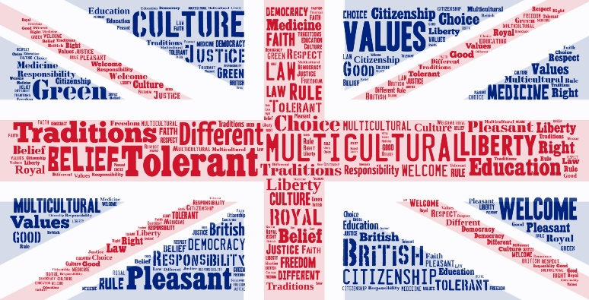

**Democracy**

Take in to account the views of others in shared activities. Vote for outcomes

**The Rule of Law**

Undertake safe practices, following class rules during projects and activities for the benefit of all.

Understand the consequences if rules are not followed.

**Individual Liberty**

Work within boundaries to make safe choices in Art and Design.

Make own choices within Art and Design projects.

**Tolerance of those with different faiths and beliefs**

Experience and talk about Art and Design work from different cultures and religious beliefs.

Use Art and Design pieces to learn about different faiths and cultures around the world.

**Mutual Respect**

To behave appropriately allowing all participants the opportunity to work effectively.

Review each other’s work respectfully.  
Work together on projects, help and advise others.

**Literacy and Art**

Literacy needs to be deliberately planned into a department’s SOL in order to give it the time and priority it requires. Resources will need to be prepared in advance so that Literacy is an integral part of Art teaching and learning in lessons and develops alongside artistic skills and content. These may include word cards, question cards, books, magazines and leaflets, writing frames and worksheets and games. Whenever it is appropriate literacy objectives should be built into the lesson along with Art specific objectives. Literacy can be developed in every lesson through activities such as emphasis on word work during questioning. Some topics will lend themselves more easily to literacy development than others. Such emphasis on the language of Art will inevitably result in students being more able to articulate artistic ideas in their own words.

*Key Areas of Literacy*

|  |  |
| --- | --- |
| **Vocabulary**  **Key issues**  Technical and specialist words  Appropriate usage  Correct spelling  Understand meaning  **Common difficulties**   * Time and lots of repetition needed to ensure new words are internalised into working vocabulary and linked to appropriate concepts. * Ordinary words with alternative meanings can be difficult as it causes cognitive conflict. * Supporting strategies * Introduce words using a multisensory approach e.g. orally, visually, kinaesthetically * Use vocabulary frequently using open questions * Use words in sentences to keep reflecting back * Use models and picture to help visualise the word * Ask students to explain using pictures to encourage language development * Use visual clues e.g. hand signals | **Oracy**  **Key issues**  Use language precisely  Listen to others and respond **Common difficulties**Constant use and repetition are essential. Words which are not frequently used are easily forgotten  * Often little planned time in lessons to “talk” * One-word answers for fear of getting it wrong   **Supporting Strategies**   * Teacher model good use of artistic language * Use questions to review past knowledge and understanding, check understanding, encourage the learner to think and to practice the language * Use a range of questioning strategies * Allow students “thinking” time * Offer students challenge * Use small group discussion to develop student understanding through conversation. |

|  |  |
| --- | --- |
| **Reading** **Key issues**Strategies to help reading for understanding Summarising  Synthesise learning from reading Common difficulties  * Students often cannot relate to the type of Art texts used in school in terms of language and style * Students prefer to use interactive methods of discovering information e.g. Internet * Limited range of text that can be offered to students * Students prefer to copy chunks of text without checking their relevance  Supporting Strategies  * Develop activities to promote meaningful reading experiences. | **Writing****Key issues** Correct spelling and punctuation Follow grammatical conventions  Organise work in a logical and coherent form Common difficulties  * Many students are reluctant writers * Poor handwriting and spelling can make writing difficult to interpret * Lack of understanding what they are being asked to write about  Supporting Strategies  * Develop skills in note taking by using short simple activities e.g. jot down key words, note observations on teachers’ demo * When asking students to write analysis and evaluations teach them the specialist vocabulary and phrases needed |

**SEND**

As with all departments across school ensuring appropriate provision for pupils with SEND forms and important part of curriculum planning. Initially information is gathered from available sources (e.g. SEND register). This information is used to shape the content and delivery of lessons. Appropriate resources can be created and these can be shared with TA’s (if appropriate) ahead of the lesson. This dialogue plays an important role in ensuring appropriateness of lessons/resources.

Throughout the work students progression is constantly monitored and checked through regular dialogue during the lesson. Appropriate support and intervention can then be put in place in a timely manner on an ongoing basis. Within lessons group/paired work can often be used to further support learning.

Assessment takes the place in line with departmental policy, this can be through any of verbal, self, peer and teacher assessment. There is also a mix of practical and theoretical assessment. Consideration has to be given to the needs of each student, and depending on their area of need, adaptations can/are made to the expectations of more formal assessments.

Removing obstacles to learning is something which always requires ongoing development but there are a range of strategies which are implemented to give SEND students sound learning opportunities. Extra scaffolding can be provided for students should that be something which is likely to help them with the activity they are undertaking. On occasion the curriculum/lesson may need to be individually adapted to allow access for the pupil. The use of practical resources, visual examples and WAGOLL’s all aid the students in developing a greater understanding of the relevant task. Step-by-step guides have proven to be an effective strategy in helping students with additional needs to access various tasks.

**Art Structure**

Staffing Structure

Miss M Kozera – Teacher of Art

Mrs D Owen – Teacher of Design and Technology and Art (0.8 FTE)

Miss L Ramsdale  – Teacher of Design and Technology and Art

In Year 7 and Year 8 students have 2 x 1hour lessons over the 2 weeks

In Year 9, Year 10 and Year 11 students have 5 x 1hour lessons over the 2 weeks

**Curriculum Structure**

* Students in Year 7 and Year 8 follow a programme of study guided using the NC and the Arts Council of England key principles - (Excellence, authentic, exciting, inspiring, engaging, positive, child centred, progression, belonging)
* Year 7 students start with a baseline assessment, covering 2D, 3D and artist engagement (formative).
* We teach a range of themes, genres and disciplines.
* KS4 is a wide and varied curriculum, allowing students to pursue their own lines of investigation and self-directed study.
* The GCSE course covers Art, Craft and Design.
* Each unit of work covers the assessment objectives linked to GCSE assessment. Students will study artists for research (A01) they will experiment with their ideas (A02) they will draw from observation and take photographs (A03) and they will present a personal final outcome (A04)
* Students experience Art through visits to galleries, virtual learning and studio practise.
* The Art and Design curriculum is designed to be challenging and appropriate to each students’ stage of development by re-visiting, embedding, extending so that students become proficient in all Art, Craft and Design disciplines.
* In both key stages there is a constant dialogue between teacher and students, through verbal, written (formative and summative) feedback/assessment enabling a clear view of progression.

Year 7:

* Students will study 2 projects throughout the year. The first project is The Formal Elements. Students will study each Formal Element in detail before producing a final outcome that is inspired by what they have learnt and represents their artist group name. The second project will look at Animals. They will research 2 different artists, Abby Diamond and Pete Cromer who use a range of media such as watercolour, acrylics and collage before producing their own personal final outcome.

Year 8:

* Students will study 2 projects throughout the year. The first project will be Landscapes. They will research traditional artists such as Vincent Van Gogh, Andre Derain and Paul Cezanne before researching more modern contemporary artists. Their final outcome will be based on their chosen media and the artist that they are most inspired by. The second project will be Portraits. They will research the work of traditional portrait artists before looking at the contemporary work of Mark Powell and Kirsten Britt. Their final outcome will be based on their chosen media and the artist that they are most inspired by.

In Year 9 students are developing their skills ready for GCSE.

Year 10 to 11 students study Art from the AQA Art and Design GCSE exam board.

An overview of the topics in the courses is shown below:

* Architecture
* Cultures
* Choice Question
* Final Exam Question

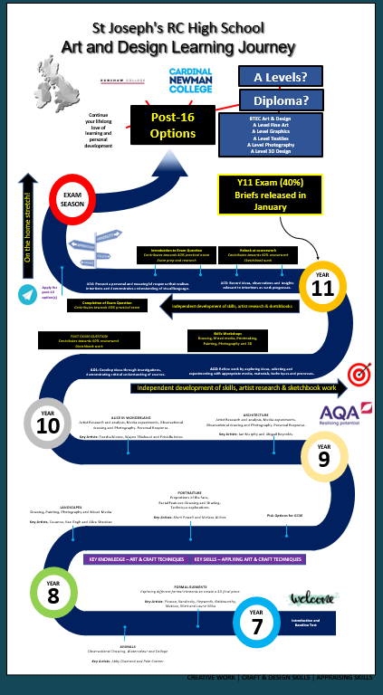

|  |  |
| --- | --- |
| 6th | Undertake your own research into different artists, using this to create exciting and varied responses.  Use detailed language when describing your work or the work of others.  Skilfully experiment with many Art techniques, combining these together to create exciting outcomes.  Skilfully observe proportion and scale when drawing. Understand how to use tone and texture to achieve depth and realism.  Mix colours and paint with considerable skill.  Select and develop techniques, integrate artist references and create exciting and individual pieces. |
| 5th | Confidently apply your understanding of the work of others by using fluent and relevant vocabulary.  Give clear and considered explanations.  Experiment with a range of relevant techniques, using different materials with skill.  Develop different approaches, using these to inform your own ideas.  Use a range of pencils to produce accurately proportioned drawings.  Paint with excellent control using a range of colours to create depth in your paintings.  Explore a range of techniques and use artist styles to inform your ideas when developing your own Artwork. |
| 4th | Look at the work of others and form opinions using the correct Art specific language.  Give specific reasons as to why you like or dislike a piece of Artwork.  Select and apply a range of experimental techniques.  Develop your own ideas using an experimental approach.  Draw using tone and texture to create a realistic appearance.  Apply your understanding of the colour theory practically when mixing paints.  Use your own ideas and images to create individual and experimental finished pieces showing some artist links. |
| 3rd | Select specific pieces of artwork and use these for your own artistic development.  Use full sentences when writing about your progress and the work of others.  Try a few techniques with growing independence.  Use different ideas to make changes to your work as it progresses.  Draw with increasing accuracy and growing skill, using tone and texture.  Mix colours and experiment with a range of paint techniques with some success.  Use your practical drawing and painting skills to develop and experiment with different ideas and approaches. |
| 2nd | Understand how artists create their work and explain the ideas that go into their pieces.  Explain your likes and dislikes about different artworks and write in full sentences.  Experiment with different Art techniques.  Use these techniques in your own work as it progresses.  Start to observe proportions and detail when drawing.  Start to mix colours and apply some layers to your paintings.  Use your practical drawing and painting skills to develop your own ideas when completing artwork. |
| 1st | Look at the work of different artists and apply simple techniques in their style.  Use basic language when describing the work of others.  Experiment with some Art techniques when drawing and painting.  Use a pencil to observe shapes and outlines and apply basic layers of shading.  Use paint to apply colour to your work.  Use your practical drawing and painting skills to create finished pieces of work. |

**Assessment Principles**

Students are assessed in Year 7 on their baseline task. Students in Year 7 and 8 are assessed based on their 2 projects.

Students will also be assessed in line with the progression scale and whether they are above, meeting, below or well below their target.

Students are assessed in line with the GCSE grading criteria. They will be assessed 4 times for each project focusing on the assessment objectives of

A01- Research A02- Experiment A03 Record and A04 Present.

**Enrichment and Extra-Curricular**

Art offer

* Art Club for Year 7 and Year 8 to encourage a love of Art and develop basic skills.
* Year 11 Intervention after-school on Wednesdays/Thursdays.
* Art Trip for Year 9 to The World Museum for their Cultures project.

**Art Strengths and Areas of Focus**

Progress is measured through formative assessment (continual) and summative assessment at the end of their SoL / project.

There is a good uptake for GCSE Art and Design and post 16 Arts uptake is positive.

Our students develop independent thinking skills through the promotion of self-directed study, developing transferrable suitable for post-16 study.

Students are able to engage and appreciate the arts through a sense of enjoyment which helps students’ overall wellbeing.

Areas of focus are to continually improve results for GCSE Art, Craft and Design each year. Students will be shown a range of techniques to improve their results for A02 which will then hopefully lead to more students achieving the higher grades.