Performing Arts Curriculum

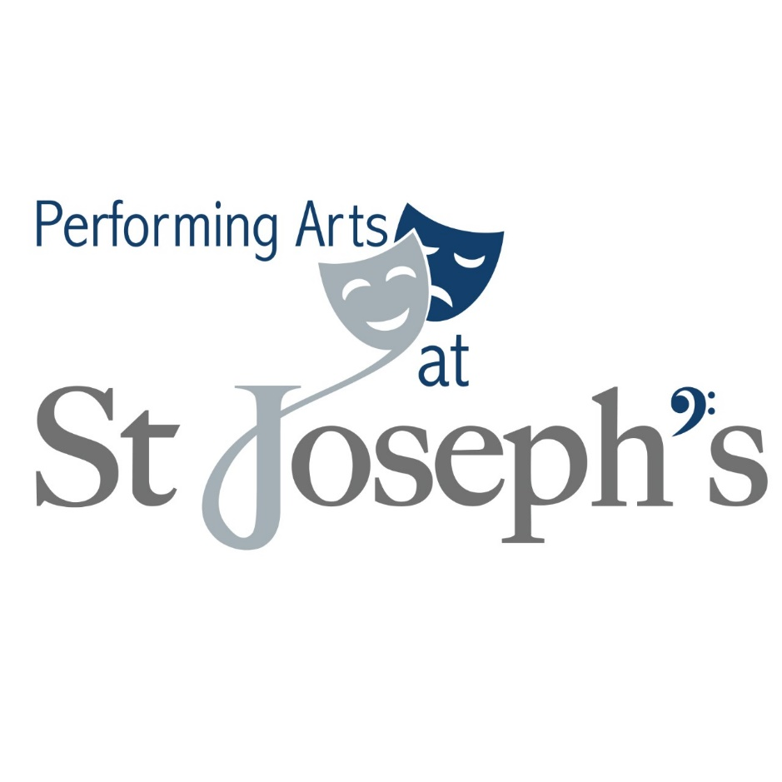

**Performing Arts Department Statement of Intent**

“Let your light shine before others, so that they may see your good works and give glory to your Father” Matthew 5:16

Performing Arts engage, inspire, challenge and develop pupils. Students will have a scaffolded education where the foundations are embedded in year 7 and the students will have the skills needed for the challenging requirements of the GCSE subject. Performing Arts has an impact on whole school by offering opportunity for whole school shows, developing relationships and also give pupils the opportunity to put into practice what they learn in lesson into an amateur production.

**Aims of the Performing Arts Department**

Students are encouraged to develop their confidence and performance skills by emphasising the skills and talents that we all share and encouraging those who are less confident to shine.

**Drama**

Drama at St Joseph’s RC school aims to raise the standard of professional practice in every theatrical discipline, pursuing excellence in the arts to promote wonder, empathy, and understanding in the world. We aim to encourage creativity, resilience, respect and imagination in a safe environment. Students should feel free to express opinion and develop skills that will shape them not only as a performer but as an enthusiastic learner.

**Music**

Music at St Joseph’s RC High school is a practical, collaborative subject, which develops student’s abilities to think creatively, whilst expanding and showcasing students’ musicianship skills. The students work independently as musicians and as ensembles to deliver effective and memorable performances with regular peer feedback. Students will have the resilience to develop knowledge of different musical genres and theory knowledge, whilst experimenting creatively with composition tasks, whilst building confidence through performance and appraisal.

**Gospel Values:**

As a Catholic school, our values are rooted in the Gospel message and we develop the values in every one of our students.

|  |  |
| --- | --- |
| **Gospel Value** | **Location in Department Teaching** |
| Faithfulness and Integrity | In performing arts pupils will be encouraged to take risks to be supported to learn Faithfulness and Integrity. |
| Dignity and Compassion | In performing arts pupils will learn about dignity and compassion with the use of performances. We encourage pupils to take risks in the supporting environment of the classroom. |
| Humility and Gentleness | In performing arts pupils will learn humility and gentleness with the use of feedback. We encourage pupils to give peer feedback that is constructive and always supportive with the correct intent. |
| Truth and Justice | In performing arts we look at topics and we explore real life and cultural differences. This will support pupils to learn Truth and Justice. |
| Forgiveness and Mercy | In performing arts we hope to allow pupils to explore forgiveness and mercy with the use of structured schemes of work. |
| Purity and Holiness | We will explore Purity and Holiness with the exploration with topics in a structured way. Giving pupils an opportunity to learn about Purity and Holiness with the use of Music and Drama |
| Tolerance and Peace | In performing arts pupils will learn about Tolerance and Peace with the use of performances and feedback. We encourage pupils to take risks in the supporting environment of the classroom. We ask pupils to work in groups to learn how to work and encourage each other. |
| Service and Sacrifice | In performing arts we work with pupils to gain an experience with Service and Sacrifice with the use of topics in Drama and Music. |

Welcome, Word, Witness, Welfare, and Worship.  In student speak, these translate as come, talk, work, walk, pray.

Welcome [come] – come together in welcome.

Drama and Music - Create a safe stimulating environment were pupils feel welcome. They also feel as if they are able to communicate with the art of Music and Drama in a respectful environment.

Word [talk] – talk together as a word of God’s community.

Drama - study of a range of scripts to look into the real lives of others. Challenge pupils to reflect on the differences. (we looks at some Challenging topics also: Rape, Drug abuse, Neglect, Bullying, Mental health are some examples of these)

Witness [work] – We look at our School mission statement and work together as a witness community.

Welfare [walk] – Walk together as a welfare community.

Drama and Music - Bringing the community together with Christmas showcase and end of year musical.

Worship [pray] – We pray together as a worship community.

Word - Music - We study a variety of musical contexts and genres. Students will look into the history of some musical genres studying the lives of famous musicians and their work.

Witness - Work together with peers in ensemble tasks.

**Drama**

Spiritual education encourages students through drama to experience the emotion and empathy involved in creativity. Feelings and expressions are nurtured and students are able to reflect on the beauty of their surroundings through performance.

Moral education plays a big part in Drama. Students, throughout both key stages, are involved in expressing their own responses to moral scenarios and dilemmas. They are able to appreciate the work of others, both inside and outside of school with practitioners encouraging critical discussion which is an integral part of learning.

Social development within drama provides all students with the experience that in turn will develop their social skills. Through collaborative work with their peers, students develop the skills that are necessary for collating ideas, selecting the most effective and then coming to a mutual agreement. Similarly, performances within drama allow students to further accept each other and their place in the class.

Cultural education involves students drawing on a wide variety of traditions and cultures and developing an aesthetic appreciation for them. Furthermore, students are able to explore their own culture and begin to recognise and appreciate similarities and differences.

**Music**

Music enables students to develop their aural awareness and appreciate and have knowledge on a variety of different musical styles, cultures and ideas. Students will develop their communication, cooperation and skill through highly practical and inclusive creative tasks. Students will explore practically, with theory and history interweaved, a variety of different music icons and their methods of practice. Students will work collaboratively during ensemble tasks and through this will develop social skills, leadership, the ability to empathise and will be able to develop teamwork to enhance theirs and peer performances.

**Performing Arts Department Overview of Intent**

**Drama**

**Curriculum Intent – Year 10**

By the end of Year 10 our Drama practitioners will be developed performers and researches of Drama. Pupils will confidently and accurately be able to use skills to engage with a range of topics.

**Subject Content**

* Practical work development, Introduction to live theatre review, Noughts and Crosses, Written exam, Script work, Devising Drama, GCSE exam Devising Drama 40% (practical and written), Mock in Devising, Written, written exam and script unit.

**Curriculum Intent – Year 11**

By the end of Year 11 our Drama practitioners will be able to use skills to accurately evaluate, assess, perform and reflect on practice. They will be developed as performers and researchers.

**Subject Content**

* Written exam all elements, noughts and crosses, script work, GCSE Script exam 20% (2x Practical), Written exam preparation, GCSE Written Exam 40%.

**Curriculum Intent – Year 8**

By the end of Year 8 our Drama practitioners will continue to explore Drama, building confidence with a range of skills and topics. Drama will enable pupils to be creative and develop group work.

**Subject Content**

* Introduction to Drama, Script work: “Our Dray Out”, Devising Drama – Urban Myths, Devising Drama – “Peer Pressure”, Script work Anti-Social behaviour/ Animal testing, Live theatre review – Forum Theatre.

**Curriculum Intent – Year 9**

By the end of Year 9 our Drama practitioners will start to master the art of Drama. Pupils will explore skills and topics in a creative way. Pupils will develop as performers and researchers.

**Subject Content**

* Introduction to GCSE Drama, Script work – introduction to noughts and crosses, Devising Drama – Topic and Stimuli, Script work introduction, GCSE written exam (Mock exams in Devising Drama and Written exam (Section A and B) Script mock.

**Curriculum Intent – Year 7**

By the end of Year 7 our Drama practitioners will develop an understanding of Drama in education, Pupils will explore topics in a creative way. They will experience a range of skills and topics.

**Subject Content**

* Introduction to Drama, Script work: “Simon and the head teacher”, Devising Drama – Physical theatre, Storytelling, Script work – Pantomime, Live theatre review – Pantomime.

**Music**

**By the end of Year 7 students should be able to:**

* Identify some musical elements in performances and listening tasks.
* Perform simple melodies and chord patterns on keyboard and ukulele
* Understand basic rhythmic techniques and be able to implement these into a performance.
* Be able to identify some musical symbols and state their meaning.
* Give constructive peer feedback of performances using key terminology.

**By the end of Year 8 students should be able to:**

* Identify some musical elements in performances and use this knowledge to further develop your own performance skill.
* Perform simple melodies and chord patterns on keyboard and ukulele and be able to play with different rhythmic patterns.
* To be able to explore basic composition skills.
* Understand basic rhythmic techniques and be able to implement these into a performance.
* Be able to understand some music notation and be able to write it themselves.
* To perform effectively as an ensemble.
* Explore different musical genres and state some stylistic features of the specific genre (I.e. Rock, Reggae, Film music).

**By the end of Year 9 students should be able to:**

* Implement the DR PAT SMITH terminology anagram into appraisal questions.
* Perform and develop a solo piece on their chosen instrument.
* Demonstrate the ability to change a piece of music through arrangement, composition and improvisation.
* Understand more advanced theory knowledge than in year 7 and 8: Rests, circle of fifths, music notation on bass and treble clef, sharps and flats identification, rhythmic notation.
* Give constructive peer feedback of performances using key terminology.
* Understand different musical structures and forms.
* Have the confidence to compose a chord progression and simple melodic idea.

**By the end of Year 10 students should be able to:**

* Appraise set work studies and analyse using DR PAT SMITH terminology.
* Refined and rehearsed solo performance piece ready to record for their exam.
* Work effectively as an ensemble to create an arrangement of an ensemble piece of their choice.
* Complete their ‘free composition’ using computer notation and recording software; Garageband.
* Understand different musical structures and forms.
* Be able to identify musical features, instrumentation and instrument techniques through listening and appraisal tasks.
* Have the confidence to compose a chord progression and simple melodic idea and be able to have the musical awareness to compose to a specific brief successfully.

**By the end of Year 11 students should be able to:**

* Completed their solo and ensemble performances. (30%)
* Completed their free composition and set brief compositions (30%)
* Have studied a range of musical styles, genres and instrumental techniques through theory and performance.
* Have improved aural awareness.
* Be able to identify and implement a range of key music terminology in feedback and written responses.
* Have revised and have clear knowledge of the set work studies.

**Drama Teaching Overview.**

*AQA Drama (Component 1 = written exam section A- Theatre roles and responsibilities, Section B: Noughts and crosses, Section C: Live theatre review. Component 2: Devising Drama (performance and coursework internally moderated.) Component 3: Script work (2 extracts from same text externally assessed by visiting examiner)*

*Split into 5 sections*

*General Drama – Written exam section A theatre roles and responsibilities.*

*Script work Component 3 – Performing a script*

*Devising Performance Component 2*

*Script work – Written exam section B – Script evaluation*

*Live theatre – Written exam Section C – Live performance review*

National curriculum/ Department of Education overview (Knowledge and understanding/ Skills)

GCSE Preparation

SMSC & 5W’s

Careers

Cross curriculum

|  |  |  |  |  |  |  |
| --- | --- | --- | --- | --- | --- | --- |
|  | Autumn T1  7 Weeks | Autumn T2  8 Weeks | Spring T1  6 Weeks | Spring T2  5 Weeks | Summer T1  7 Weeks | Summer T2  7 Weeks |
| Year 7 | Introduction to Drama | Script work: Simon and the head | Devising Drama – Physical theatre & Storytelling | Performing – Spy School | Script work- Pantomime | Live performance Pantomime  Theatre roles |
| Year 8 | Introduction to Drama – Vocal and Physical | Script work: The Riots | Devising Drama – Urban Myths | Devising Drama – | Script work Stormbreaker | History and Drama - |
| Year 9 | GCSE Drama Intro  Theatre Roles  (C1,2&3) | Script work: Noughts and crosses  (C1) | Devising mock (C2) | Epic theatre and the rise and fall of Hitler  (C2) | Section A and technical theatre (C3) | DNA and an Introduction to noughts and crosses (C1) |
| Year 10 | Practical work mini tasks  Noughts and crosses  Live theatre  (C1,2&3) | See live performance and review/ Text Study noughts & crosses  Theatre roles  Dystopian  (C1) | Devising  Topic and Stimuli  (C2&C3) | Devising  Topic and Stimuli  (C1) | GCSE Devising component 2 exam  Mock exam/ devising  (C1) | GCSE Devising component 2 exam (devising log)  Live review  Noughts and crosses  (C2) |
| Year 11 | See live performance and review/ noughts & crosses (recap)  Theatre Roles  (C2) | Script work  Context of script  Component 3 assessment  (C1& C3) | Scrip work  Context of script  Component 3 assessment  (C1&C3) | Exam prep  (C1) | Component 1 Exam  (C1) | Exams |

**Music Teaching Overview**

Edexcel Music – Appraisal (Set Works), Composition (Composition A & B), Performing

Music Theory – General knowledge of music – Preparation for appraisal component

Performing – Solo performance and Ensemble work

Composition – Developing creativity through composition (Two compositions)

Listening and Appraisal – Set-works and musical analysis

Self -Assessment and Peer feedback

**National curriculum**

**GCSE Preparation**

**SMSC and Careers**

|  |  |  |  |  |  |  |
| --- | --- | --- | --- | --- | --- | --- |
|  | **Autumn T1**  7 Weeks | **Autumn T2**  8 Weeks | **Spring T1**  6 Weeks | **Spring T2**  5 Weeks | **Summer T1**  7 Weeks | **Summer T2**  7 Weeks |
| **Year 7** | Introduction to Music. Keyboard skills. Solo Performance. ‘Stitches’ and ‘7 Years Old’.  Reading and performing music notation.  Starter tasks 🡪 music appraisal using terminology (AOS3)  Understanding and performing chord patterns (AOS 1)  Listening skills  Peer feedback 🡪 Students being constructive and supportive | Developing ensemble skills. Pop Music scheme of work 🡪 Band skills, performing ‘Forget You’.  Teamwork and communication  Developing knowledge of music theory and notation.  Rhythm and metre introduction; Canon, Unison, Call and response, improvisation.  Giving feedback on performances using 12 steps and music terminology (AOS1 & 3).  Peer feedback 🡪 Students being constructive and supportive | African Drumming – Samba (STOMP unit)  Study of rhythm and beat through appraisal and performance  Composing your own rhythmic drumming performance. (AOS2) (AOS1)  Careers – Composer, writer of film and TV music  Theory development; cross rhythms and polyrhythms. (AOS3) | Music Theory and elements of music through performance. Ukulele – 4 chord songs (AOS1)  (Pitch, Dynamics, Tempo, Structure, Texture, Timbre) (AOS3).  Understanding different note values, rests and sharps and flats. | Music for Media (Film Music)  Writing for adverts and film trailers and computer games.  Appraisal of how music is effective for the ‘moving image’ 🡪 Intro to tonality 🡪 Major/Minor. (AOS2)  Ostinatos, Riffs, Major/Minor. (AOS3) | Live performance (Musical Futures)  Ensemble and Solo work.  Instruments covered;  Voice, Keyboard, Ukulele, Guitar, Drums.  Whole class performance (AOS1).  Careers – Musician/performer |
| **Year 8** | Rock Music –  Study of stylistic features, history and culture. Power Chords, famous Rock riffs – Study and perform Queen and Bon Jovi (Appraisal, performance and creative composition) | Musical styles: Reggae Music  ‘Musical Futures’ scheme of work. Solo and Ensemble performance.  Studying, Bob Marley. ‘Three Little Birds’ ‘Buffalo Soldier’.  Stylistic conventions 🡪 Syncopation, cross rhythms,  Appraisal with key terminology (AOS3) and performance tasks (AOS1). | Song-writing – (4 chord songs).  Discussion of song writing structure. All students will be able to perform a 4-chord progression and then create their own. (AOS2)  Major/Minor tonality discussion.  (Structure, Chords, Riff, Melody writing, lyrics, bass line)  Ensemble group work and practical assessment task (AOS1).  Team work , communication and unity.  Appraisal and feedback (AOS3). | Music for soundtracks;  ‘Skyfall’, ‘Mission Impossible’, ‘Toy Story’, ‘Up’, ‘Jaws’.  Students will appraise and analyse the important of music to create atmosphere using key terminology (AOS3).  (Study of Leitmotifs) | Covers and arrangements scheme of work – Students will study ways of creating their own interpretation of pieces of music in groups. BBC live lounge listening and appraisal tasks. Developing ensemble skills and performance skills. | Live performance  Musical Futures “Just Play” module – Band Ensemble skills  Instruments covered; Voice, Keyboard, Ukulele, Guitar, Drums.  Whole class performance (AOS1). |
| **Year 9** | Introduction to Music GCSE.  Solo performance introduction; Expression, interpretation. (AOS1).  Development of music theory, notation (Circle of fifths) (Reading bass and treble clef) Introduction to DR PAT SMITH (AOS3). | Introduction to set work studies. ‘Glam Rock study – Killer Queen’.  Learning about different artistic cultures and historical contexts.  Study of stylistic conventions of Glam Rock Music. (Guitar effects, power chords, recording techniques/effects).  Performing the melody of the set work piece.  Close score analysis using DR PAT SMITH.  Continued solo performance and performance skills development (AOS1).  Terminology development (DR PAT SMITH). | Music theory development 🡪 harmony and tonality.  Ensemble performance ‘Musical ‘Futures’ class tasks (AOS1).  Appraisal question tasks with terminology (AOS3).  Introduction to dictation melodic and rhythmic dictation questions and cadence recognition (AOS3). | Music for Stage and Screen 🡪 Defying Gravity Set Work study.  Stylistic features of Musical Theatre.  (Performing leitmotifs, recognition of intervals perfect 4ths and 5th and their effectiveness).  Close score analysis of Defying Gravity using DR PAT SMITH (AOS3).  Wider listening question practice (AOS3).  Continued dictation practice (AOS3).  Continued solo performance practice (AOS1). | Music for stage and screen continued through starting composition tasks.  Introduction to using composition software; Garageband.  Composer, Producer, Engineer  Composition task: Step by step process.  Creating music for moving image; film trailer.  Development of composition techniques. (AOS 2).  Continued performance development and one to one theory support (AOS 1 and 3) | Recap of ‘Killer Queen and Defying Gravity’ set work studies. (DR PAT SMITH analysis)  Practice wider listening and dictation questions.  Continued performance development and one to one theory support (AOS 1 and 3). |
| **Year 10** | Starting your ‘Free Composition’ – Students will begin working on their composition (15% of GCSE).  Study of different musical styles and structures to influence this. (AOS 2)  Music theory continued development and progression with solo and ensemble piece ideas. (AOS 1 and 3) | Continue with Free Composition. (AOS2)  Vocal Music set works – H Purcell Vocal Music wider listening  Learning about different artistic cultures and historical contexts.  Performing  Mock Performance Exam  DR PAT SMITH analysis score analysis  Continued music theory and performance development (AOS 1 and 3) | Vocal Music set works continued  Composition A Free composition using GarageBand on the Macs  Career links – Composer, Producer, Mixing/Mastering Engineer  Dictation and notation practice. (AOS3)  Introduction to written commentaries. | Music for Stage and Screen set works – Star Wars ‘Blockade Runner’.  Learning about different artistic cultures and historical contexts.  Study of Ternary form and close score analysis. (AOS3)  Free composition continued (Responding to feedback) (AOS2)  Performing - ensemble performance (AOS1) | Music for Stage and Screen set works  Music for Stage and Screen wider listening (AOS3)  Free composition (AOS2)  Performing  Mock Appraisal Exam | Ensemble and Solo performances refining for Autumn 1 Year 11 recording exam.  Unity and Co-operation  (AOS1)  Introduction to Beethoven Piano Sonata set work study.  Study of Romanticism and Sonata form.  Completing written commentaries for ‘Free composition’. (AOS2) |
| **Year 11** | Continuation and recap on instrumental set work study: Beethoven Piano Sonata.  Study of different artistic cultures and contexts  Key word recap and continued close score analysis.  Final term to perfect solo and ensemble performance pieces ready for next terms assessment. (30%) (AOS1). | Solo and Ensemble performance exam. (AOS1 30% of GCSE).  Introduction to set brief composition: Students to decide and begin composing from one of the 4 stated briefs. (AOS2). | Instrumental Music – Brandenburg Concerto begun.  Study of Baroque music, Concerto Grosso etc.  Close score analysis and practice questions.  Continuation of Set Brief Composition (AOS2). | Finishing the final set work study (Brandenburg Concerto) Recap of key music terminology for DR PAT SMITH. Finishing set brief composition and supporting commentary. | Written Appraisal exam revision. (AOS3). | Written appraisal exam revision (AOS3). |

Curriculum Development: Intent and Implementation

St Joseph’s Curriculum Implementation Drama

The Drama curriculum has been impacted by Covid-19. Students mainly completed theory work during the period of home learning and although some practical work was set, this was the area of the Drama curriculum that was most impacted by the remote learning.

Therefore, to close the gaps in practical skills, we will be focusing on the following:

* Group Work
* Practical skills
* Confidence building
* Collaboration
* Performance and presentation skills

Consolidation was a main focus of the curriculum on returning to face-to-face teaching and promoting positivity and re-establishing learning routines.

Moving forward SOW have been adapted and the use of online support with continue for pupils independent learning skills.

* Online PowerPoints with voice over for independent revision
* Revision guides created
* Challenge options in practical lessons (pupils to self challenge)
* Next step homework after assessments to focus pupils.

As a school we are looking at Digital theatre + as a resource to use for all pupils as this platform has a range of performances and supporting documents to support pupils at home.

We have a small group of pupils who are attending intervention and support where a personalised strategy for consolidation has been identified.

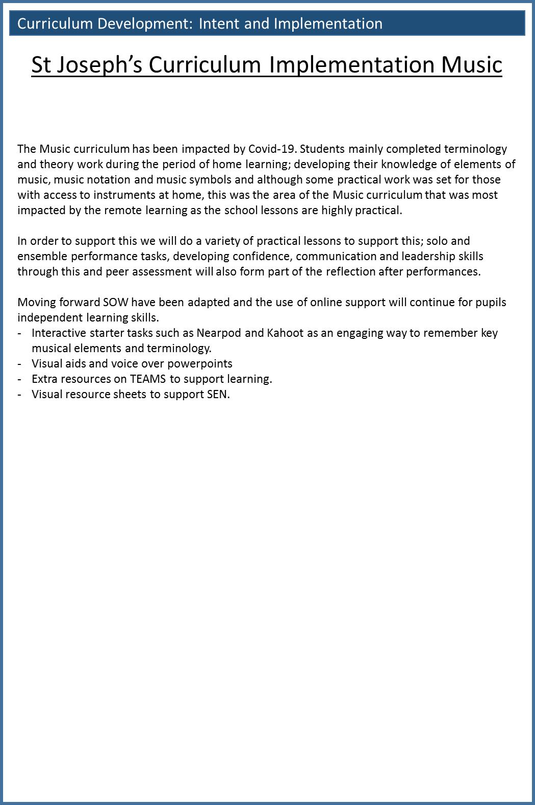

**SMSC in Performing Arts**

***Spiritual Development:***

Sometimes the topics we look at in performing arts challenge our spiritual ideals. Performing Arts is a way of looking at life in a creative way. It helps us gain respect for our spiritual beliefs and the beliefs of others. It helps us question society and it is important to understand why conflicts arise so we can respect the views of others and move forward. It is also seen more often that Performing Arts is able to stand alongside the spiritual beliefs of many.

***Moral Development:***

Our understanding of Drama and Music is a way of expanding and developing understanding of “people”. For hundreds of year people have used Drama and Music to tell stories and capture moments in history.

We must now use this to expand our understanding. Using Drama and Music to express our thoughts, beliefs and topics we want to explore. We can also use Drama and Music as a way to challenge society and to create work that marks a moment or challenges morals.

***Social Development:***

Performing Arts is changing our society. Music and Drama can be a direct reflection of society and time it was create, From Shakespeare and Hamilton to Musical genres and contexts.

Our society is developing so fast performing arts can be a way to capture a moment and to document a period of time. This can be a way to look into the past or to educate and help future generations.

***Cultural Development:***

Creative development comes from all across the world, from people of all backgrounds and cultures. Some of the most important Performance creators and musicians have come from other parts of the world and it's important for students to understand this. It is also important to understand how the different cultures around the world can have different impacts on creativity. People are invited to experience Drama and Music from around the world. It helps people extend their view point and be enriched into a multi-cultural experience. The creative influences from around the globe has a direct impact on what we teach in Performing Arts. We believe it can be an immersive experience.

Performing Arts contributes to our students’ SMSC development through:

* Anti-social behaviour
* Animal testing
* Peer pressure
* Mental health
* History of Drama and Music
* Teamwork
* Communication

**SEND Students and Curriculum Planning – Performing Arts**

The [Equality Act 2010](https://www.legislation.gov.uk/ukpga/2010/15/contents)and [Special Educational Needs and Disability (SEND) Regulations 2014](https://www.legislation.gov.uk/uksi/2014/1530/contents/made) place certain duties on schools to ensure that students with SEND are able to take advantage of the same opportunities that other students have. To help students with special educational needs **and** disabilities (**SEND**) reach their full potential, they first must have equal access to your **curriculum**.

In performing Arts when we plan our Schemes of work SEND is at the forefront of our mind. Each year SOW are adapted with the pupils in that year group. Over the years with CPD training we have acquired new techniques to best support our SEND pupils.

This will ensure good progress of all learners as pupil’s needs are considered. These pupils are monitored during data drops and during assessments.

In performing Arts we ensure that pupils requires and needs are considered when planning for assessment.

To remove gap and barriers for SEN pupils we ensure we provide the following:

Extra scaffolding

Sequencing learning – following the same pattern of lessons for consistency.

Opportunities to revisit and embed skills and knowledge

Adapting methods of assessing knowledge and skills

Visual resources and modelling.

**Promoting British Values in Performing Arts**

*The Rule of Law*

We actively promote civic institutions so that students value and appreciate the local the Health system, the Police, the justice system and Social Services and how Performing Arts had reflected these establishments within the work of performers and artists.

*Mutual Respect and Tolerance*

Drama and Music has many complex ethical issues from animal testing, culturally movements to antisocial behaviour. Students are expected to weigh up both sides of any argument and provided reasoned response that underpins their own stance to these issues.

*Democracy*

Drama and Music are fundamental pillars of any society.  Music and Drama is use as a form of expression everywhere in the world regardless of race, language or religion. We show how artists collaborate worldwide to share ideas and creative platforms. We look at Drama and Music as the most effective expression of values beyond the written word. We look at all genres and look at how Drama and Music shape the society and community regardless of ethnicity, background or beliefs. This supports the British ethos behind democracy.   *Individual Liberty*

Drama and music changes over time and is a direct reflection of society at the time of creation. We can use past performances to research history and current to depend out understanding of the world today. The Performing Arts department promotes FBV

***In Performing Arts, students:***

* Value each other’s opinions, religions and beliefs.
* Demonstrate positive attitudes.
* Collaboration and teamwork.
* Create an atmosphere where we celebrate mistakes and learn from them
* Are fully engaged and participate.
* Explore current affairs (use of Music and Drama).
* Value the use of Pupils’ voice.
* Encourage Mutual respect.

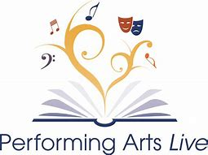**Literacy and Performing Arts**

Literacy needs to be deliberately planned into a department’s SOL in order to give it the time and priority it requires. Resources will need to be prepared in advance so that Literacy is an integral part of Performing Arts teaching and learning in lessons and develops alongside skills and content. These may include word cards, question cards, books, magazines and leaflets, writing frames and worksheets and games.

Whenever it is appropriate literacy objectives should be built into the lesson along with Music and Drama specific objectives. Literacy can be developed in every lesson through activities such as emphasis on word work during questioning and mental start-up activities at the start of each lesson. Some topics will lend themselves more easily to literacy development than others. Such emphasis on the language of Music and Drama will inevitably result in pupils being more able to articulate ideas in their own words.

*Key Areas of Literacy*

|  |  |
| --- | --- |
| **Vocabulary**  **Key issues** Technical and specialist words  Appropriate usage  Correct spelling  Understand meaning  **Common difficulties**   * Time and lots repetition needed to ensure new words are internalised into working vocabulary and linked to appropriate concepts. * Ordinary words with alternative meanings can be difficult as it causes cognitive conflict.  Supporting strategies  * Introduce words using a multisensory approach e.g. orally, visually, kinaesthetically * Use vocabulary frequently using open questions * Use words in sentences to keep reflecting back * Use models and picture to help visualise the word * Use flash cards to test pupils understanding * Ask pupils to explain using pictures to encourage language development * Use visual clues e.g. hand signals * Use poetry, rhymes, raps and rhythms to aid memory and link to modern culture * Get pupils to make own word lists to collect new words and test and check their meaning | **Oracy**  **Key issues** Use language precisely  Listen to others and respond by  building on ideas and views **Common difficulties**Constant use and repetition are essential. Words which are not frequently used are easily forgotten  * Often little planned time in lessons to “talk” * One word answers for fear of getting it wrong   **Supporting Strategies**   * Teacher model good use of topic based language * Use questions to review past knowledge and understanding, check understanding, encourage the learner to think and to practice the language * Use a range of questioning strategies * Allow pupils “thinking” time * Offer pupils challenge * Use games to encourage meaningful peer group talk and embed new word and concepts * Use small group discussion to develop pupil understanding through conversation in a less threatening atmosphere |

|  |  |
| --- | --- |
| **Reading** **Key issues** Strategies to help reading for understandingLocating and using information Summarising  Synthesise learning from reading Common difficulties  * Pupils often cannot relate to the type of Music and Drama texts used in school in terms of language and style * Children often prefer fiction to non-fiction texts * Children prefer to use interactive methods of discovering information e.g. Internet * Limited range of text that can be offered to pupils * Weak readers can lack the ability to scan and skim read * Pupils prefer to copy chunks of text without checking their relevance  Supporting Strategies  * Develop activities to promote meaningful reading experiences e.g. EXIT model * Activities prior to reading that give pupils a desire to find out more e.g. using a contents page or index * Activities associated with reading to make the data processing easier e.g. DARTS, cloze procedure, sequencing, underlining * Activities following reading to encourage reformulation of the information into personal knowledge e.g. table/diagram completion, summarising | **Writing****Key issues C**orrect spelling and punctuation Follow grammatical conventions  Organise work in a logical and  coherent form Common difficulties  * Many pupils are reluctant writers * Poor handwriting and spelling can make writing difficult to interpret * Lack of understanding what they are being asked to write about * Time pressure in lessons to get ideas or work down onto paper  Supporting Strategies  * Plan to incorporate the different forms of artistic writing into lessons e.g. recount and report, instruct etc. * Use different types of text * Get pupils to analyse prose to look for key words and phrases * Get pupils to criticise and improve on received text * Encourage use of a variety of genre e.g. narrative, descriptive, persuasive, reports, imaginative when appropriate * Use writing frames where appropriate, encouraging children to use it as a guide line and eventually manage without * Encourage children to redraft work in lessons using teacher comments * Develop skills in note taking by using short simple activities e.g. jot down key words, note observations on teachers demo * Teach pupils how to summarise text e.g. crosswords, catchword * When asking pupils to write analysis and evaluations teach them the specialist vocabulary and phrases needed |

**Performing Arts Structure**

The Performing Arts department is made up

Miss K Collier – Head of Department

Mrs I Starbuck – Teacher of Music

Miss B Breakspeare – Teacher of Drama, Music and Performing Arts

Mr O Wright – Maternity cover Music

In Year 7 and Year 8 students have 2 x 1hour lessons over the 2 weeks in both Music and Drama

In Year 9, Year 10 and Year 11 students have 5 x 1hour lessons over the 2 weeks

*Curriculum Structure*

Students in Year 7 and Year 8 are follow a programme of study which aligns to the National Curriculum for

Music and English (Drama - National curriculum/ Department of Education overview (Knowledge and understanding/ Skills)

Each unit of work for Drama:

Year 7:

* Introduction to Drama
* Script work
* Devising Drama
* Performing skills
* Pantomime
* Live performance

Year 8:

* Introduction to Drama
* Script work
* Devising Drama
* Creating a performance from a social topic.
* Creating Drama from a cultural topic.
* Live performance.

Each unit of work for Music:

Year 7:

* Introduction to Music
* Keyboard and Ukulele
* Developing ensemble skills.
* African Drumming – Samba
* Music Theory and elements of music through performance.
* Composition
* Live performance
* Musical futures ensemble performance

Year 8:

* Introduction to Musical Theatre Script work
* Musical styles: Reggae Music
* Song-writing
* Music for soundtracks.
* Musical styles: Rock Anthems.
* Live performance
* Covers and arrangements

In Year 9 to 11 students study **GCSE Drama (8261)** from the **AQA** suite of GCSE qualifications.

The AQA specification engages and encourages students to become confident performers and designers with the skills they need for a bright and successful future. The written exam paper is designed to help all students realise their full potential. AQA use a variety of question styles and ask students to combine what they’ve learned about how drama is performed with their practical experience and imagination. There is a clear progression to AS and A-level This specification ensures continuity for students progressing from GCSE Drama to AS and A-level Drama and Theatre. Students who go on to AS or A-level are already familiar with studying a whole set text for the written paper. They have built solid foundations in reviewing a live theatre production and in interpreting key extracts. All of these aspects feature in the AS and A-level as well as the GCSE.

Transferable skills Students learn to collaborate with others, think analytically and evaluate effectively. They gain the confidence to pursue their own ideas, reflect and refine their efforts. Whatever the future holds, students of GCSE Drama emerge with a toolkit of transferable skills, applicable both in further studies and in the workplace.

The Drama GCSE consists of three units:

**Component 1:** Understanding drama. 40%

**What's assessed** • Knowledge and understanding of drama and theatre • Study of one set play. • Analysis and evaluation of the work of live theatre makers How it's assessed

**Written exam**: 1 hour and 45 minutes • Open book • 80 marks • 40% of GCSE Questions

Section A: multiple choice (4 marks)

Section B: four questions on a given extract from the set play chosen (44 marks)

Section C: one question (from a choice) on the work of theatre makers in a single live theatre production (32 marks)

**Component 2:** Devising Drama 40% (internal assessment)

* 80 marks overall
* 20 marks performance
* 60 marks on a written documentation of the process.

**Component 3:** Text in Practice20% (external assessment)

* 40 marks overall
* Two performances from one script

In Year 9 to 11 students study **GCSE Music (1MU0)** from **Edexcel** the suite of GCSE qualifications.

Edexcel have recently used the opportunity to have a curriculum change to redesign a qualification that reflects the demands of a truly modern and evolving music environment – a qualification that enables students to apply themselves and gives them the skills to succeed in their chosen pathway.

**Clear and coherent structure** – A straightforward structure with three engaging components, assessed through practical performances, compositions and one externally examined paper.

**Provides a real music focus** – the key content of musical elements, musical contexts and musical language are taught through the areas of study and set works to show real examples of how these are used within different types of music. Holistic understanding of music – students investigate, analyse and evaluate music and its features. Building on this, and by using practical methods, students are encouraged to take a more holistic view of their knowledge, performance and compositional skills.

**Breadth and depth** – the set works enable students to conduct in-depth studies into different musical styles and genres, and put them in a wider context.

**Diverse musical heritage** – students will learn to perform, compose and appreciate different types of music, developing critical and creative thinking, cultural, aesthetic and emotional awareness, and the ability to make music individually and as part of a group.

**Continuous progression** – the content builds on the understanding developed at Key Stage 3, avoiding unnecessary repetition while also ensuring that students new to the subject are appropriately supported. Progression to AS and A Level – the content allows students to develop their knowledge and skills of music, enabling them to progress into the AS and A Level qualifications in Music.

**Component 1:** Performing 60 marks

**Component 2:** Composing 60 marks

**Component 3:** Apprising 80 marks

This is an externally set and assessed examination

● the assessment is 1 hour and 45 minutes.

● the assessment consists of nine questions.

● Students must answer all questions.

● the paper will include multiple-choice, short open, and extended writing questions.

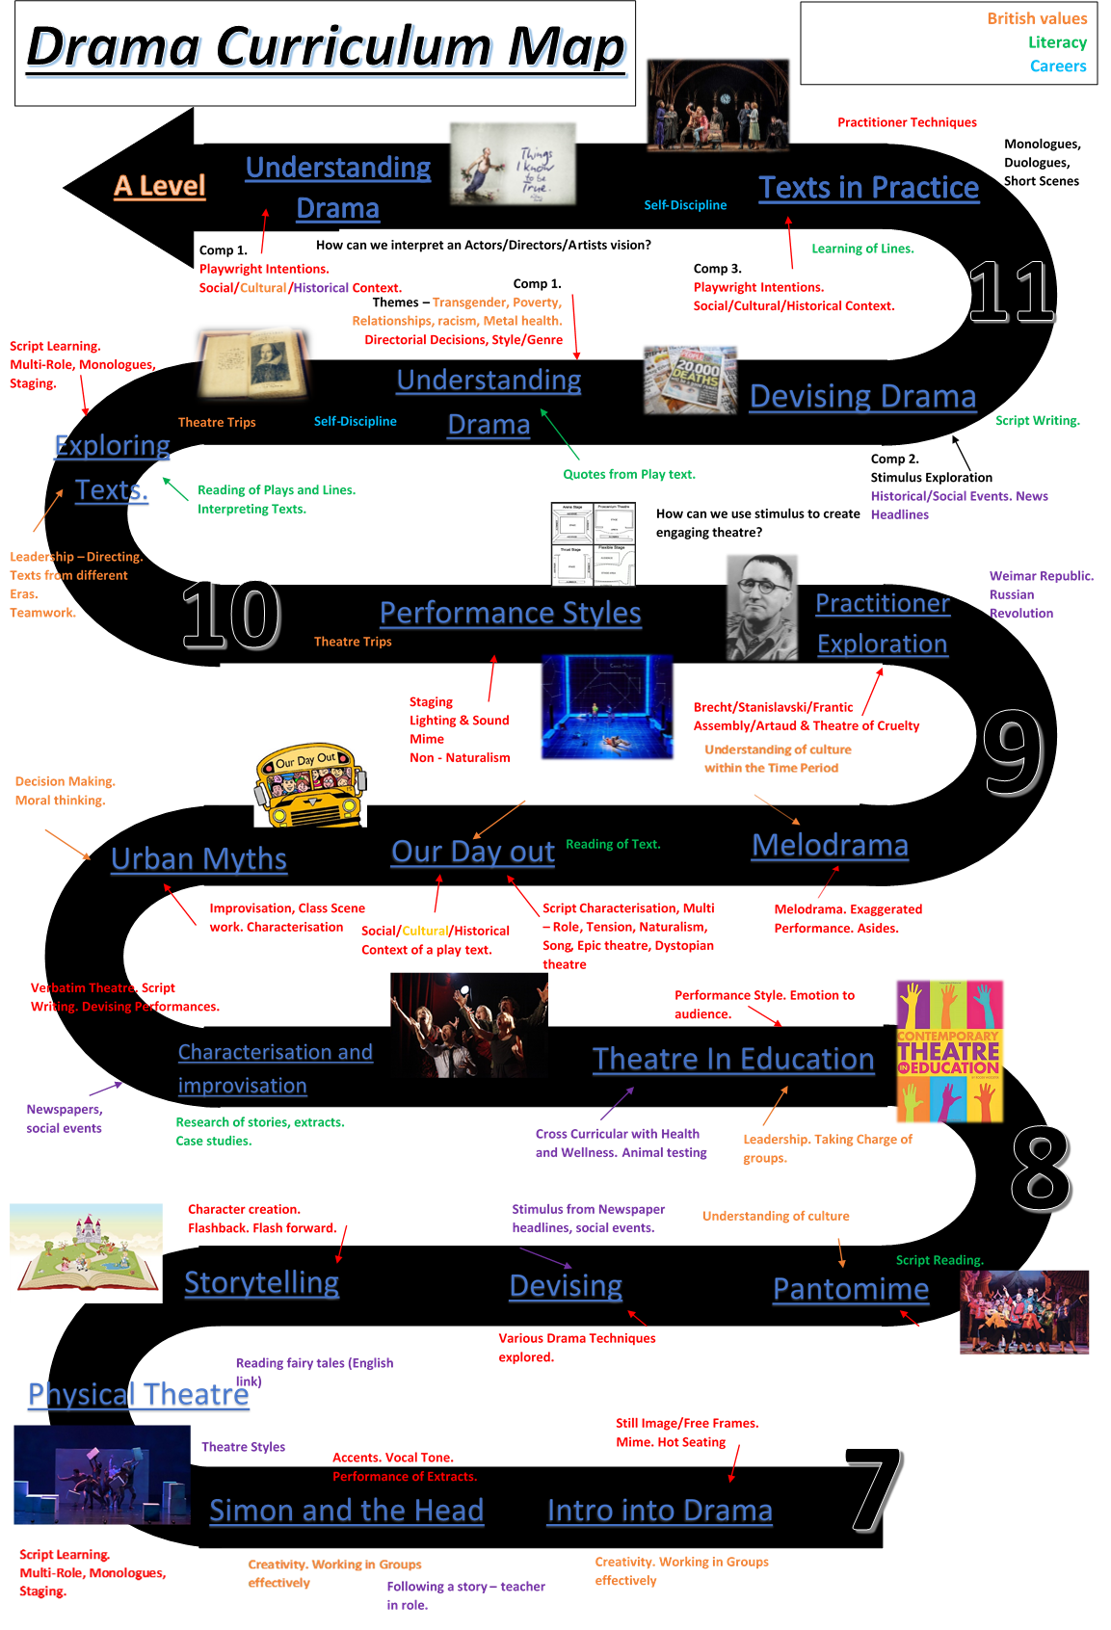

Cross curriculum

Knowledge

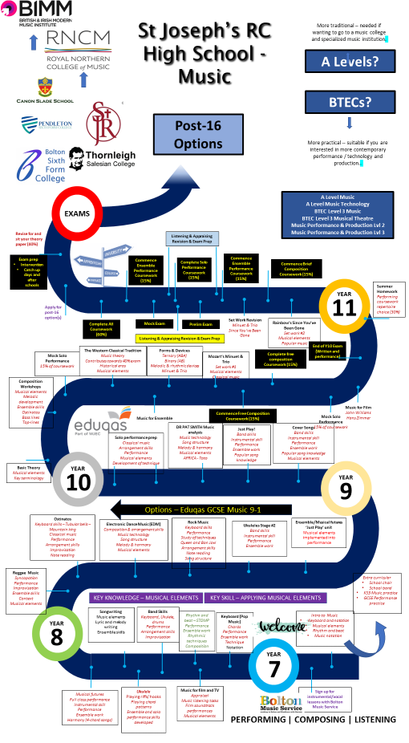

**Drama 12 Step Progression Scale**

|  |  |  |
| --- | --- | --- |
| **Step** | **Theory** | **Practical** |
| 12 | Demonstrate a rich knowledge and understanding in developing performance drama, using consistent, accurate and effective specialist terminology.  Be able to produce a sensitive, critical and insightful analysis and evaluation of drama seen and made. | Develop unique ideas for performance that communicate meaning(s) to provoke thought for the audience.  Able to effectively demonstrate a rich range of skill in performance.  Apply theatrical skill in a highly competent and sustained manner to realise artistic intention |
| 11 | Develop creative ideas for performance outcomes the communicate meaning(s) with impact to the audience.  To be able to produce perceptive and well – informed critical analysis and evaluate of drama seen and made | Apply theatrical skills in a skilful and effective way to realise artistic intentions.  Able to creatively use practical skills to communicate a clear well thought out meaning for the audience.  To be able to demonstrate breadth and depth of knowledge and understanding in developing and performing performance, using accurate and effective specialist terminology. |
| 10 | Develop effective ideas for performance outcomes the communicate meaning(s) with commitment.  Demonstrate advanced knowledge and understanding in developing and performing drama and when evaluating and analysing use relevant and specialist terminology.  Produce an appropriate analysis and evaluation of drama seen and made, using evidence to support. | Apply theatrical skills in a fluid and expressive manner to realise artistic intentions.  Demonstrate advanced knowledge and understanding in developing and performing drama. |
| 9 | Develop secure and appropriate ideas for performance outcomes the communicate meaning(s) with confidence.  Demonstrate strong knowledge and understanding in developing and performing drama and when evaluating and analysing use correct and specialist terminology.  Produce a comprehensive judgement analysis and evaluation of drama seen and made, using evidence to support. | Apply theatrical skills in a developed, secure and consistent manner to realise artistic intentions.  Demonstrate strong knowledge and understanding in developing and performing drama. |
| 8 | Develop clear and rational ideas for performance outcomes.  Demonstrate a secure knowledge understanding of drama and be able to talk confidently using specialist terminology.  To be able to produce a detailed analysis of drama seen and made. | Performance skills should be used effectively to communicate a clear idea that support an artistic intention.  Have a clear understanding of what skills will be best to demonstrate an idea clearly to the audience.  To be able to be reflective when creating practical work. |
| **Step** | **Theory** | **Practical** |
| 7 | Develop clear and coherent ideas for performance outcomes that communicate meaning(s)  Provide clear and insightful comments on drama seen and made | Apply theatrical skills in a confident and mostly effective way to realise artistic intentions.  Demonstrate sound knowledge and understanding of developing and performing drama using specialist terminology. |
| 6 | Be able to develop ideas for performance and have clear ideas for outcomes that communicate clear meaning(s)  Provide clear comments on drama seen and made that can be supported with examples. | Apply theatrical skills in a mostly effective way to realise artistic intentions.  Demonstrate some knowledge and understanding of developing and performing drama using specialist terminology. |
| 5 | Be able to develop ideas for performance that communicate clear meaning(s)  Use examples to comment on drama seen and made. | Apply theatrical skill with some effect to realise some of the artistic intentions  Demonstrate awareness and understanding of developing and performing drama using specialist terminology. |
| 4 | Be able to communicate clear meaning(s)  Justify comments on drama seen and made. | Apply theatrical skill with limited effect to realise some of the artistic intentions  Demonstrate awareness of developing and performing drama using specialist terminology. |
| 3 | Be able to communicate straightforward meaning(s)  Able to apply theatrical skills with limited effect to realise artistic intentions.  When evaluating performance have an inconsistent use of specialist terminology. | Develop some ideas for performance  Able to apply theatrical skills with limited effect In performance.  Have the ability to demonstrate a basic awareness of developing and performing drama |
| 2 | Use a theatrical skill to realise part of the artistic intention.  Contribute ideas to communicate simple meaning(s)  Start to use specialist terminology.  Able to comment on drama seen and made | Some use of theatrical skill in performance.  Some awareness of developing performance.  Have some ability to understand how and why performance skills are used practically. |
| 1 | Demonstrate limited understanding of theatrical skill and how it can be used practically.  Demonstrate occasional contributions to ideas to communicate meaning.  Have some ability to analyse performance. | Demonstrate limited use of theatrical skill.  Demonstrate an awareness of developing ideas in performance.  Demonstrate limited ability to understand how and why performance skills are used practically. |

**Music 12 step progression scale.**

|  |  |  |  |
| --- | --- | --- | --- |
| **Step** | **Theory and Musical Knowledge** | **Performing** | **Composition** |
| 12 | Demonstrate a secure and sophisticated level of musical understanding when appraising and listening identifying - Able to describe, explain and evaluate, as well as making comparisons | Demonstrate a high level of performance skill and is able to evaluate and draw comparisons to their performance with other pieces of music  Perform with empathy to the other performers and made a powerful contribution to the impact of the performance | Demonstrate a secure and sophisticated level of music composition  Being able to compose in different musical styles effectively and draw comparisons in their own compositions to other pieces |
| 11 | Demonstrate a high level of musical understanding when appraising and listening identifying using music terminology – Able to describe and explain | Perform with a developing sense of style and flair. | Uses advanced compositional techniques and technology to its full and the structural framework supports the impact of the piece. |
| 10 | Shows a good level of musical knowledge when appraising and listening identifying – Able to describe  Major, minor and dominant seventh chords using Roman numerals/chord symbols  Key up to 4 sharps and 4 flats  Imitative, canonic and layered textures  Evaluate and make critical judgments about your work, | Perform with control and detailed attention to instrument specific techniques, breathing, diction and posture.  Perform with empathy to the other performers | Demonstrated a wide range of musical techniques and technology to its full and the structural framework supports the impact of the piece. |
| 9 | Demonstrate a good level of musical understanding when appraising and listening identifying:  Dotted rhythms, triplets, syncopation  Evaluate and make critical judgments about yours and others work.  Justify reasons for yours and others choices | Show when performing stylistic awareness  Make a significant contribution to the impact of the performance. | Create compositions that are more extended using highly imaginative and original musical ideas, which have been adapted, extended.  Give direction to others.  Discard ideas, which demonstrate a high level of musical understanding.  Make accurate use of appropriate notation.  Challenge conventions. |
| 8 | Identify when listening;  Regular, irregular, free time  Diatonic, chromatic harmony  Tonal, major, minor, modal tonality  Different musical textures  Conjunct, disjunct, triadic, broken chords, scalic, arpeggio melodies  Discuss music with reference to key terminology. | Sing extended melodies with a sense of shape and expression  (Melodic instruments) – Perform complex melodies and chord sequences  (Percussion) – Perform syncopated, repeated rhythms  Co-ordinate your part with the other performers showing a good awareness of balance throughout.  Maintain more significant parts and perform with sensitivity to the group making adjustments as necessary.  Work independently of the teacher. | Extended, adapt and develop imaginative and original musical ideas  Show advanced compositional techniques are used  Use appropriate notation.  Follow and challenge conventions.  Demonstrate an understanding of stylistic and structural conventions.  Make use of imaginative musical ideas in composition.  Demonstrate good understanding of stylistic and structural conventions using relevant notation. |
| **Step** | **Theory and Musical Knowledge** | **Performing** | **Composition** |
| 7 | Able to identify, describe and explain different musical techniques when listening and give comparisons to other pieces of music | Sing longer melodic phrases with shape and some expression  (Melodic instruments) – Perform more complex, repeated melodies and simple chord sequences with rhythm and some expression.  Percussion/drum kit – Perform more complex repeated rhythms in time  Maintain a more significant part. | Show some imagination when composing.  Use appropriate musical elements and devices.  Use relevant notation such as lead sheet  Demonstrate that appropriate musical elements and devices have been selected and used effectively |
| 6 | Identify when listening; different dynamics, tempos and pitches, as well as explaining texture, structure, rhythm and harmony and its effectiveness | Able to use more complex performing techniques and identify their effectiveness | Demonstrate creative ideas and use some musical elements successfully.  Show there is some development using appropriate devices.  Use structure that is well defined and appropriate.  Use simple notations.  Show your composition has creative ideas and uses some musical elements successfully in combination. |
| 5 | Beginning to use more detailed musical terminology (Texture, Structure, Rhythm, Harmony) | Is able to begin performing intermediate level pieces comfortably  Introduces performance techniques into performance; Harmonies, changing tempo | Can compose music of different styles and able to identify the musical features used and emotions/atmospheres created  Able to identify why certain parts of the composition are effective and how they could improve it |
| 4 | Able to identify a range of musical features giving some explanation as to why they are used | Performs confidently as an ensemble and solo  Can explain what musical features are effective and how they could develop a performance | Can use a range of different rhythm and notes to create an effective melodic pattern  Able to identify why certain parts of the composition are effective and how they could improve it |
| 3 | Can describe different musical features and instruments used in pieces of music (Dynamics Pitch, Tempo) | Is able to perform confidently in an ensemble and can begin to describe musical features that will develop performances | Able to use a range of rhythms and notes to create a melodic pattern |
| 2 | Able to identify instruments and simple music terminology (Dynamics, Pitch, Tempo) without giving in-depth description | Can perform as an ensemble and identify basic musical features to develop student performances | Able to compose basic melodic patterns using the C major scale |
| 1 | Has a basic understanding of music theory but often needs extra guidance  Limited use of musical terminology | Can perform as an ensemble but often needs guidance from the teacher  Struggles to perform confidently on their own | Able to compose a basic melodic pattern using five notes of the C major scale |

**Drama Year 7 and 8 interactive 12 steps:**

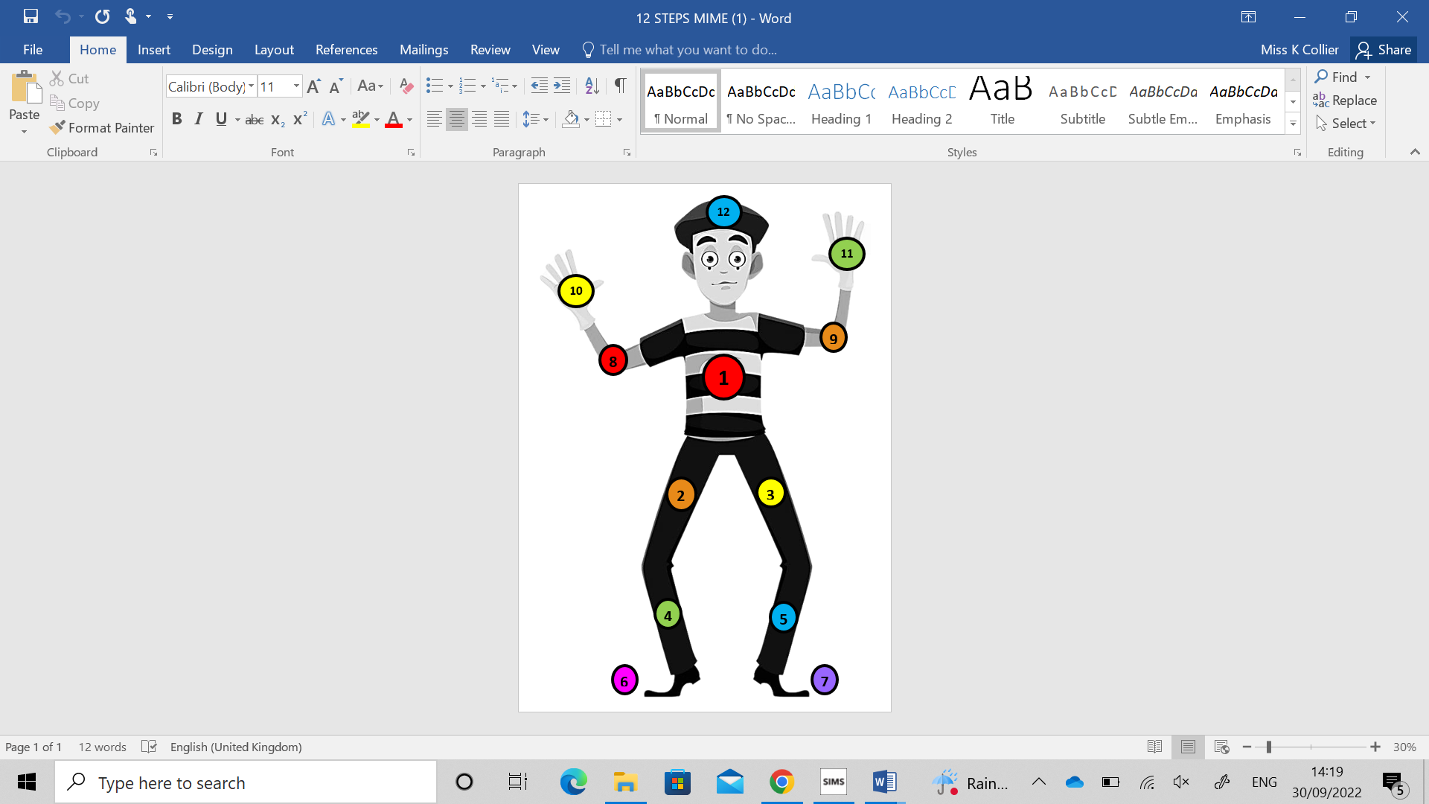

After an assessment you will complete a reflection, personal next step and colour in the step achieve on your mime based on the feedback from the class teacher.

|  |  |
| --- | --- |
| **STEP** | **ASSESSMENT CRITERIA** |
| **1** | You use of some of the basic drama skills – facial expressions, posture, gait etc.  You are showing some understanding as to how and why we use them in performances. |
| **2** | You are using basic drama skills with growing confidence.  You are developing a clear understanding as to why we use skills in performance and developing confidence when using key terminology. |
| **3** | You are developing an understanding of how to communicate meaning or storytelling through performances.  You are beginning to show an awareness of dramatic intentions and how they can affect your performance and confidently developing understanding of personal next step and how to achieve them. |
| **4** | You show clear communication of meaning within performance.  You are beginning to think about what your intentions are for your performance, and using your key skills during performance confidently.  You are also beginning to develop evaluation skills when feeding back to peers and self-reflection, using key words in evaluations. |
| **5** | You are developing a clear understanding of how to develop your own or group performances.  You are confidently using key skills to help communicate meaning, character or emotions and key vocabulary is used with confidence and used when feeding back and evaluating. |
| **6** | Your personal and group ideas are clear and have meaning behind the ideas.  You have clear intentions within your performance and when evaluating you are clear and concise and use key vocabulary within explanations. |
| **7** | Your meaning behind your performance is clear and evident throughout your performance – group or individual.  You use your key skills confidently within performance and when evaluating you use key vocabulary to help support your evaluations. |
| **8** | Your performance ideas are clear and are well thought through for your topic/style.  You are able to confidently analyse drama – live theatre or peers using key vocabulary and specialist terminology.  You are beginning to develop your reflective practice within the creative process. |
| **9** | Your ideas are secured and appropriate for your performance topic, this is backed up by research of topic/practitioner/style.  You have a strong knowledge and understanding when evaluating or analysing.  You consistently use specialist terminology and key vocabulary. |
| **10** | You are able to use your theatrical skills fluidly within performance, doing so with confidence and conviction.  You have developed the ability to analyse and evaluate using evidence to support and also critically highlight areas for development and create a framework to achieve next steps. |
| **11** | You deploy specialist skills in a skilful and effecitive manner which conveys meaning and creates impact on the audience.  You use critical thinking when evaluating and analysing work of your peers and your own using specialist terminology accurately and effectively. |
| **12** | You have a rich knowledge and understanding of drama and performance.  When evaluating and analysing live theatre and that of others your refelections are insightful.  When performing you have a rich range of theatrical skills deployed, your stylistic elements and intentions are clear and are delivered with conviction. |

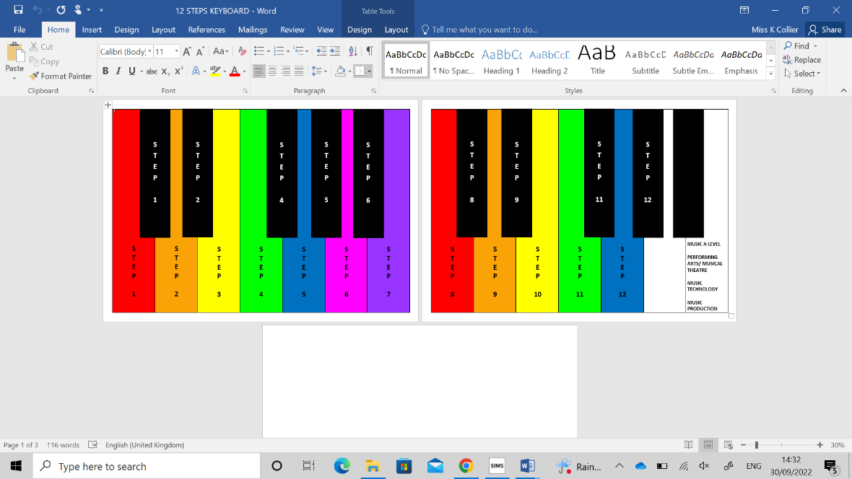**Music Year 7 and 8 interactive 12 steps:**

|  |  |
| --- | --- |
| **STEP** | **ASSESSMENT CRITERIA** |
| 1 | You perform as part of a group or on your own with some support  + You are using your vocabulary when giving feedback + |
| 2 | You perform as part of a group or on your own with growing confidence  + You are expanding your knowledge of vocabulary by knowing the definitions of vocabulary used + |
| 3 | You perform as part of a group or on your own accurately with confidence. You are developing your understanding of vocabulary and developing your ability to identify elements of musical styles with growing confidence. |
| 4 | You perform confidently as a group and on your own and developing knowledge of rhythms and notation.  + You are beginning to be able to identify musical elements and how they change a piece + |
| 5 | You are beginning to develop your composition skills to help create mood and atmosphere.  + You are continuing to develop vocabulary and be able to clearly identify your personal next step + |
| 6 | You are developing more complex performance techniques and understand how they effective to your piece.  + You are using intermediate vocabulary and developing creative ideas for pieces of music + |
| 7 | You are effectively comparing and contrasting different pieces of music. Developing the ability to experiment with complex melodies, rhythms and melodic phrases. |
| 8 | You are developing original music ideas during performance and composition. When working in groups or independently you are developing the ability to be aware of balance between musical instruments/vocals.  +you have an ability to identify complex elements, stylistic and structural conventions + |
| 9 | You perform confidently making a significant contribution to performances as a soloist or as a group. You are creating imaginative and original compositions.  +You are confidently using complex vocabulary when evaluating the work of peers and your own + |
| 10 | You perform with control and detailed attention to the instrument you are playing. You actively explore a wide range of techniques and have a strong vocabulary bank which you use in feedback, evaluation and listening questions. |
| 11 | You perform with style and flair, showing a high level of musical understanding.  + You evaluate, identify key components in the work of others and your own. + |
| 12 | You have secure and sophisticated level of musical understanding both when performing and listening.  + You compare and contrast your own composition by describing, evaluating and explaining key features + |

After an assessment you will complete a reflection, personal next step and colour in the step achieve on your mime based on the feedback from the class teacher.

**Assessment Principles**

Year 7 begins our 5 year spiral curriculum. Year 7 and 8 pupils will have one lesson per week of Drama and Music as a part of the curriculum. Pupils then can choose to take Music or Drama as a GCSE option.

Year 7 and 8 drama and music looks at fundamental skills and knowledge which are covered and revisited across the first two years at St Joseph’s. Teaching of these units should focus on mastery of skills before moving on, this will ensure students make progress through the curriculum each year.

We aim to develop pupil’s confidence and communication ability. The skills learnt in year 7 and 8 can be transfer to other subjects if they do not choose performing arts as a GCSE subject. We aim to develop curiosity and creative skills. Also developing confidence that will be useful in future carers we want to promote and encourage the love of learning.

The progression through the units for attainment is set out in the progression scales which should be used alongside curriculum planning. Pupil will be given a pathway to set individual targets to move up the scale over the 2 or 5 years.

GCSE Drama and Music: From Year 9 pupils will be taught the AQA Drama GCSE or GCSE Music from Edexcel from 2022 GCSE music will be moving to edexcel.

The scheme of work is develop around the topics set to be assessed in year 10 and 11. Also within these areas are teaching resources and materials Progression scales also support the tracking of skills and content through the GCSE specifications.

Class books will contain all notes from lessons and all homework. They should have a front cover on the front of the book and then progression scales at appropriate points depending on the year group and topics. Class books should predominantly use peer and self-assessment as a method of marking with student responses to this marking as appropriate. Teacher book reviews should be completed before end of unit assessments take place to ensure any misconceptions/errors are corrected and that sufficient progress through a unit has occurred.

Alongside the written element of the subject. Drama and Music include lots of practical work. Each half term pupils will be assessed on practical work and will reflect on their own development.

In the class books pupils will use an assessment tracker, this will track both written and practical assessments. Pupils can use this tracker to notice gaps in learning and this sets out targets from them moving forward. These targets are set with the teacher and also the pupils.

In music pupils will also have a music theory book and a practical work book that pupils will use each lesson.

Books should be marked in line with the school impact marking policy.

Forming Judgements for Data Drops: All judgement should be skills based using the progression scales not grades in year 7 and 8. When judgments are to be formed for reporting purposes, a holistic approach should be used considering each pupil’s learning journey. This should include all evidence from the assessment book, class work book, homework responses, attitude to learning. In year 9, 10 and 11 grades will also be given for GCSE Drama and music.

**Enrichment and Extra-Curricular**

The Performing Arts department offers weekly enrichment during P6 and also other activities and trips/visits as they arise from external providers.

Drama offer

* Drama Club
* GCSE Year 9 Club
* GCSE Year 10 Club
* GCSE Year 11 Club
* School Musical

Music Offer

* Choir
* GCSE Year 9 Club
* GCSE Year 10 Club
* GCSE Year 11 Club
* School Musical

Peripatetic Music lessons on offer with Bolton Music Service

* Vocals
* Piano
* Strings
* Brass
* Guitar
* Drums

Extra-curricular visit include

* Theatre Trips
* Bolton Music concerts
* Workshop Trips

**Performing Arts Strengths and Areas of Focus**

A comprehensive evaluation of the department and its performance is detailed in the department SEF and a comprehensive action plan for improvement is detailed the department improvement plan.

Below is concise summary of the departments’ main strengths and areas for development.

• Effectiveness of leadership and management - Good

• Quality of teaching, learning and assessment - Good

• Personal development, behaviour and welfare – Good

• Outcomes for pupils – RI

*Strengths*

*Behaviour and engagement in the department is a key strength in performing arts. The Department option numbers are growing each year and participation in extra curricula activities is growing.*

*Quality of teaching is good in performing arts and both KCO and IH are working hard in developing SOW and reflecting on what works and adapting to fit pupils needs effectively in the classroom*

*Areas of Focus*

In performing arts we need to continue to improve outcomes of pupils with high quality teaching.