Religious Education

Curriculum

Handbook



**Religious Education Department Statement of Intent**

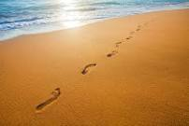**““…..to act justly, to love tenderly and to walk humbly with your God.” Micah 6:8**

*Religious Education at St Joseph’s is about engaging, inspiring, challenging and encouraging pupils, equipping them with the knowledge and skills to answer challenging questions, explore different religious beliefs, values and traditions and develop a more rigorous understanding of the numerous religious traditions, beliefs and practices that are followed in our multi-cultural society and encourage respect for all beliefs. We want them to know how religious education promotes discernment in an environment where the Catholic faith enables pupils to combat prejudice, preparing them for adult life, employment and life-long learning.*

**Aims of the Religious Education Department**

Catholic schools, with RE at their core, exist in order to "help parents, priests and teachers to hand on the Deposit of Faith in its fullness to a new generation of young people so that they may come to understand the richness of the Catholic faith, and thereby be drawn into a deeper communion with Christ in his Church." (Religious Education Curriculum Directory). With this as their primary aim, Catholic schools serve diverse populations of pupils and within this context the Religious Education Curriculum Directory (RECD) makes the aims of Religious Education explicit:

* 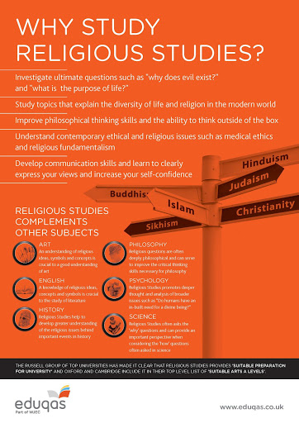To present engagingly a comprehensive content which is the basis of knowledge and understanding of the Catholic faith;
* To enable pupils continually to deepen their religious and theological understanding and be able to communicate this effectively;
* To present an authentic vision of the Church's moral and social teaching so that pupils can make a critique of the underlying trends in contemporary culture and society;
* To raise pupils' awareness of the faith and traditions of other religious communities in order to respect and understand them;
* To develop the critical faculties of pupils so that they can relate their Catholic faith to daily life;
* To stimulate pupils' imagination and provoke a desire for personal meaning as revealed in the truth of the Catholic faith;
* To enable pupils to relate the knowledge gained through Religious Education to their understanding of other subjects in the curriculum;
* To bring clarity to the relationship between faith and life, and between faith and culture.

The outcome of excellent Religious Education is religiously literate and engaged young people who have the knowledge, understanding and skills – appropriate to their age and capacity – to reflect spiritually, and think ethically and theologically, and who are aware of the demands of religious commitment in everyday life

Religious Education is not within the National Curriculum framework. As a Catholic school, our planning follows the Curriculum Directory. The Curriculum Directory specifies that topics be taught through four key themes, based on documents from Vatican II. These are: Revelation, The Church, Celebration, and Life in Christ. The Curriculum Directory also mandates the teaching of other world religions apart from Christianity. Taking each of these themes, we combine knowledge and skill to allow pupils to develop and nurture the following:

• A rich and deep knowledge of Christianity Beliefs and Practices.

• An ability to navigate relevant ideas surrounding philosophy, theology and ethical studies.

• RE will also contribute to the student’s knowledge and development of British Values and SMSC.

• An understanding of skills such as ‘outline’, ‘describe’, ‘explain’, ‘evaluate’ and ‘analyse’

• Religious literacy

• An understanding of how a successful Religious Education can lead to many opportunities in terms of careers and a successful society.

Throughout Year 7 and Year 8 we aim to do at least two media studies, where we look at religious themes in films and newspaper articles. We do this to allow pupils to develop a critical eye when judging what we see in the media and to show them practical application of these themes in their lives. We also use our extra-curricular opportunities to feed into successful lessons, allowing pupils to live out the values and experience first-hand the practices taught in our lessons. Examples include our Parish Priest leading a lesson every term, class Mass, our strong chaplaincy team, and our retreats.

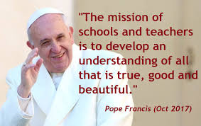

**Religious Education Department Overview of Intent**

**Year 7**

As we have pupils arrive to us from a mixture of primary settings, all of which will have taught RE to a various degree, we assume no prior knowledge in any pupils whilst also allowing stretching opportunities for those who have a substantial amount of knowledge.

We have chosen to dedicate this year to teaching the required topics from the Curriculum Directory chronologically. We have done this to impress upon our pupils the historical nature of our subject – these themes and events we are looking at are not merely abstract but the history of our living faith. We also hope that teaching in this way will prevent confusion, such as pupils being unable to understand that Jesus was Jewish.

We therefore start with the module ‘People of Promise – Covenant’ covering topics such as: the nature and purpose of a covenant; the life of Abraham; the sacrifice of Isaac; the life of Moses, including a media study; the 10 plagues; and the 10 commandments.

This leads nicely into our next module ‘Judaism’. It is vital that we teach the about the Jewish religion for numerous reasons. Firstly, as Catholics Judaism is the religion of Jesus and the foundation that our faith grew from. Secondly, Catholics schools are mandated to teach Judaism as part of the GCSE and therefore an early understanding of the religion can only be beneficial to our students. Finally, the rise in antisemitism in the UK and around the world must be challenged. We at St. Joseph’s believe that the best way to do this is through education where pupils are in a secure environment allowing them to ask questions and have misconceptions addressed by qualified staff. In this module students will learn about: how the 10 commandments are applied today and evaluate the usefulness of them as rules for the 21st century; Torah; Mitzvot including food laws; creation; festivals such as Shabbat, Passover, Hanukkah, Rosh Hashanah and Yom Kippur; and rituals and ceremonies such as Bar and Bat Mitzvah, weddings and funerals.

After this we focus on the ‘Life of Jesus’ in our next module. This covers topics such as: the annunciation and birth of Jesus; the early life and baptism of Jesus; miracles; parables; and the Sermon on the Mount. Through this module students can explore and understand the life and teachings of Jesus. This leads them to analysis of how we can and do apply these to our modern day.

Our next module is ‘Paschal Mystery’ where pupils: encounter teaching of the events of Holy Week, including their importance and significance in worship today; undertake a media study focused on Holy Week, specifically Easter Sunday; evaluate alternative resurrection theories; and analyse and evaluate both the Jewish and Christian idea of ‘Messiah’.

This then leads us on to teach the module ‘Early life of the Church’ which teaches how Christianity spread from Jerusalem around the world, with a particular focus on the spread of Christianity to the UK. To this end, this module contains lessons on: Judas’ replacement; Pentecost; how early Christians avoided persecution; Saints Stephen, Peter and Paul; how Christianity was brought to the UK; Celtic Christianity; the Reformation; and Thomas Beckett.

Having covered the events of early Christianity and its spread, we dedicate our last module in Year 7 to ‘Our World’ which helps pupils to understand how we can put Christian teachings into practice by applying them to topics such as: Asylum Seekers and Refugees; Human Rights; prejudice and discrimination, including a media study; and stewardship and climate change.

**Year 8**

Once we have laid the foundation of the history of Christianity in Year 7, Year 8 is our opportunity to build upon this knowledge of beliefs and teachings by examining Christian practices. We start the year with the module ‘Vocation and Tradition’ which includes lessons focused on: the Bible, its contents, writers and impact today; the Magisterium, its history, organisation and impact today; and vocation, including the call to priesthood and religious life, alongside a media study.

Our next module ‘Parish and Pilgrimage’ affords us the opportunity to build on knowledge of the paschal mystery by examining the layout of and objects in a Catholic church. We further build on this knowledge and the idea of miracles by taking an in-depth look at the story of Saint Bernadette and the events at Lourdes, including how that has inspired pilgrimage there today. This allows pupils the understanding and appreciation of the importance of pilgrimage across all religions.

We then move onto the module ‘The Church in the World’ which builds on pupil knowledge of the teachings of Jesus by demonstrating how and why charities do their work. There is a specific focus on specifically Catholic and Christian charities such as CAFOD, SVP and Fairtrade. This module allows for group work and pupils to think of innovative ways to ensure the teachings of Jesus are still lived out today.

Pupils then encounter the module ‘Sacraments’ which builds on their knowledge of the life of Jesus and Biblical events and teachings. In lessons we do deep dives into all seven of the sacraments, understanding the nature, importance, and symbols of each one.

After this module is completed, we look at two smaller modules. The first is ‘The Trinity’ where we look at the significance of the Trinity for Christians, alongside biblical text (Jesus’ Baptism) and sources of wisdom and authority (The Nicene Creed). Pupils will also study the symbols of the Trinity and have an opportunity to create their own. Next, we move onto ‘The Holocaust’. This module gives pupils the chance to consider moral questions surrounding the Holocaust, as opposed to historical considerations. Pupils will engage with questions such as how this could happen and why it did so. We also look at the role of Catholic figures such as Saint Maximillian Kolbe.

Finally, as the Curriculum Directory instructs us to teach “the life and practices of…other religious communities” and British Values directs us to foster a “mutual respect for and tolerance of those with different faiths and beliefs and for those without faith” we dedicate a whole term to the faiths of Hinduism, Buddhism and Sikhism. For each religion pupils develop a knowledge and understanding of: the nature of God; the creation story; the rituals and ceremonies; festivals; prayer life; places of worship; and important figures.

**Year 9**

**Subject Content**

Year 9 affords us the opportunity to introduce more philosophical and ethics units of study. We encourage students to think critically as we start laying the foundations for the GCSE course.

The first module we complete in Year 9 is ‘Philosophy of Religion’ which looks at the philosophical questions, concepts and theodicies such as: the characteristics of God; the design argument; the cosmological argument; the problem of evil and suffering and the Catholic response; moral decision making. We also include the ethical topics war and pacifism.

Next, we move on to the module ‘Medical Ethics’ where pupils explore: sanctity of life; abortion; euthanasia; genetic engineering and transplant surgery. This module also includes media studies surrounding Euthanasia.

Our final ethical modules of study is ‘Religion and Society’ where pupils engage with topics such as: Capital Punishment; the equality of men and women; living in a multi-ethnic society; racial harmony; living in a multi-faith society; marriage; divorce; sexual relationships; and contraception. This module allows for a couple of media studies around capital punishment and racial harmony.

Again, following the Curriculum Directory instruction to teach “the life and practices of…other religious communities” and the British Value of “mutual respect for and tolerance of those with different faiths and beliefs and for those without faith” we finish Key Stage Three with an in-depth look as Islam. We hope that through an education where pupils are in a secure environment and allowed them to ask questions and have misconceptions addressed by qualified staff we will play our part in tackling the rise of instances of Islamophobia in the UK. This topic covers: Islamophobia and the media; Prophet Muhammad (PBUH); Qur’an; the 5 Pillars of Islam; Jihad; and the veil.

**Year 10 and 11**

All students at Key Stage 4 follow Edexcel GCSE Religious Studies Specification A. The combination of the units below fulfils the criteria of the Bishops Conference Curriculum Directory for KS4 and the requirement to study a second world faith. Final assessment of KS4 is via three exam papers. Assessment over two years at KS4 based on Edexcel Assessment Objectives.

A01: Describe, explain, analyse, using knowledge and understanding. (50%)

A02: Use evidence and reasoned argument to express and evaluate personal responses, informed insights and differing viewpoints (50%)

It is intended that all students will gain a GCSE in Religious Studies.

|  |  |  |  |
| --- | --- | --- | --- |
| **Year** | **Component** | **Content** | **Exam** |
| **10** | Paper One Catholic Christianity | Beliefs and Teachings  Practices  Sources of Wisdom and Authority  Forms of Expression and Ways of Life | 50% |
| **10**  **11** | Paper Two Judaism | Beliefs and Teachings  Practices | 25% |
| **11** | Paper Three Philosophy and Ethics | Arguments for the Existence of God  Relationships in the Twenty-First Century | 25% |
| **11** | Revision Programme |  |  |

**SMSC in Religious Education**

***Spiritual Development:***

Pupils are encouraged to discuss the meaning and purpose of life. There are many opportunities to learn from and share their own experiences, to reflect on and interpret spirituality in their own lives and discuss and to consider responses to ultimate questions. Pupils are given opportunities to be reflective about their beliefs, religious or otherwise, which inform their perspective on life and their interest in and respect for different people’s feelings and values sense of enjoyment and fascination in learning about themselves, others and the world around them, including the intangible.

***Moral Development:***

Pupils debate moral topics in all units of work covered in RE. Pupils are expected to justify personal responses to moral issues and listen to the opinions of others. Issues of right & wrong and good & bad are explored consistently and pupils are often asked to approach topics including; abortion, the death penalty and euthanasia objectively which requires them to critique their own personal moral codes and allows them to understand and appreciate the viewpoints of other people. Pupils develop their understanding of Catholic gospel values and how these impact on their behaviour; For example, respect.

***Social Development:***

Discussion is central to any RE lesson at St Joseph’s. This encourages pupils to become adept in both speaking and listening. Social education in RE involves exploring similarities and differences in religions and cultures through which pupils can start to link religion to personal action in everyday life. This is also reflected in their relations with others in the classroom and their ability to work productively with their peers and to resolve conflicts effectively. Social Development in RE enables pupils to have the ability to accept and engage with the fundamental British values of democracy, the rule of law, individual liberty and mutual respect and tolerance of those with different faiths and beliefs. It also allows pupils to develop and demonstrate skills and attitudes that will allow them to participate fully in and contribute positively to life in modern Britain.

***Cultural Development:***

Pupils will learn about other religions, giving them an opportunity to appreciate what it means to belong to a religious group. Pupils will have an understanding and appreciation of the wide range of cultural influences that have shaped their own heritage and those of others as well as an understanding and appreciation of the wide range of cultural influences that have shaped their own heritage and those of others. Pupils will cover the meaning of belonging to a multi-faith ever changing society as well as being given an appreciation of the range of different cultures within school and further afield as an essential element of their preparation for life in modern Britain.

Pupils will develop their understanding of their cultural heritage including an understanding of the Catholic values and have a promoted interest in exploring and improving their understanding of, and showing respect for cultural diversity. Pupils will also be given opportunities to understand, accept, respect and celebrate diversity, as shown by their attitudes and respect for different religious, ethnic and socio-economic groups in the local, national and global communities

**Religious Education contributes to our students’ SMSC development through:**

* Developing an understanding of individual identity
* Focusing on the beliefs of self and exploring the origins of these
* Studying of major world religions (such as; Christianity, Islam, Judaism, Hinduism and Sikhism) to see how different people live, promoting tolerance and understanding
* Reflecting on responses to ‘ultimate questions’
* Studying different moral issues and justifying own views such as abortion, euthanasia and the death penalty
* Exploring two key religions at GCSE (Catholic Christianity and Judaism). This includes detailed coverage of the beliefs and teachings of these religions and the main practices
* Working as part of a group or team, sometimes to create their own working teams
* Sharing of views and opinions with others and resolving any differences maturely, this is particularly prevalent during the curriculum covered in Year 9
* Showing respect for people, living things, property and the environment
* Reflecting on one's contribution to society and how we can support other communities
* Learning about religious groups in the school and wider community and how they contribute towards the wider local community
* Considering non-religious and social responses to issues



**Gospel Values**

|  |  |
| --- | --- |
| **Gospel Value** | **Found in RE:** |
| Faithfulness and Integrity | Being supportive of all staff, being honest in character. Consistency in praise, rewards and sanctions. Allowing pupils to have faith in their ability. Found in the study of; Marriage, Being made in God’s image, Relationships, Euthanasia, Abortion, Death Penalty, Human Rights |
| Dignity and Compassion | Acknowledging that everyone is made in God’s image and should be treated as a child of God. Helping people see their worth and understanding individual needs and circumstances. Found in the study of; Euthanasia, Abortion, Prejudice and Discrimination, Human Rights, Study of other Faiths |
| Humility and Gentleness | Encouraging people to accept mistakes and demonstrating that no-one is perfect, accepting constructive criticism and areas for development, developing empathy. Found in the study of; Environment, Genetic Engineering, Fertility Treatment, Reconciliation, Class discussions and Debates |
| Truth and Justice | Promoting fairness, forgiveness and honesty. Found in the study of; Death Penalty, War, Human Rights, Refugees, Fairtrade, Community Cohesion, Prejudice and Discrimination, Sacraments |
| Forgiveness and Mercy | Everyone is entitled to a second chance, modelling the behaviour and actions of Jesus. Encouraging people to be able to forgive themselves and others. Found in the study of; Reconciliation, War, Islam, Death Penalty, Jimmy Mizen and Anthony Walker |
| Purity and Holiness | Encouraging self-reflection, Crucifixes in classrooms, Prayer at the end of the day, modelling of the Gospel values. Found in the study of; Form Patrons, Baptism, Marriage and Family Life, Pilgrimage, Prayer, Meditation and time in chapel, Class Masses |
| Tolerance and Peace | Being tolerant of others and their views, resolving disputes, being accepting of others, team work and collaborative learning. Found in the study of; War, Human Rights, Pilgrimage, Community Cohesion, Human Rights, Study of Judaism, Hinduism, Sikhism, Buddhism, Islam, Humanism and those of no faith |
| Service and Sacrifice | Giving time up for others – staff and pupils, being generous with our time, Loving your neighbour, encouraging others to serve the community. Enrichment and extra-curricular activities. Found in the study of; Vocation, Stewardship, Life of Jesus, CAFOD, SVP, Fairtrade, Class Masses, class visits from Fr Richard |

**Promoting British Values in Religious Education**

The promotion of ‘British values’ is central to Catholic education because British values have their origin in the Christian values of our nation.

***The Rule of Law***

Pupils gain an understanding of the value by highlighting the rules of the Church and God in the Religious Education curriculum, for example the Ten Commandments and the Precepts of the Church. Pupils also consider topics such as the death penalty, abortion and euthanasia and reflect on whether laws should be adapted or changed. Pupils have the opportunity to consider what the world would be like without laws. There is a clear code of conduct in lessons which pupils are expected to follow. We learn about the truth that the Church and Jesus Christ teaches us and the need to be just and honest, highlighting that our laws are inspired by Christian values.

***Mutual Respect and Tolerance***

Our Religious Education curriculum follows the teaching of the Church in providing a broad and balanced education, which includes an understanding of, and respect for, people of other faiths or none, and other religions, cultures and lifestyles. Studying stories in the Bible that Show how Jesus encouraged tolerance in stories such as The Good Samaritan and The Women at the Well. We also place an emphasis in RE that every person is unique and “created in the image of God”. Our pupils learn about the wrongs of religious extremism and how living side by side, despite our differences, brings peace. We explore what unites us rather than what divides us. We have a freely accessible chapel which is open for all faiths to use.

***Democracy***

Pupils are always listened to by adults and are taught to listen carefully and with concern to each other, respecting the right of every individual to have their opinions and voices heard. Pupils also have the opportunity to air their opinions and ideas during class discussions and Pupil Voice within Religious Education. This allows pupils to have their opinions heard and helps influence the delivery of the curriculum. Pupils also experience the democratic voting system when considering how Judas was replaced after his death. ***Individual Liberty***

In Religious Education we encourage pupils to be independent in their learning. Providing pupils with opportunities for reflection as they take responsibility to discerning their vocation. Pupils are encouraged to form their own opinions about the topics we cover and be able to express and explain these in an articulate way.

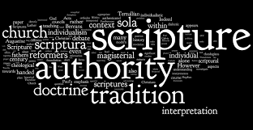**Literacy and Religious Education**

Literacy needs to be deliberately planned into a department’s SOL in order to give it the time and priority it requires. Resources will need to be prepared in advance so that Literacy is an integral part of Religious Education teaching and learning in lessons and develops alongside scientific skills and content. These may include word cards, question cards, books, magazines and leaflets, writing frames and worksheets and games.

Whenever it is appropriate literacy objectives should be built into the lesson along with RE specific objectives. Literacy can be developed in every lesson through activities such as emphasis on word work during questioning and mental start-up activities at the start of each lesson. Some topics will lend themselves more easily to literacy development than others. Such emphasis on the language of RE will inevitably result in pupils being more able to articulate theological and philosophical ideas in their own words.

*Key Areas of Literacy*

|  |  |
| --- | --- |
| **Vocabulary**  **Key issues** Technical and specialist words  Appropriate usage  Correct spelling  Understand meaning  **Common difficulties**   * Time and repetition needed to ensure new words are internalised into working vocabulary and linked to appropriate concepts. * Ordinary words with alternative meanings can be difficult as it causes cognitive conflict.  Supporting strategies  * Introduce words using a multisensory approach e.g. orally, visually, kinaesthetically * Use vocabulary frequently using open questions * Use words in sentences to keep reflecting back * Use models and picture to help visualise the word * Use flash cards to test pupils understanding * Ask pupils to explain using pictures to encourage language development * Use visual clues e.g. hand signals * Use poetry, rhymes, raps and rhythms to aid memory and link to modern culture * Get pupils to make own word lists to collect new words and test and check their meaning * Regular review of key vocabulary through tests and home learning tasks | **Oracy**  **Key issues** Use language precisely  Listen to others and respond by  building on ideas and views **Common difficulties**Constant use and repetition are essential. Words which are not frequently used are easily forgotten  * Often little planned time in lessons to “talk” * One word answers for fear of getting it wrong   **Supporting Strategies**   * Teacher model good use of theological and philosophical language * Use questions to review past knowledge and understanding, check understanding, encourage the learner to think and to practice the language * Use a range of questioning strategies * Allow pupils “thinking” time * Offer pupils challenge * Use games to encourage meaningful peer group talk and embed new word and concepts * Use small group discussion to develop pupil understanding through conversation in a less threatening atmosphere |

|  |  |
| --- | --- |
| **Reading** **Key issues** Strategies to help reading for understandingLocating and using information Summarising  Synthesise learning from reading Common difficulties  * Children often prefer fiction to non-fiction texts * Children prefer to use interactive methods of discovering information e.g. Internet * Limited range of text that can be offered to pupils * Weak readers can lack the ability to scan and skim read * Pupils prefer to copy chunks of text without checking their relevance  Supporting Strategies  * Develop activities to promote meaningful reading experiences * Activities prior to reading that give pupils a desire to find out more e.g. using a contents page or index * Activities associated with reading to make the data processing easier e.g, cloze procedure, sequencing, underlining * Activities following reading to encourage reformulation of the information into personal knowledge e.g. table/diagram completion, summarising | **Writing****Key issues C**orrect spelling and punctuation Follow grammatical conventions  Organise work in a logical and  coherent form Common difficulties  * Many pupils are reluctant writers * Poor handwriting and spelling can make writing difficult to interpret * Lack of understanding what they are being asked to write about * Time pressure in lessons to get ideas or work down onto paper  Supporting Strategies  * Plan to incorporate the different forms of exam question responses into lessons * Use different types of text * Get pupils to analyse prose to look for key words and phrases * Get pupils to criticise and improve on received text * Encourage use of a variety of genre e.g. narrative, descriptive, persuasive, reports, imaginative when appropriate * Use writing frames where appropriate, encouraging pupils to use it as a guide line and eventually manage without * Encourage pupils to redraft work in lessons using teacher comments * Develop skills in note taking by using short simple activities e.g. jot down key words, note observations on teachers demo * Teach pupils how to summarise text e.g. crosswords, catchword * When asking pupils to write analysis and evaluations teach them the specialist vocabulary and phrases needed e.g. This is a strong argument because……., however, in contrast…….. |

**Religious Education Structure**

|  |  |
| --- | --- |
| **Name** | **Role** |
| Mrs Jessica Sneyd | Head of Religious Education |
| Mrs Helen Rimmer | Assistant Head of Religious Education and PSHE Co-ordinator |
| Mrs Sara Pepperday | Shepherd of Catholic Life |
| Miss Jeanette McShane | RE Teacher |
| Mrs Karen Briggs | RE Teacher (Part Time) |
| Mr Paul Smith | Temporary Teacher of RE |
| Mr Michael Singleton | Assistant Headteacher |

The Religious Education department is made up of an experienced team of staff who are highly dedicated to the subject area. The department provides lessons that are active and engaging, maximising the interest and enthusiasm of our students, so that lessons are thoroughly enjoyed and understood. We endeavour to promote lessons that are imaginative, creative and involving current affairs.

There are currently four specialist RE classrooms that are suited together on the first floor of the tower block. Three rooms have a projector and one room is equipped with an interactive TV screen. All rooms have a desk top computer. There is a chapel on the second floor of the tower block. The department has a small collection of religious artefacts, various textbooks to suit all year groups and Bibles.

***Curriculum Structure***

Students in Year 7, 8 and 9 follow a programme of study which aligns to the Religious Education Curriculum Directory as set out by the Catholic Bishops of England and Wales and the Catholic Education Service.

In Years 10 and 11 students study Religious Studies following Edexcel Specification A.

In Year 7 and Year 8 students have 5 x 1hour lessons over the 2 weeks

In Year 9, Year 10 and Year 11 students have 5 x 1hour lessons over the 2 weeks

An overview of the topics in the courses is shown below:

**Year 7**

|  |  |
| --- | --- |
| **Autumn Term**  **People of Promise**  Welcome to St Joseph’s  God’s Covenant with Abraham  God’s Covenant with Moses  The Ten Plagues of Egypt | **Autumn Term 2**  **Judaism Today**  The Torah, Mitzvot and Ten Commandments  Jewish Food Laws  Shabbat  Jewish Festivals  Jewish Rituals  The question of Messiah |
| **Spring Term 1**  **Life of Jesus**  Jewish understanding of Messiah  Jesus’ early life  Jesus’ Miracles  Jesus’ teaching and parables  Jesus’ temptation | **Spring Term 2**  **Holy Week and Easter**  Palm Sunday  Maundy Thursday  Good Friday  Easter Sunday  Stations of the Cross |
| **Summer Term 1**  **The Early Church**  The disciples and Pentecost  Persecution in the early church  Early church saints  The church in Britain  Martin Luther | **Summer Term 2**  **Our World**  Creation and Stewardship  Jesus’ treatment of others  Human Rights  Asylum seekers and refugees |

**Year 8**

|  |  |
| --- | --- |
| **Autumn 1**  **The Bible and Church**  The Bible; its content, importance and referencing it  Apostolic Succession  Magisterium and Catechism  Vocation | **Autumn 2**  **Church in the World**  Features of a church building  The Catholic Parish  Catholic charity, including CAFOD and SVP  Fairtrade  Pilgrimage |
| **Spring 1**  **Sacraments**  Infant and believer’s baptism  The gifts of the Holy Spirit  Confirmation  Eucharist  Reconciliation  Marriage  Sacrament of the Sick  Holy Orders | **Spring 2**  **Core Beliefs and the Holocaust**  Trinity and Creed  Life after death  God and the Holocaust |
| **Summer 1**  **World Religions: Hinduism**  Trimurti  Creation stories  Hindu deities  Hindu worship in the home and at the mandir  Hindu festivals  Karma and reincarnation | **Summer 2**  **World Religions: Sikhism and Buddhism**  Sikh beliefs about God  The Ten Gurus and the Khalsa  Sikh worship and festivals  Life of Buddha  The three universal truths  The eightfold path |

**Year 9**

|  |  |
| --- | --- |
| **Autumn 1**  **Believing in God**  Christian beliefs about the nature of God  Philosophical arguments from Design and Causation  The Problem of evil and suffering | **Autumn 2**  **Matters of Life and Death**  Making moral decisions  Sanctity of life  Issues of war  Abortion  Euthanasia  Capital punishment |
| **Spring 1**  **Medical Ethics**  Fertility treatments  Transplant surgery and organ donation  Genetic engineering | **Spring 2**  **Community Cohesion**  Changing roles of men and women in society and in the church  Martin Luther King and Christian teachings on racial harmony  Multi faith and multi ethnic society |
| **Summer 1**  **Marriage and Family Life**  Catholic marriage  Attitudes to divorce  Types of family  Catholic teachings on sexual relationships  Contraception | **Summer 2**  **World Religions: Islam**  Challenging Islamophobia  Prophet Muhammad and the Qur’an  The Five Pillars  Prayer and the mosque  The veil  Jihad  Islamic art |

**Year 10**

|  |  |
| --- | --- |
| **Autumn 1**  Paper 1 CATHOLIC CHRISTIANITY  Beliefs and Teachings  The Trinity  Biblical understandings of God as Trinity  Creation  The nature of humanity  The Incarnation  The events of the Paschal Mystery  The nature of salvation and grace  Eschatology | **Autumn 2**  Paper 1 CATHOLIC CHRISTIANITY  Practices  The sacramental nature of reality  Liturgical worship  The funeral rite  Prayer  Forms of popular piety  Pilgrimage  Catholic Social Teaching  Catholic mission and evangelism |
| **Spring 1**  Paper 1 CATHOLIC CHRISTIANITY  Sources of Wisdom and Authority  The Bible  Interpretations of the Bible  Scripture, tradition and the Magisterium of the Church  The Second Vatican Council  The Church as the Body of Christ and the People of God  The Four Marks of the Church  Mary as a model of the Church  Sources of personal and ethical decision-making | **Spring 2**  Paper 1 CATHOLIC CHRISTIANITY  Forms of Expression and Ways of Life  Catholic Church architecture  Catholic Church features  Sacred Objects  Art work in Catholicism  Sculpture and Statues  Symbolism and Imagery in religious art  Drama  Music in worship |
| **Summer 1**  Paper 2 JUDAISM  Beliefs and Teachings  The nature of the Almighty  Shekhinah  Messiah  The covenant at Sinai  The covenant with Abraham  Sanctity of life  Moral principles and the Mitzvot  Jewish beliefs about life after death | **Summer 2**  Revision and preparation for Year 10 Exams  Year 10 Exams  Year 10 Work Experience  Revision of work covered so far |

**Year 11**

|  |  |
| --- | --- |
| **Autumn 1**  Paper 2 JUDAISM  Practices  Public acts of worship  The Tenakh and Talmud  Prayer  Shema and Amidah  Rituals and Ceremonies  Shabbat  Festivals  Features of a synagogue | **Autumn 2**  Paper 3 PHILOSOPHY AND ETHICS  Arguments for the Existence of God  Revelation  Visions  Miracles  Preparation for Pre-Public Exams and completion of exams  Religious Experience  The Design Argument  The Cosmological Argument  The existence of suffering |
| **Spring 1**  Paper 3 PHILOSOPHY AND ETHICS  Religious Teachings on Relationships and Families in the 21st Century  Marriage  Sexual relationships  The family  Support for the family  Family planning  Divorce, annulment and marriage | **Spring 2**  Revision |
| **Summer 1**  Revision and completion of GCSE Exams | **Summer 2**  Exams completed |

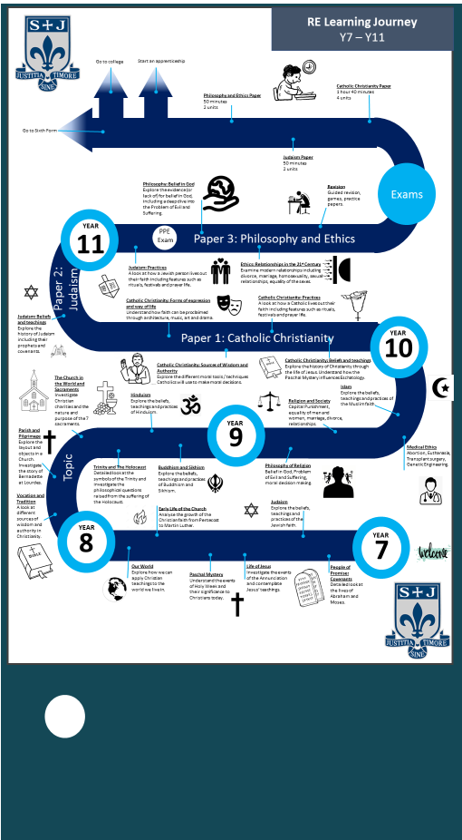

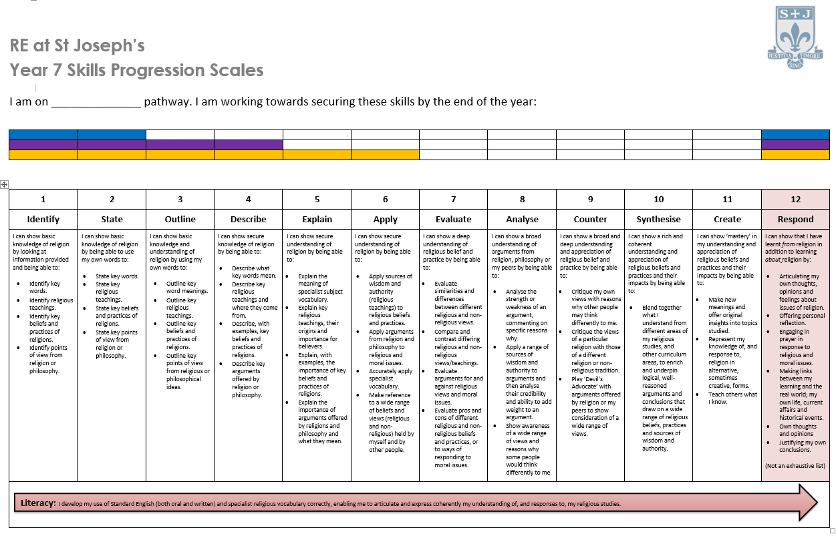

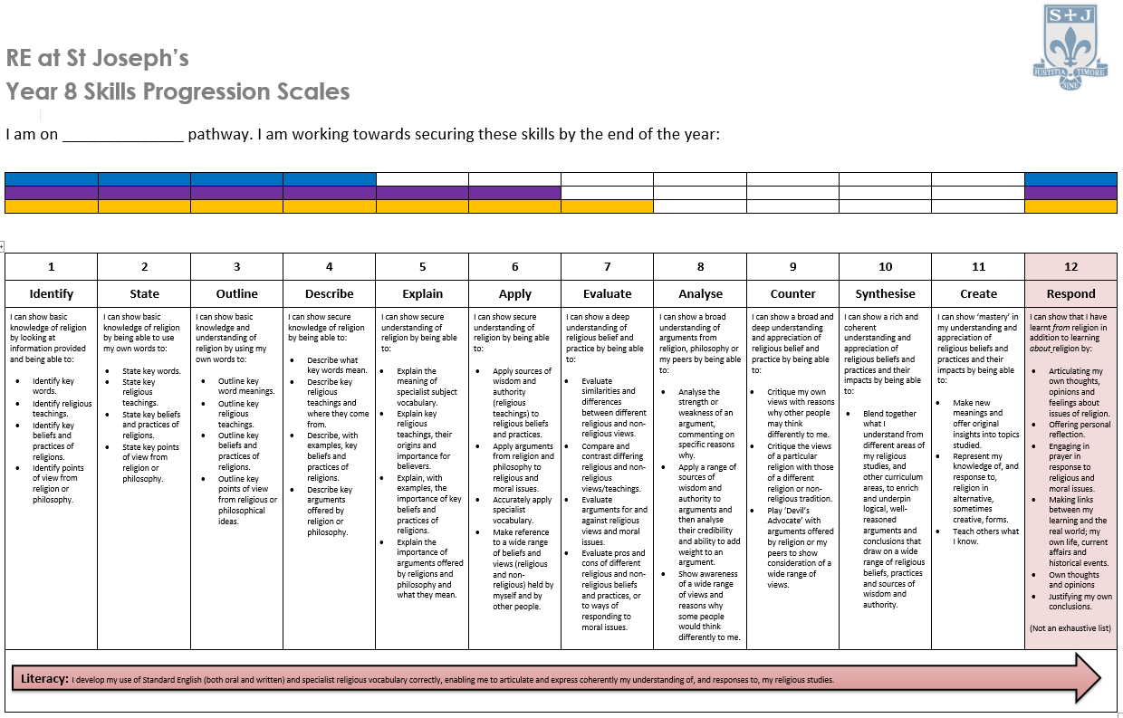

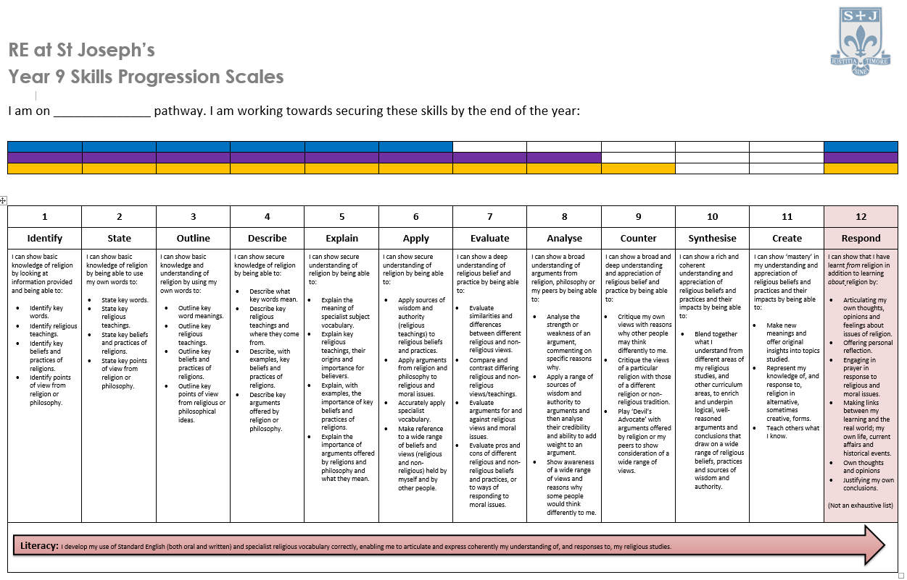

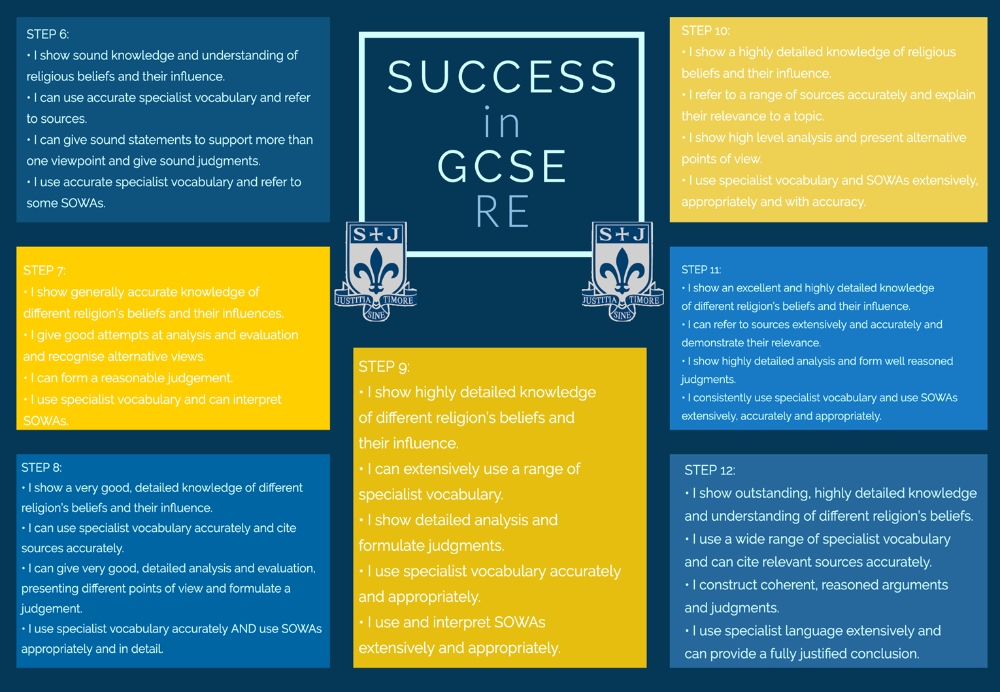

**Assessment Principles**

The schemes of learning and lesson outcomes for each Year group are within the relevant areas on the shared drive.

In Religious Education, pupils in Year 10 and 11 will have two books – one which will contain all notes from lessons and another which will contain all assessments. The Class-Notes Book should have a cover on the front of the book and the relevant progression scales on the inside front cover. The Assessment Book should have an Assessment Tracker on the inside page and first lined page Class work notes should predominantly use peer and self-assessment as a method of marking with student responses to this marking as appropriate. Teachers will give feedback on a 4 question, 27 mark assessment approximately every two weeks. Pupils will then purple pen these assessments for improvement. Marks should be recorded on the marksheets on TEAMS and pupils should also record these on their progress trackers so that progress can be monitored. Pupils in Year 7, 8 and 9 will have one exercise book for both class work and assessed pieces. They will also be given feedback on specific pieces of work as identified in the curriculum plans. Pupils will then purple pen these tasks for improvement. Half termly knowledge checks and assessed tasks will be undertaken, and progress also recorded on the tracker sheet.

Exam questions (at GCSE), knowledge checks, skills building tasks and more formal assessments will support the tracking behind pupil progress. Teacher feedback should be used to assess the pieces of work using the progression scales to provide a constructive next step for the student, work should be given the relevant mark (when applicable) and then a ‘Next Step’ to allow pupils to improve their work using purple pen. The ‘Next Step’ should explicitly show pupils how to improve their work in order to progress.

Feedback in books should be given in line with the whole school feedback and marking policy. Literacy marking should be completed in line with school policy and following the codes that are on the front of every pupil exercise book.

The RE Department expects that oral feedback should be given to pupils on a frequent and regular basis. It may be given at any time during a lesson to a pupil or a group of pupils.

An important aspect of Religious Education is that we must foster positive relationships between teacher and pupils. This allows pupils to have a safe environment to express feelings and reflect on experiences which encourage pupils to formulate beliefs and promote pupil’s own self esteem. The RE Department’s expectation is that opportunities for good questioning and dialogue should be planned within the scheme of work. Questioning and Dialogue should be included at various moments in a lesson but most specifically in the Starters and Plenaries. Quality questioning will develop and reflect on pupils’ personal experiences and encourage the formulation of their own beliefs.

Model answers and mark schemes for tests should be shared with pupils so that they can correct, evaluate and improve responses during purple pen time.

Forming judgements for Data Drops: All judgement should be skills based using the progression scales in Years 7, 8 and 9. When judgments are to be formed for reporting purposes, a holistic approach should be used considering each pupil’s learning journey. This should include all evidence from the assessments, class work, homework responses and attitude to learning.

All assessment data entered onto SIMS recording pupil progress at each Data Drop is monitored by the Head of Department in accordance with school policy. Each class teacher is responsible for highlighting any pupils in their classes who are underachieving or are a cause for concern in Class Intervention Sheets and Progress To Target meetings with the Head of Department.

Moderation of assessments and the sharing of good practice will take place during departmental meetings where possible on Tuesday evenings.

When writing reports to parents, all staff should follow school guidelines. Staff should provide a current and forecast grade, an attitude to learning score and a target comment of no more than two sentences.

**Sanctions and Rewards**

The Department follows the school policy in relation to sanctions and rewards. Behaviour for learning strategies should be used to provide a positive learning environment for all pupils. Unacceptable behaviour should be reported using the school behaviour system. The school system for incidents, referral and detentions should be followed.

The department recognises the importance of rewarding pupils for their work in order to encourage as well as praise.

Rewards for work produced has a motivational role in helping pupils to realise that their work is valued and that it is always important to produce work to the best of their ability.

Pupils will receive EPraise points from their class teacher for a piece of work that falls into one of the following: A piece of work that reflects that pupils’ level or target grade. A piece of work where the pupil has clearly tried hard and made an effort, even if it falls short of their target. Pupils should be rewarded with Epraise points for excellent attitude or effort, for achievement or contributions to school life. The Department are encouraged to make contact with parents at least once a half term with praise emails or postcards. Staff should also nominate pupils for their Stars of the Week to be published on the school Facebook page every week.

**Home Learning**

The Department follows school policy in relation to homework:

• Homework should be set once a week using the Epraise facility.

• Pupils should be set a variety of tasks; some checking knowledge recall, some to promote literacy, some creative, using research/online learning to more academic tasks.

• Class teachers should keep a record of homework completion.

• Appropriate sanctions should be given to pupils who regularly fail to complete homework.

• Home learning tasks should be decided on by the teacher as each class is very different and has unique needs.

• Home learning tasks should be appropriate to the class that pupils are in.

• When marking exam questions, teachers should give them a mark and what could be improved. It is important that pupils are well informed of how to reach their full potential.

**Monitoring and Evaluation**

The Department follows the school monitoring and evaluation procedures.

• Exercise books are monitored formally once a term by JS & HJ and feedback given to staff and SLT. Informal book looks may happen more often in a supportive capacity.

• Lessons are formally and informally monitored through observations, learning walks and pop ins from JS and HJ in order to ensure classes are in order and to provide appropriate coaching and support for all staff. These are also available by request to provide support and enable staff to agree suitable targets.

• Mutual observations and Team Teaching will also take place to ensure that good practice is shared effectively within the department.

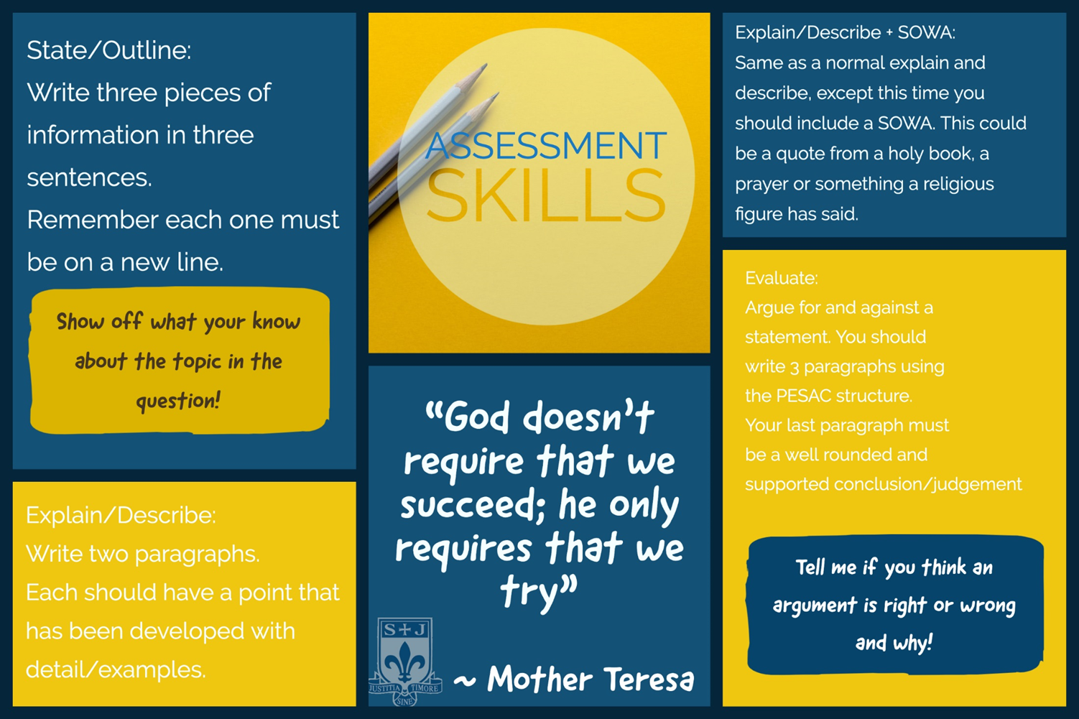**Enrichment and Extra-Curricular**

The Religious Education department offers weekly enrichment during P6 and also other activities and trips/visits as they arise from external providers.

Religious Education offers

* Mission Team
* Entering the Schools Bible Project Competition
* Entering the Catholic Young Writers Award
* Entering the Spirited Arts Competition
* Supporting the provision of PSHE and delivering the SRE programme as part of whole school and cross-curricular SRE provision
* Visiting speakers
* Confirmation Preparation
* Chaplaincy
* Culture Club

Extra-curricular visits include

* FLAME every two years in London
* Retreats to Savio House, Bollington and / or Castlerigg
* Attending BOSCEP school events such as ‘The Way’ held at Thornleigh and the BOSCEP schools GIFT Team day

**Religious Education Strengths and Areas of Focus**

A comprehensive evaluation of the department and its performance is detailed in the department SEF and a comprehensive action plan for improvement is detailed the department improvement plan.

Below is concise summary of the departments’ main strengths and areas for development.

***Strengths***

Behaviour for learning

Collaborative planning and quality of lessons

Two current exam markers

Staff subject knowledge

Staff with additional responsibilities

Stable staffing

Extra-Curricular opportunities

Whole school involvement

Regular visits from parish priest

Collective worship in lessons

***Areas of Focus***

Consistency of marking across the department

More opportunities for visiting speakers

Consistent implementation of progression scales in lessons

Consistency of homework across each year group

**SEND Provision**

The ‘Equality Act 2010’ and ‘Special Educational Needs and Disability (SEND) Regulations 2014’ place certain duties on schools to ensure that students with SEND are able to take advantage of the same opportunities that other students have. To help students with special educational needs and disabilities (SEND) reach their full potential, they first must have equal access to the curriculum.

Students have access to a range of resources which have been designed to support their needs.

Firstly, the department encourages the use of various tools and techniques which can be utilised to support SEND students, for example coloured paper / PowerPoints in place of overlays and a Twinkl subscription to help with scaffolding and resources.

The assessment rubrics within the department have been designed to be fully inclusive and cover the range of abilities of all students, ensuring that everyone can see that they have achieved and made progress. Students are supported by teachers and teaching assistants (where appropriate) to achieve well, often being given verbal feedback -this allows immediate and timely feedback and correcting of misconceptions as they arise. Pupils also track their progress from each assessment, allowing them to see progress made. This is celebrated by staff in class and by contacting home via email, phone call and postcards.

The assessment rubrics and SOL are scaffolded so that all children are taught knowledge and skills in a step-by-step structured format with many opportunities to revisit/recap and embed learning.

Various methods of formative assessment are used within the classroom including no hands up checking for understanding with targeted questioning designed to increase confidence/enhance and develop understanding. We regularly use online assessment tools such as epraise quizzes, these allow assessment in a fun and none-threatening environment.

Seating plans are designed strategically with children with SEND seated as priority. Specific needs I.e. visual/hearing impaired children will be seated toward the front of the classroom. Seating positions will be chosen to ensure that they are accessible for teaching assistants and teacher support when necessary. The students selected to sit either side of the SEND student are typically chosen as a learning buddy (HA to support) or as a safety friend to ensure that they feel safe in the environment and help to increase their confidence.

A wide range of resources are used to support SEND students within the department, these range from laminated and/or enlarged resources to allows easy demonstration, WAGOLL resources, scaffolded activities, text based helpsheets, and media clips.

Teachers in the Department will have noted SEND pupils on their seating plans, and pay particular attention to marking their books. They also read all Pupil Passports and refer often to the SEND register.