Science Curriculum



**Science Department Statement of Intent**

**“For there is hope for a tree, if it be cut down, that it will sprout again, and that its shoots will not cease.” Job 14:7**

*Science at St Joseph’s delivers the opportunity for students to understand the beauty and wonder of God’s world and their role in that world and society. We are committed to developing the minds of life-long learners in an environment of the Gospel values through the skills of observation, investigation, communication, critical thinking, logical reasoning and independent study.*

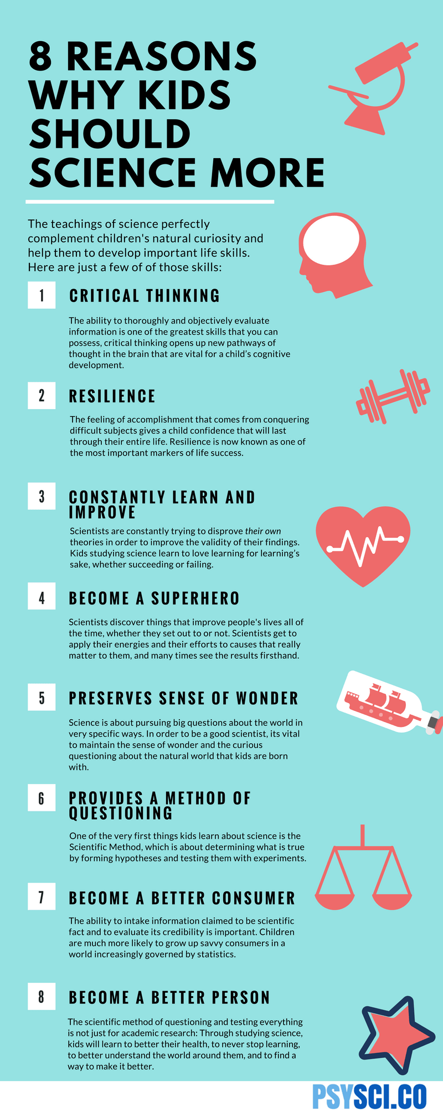**Aims of the Science Department**

1. Science is taught so that students become familiar with natural phenomena in their environment and develop as scientists in our world with logical reasoning and scientific enquiry.
2. Science is taught so that students witness the broad overviews of scientific principles and the ways in which these are exemplified and applied in the service of our communities.
3. Science learning is to prepare children to make a difference to our society once they leave education. They can go on to become doctors, agricultural officers, engineers, etc. with their determined goal of life.
4. Science teaching aims at helping children in their life to use the gifts of science every day.
5. Science teaching is to make the students wonder about things and to make them put question out of curiosity.
6. Science teaching aims to educate students to understand the system of observation, guess and experiment which is known as scientific method.

**Science Department Overview of Intent**

**Year 7**

By the end of Year 7 our Scientists will develop a scientific knowledge and conceptual understanding through the specific disciplines of biology, chemistry and physics. Students will develop an awe and wonder of science and a curiosity for what else we can learn about the world through enquiry based learned.

**Subject Content**

* Forces, Particle model, Cells, Electricity, Chemical reactions, Ecology, Waves, Growing up, Space, Structure of the Earth and Energy
* Development of practical skills throughout the year

**Year 8**

By the end of Year 8 our Scientists will develop an understanding of the nature, processes and methods of science through different types of enquiries that help them to answer scientific questions about the world around them. Students will develop informed and ethical opinions about the big scientific questions facing society and make and record observations and measurements using a range of methods for different investigations; and evaluate the reliability of methods and suggest possible improvements.

**Subject Content**

* Forces, Periodic table, Bioenergetics, Waves, Environmental chemistry, Body systems, Electricity

**Year 9**

By the end of Year 9 our Scientists will developed a keen understanding of how scientific principles are applied in context, in everyday life. They will have improved their understanding of fundamental ideas in biology, chemistry and physics. Practical skills will be further embedded through carrying out a range of practicals – focussing on variables, writing methods and processing and presenting data.

**Subject Content**

* Cells, organisation, infection and response
* Atomic structure & Periodic table, Bonding, structure & properties, Chemical Changes
* Particle model of matter, Energy, Electricity

**Year 10**

By the end of Year 10 our Scientists will enhance their skills to communicate effectively in Science and apply knowledge to unfamiliar concepts. They will have improved their understanding of big ideas in biology, chemistry and physics and be able to see links between disciplines and concepts. Practical skills will be further embedded through the study of Required Practical Activities, with a particular focus on critically evaluating techniques and data.

**Subject Content**

* Bioenergetics, Homeostasis & response, Inheritance
* Energy changes, Rate of reaction, Organic Chemistry and Chemical Analysis
* Atomic structure & radioactivity, Forces, Waves

**Year 11**

By the end of Year 11 our Scientists will be ready for the next stage of their scientific education. They will have a firm understanding of all the big ideas in Science and be able to incisively link these ideas to a wide range of contexts – and articulate in a clear, logical and reasoned manner when explaining, analysing and evaluating. They will be able to apply their understanding of a range of Required Practical Activities independently to unseen practicals.

**Subject Content**

* Variation & evolution, Ecology
* Atmosphere, Using resources
* Waves, Electromagnetism
* Consolidation of GCSE material and RPAs

**COVID-19 RECOVERY CURRICULUM PLAN**

General strategies to support students back into Science learning:

* Regular low stakes testing to assess understanding and gaps in knowledge
* Regular retrieval of content, new and old
* Checking for understanding in every lesson
* Responsive teaching - teachers use assessment to adapt pace and direction of individual lesson or route through a unit
* Spiral curriculum allows for assessing prior knowledge and building on this through year 7 to 11
* Build confidence through positive praise, and regular teacher-pupil dialogue
* Long term curriculum plan incorporates consolidation time to revisit concepts studied via Home Learning

Our new Year 7 intake may have profound gaps in knowledge (KS2). All curriculum resources in year 7 and beyond consider the starting knowledge that students *should* have (KS2 National Curriculum Programme of Study), but include regular opportunities to assess the actual knowledge and build from there.

Where possible, additional science teaching staff are allocated to Year 7 lessons to support their transition, and to quickly identify those most in need of additional support and provide it on a one-to-one or small group basis.

Year 9 have not yet completed the Programme of Study from the 2014 National Curriculum for Key Stage 3, and some units of study do need to be revisited to offer opportunity to further develop specific Working Scientifically skills and to cover key concepts– such as chemical reactions and energy.

They will begin the year honing their Working Scientifically skills of identification; data gathering and, interpretation; plotting graphs; drawing curved and straight lines of best fit; method writing; and evaluating scientific methodologies. This is a bespoke unit of study crafted with their unique situation in mind that will revisit these key concepts but go further than their lower-school studies.

A newly appointed Higher Level Teaching Assistant (0.8 FTE in science) works with key groups and individuals to support the identification and filling of gaps in knowledge and skills.

Year 11 summer school provided the opportunity for all students to work on these critical Working Scientifically skills and apply them to a novel investigation.

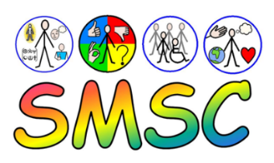**SMSC, GV and FBV in Science**

**Spiritual** – what we **believe** about purpose and meaning of life

**Moral** – principles that guide our **choices** based on our beliefs

**Social** – how we **relate to self and others** influenced by our beliefs

**Cultural** – ways in which we **do things** based on our beliefs

**Gospel Values**

Service

Truth & Justice

Forgiveness & Mercy

Purity & Holiness

Faithfulness

Tolerance & Peace

Sacrifice

Humility & Gentleness

Dignity & Compassion

Integrity

**God asks “why?”…….. but Science asks “how?”**



|  |  |  |
| --- | --- | --- |
| **Fundamental British Values (FBV)** |  | **Gospel Value** |
| **Democracy** | Making decisions together.  The right to an opinion/voice. | **Service & Sacrifice.**  **Humility & Gentleness.** |
| **Rule of Law** | Understanding rules & their importance  Following rules to develop order | **Truth & Justice.**  **Forgiveness & Mercy.** |
| **Individual Liberty** | Freedom of speech for all.  The right to make our own choices. | **Faithfulness & Integrity.**  **Purity & Holiness.** |
| **Mutual respect** | Treating others as you would want to be treated.  Respect for each other.  Working together. | **Dignity & Compassion.** |
| **Tolerance** | Learning about different faiths & cultures.  Listen to other viewpoints.  Learning about diversity. | **Tolerance & Peace** |

The Science department has a document covering appropriate and detailed questions which could be the focus of discussion in Science.

“Seeds of great discoveries are constantly floating around us, but they only take root in minds well prepared to receive them”

Joseph Henry

“DNA is like a computer program but far, far more advanced than any software ever created”

Bill Gates

“Strive not to be a success, but rather to be of value”

Albert Einstein

“Gravity explains the motion of the planets, but it cannot explain who sets the planets in motion”

Sir Isaac Newton

“It always seems impossible until it’s done”

Nelson Mandela

“When you realise the value of all life, you dwell less on what is past and concentrate more on the preservation of the future”

Diane Fossey

**SMSC in Science**

*Spiritual Development:*

Sometimes science and spiritual ideas do cause conflict but in a modern society it is important to understand why these conflicts arise so we can respect the views of others and move forward. It is also seen more often that science is able to stand alongside the spiritual beliefs of many. This is looked at often from a neutral stand point within science lessons.

*Moral Development:*

Our understanding of Science has allowed us to develop technology we couldn't have imagined 50 years ago. Now however, we must start deciding if we should we do all th e scientific activities we are able to or morally should we decide not to. This can be as simple as should we test medicines for humans that could save lives on animals causing them cruelty? It could be as complex as should we allow somatic or germ line cell therapy. Moral development is a vital part of any scientist's development.

*Social Development:*

Science is changing our society. People are driving more efficient cars, more people are putting solar panels on their rooftops. Our society has become dependent on scientific developments which we could not have foreseen 50 years ago but also our lives are likely to change significantly in the future because of our reckless damaging activities to the environment as a human society. Students must consider their impact on the world around them and start to look at what we can do to help the next generation have a habitable planet.

*Cultural Development:*

Scientific development comes from all across the world, from people of all backgrounds and cultures. Some of science's most important discoveries have come from other parts of the world and it's important for students to understand this. It is also important to understand how the different cultures around the world can have different impacts on the planet and what impact more economically developed countries have on poorer areas. This will also be vital into the future as we need to monitor the impact of quickly developing cultures around the world on our environment.

Science contributes to our students’ SMSC development through:

* Encouraging students to reflect on the wonder of the natural world.
* Awareness of the ways that Science and Technology can affect society and the environment.
* Consideration of the moral dilemmas that can result in scientific developments.
* Showing respect for differing opinions, on creation for example.
* Co-operation in practical activity.
* Raising awareness that scientific developments are the product of many.

**Promoting British Values in Science**

*The Rule of Law*

Law is an integral part of science. New research into drug design, stem cell technology, genetic engineering, mining, engineering, mobile phone and computer research all have to follow strict laws that govern their safety and application. From patenting work to following British Safety Standards, to destroying a cloned embryo before the cells can specialise, civil and criminal law must be considered by all scientists developing new and existing technology. We actively promote civic institutions so that students value and appreciate the local the Health system, the Police, the justice system and Social Services and how Science has an active role in the day to day functioning of these establishments.

*Mutual Respect and Tolerance*

Science has many complex ethical issues from genetic engineering, cloning, drug testing and pollution to nuclear power stations. Students are expected to weigh up both sides of any  argument and provided reasoned response that underpins their own stance to these issues. This is done through class discussion, links with industry and careers in lessons and other extracurricular visit and events throughout the year.

*Democracy*

Science is a universal language and discipline that can be used anywhere in the world regardless of race, language or religion. We show how Scientists collaborate worldwide to share data, theories and conclusion. Through topics such as evolution, biodiversity and variation, we emphasise how we are all the same species regardless of ethnicity, background or beliefs. This supports the British ethos behind democracy.   *Individual Liberty*

From inventing the World Wide Web, to mobile phones, Stem Cell Transplants and DNA Fingerprinting, our country and scientists have contributed much to our modern life. The Science department promotes, through its teaching and education about scientists such as Charles Darwin, Robert Hooke, Watson and Crick, Rosalind Franklyn and Marie Curie. By setting these examples and role models we endeavour to support a new wave of scientists who will contribute positively to modern Britain. The fundamental principle of Science is to understand the world in such a way as to improve the quality of life for all species that inhabit it.

**Literacy and Science**

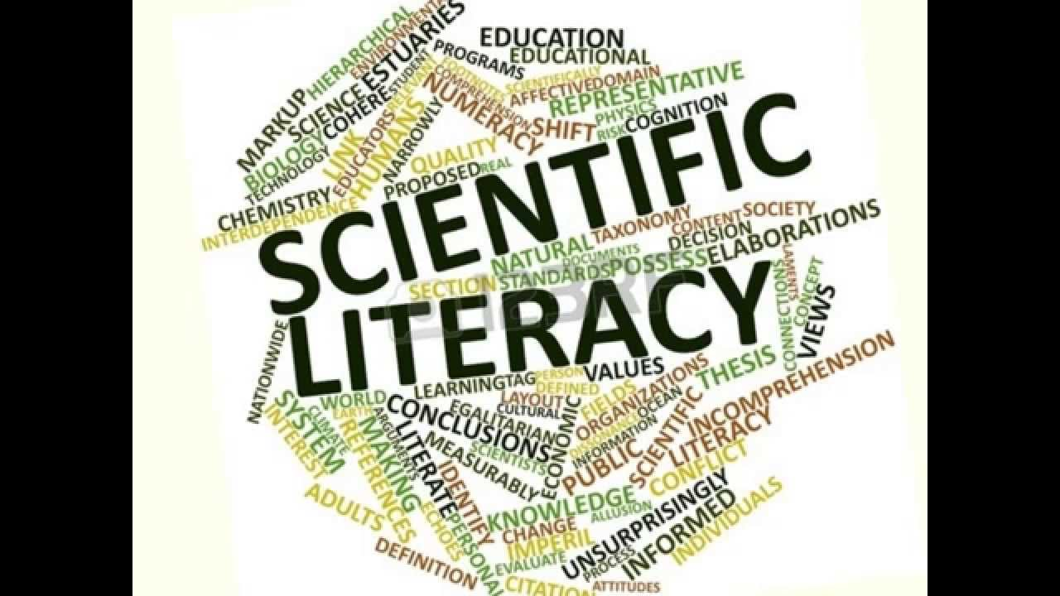

Literacy needs to be deliberately planned into a department’s SOL in order to give it the time and priority it requires. Students should be armed with the vocabulary and literacy skills to be able to make sense of scientific literature presented to them in lessons, in assessments and in the wider world.

Resources are prepared by the department in advance so that Literacy is an integral part of Science teaching and learning in lessons and develops alongside scientific skills and content. These may include word cards, question cards, books, magazines and leaflets, writing frames and worksheets and games. Regular recall of key terms is a feature of our SOL.

Whenever it is appropriate literacy outcomes should be built into the lesson along with science specific outcomes. Literacy can be developed in every lesson through activities such as emphasis on word work during questioning and mental start-up activities at the start of each lesson. Some topics will lend themselves more easily to literacy development than others. Such emphasis on the language of science will inevitably result in students being more able to articulate scientific ideas in their own words and make sense of unfamiliar and unusual contexts.

In addition to content-specific vocabulary, attention is paid to command words to enable students to understand what an exam question requires, and how to structure answers appropriately. Again, a variety of techniques are employed in the department to develop these skills.

All departmental resources are reviewed on an ongoing basis, and discussed during departmental CPD to ensure continuous improvement.

*Key Areas of Literacy*

|  |  |
| --- | --- |
| **Vocabulary**  **Key issues** Technical and specialist words  Appropriate usage  Correct spelling  Understand meaning  **Common difficulties**   * Time and lots repetition needed to ensure new words are internalised into working vocabulary and linked to appropriate concepts. * Ordinary words with alternative meanings can be difficult as it causes cognitive conflict. There may be a precise scientific and an everyday meaning to the same word e.g. mass, element.  Supporting strategies  * Introduce words using a multisensory approach e.g. orally, visually, kinaesthetically * Use vocabulary frequently using open questions * Use words in sentences to keep reflecting back * Use models and picture to help visualise the word * Use flash cards to test students understanding * Ask students to explain using pictures to encourage language development * Use visual clues e.g. hand signals * Use poetry, rhymes, raps and rhythms to aid memory and link to modern culture * Get students to make own word lists to collect new words and test and check their meaning | **Oracy**  **Key issues** Use language precisely  Listen to others and respond by  building on ideas and views **Common difficulties**Constant use and repetition are essential. Words which are not frequently used are easily forgotten  * Often little planned time in lessons to “talk” * One word answers for fear of getting it wrong   **Supporting Strategies**   * Teacher model good use of scientific language * Use questions to review past knowledge and understanding, check understanding, encourage the learner to think and to practice the language * Use a range of questioning strategies * Allow students “thinking” time * Offer students challenge * Use games to encourage meaningful peer group talk and embed new word and concepts * Use small group discussion to develop student understanding through conversation in a less threatening atmosphere |

|  |  |
| --- | --- |
| **Reading** **Key issues** Strategies to help reading for understandingLocating and using information Summarising  Synthesise learning from reading Common difficulties  * Students often cannot relate to the type of science texts used in school in terms of language and style * Children often prefer fiction to non-fiction texts * Children prefer to use interactive methods of discovering information e.g. Internet * Limited range of text that can be offered to students * Weak readers can lack the ability to scan and skim read * Students prefer to copy chunks of text without checking their relevance  Supporting Strategies  * Develop activities to promote meaningful reading experiences e.g. EXIT model * Activities prior to reading that give students a desire to find out more e.g. using a contents page or index * Activities associated with reading to make the data processing easier e.g. DARTS, cloze procedure, sequencing, underlining * Activities following reading to encourage reformulation of the information into personal knowledge e.g. table/diagram completion, summarising | **Writing****Key issues C**orrect spelling and punctuation Follow grammatical conventions  Organise work in a logical and  coherent form Common difficulties  * Many students are reluctant writers * Poor handwriting and spelling can make writing difficult to interpret * Lack of understanding what they are being asked to write about * Time pressure in lessons to get ideas or work down onto paper  Supporting Strategies  * Plan to incorporate the different forms of scientific writing into lessons e.g. recount and report, instruct etc. * Use different types of text * Get students to analyse prose to look for key words and phrases * Get students to criticise and improve on received text * Encourage use of a variety of genre e.g. narrative, descriptive, persuasive, reports, imaginative when appropriate * Use writing frames where appropriate, encouraging children to use it as a guide line and eventually manage without * Encourage children to redraft work in lessons using teacher comments * Develop skills in note taking by using short simple activities e.g. jot down key words, note observations on teachers demo * Teach students how to summarise text e.g. crosswords, catchword * When asking students to write analysis and evaluations teach them the specialist vocabulary and phrases needed e.g. the relationship between, the gradient of the line…, my results do not support my prediction. |

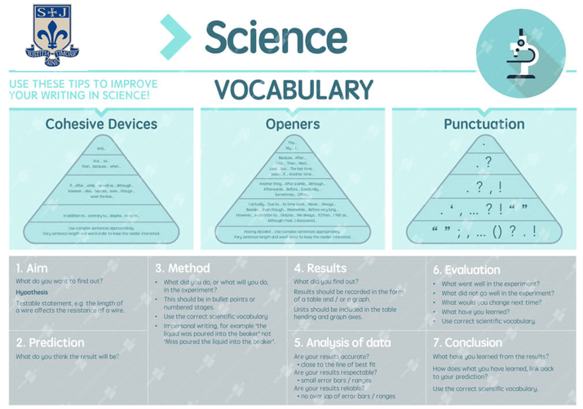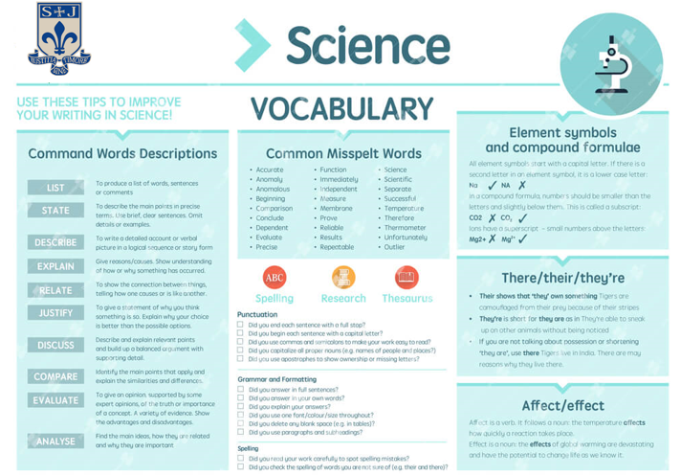

**Promotion of Careers in Science**

One way the department supports the schools’ CEIAG programme through the embedding of careers information in our SOL. Each unit of study includes a link to relevant STEM careers. The activities may take the form of a discussion about which careers may use the information gleaned in the lesson; or watching a video / reading an article about a real-life scientist applying the content in context; researching scientists and the impact their work has had on our lives; or thinking about the skills developed in a lesson and how they could be used in the workplace. For example:

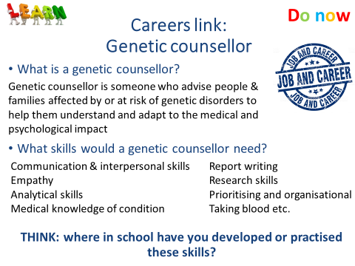

In addition, the majority of our classrooms have displays showcasing real-life scientists and their work, or guidance on careers. For example:

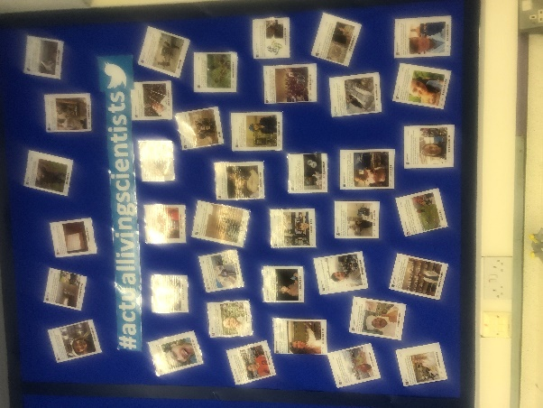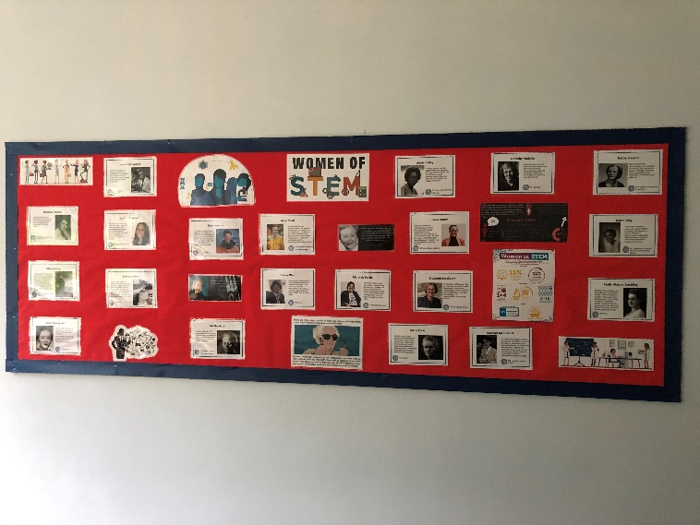

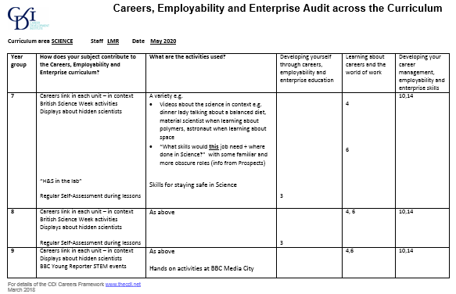 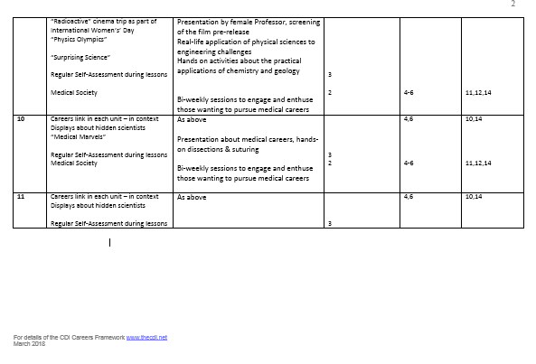

**Science Structure**

The Science department is made up of an experienced team of staff who are highly dedicated and specialised to their subject area. Qualifications are offered up to GCSE Level including AQA Trilogy Combined Science and individual GCSEs in Biology, Chemistry and Physics. A small cohort of students entering Y9 in 2020/21 will study towards AQA Entry Level Certificate in Science (Single Award) – to embed ideas from Year 7 and Year 8 and prepare for the rigour of GCSE.

Students are encouraged to be innovative and think about how Science affects everything we do: from how we function to the science behind our cameras and the components of the food we eat. The department provides lessons that are active and engaging, maximising the interest and enthusiasm of our students, so that lessons are thoroughly enjoyed and understood.

We have a Curriculum Leader for Science, and a Second in Science who are supported by a team of 8 Teaching Staff. Their teaching is complemented by 3 laboratory technicians who work in our laboratory preparation rooms to ensure that all of the practical Science lessons go ahead smoothly. We have six science laboratories and endeavour to promote lessons that are imaginative, creative and involving current affairs.

In Year 7 and Year 8 students have 5 x 1hour lessons over the 2 weeks

In Year 9 students have 9 x 1hour lessons over the 2 weeks

In Year 10 and Year 11 students have 10 x 1hour lessons over the 2 weeks

*Curriculum Structure*

Students in Year 7 and Year 8 are follow a programme of study which aligns to the National Curriculum for Science 2014, and is underpinned by AQAs Big Ideas in Science. Our scheme of learning aims to stimulate students’ curiosity in the world around them and enable to develop investigative and evaluative skills in preparation for GCSE.

Each unit of work is built around the development of a particular investigative skill alongside the improvement in knowledge and understanding of scientific concepts.

Year 7:

* Unit 1 – Skills for Science
* Unit 2 – Forces
* Unit 3 – Particle model of matter
* Unit 4 – Cells
* Unit 5 – Electricity
* Unit 6 – Metals, acids & alkalis
* Unit 7 – Interdependence
* Unit 8 – Waves
* Unit 9 – Space & Earth
* Unit 10 – Reproduction & variation
* Unit 11 – Energy transfers

Year 8:

* Unit 1 – Skills for Science
* Unit 2 – Forces
* Unit 3 – Periodic Table & materials
* Unit 4 – Bioenergetics
* Unit 5 – Waves
* Unit 6 – Climate & Earth
* Unit 7 – Systems
* Unit 8 – Magnets & Electromagnets
* Unit 9 – Reactions
* Unit 10 – Inheritance & Evolution

Science is one of the core subjects of the National Curriculum and therefore it is compulsory to study at GCSE.

Students study Science from the AQA suite of GCSE qualifications. Students will either follow the programme of study towards:

* Entry Level Certificate (Single Award)
* GCSE Combined Science – Trilogy
* Or GCSE Biology, GCSE Chemistry and GCSE Physics

An overview of the topics in the courses is shown below:

*Biology*

1. Cell biology

2. Organisation

3. Infection and response

4. Bioenergetics

5. Homeostasis and response

6. Inheritance, variation and evolution

7. Ecology

*Chemistry*

8. Atomic structure and the periodic table

9. Bonding, structure, and the properties of matter

10. Quantitative chemistry

11. Chemical changes

12. Energy changes

13. The rate and extent of chemical change

14. Organic chemistry

15. Chemical analysis

16. Chemistry of the atmosphere

17. Using resources

*Physics*

18. Energy

19. Electricity

20. Particle model of matter

21. Atomic structure

22. Forces

23. Waves

24. Magnetism and electromagnetism

*Students that are sitting GCSE Physics will also study*

*25. Space*

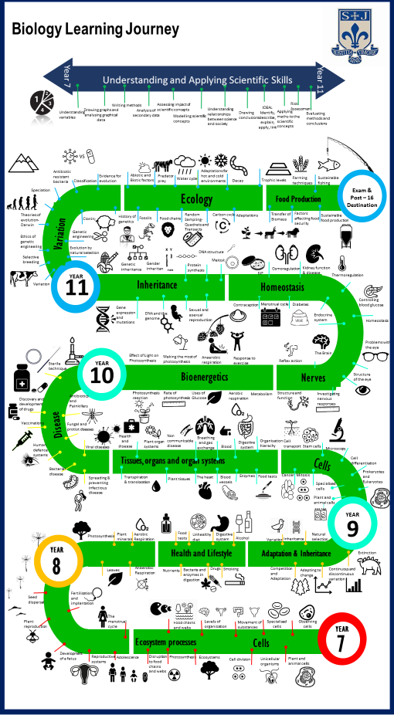

**Assessment Principles**

Year 7 begins our 5-year spiral curriculum. The scheme of learning and lesson outcomes are within the relevant areas on the shared drive. There are 10 key ideas which are covered and revisited across the first two years at St Joseph’s. Teaching of these units should focus on mastery of skills before moving on, this will ensure that students to progress through the curriculum each year. Required Practical Activities have been introduced into the teaching from Year 7 to support students in their academic and scientific development. The progression through the units for attainment is set out in the progression scales which should be used alongside curriculum planning and assessment.

For AQA Science the specification and scheme of learning are within the relevant areas of the shared drive. Also within these areas are teaching resources and materials Progression scales also support the tracking of skills and content through the GCSE specifications. Teaching order and unit deadlines can also be found in the shared curriculum area.

Class books will contain all notes from lessons, assessed tasks and all homeworks. They should have a front cover on the front of the book and then progression scales at appropriate points depending on the year group and topics. Regular recall activities should be self-marked or peer-marked, and staff should use a variety of AFL techniques and strategies to inform planning. Class books should predominantly use peer and self-assessment as a method of marking with student responses to this marking as appropriate. SOLs have been updated to ensure there are a range of appropriate opportunities and tools embedded into our shared resources to enable effective SA and PA – though the development of these and student skill and accuracy remains an area for us to work on as a team.

Class books should be teacher-marked using the standardised assessment materials for each unit, and feedback should enable students to actively engage in the feedback process by answering specific questions or improving specific areas of their work. Wherever possible, feedback should link to the topic-specific progression scales. Again, there are a variety of tools to support teachers to provide effective feedback.

Assessment books will support as the tracking behind student progress. They should be set up with a skills based progression scales for the year group and an assessment tracker in the front of the book. It should contain end of unit assessments.

Teacher marking should be used to assess the pieces of work using the progression scales to provide a constructive next step for the student, which should be responded to using purple pen. The results of the assessment should be tracked on the student tracker, therefore indicating a students’ areas for development.

Each end of unit assessment should be supported by Whole-Class Feedback and a Personal Question Level Analysis, which should also be included in the Assessment book. PQLA will be both knowledge and skills based, and linked to progression scales allowing students to take ownership of areas for development. This will provide students with a more detailed understanding of their “gaps to address” within this topic, and guidance to support the improvement of exam technique. Where appropriate model answers should be shared. The development of the most appropriate tools and format for whole-class feedback will be an area for the department to consider and explore in 2020/21.

**Examples of whole-class feedback**

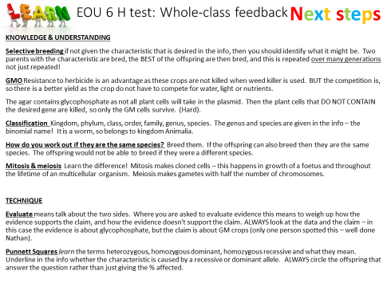

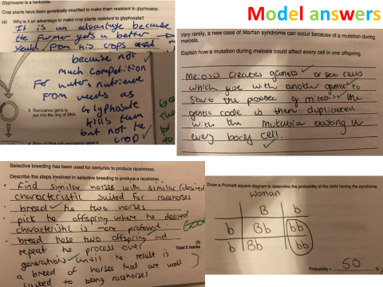

**Forming judgements for data drops**

It is important that data drops accurately reflect an individual’s learning journey, and vital that they are consistent across the department.

All end of unit assessments at align with the principles outlined by JNC, Ofqual and AQA – in terms of proportion of marks available for the various Assessment Objectives, mathematical skills and practical skills. Boundaries at GCSE at linked to historical published boundaries and observed trends. End of unit assessment boundaries incorporate a buffer. To this end, these tests offer a reliable snapshot of performance against the criteria students will be judged upon at the end of their studies.

When forming data drops, teachers should consider all assessment including: homeworks, retrieval activities in lesson, standardised assessed pieces and end of unit assessments. Grades entered should reflect a best fit. Teachers should also apply professional judgement and consider a student’s attitude to learning when forecasting future attainment.

In Year 7 and Year 8, data drops are NOT linked to grades – and instead communicate the students’ progress linked to KS2 prior attainment (above expected, expected, below, well below expected progress). To ensure consistency, this is standardised using our departmental progress tracker.

Data drop entries are Quality Assured by HOD and AHOD to ensure agreed principles have been followed fairly and consistently. Exam marking is moderated internally, and our approach verified externally via the Bolton Hub for Science.

**Generic** **progression scale**

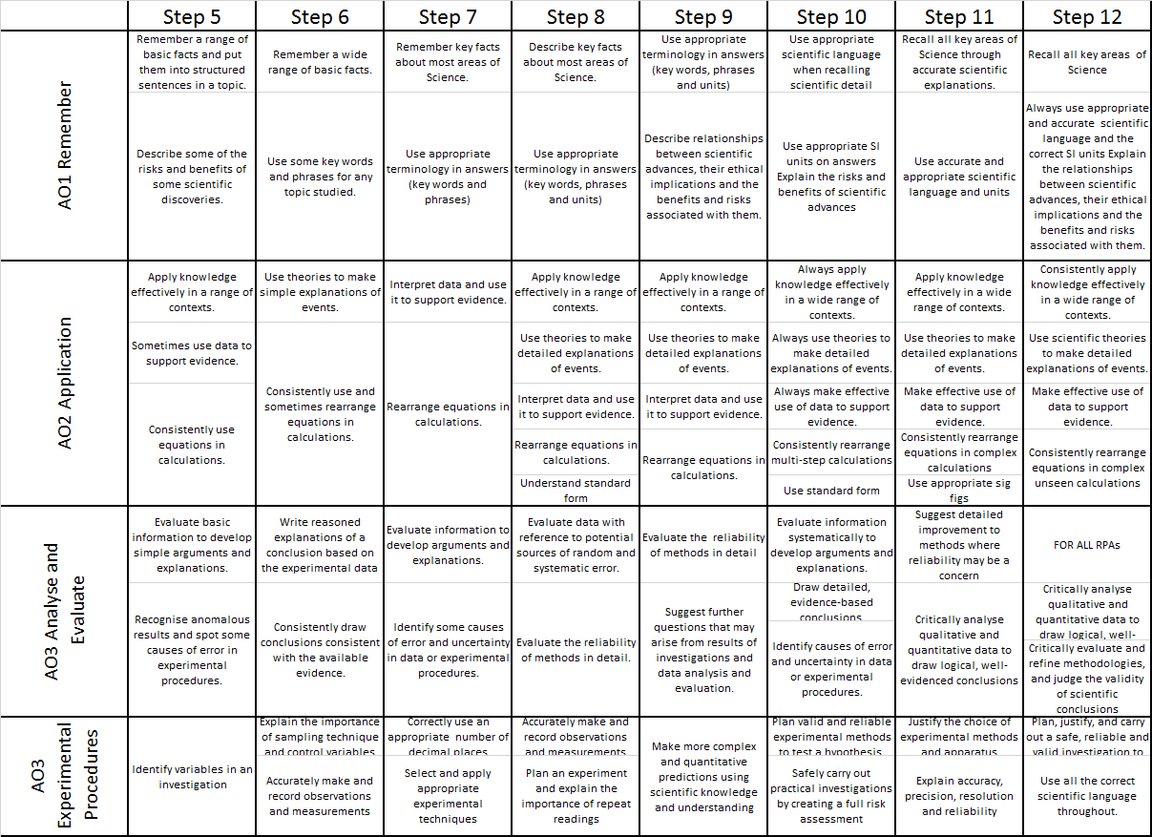

**Example GCSE topic-specific progression scale** for C2

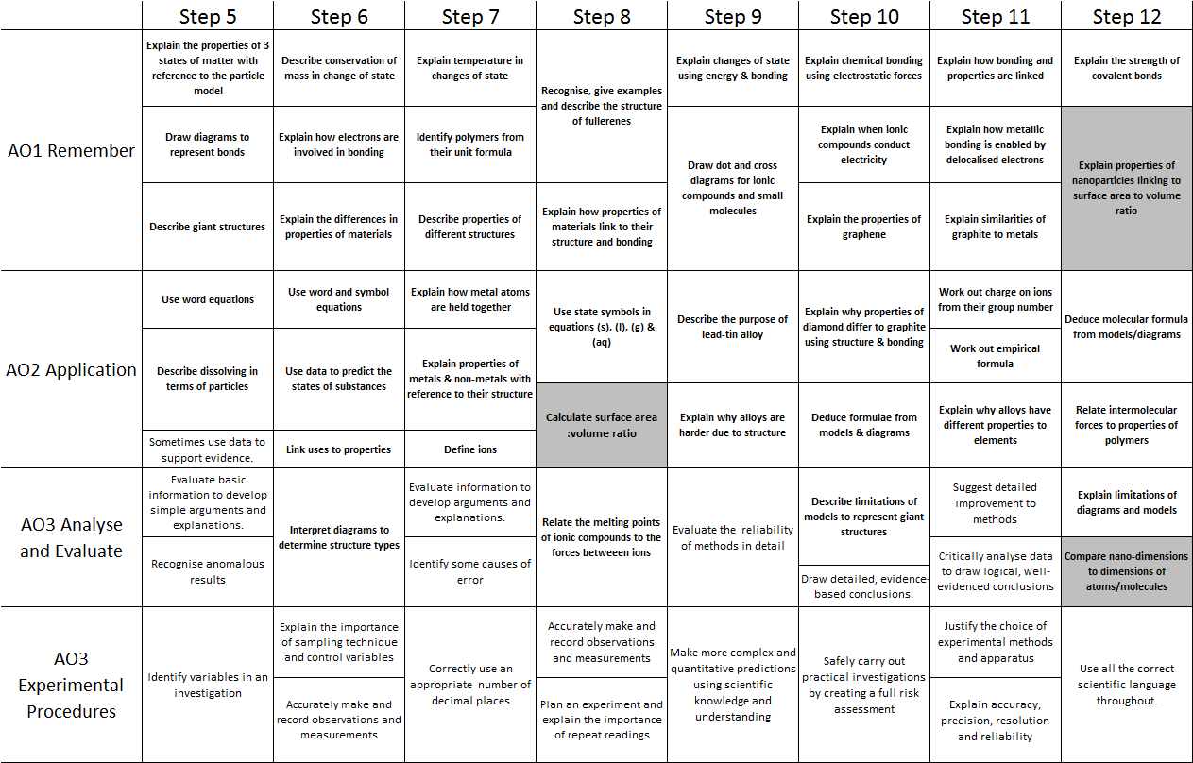

**Examples of use of Progression Scales**

*When sharing outcomes:*

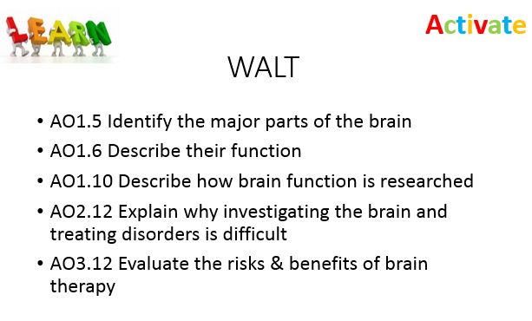

*When completing tasks:*

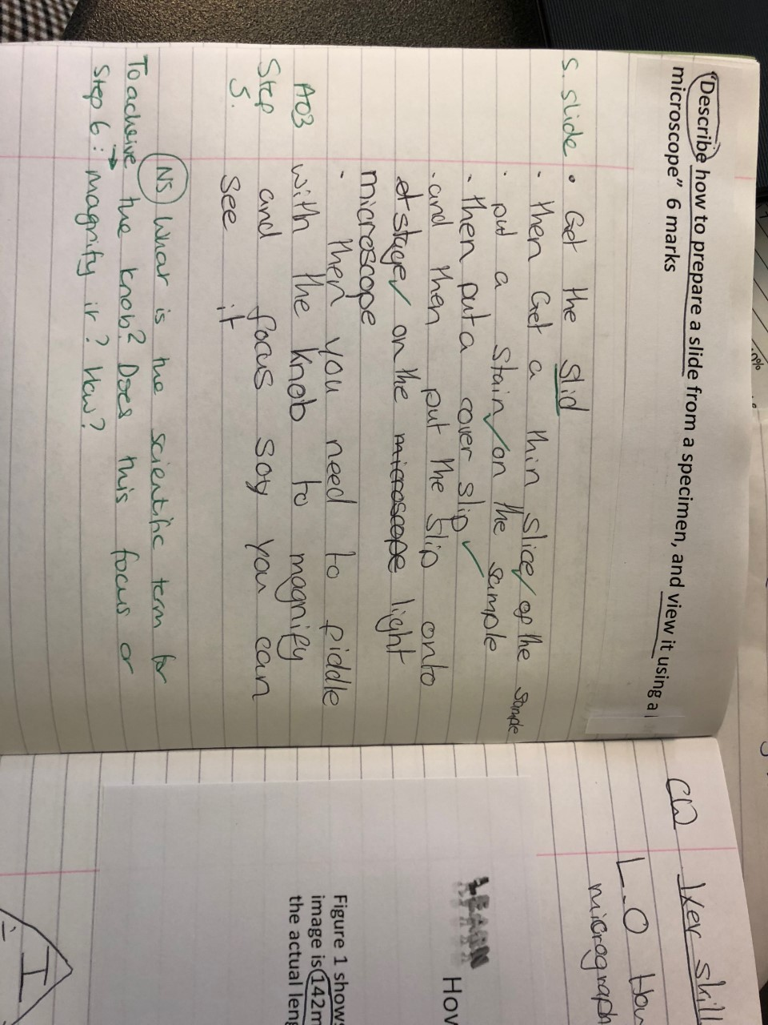 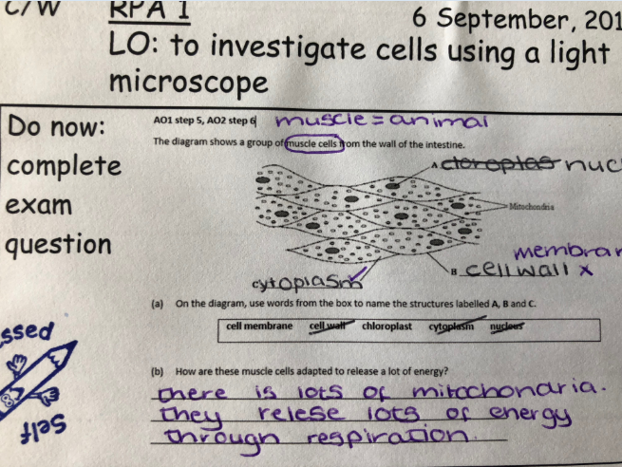

*When self- or peer-assessing*

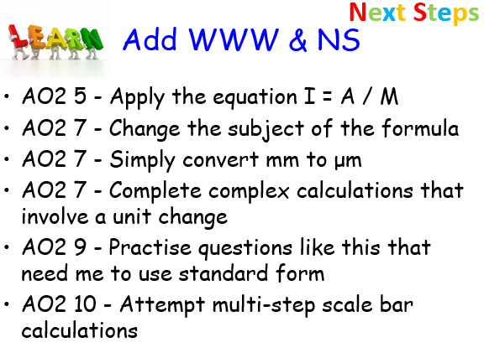

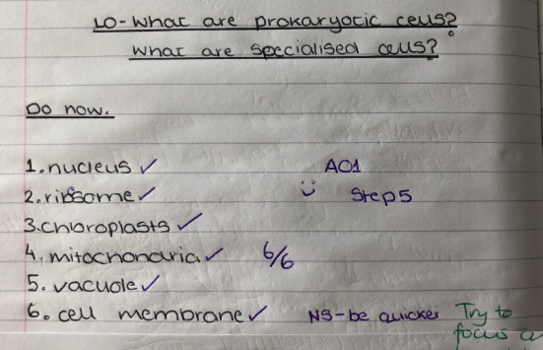

*In teacher-feedback:*



*To support student ownership following a test (i.e. PQLA):*

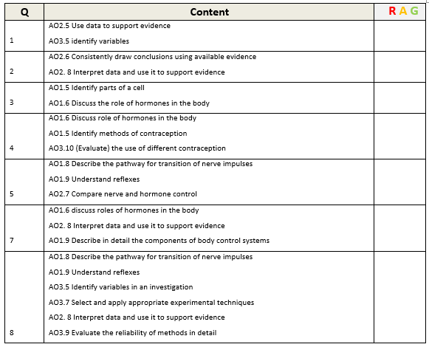

**Enrichment and Extra-Curricular**

We take every opportunity to make links to contexts where science is applied in everyday life and highlight relevant careers in our SOL, as we want students to experience the awe and wonder of science and we have a firm belief in the role of science education in preparing students for life as a well-rounded citizen, and inspiring students to contribute to the field in the future. The achievement of this vision is further supported by extracurricular activities, trips and visits.

The Science department offers weekly enrichment during P6 and also other activities and trips/visits as they arise from external providers.

* STEM Club
* Eco-Club
* Medical society – for KS4 students interested in a career in medicine, dentistry and veterinary science
* Period 6 Revision
* Board game club

Extra-curricular visits in the past have included:

* BBC Young Reporter – a hands on experience at BBC Media City (Salford) showcasing STEM careers in the media,
* Radioactive Film preview – to engage lower-achieving and PP girls in contextual science and to celebrate women in STEM
* Medical Marvels – for more-able KS4 students interested in medical careers
* Surprising Science – an opportunity to visit a local college, for students interested in pursuing Science at A level
* Chem Quiz – an annual hands on chemistry challenge, run by RSC and MMU
* GCSE Separate Science masterclasses – pitched at Grade 8/9 students at the lead school for Science in Bolton (Sharples)
* Physics Olympics – an annual hands-on physics and engineering challenge hosted by Bolton School boys’ division
* Salters’ Festival of Chemistry - an annual hands on chemistry challenge

**SEND in Science**

The Equality Act 2010 and Special Educational Needs and Disability (SEND) Regulations 2014 place certain duties on schools to ensure that students with SEND are able to take advantage of the same opportunities that other students have. To help students with special educational needs and disabilities (SEND) reach their full potential, they first must have equal access to the curriculum.

The Science Department progress scales have been designed to be fully inclusive and cover the range of abilities of all students, ensuring that everyone can see that they have achieved and made progress. Whilst we have a shared curriculum, teachers adapt and plan individual lessons (and the success criteria and learning outcomes) with individual students and their needs and abilities considered. The assessment criteria and schemes of learning are scaffolded so that all children are taught knowledge and skills in a step-by-step structured format. Our spiral curriculum and schemes or learning are deliberately designed to provide many opportunities to revisit/recap and embed learning. The teaching of exam technique, literacy and Working Scientifically skills is embedded into our spiral curriculum – and whilst this benefits all students, promotes the progress of SEND students.

Where appropriate, some SEND pupils may study towards an Entry Level Certificate in Science before embarking upon their GCSE studies. This course is designed to embed the Working Scientifically skills needed for the GCSE course, and build confidence towards sitting high-stakes exam papers.

Various methods of formative assessment are used within the classroom including no hands up checking for understanding with targeted questioning designed to increase confidence/enhance and develop understanding. We regularly use mini white boards, and online assessment tools such as Kahoot quizzes, these allow assessment in a fun and non-threatening environment. This checking for understanding of all students allows immediate and timely feedback and correcting of misconceptions as they arise.

Students are supported by teachers and teaching assistants (where possible and appropriate) to achieve well. This may involve:

* Simply monitoring of students whilst they work, and providing intervention where required
* Or working more closely to provide more in-depth support on a one-to-one or small group basis
* Prompting students or chunking of activities
* Differentiated activities
* Provision of coloured exercise books and print outs as required

A wide range of resources are used to support SEND students within the department, these range from use of visualisers to demonstrate a technique (such as graph drawing or decoding a question) laminated and/or enlarged resources to allows easy demonstration, WAGOLL resources, scaffolded activities, text based help-sheets, video help resources to support online learning and homeworks.

Class groupings consider SEND students and TA support. Seating plans are designed strategically with children with SEND seated as priority. Specific needs I.e. visual/hearing impaired children will be seated toward the front of the classroom. Seating positions will be chosen to ensure that they are accessible for teaching assistants and teacher support. The students selected to sit either side of the SEND student may be chosen as a learning buddy (HA to support) or as a safety friend to ensure that they feel safe in the environment and help to increase their confidence.

SEND is discussed regularly at department meetings, SEND students are always included in Quality Assurance activities (such a book looks and work scrutiny) and SEND is a key group considered when analysing progress data for classes and year groups.

**Science Strengths and Areas of Focus**

A comprehensive evaluation of the department and its performance is detailed in the department SEF and a comprehensive action plan for improvement is detailed the department improvement plan.

Below is concise summary of the departments’ main strengths and areas for development.

*Strengths*

* Improved outcomes for Separate Science and Foundation students
* Collaboration and shared planning – scheme of learning
* Staff subject knowledge
* Pedagogy – improved frequency and effectiveness of SA/PA, retrieval practise, improved scaffolding & modelling particularly AO1 & 3
* Improved accuracy of progress judgements across all year and forecasting at Year 10 and Year 11 – as demonstrated by AQA external moderation of TAGs in 2020/21
* Use of Progression Scales to support T&L
* Approach to Required Practical Activities
* Separate Science outcomes for the most able are good
* Increasing proportion of Grade 7+ outcomes
* Curriculum offer improving to meet needs of all students – Biology, Chemistry, Physics, Combined Science (Trilogy) and Entry Level Certificate
* Approach to observations and QA, and use of this QA to inform CPD and DIP
* Progress made with students who speak English as an Additional Language

*Areas of Development*

Main aims of the department in next three years:

* Close the gender gap, PP gap and SEND gap (in some year groups)
* Improve engagement and confidence in Chemistry
* Make more effective use of data at the class teacher level
* Improve quality and effectiveness of homework
* Science capital and curriculum enrichment