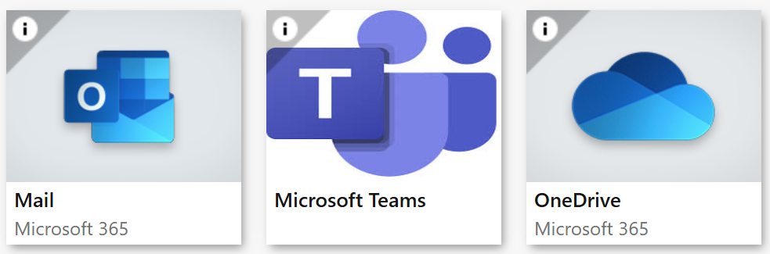 | 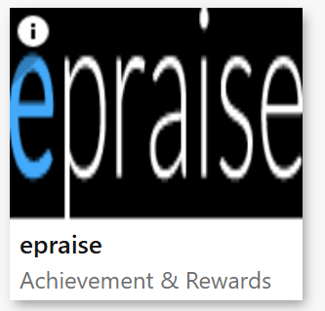
https://portal.office.com | http://www.epraise.co.uk
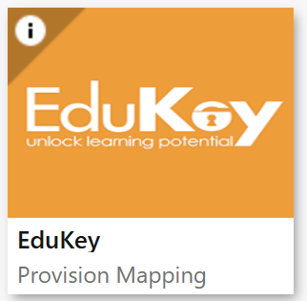 | 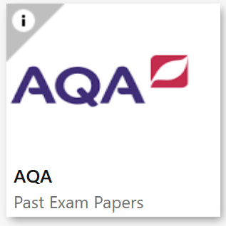
https://edukeyapp.com/account/login | https://www.aqa.org.uk/
 | 
https://www.sisraanalytics.co.uk/ | https://www.every.education
 | 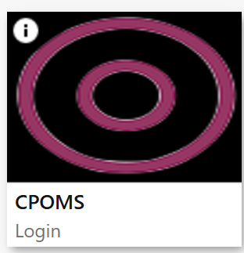
https://www.whysup.co.uk/login/ | https://apps.cpoms.net/studentsafe/dash
 | 
https://stjosephshorwich.schoolcloud.co.uk/Auth/Teacher | https://login.arbor.sc/
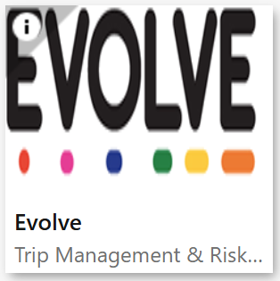 | 
https://evolve.edufocus.co.uk/evco10/evchome_public.asp?domain=boltonvisits.org.uk | https://nationalcollege.com/
 | 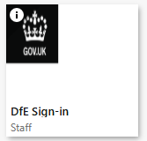
https://explore-education-statistics.service.gov.uk/find-statistics/pupil-attendance-in-schools/2025-week-29 | https://services.signin.education.gov.uk/

 | 
https://stjosephsbolton.org.uk/ | https://www.educationsupport.org.uk/
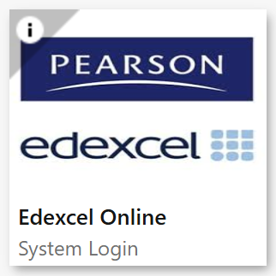 | 
https://iam.pearson.com/auth/XUI/?realm=/pearson#login/ | https://www.bekindtomymind.co.uk/
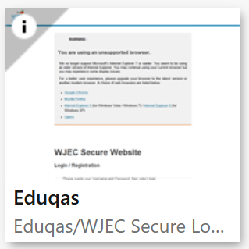 | 
https://portal.wjec.co.uk/ | https://www.ceopeducation.co.uk/
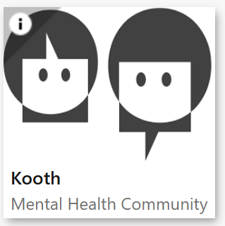 | 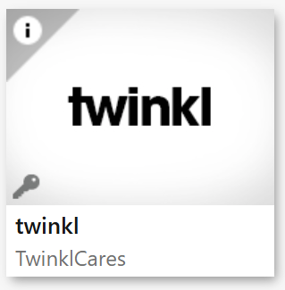
https://www.kooth.com/ | https://www.twinkl.com/
 | 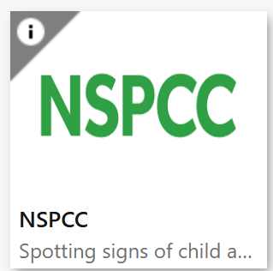
https://padlet.com/hannahdebacker1/ithrive-wider-community-offer-f6p473m6r85hw63h | https://www.nspcc.org.uk
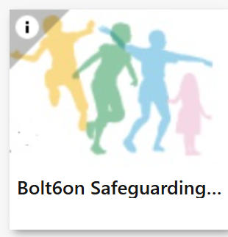 | 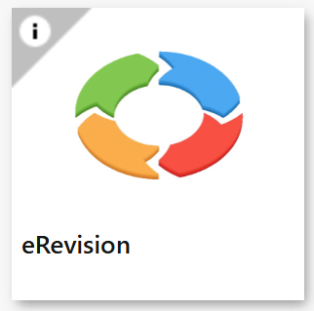
https://www.boltonsafeguardingchildren.org.uk/managing-allegations | https://www.erevision.uk/
Departmental resources

 | 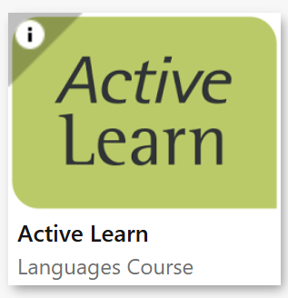
Https://senecalearning.com/en-GB/ | https://www.pearsonactivelearn.com/app/Home
 | 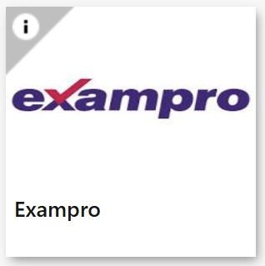
https://www.prodigygame.com/main-en | https://www.exampro.co.uk/
 | 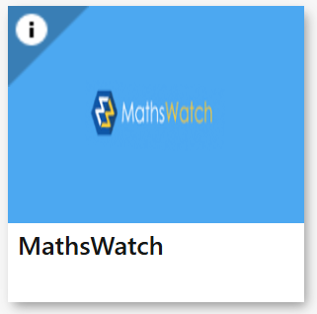
https://www.myjewishlearning.com/ | https://vle.mathswatch.co.uk/vle
 | 
https://idea.org.uk/ | https://uk.ixl.com/signin
 | 
https://www.onshape.com/en/ | https://www.unifrog.org/sign-in
 | 
https://edu.digitaltheatreplus.com/login?redirect=%2F | https://xello.world/en-gb/

