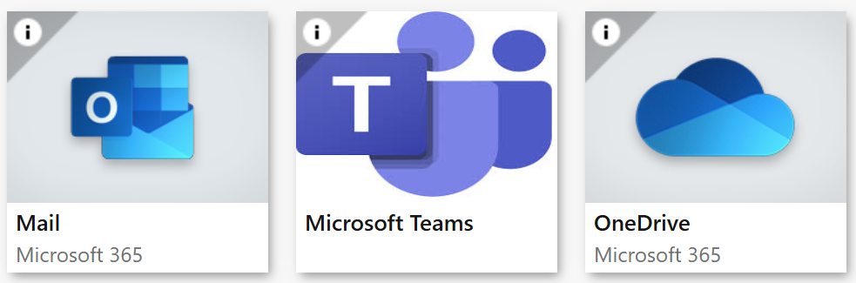 | 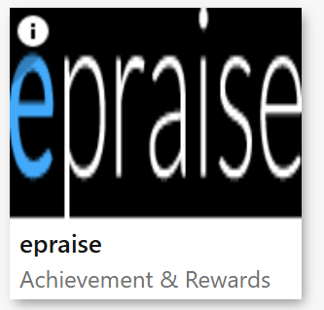
https://portal.office.com | http://www.epraise.co.uk
 | 
https://www.bbc.co.uk/bitesize/secondary | https://senecalearning.com/en-GB/
 | 
https://stjosephsbolton.org.uk/ | https://www.bekindtomymind.co.uk/
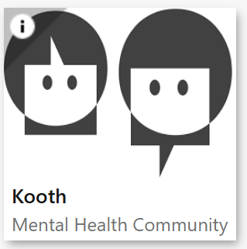 | 
https://www.kooth.com/ | https://www.ceopeducation.co.uk/

 | 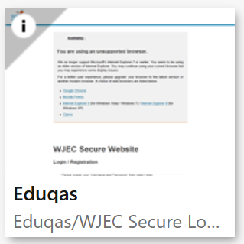
https://iam.pearson.com/auth/XUI/?realm=/pearson#login/ | https://portal.wjec.co.uk/
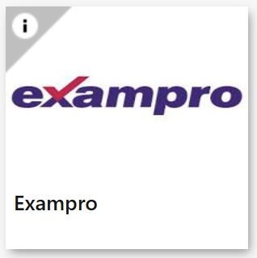 | 
https://www.exampro.co.uk/ | https://www.aqa.org.uk/find-past-papers-and-mark-schemes

 | 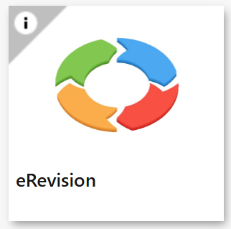
https://www.thenational.academy/ | https://www.erevision.uk/

 | 
https://vle.mathswatch.co.uk/vle/ | https://www.mathsbox.org.uk/
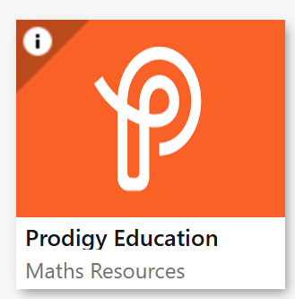 | 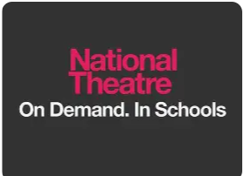
https://www.prodigygame.com/main-en | https://www.nationaltheatre.org.uk/learn-explore/schools/national-theatre-collection/
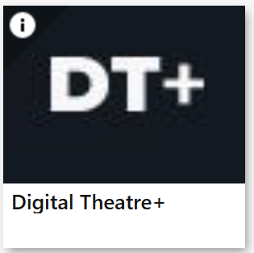 | 
https://edu.digitaltheatreplus.com/login?redirect=%2F | https://www.kerboodle.com/users/login
 | 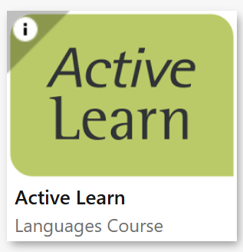
https://www.onshape.com/en/ | https://www.pearsonactivelearn.com/app/Home
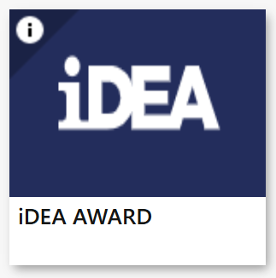 | 
https://idea.org.uk/ | https://uk.ixl.com/signin
 | 
https://www.unifrog.org/sign-in | https://xello.world/en-gb/

