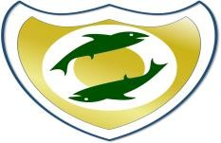
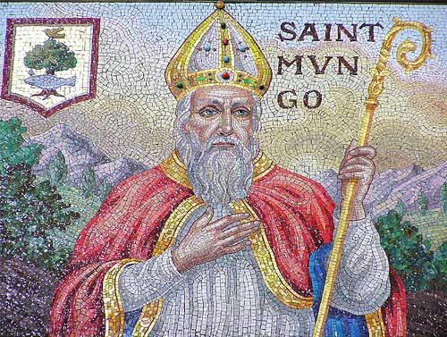
St Kentigern’s Catholic Primary School
Prayer Progression Map
Age Phase | Common Prayers Taught | Any Additional Prayers we have learnt
EYFS  Reception | - Know Sign of the Cross  - Know Hail Mary  - Recognise Our Father  - Grace before meals
KS1  Years 1 & 2 | All of the above plus:  - Our Father  - Glory Be
LKS2  Years 3 & 4 | All of the above plus:  - The Apostles' Creed  - An Act of Contrition  - Angel of God  - Come, Holy Spirit  - The Angelus (in May and October)  - Eternal Rest
UKS2  Years 5 & 6 | All of the above plus:  - Morning Offering  - The Rosary  - The Magnificat  - Act of Faith  - Act of Hope

