**It’s Paralympian Time**

**‘Set for Success’**

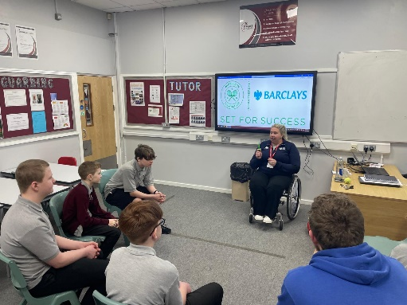

We had the pleasure of inviting ‘Louise’ to attend St Luke’s Academy. Louise is a Paralympic athlete who is a tennis super star and she works for the Youth Sports Trust on the ‘Set to Success’ programme. Her aim was to support our young people who could be at risk of ‘NEET – not in education, employment or training’.

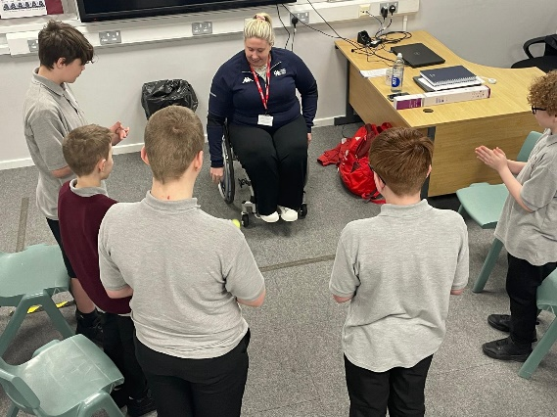

‘Set for Success’ supply targeted interventions that can help inspire students to be the best they can be.

We are extremely fortunate because Louise will be visiting our school frequently until the end of the year; she will be working with a small group of students on a project within the community.

So far, our students have really enjoyed the sessions; we hope that this continues throughout the rest of the year.

“It was really interesting learning about the importance of being in education”.