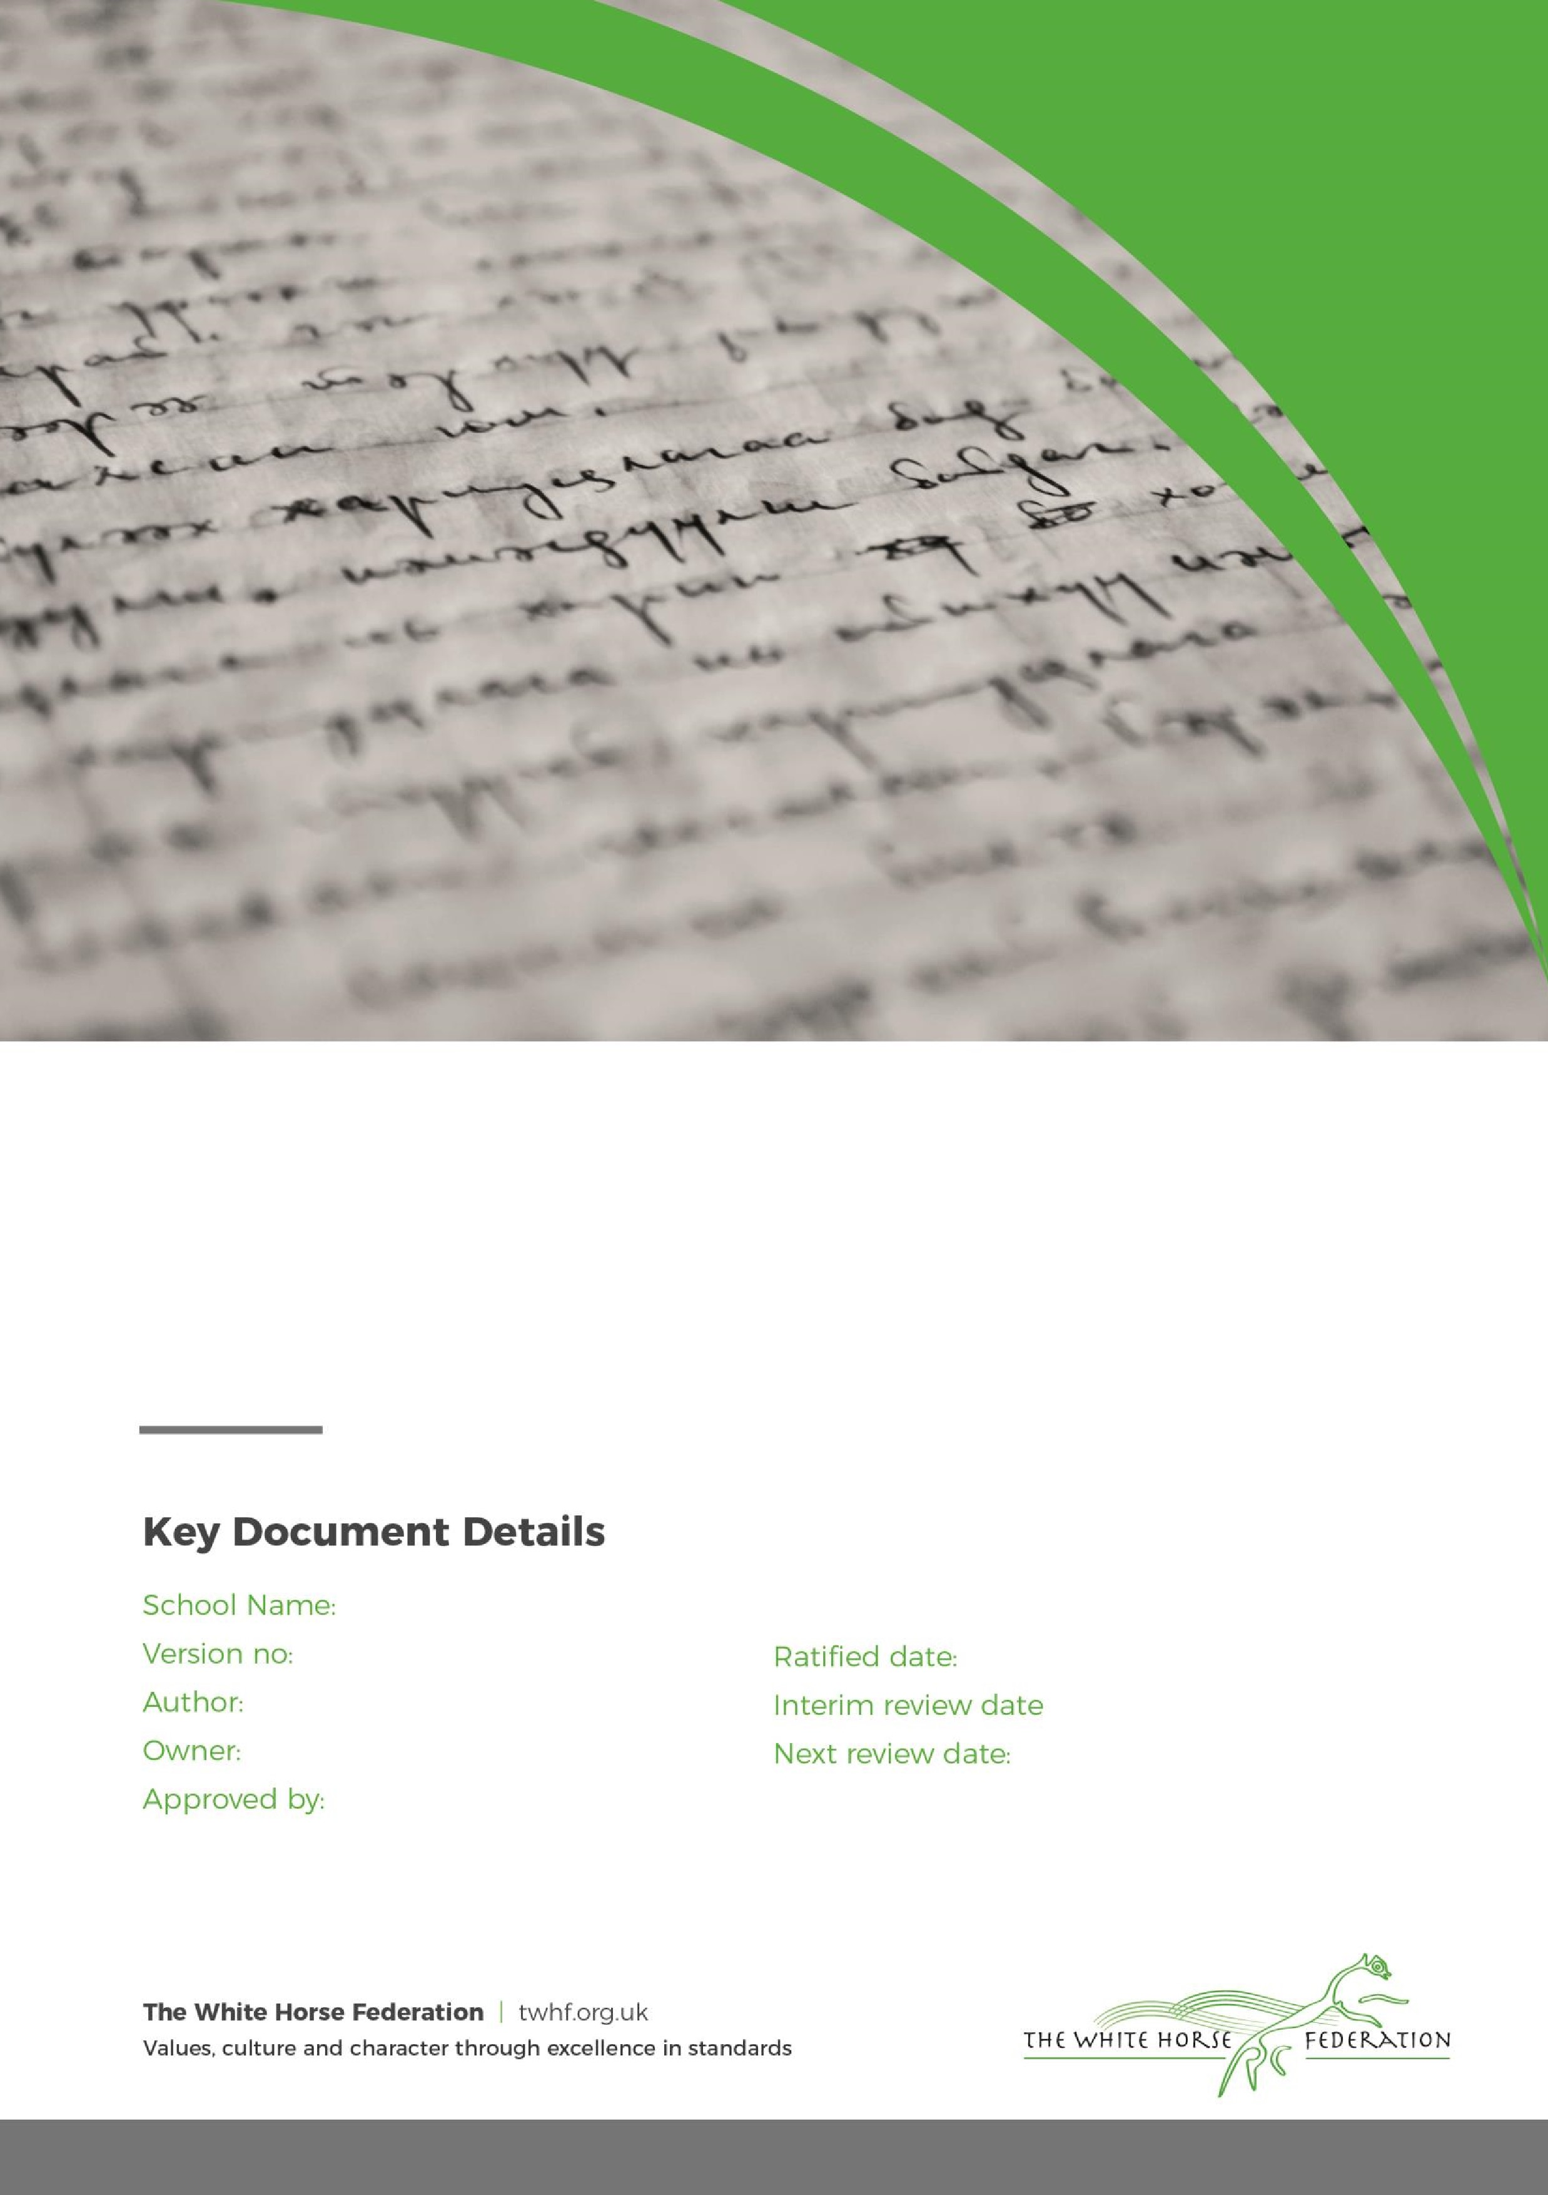
Reviewed September 2025

Special Education Needs (SEN)
Information Report

1

Tim James

Tim James

September 2024

September 2026

St. Luke’s Academy

Dear Parents and Carers,

The aim of this information report is to explain how we implement our SEND policy. In other words, we want to show you how SEND support works in our school.
If you want to know more about our arrangements for SEND, read our SEND policy.
You can find it on our website
Note: If there are any terms we’ve used in this information report that you’re unsure of, you can look them up in the Glossary at the end of the report.

1. What types of SEN does the school provide for?

Our school provides for students with the following needs:
Area of need | Condition
Primary need:
Social, emotional and mental health | Attention deficit hyperactive disorder (ADHD)
Social, emotional and mental health | Attention deficit disorder (ADD)
Secondary / Addition needs:
Communication and interaction | Autism spectrum disorder
Communication and interaction | Speech and language difficulties
Cognition and learning | Specific learning difficulties, including dyslexia, dyspraxia, dyscalculia
Cognition and learning | Moderate learning difficulties
Sensory and/or physical | Hearing impairments
Sensory and/or physical | Visual impairment
Sensory and/or physical | Physical impairment

2. Which staff will support my child, and what training have they had?
Our special educational needs co-ordinator, or SENCO
Our SENCO’s are Sara Lowndes (Key Stage 3) and Claire Shaw (Key Stage 4)
They are currently working towards the National Award in Special Educational Needs Co-ordination, and expect to be qualified by December 2026.

Class/subject teachers
All of our teachers receive in-house SEN training, and are supported by the SENCO to meet the needs of students who have SEN.
This covers a range of topic areas such as:
- Supporting students with ADHD and ASD
- Attachment
- Trauma and Resilience
- Adverse Childhood Experiences (ACE’s)
- Emotional Literacy
- Medical needs training
- Team Teach for physical interventions as required

Teaching assistants (TAs)
We have a team of five TAs who are trained to deliver SEN provision.
We have a member of staff who is trained to deliver ELSA interventions.

External agencies and experts
Sometimes we need extra help to offer our students the support that they need. Whenever necessary we will work with external support services to meet the needs of our students with SEN and to support their families. These include:
- Speech and language therapists
- Educational psychologists
- Occupational therapists
- GPs or paediatricians
- School nurses
- Child and adolescent mental health services (CAMHS)
- Education welfare officers
- Social services and other LA-provided support services
- Voluntary sector organisations

3. What should I do if I think my child has SEN?

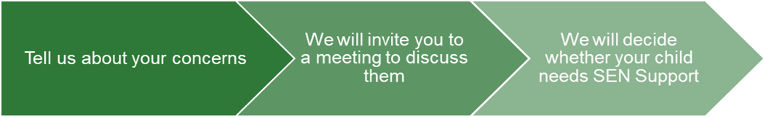
If you think your child might have SEN or require additional support for existing needs, the first person you should tell is your child’s teacher or tutor.  They will pass the message on to our SENCO, who will be in touch to discuss your concerns.  You can also contact the SENCO directly via telephone or email. | We will meet with you to discuss your concerns and try to get a better understanding of what your child’s strengths and difficulties are.  Together we will decide what outcomes to seek for your child and agree on next steps.  We will make a note of what’s been discussed and add this to your child’s record. You will also be given a copy of this. | If we decide that your child needs SEN support, we will formally notify you in writing and your child will be added to the school’s SEND register.

4. How will the school know if my child needs SEN support?

All our class teachers have a good understanding of SEN and are on the lookout for any students who aren’t making the expected level of progress in their schoolwork or socially. This might include reading, writing, processing information, interacting with others or regulating emotions. All teachers and support staff who work with the student will be made aware of their needs, the outcomes sought, the support provided, and any teaching strategies or approaches that are required. We will regularly review the effectiveness of the support and interventions and their impact on the student’s progress.

If the teacher notices that a student is falling behind, they try to find out if the student has any gaps in their learning. If the student is still struggling to make the expected progress, the teacher will talk to the SENCO, and will contact you to discuss the possibility that your child has an additional need or needs additional interventions to support their existing needs.
The SENCO will observe the student in the classroom and during social / unstructured times to see what their strengths and difficulties are. They will have discussions with your child’s teacher/s, to see if there have been any issues with, or changes in, their progress, attainment or behaviour. They will also compare your child's progress and development with their peers and available data.
The SENCO will ask for your opinion and speak to your child to get their input as well. They may also, where appropriate, ask for the opinion of external experts such as a speech and language therapist, an educational psychologist, or a paediatrician.
Based on all of this information, the SENCO will decide whether your child needs additional support.
If your child does need SEN support, their name will be added to the school’s SEN register, and the SENCO will work with you to create a SEN support plan for them.

5. How will the school measure my child’s progress?

We will follow the ‘graduated approach’ to meeting your child’s SEN needs. The graduated approach is a 4-part cycle of assess, plan, do, review. The Assess, Plan, Do, Review cycle is key to the graduated response to special educational needs laid out in the SEND Code of Practice 0-25 (2015): SEND_Code_of_Practice_January_2015,
Assess
If your child is not making the
expected level of progress, we will
make an assessment to find out what strengths and difficulties your child has. We will ask for you and your child’s input, as well as getting help from external professionals where necessary.
Review
We will assess how well the support we put in place helped the student to meet the outcomes we set. We will use our improved understanding of
your child’s needs to improve the support we offer.
Plan
In discussion with you and your child, we will decide what outcomes we are hoping to achieve. We will make a plan of the support we will offer your child to help them meet those outcomes. We will make a record of this and share it with you and all relevant school staff.
Do
We will put our plan into practice.
The class teacher, with the support of the SENCO, will be responsible for working with your child on a daily basis, and making sure the support we put in place is having the impact we intended.

As a part of the planning stage of the graduated approach, we will set outcomes that we want to see your child achieve.
Whenever we run an intervention with your child, we will assess them before the intervention begins. This is known as a ‘baseline assessment’. We do this so we can see how much impact the intervention has on your child’s progress.
We will track your child’s progress towards the outcomes we set over time and improve our offer as we learn what your child responds to best.
This process will be continual. If the review shows a student has made progress, they may no longer need the additional provision made through SEN support. For others, the cycle will continue and the school's targets, strategies and provisions will be revisited and refined.

6. How will I be involved in decisions made about my child’s education?

We will provide termly reports on your child's progress.
Your child’s class/form teacher will meet you 3 times a year, to:
- Set clear outcomes for your child’s progress
- Review progress towards those outcomes
- Discuss the support we will put in place to help your child make that progress
- Identify what we will do, what we will ask you to do, and what we will ask your child to do
The SENCO may also attend these meetings to provide extra support.
We know that you’re the expert when it comes to your child’s needs and aspirations. So, we want to make sure you have a full understanding of how we’re trying to meet your child’s needs, so that you can provide insight into what you think would work best for your child.
We also want to hear from you as much as possible so that we can build a better picture of how the SEN support we are providing is impacting your child outside of school.
If your child’s needs or aspirations change at any time, please let us know right away so we can keep our provision as relevant as possible.
After any discussion we will make a record of any outcomes, actions and support that have been agreed. This record will be shared with all relevant staff, and you will be given a copy.
If you have concerns that arise between these meetings, please contact your child’s class teacher or tutor.

7. How will my child be involved in decisions made about their education?

The level of involvement will depend on your child’s age, and level of competence. We recognise that no children are the same, so we will decide on a case-by-case basis, with your input.
We may seek your child’s views by asking them to:
- Attend meetings to discuss their progress and outcomes
- Prepare a presentation, written statement, video, drawing, etc.
- Discuss their views with a member of staff who can act as a representative during the meeting
- Complete a survey

8. How will the school adapt its teaching for my child?

Your child’s teachers are responsible and accountable for the progress and development of all the students in their class.
High-quality teaching is our first step in responding to your child’s needs. We will make sure that your child has access to a broad and balanced curriculum in every year they are at our school.
We will adapt how we teach to suit the way the student works best. There is no 'one size fits all’ approach to adapting the curriculum, we work on a case-by case basis to make sure the adaptations we make are meaningful to your child.
We make the following adaptations to ensure all students’ needs are met:
- A structured teaching approach which incorporates routines, structured tasks and rewards.
- Differentiating our curriculum to ensure all students are able to access learning, for example, by grouping, 1:1 work, teaching style, content of the lesson.
- Adapting our resources and staffing.
- Classes supported by a Teaching Assistant, and the pastoral team are trained to provide an additional level of intervention when required.
- Using recommended aids, such as laptops, coloured overlays, visual timetables, larger font.
- Differentiating our teaching, for example, giving longer processing times, pre-teaching of key vocabulary, reading instructions aloud.
- Specialist literacy programmes are used by all staff across all curriculum subjects to improve reading outcomes and vocabulary knowledge.

We may also provide the following interventions:
Area of need | Condition | How we support these students
Social, emotional and mental health | ADHD, ADD | Quiet workstation / support spaces  Nurture groups / pastoral support  BU Swindon  SMASH Youth Project  Mentoring services - BEST, iProvefit, Stride  CAMHS
Social, emotional and mental health | Adverse childhood experiences and/or mental health issues
Communication and interaction | Autism spectrum disorder | Visual timetables  ASD Advisory Service/ ARC
Communication and interaction | Speech and language difficulties | Speech and language therapy
Cognition and learning | Specific learning difficulties, including dyslexia, dyspraxia and dyscalculia | Writing slope  Assistive technologies  Educational Psychologists
Cognition and learning | Moderate learning difficulties
Sensory and/or physical | Hearing impairment | Assistive technologies  Hearing impairment advisory services
Sensory and/or physical | Visual impairment | Assistive technologies  Visual impairment advisory services  Limiting classroom displays
Sensory and/or physical | Physical impairment | Occupational Therapist
These interventions are part of our contribution to Swindon’s local offer.

9. How will the school evaluate whether the support in place is helping my child?

We will evaluate the effectiveness of provision for your child by:
- Reviewing their progress towards their goals each term
- Reviewing the impact of interventions regularly
- Using student questionnaires
- Monitoring by the SENCO
- Using provision maps to measure progress
- Holding an annual review (if they have an education, health and care (EHC) plan)

10. How will the school resources be secured for my child?

It may be that your child’s needs mean we need to secure:
- Extra equipment or facilities
- More teaching assistant hours
- Further training for our staff
- External specialist expertise
If that’s the case, we will consult with external agencies to get recommendations on what will best help your child access their learning. This will be done either on consultation before admission to school, or during annual or interim reviews of the EHCP.
The school will cover up to £10,000 of any necessary costs. If funding is needed beyond this, we will seek it from our local authority.

11. How will the school make sure my child is included in activities alongside students who don’t have SEND?

All of our extra-curricular activities, enrichment and school visits are available to all our students.
All students are encouraged to go on educational visits linked to specific subject learning, and organised trips and offsite activities to encourage social and emotional development. We will sometimes link with mainstream partner schools or the community to enhance or broaden the experience.
All students are encouraged to take part in sports days, workshops and other activities throughout the year.
No student is excluded from taking part in these activities because of their SEN or disability. Where required, steps are taken to accommodate the individual needs of a student based on their EHCP, or taking into consideration medical or accessibility needs.

12. How does the school make sure the admissions process is fair for students with SEN or a disability?

In the first instance a formal consultation is held between St Luke’s Academy and the placing Local Authority to review the Education, Health and Care Plan (EHCP) and determine if our setting can meet the needs of the young person. We will invite parents/carers, the young person and a Local Authority representative for a discussion to further identify the suitability of our setting in meeting the young person’s needs. These conversations will make sure that:
- Everyone develops a good understanding of the student’s areas of strength and difficulty.
- We take into account the parents’ concerns.
- Everyone understands the agreed outcomes sought for the child.
- Everyone is clear on what the next steps are.
Once a conclusion is reached, a follow-up letter is sent to the local authority informing them of our decision, and reasons why we either can or cannot meet the needs of the young person. Once this has been determined, the Academy utilises the following methods to build a picture of need to appropriately support the progress and wellbeing of each student:
- The Academy will liaise with schools and other professionals to build on their expertise and to transfer data and key information about new students to inform teaching.
- The Academy will undertake a range of baseline tests upon entry such as:
- Reading and Spelling ages.
- The Lucid Assessment to screen for specific needs in literacy.
- Cognitive Ability Tests – to assess overall ability, processing and problem-solving skills.
- EQ analysis to measure attitudes towards school and self.
- This will help The Academy to identify students who require additional support for pastoral and/or learning needs, students who may benefit from examination access arrangements, and more-able students.

13. How will the school support my child’s mental health and emotional and social development?
We provide support for students to progress in their emotional and social development in the following ways:
- Students are encouraged to be part of the school council
- Students are also encouraged to take part in enrichment clubs to promote teamwork and building friendships
- We provide extra pastoral support for listening to the views of students.
- We run additional interventions for students who need extra support with social or emotional development
- We have a ‘zero tolerance’ approach to bullying. We prevent bullying in the school by reporting all instances of bullying to the Pastoral Manager and investigating thoroughly. All types of bullying are discussed as part of the curriculum. Diversity, difference and respect for others is promoted and celebrated through various lessons and assemblies.

14. What support will be available for my child as they transition between classes or settings, or in preparing for adulthood?
Between years
To help students with SEND be prepared for a new school year we:
- Ask both the current teacher and the next year’s teacher to attend a meeting to discuss any handover of support.
- Schedule lessons with the incoming teacher towards the end of the summer term
Between schools
When your child is moving on from our school, we will ask you and your child what information you want us to share with the new setting.
Between phases
The SENCO of the primary school meets with our SENCO to discuss the needs of the incoming students near the end of the summer term.
We arrange meetings with the parents/carers of incoming students to discuss how we can best welcome their child into our community.
We set up new students with a buddy from the year above to help them get settled in and make friends.
Onto adulthood
We provide all our students with appropriate advice on paths into work or further education.
We work with the student to help them achieve their ambitions, which can include goals in higher education, employment, independent living and participation in society.

15. What support is in place for looked-after and previously looked-after children with SEN?

Sara Lowndes (designated teacher) will work with our SENCO to make sure that all teachers understand how a looked-after or previously looked-after student’s circumstances and their SEN might interact, and what the implications are for teaching and learning.
Children who are looked-after or previously looked-after will be supported much in the same way as any other child who has SEND. However, looked-after students will also have a personal education plan (PEP). We will make sure that the PEP and any SEN support plans or EHC plans are consistent and complement one another.

16. What should I do if I have a complaint about my child’s SEN support?

Complaints about SEN provision in our school should be made to the SENCO in the first instance. They will then be referred to the school’s complaints policy. The complaints policy can be found on the school website: Policies & Procedures | St Luke's Academy
If you are not satisfied with the school’s response, you can escalate the complaint. In some circumstances, this right also applies to the student themselves.

To see a full explanation of suitable avenues for complaint, see pages 246 and 247 of the SEN Code of Practice.
If you feel that our school discriminated against your child because of their SEND, you have the right to make a discrimination claim to the first-tier SEND tribunal. To find out how to make such a claim, you should visit: https://www.gov.uk/complain-about-school/disability-discrimination
You can make a claim about alleged discrimination regarding:
- Admission
- Exclusion
- Provision of education and associated services
- Making reasonable adjustments, including the provision of auxiliary aids and services
Before going to a SEND tribunal, you can go through processes called disagreement resolution or mediation, where you try to resolve your disagreement before it reaches the tribunal. Further information can be found on the Swindon local offer: Disagreement resolution, mediation and tribunal | Swindon Borough Council

17. What support is available for me and my family?

If you have questions about SEND, or are struggling to cope, please get in touch to let us know. We want to support you, your child and your family.
To see what support is available to you locally, have a look at Swindon’s local offer. Swindon Borough Council publishes information about the local offer on their website: SEND Local Offer | Swindon Borough Council
Our local special educational needs and disabilities information advice and support services (SENDIASS) organisations are: SIAS - Swindon SEND information, advice and support service | Swindon Borough Council
Local charities that offer information and support to families of children with SEND are:
STEP Swindon
Swindon Charity Ipsum - Swindon's Charity Hub
Youth Adventure Trust - Swindon's Charity Hub
Swindon Advocacy Movement - Swindon's Charity Hub
National charities that offer information and support to families of children with SEND are:
- IPSEA
- SEND family support
- NSPCC
- Family Action
- Special Needs Jungle

18. Glossary
- Access arrangements – special arrangements to allow students with SEND to access assessments or exams
- Annual review – an annual meeting to review the provision in a student’s EHC plan
- Area of need – the 4 areas of need describe different types of needs a student with SEND can have. The 4 areas are communication and interaction; cognition and learning; physical and/or sensory; and social, emotional and mental health needs.
- CAMHS – child and adolescent mental health services
- Adapt – when teachers adapt how they teach in response to a student’s needs
- EHC needs assessment – the needs assessment is the first step on the way to securing an EHC plan. The local authority will do an assessment to decide whether a child needs an EHC plan.
- EHC plan – an education, health and care plan is a legally-binding document that sets out a child’s needs and the provision that will be put in place to meet their needs.
- First-tier tribunal/SEND tribunal – a court where you can appeal against the local authority’s decisions about EHC needs assessments or plans and against discrimination by a school or local authority due to SEND
- Graduated approach – an approach to providing SEN support in which the school provides support in successive cycles of assessing the student’s needs, planning the provision, implementing the plan, and reviewing the impact of the action on the student
- Intervention – a short-term, targeted approach to teaching a student with a specific outcome in mind
- Local offer – information provided by the local authority which explains what services and support are on offer for students with SEN in the local area
- Outcome – target for improvement for students with SEND. These targets don't necessarily have to be related to academic attainment
- Reasonable adjustments – changes that the school must make to remove or reduce any disadvantages caused by a child’s disability
- SENCO – the special educational needs co-ordinator
- SEN – special educational needs
- SEND – special educational needs and disabilities
- SEND Code of Practice – the statutory guidance that schools must follow to support children with SEND
- SEN information report – a report that schools must publish on their website, that explains how the school supports students with SEN
- SEN support – special educational provision which meets the needs of students with SEN
- Transition – when a student moves between years, phases, schools or institutions or life stages

