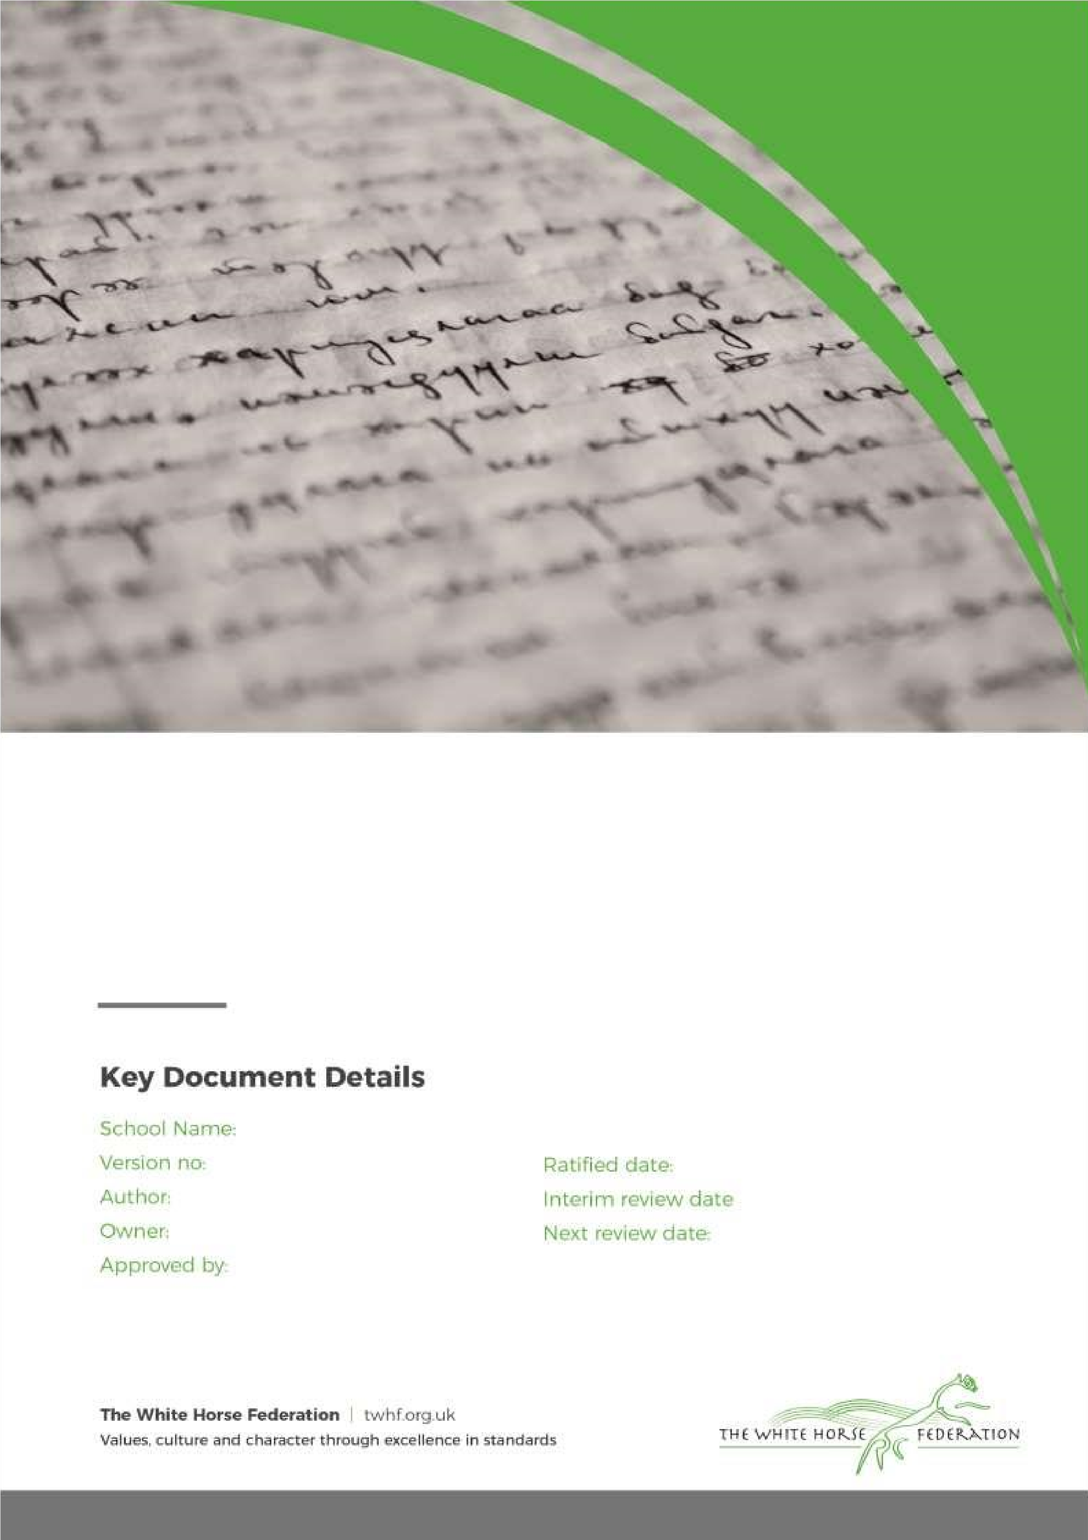

S
R
E

P
o
l
i
c
y

St. Luke’s
Academy

1

T Green

T Green

Principal/LGB

February 2025

n/a

September 2026

Contents

Statement of intent

- Legislation
- Organisation of the programme
- Key stage 1
- Key stage 2
- Key stage 3
- Key stage 4
- Training of staff
- Delivery of the programme
- Working with parents
- Equal opportunities
- Confidentiality
- Bullying incidents
- Monitoring and review Appendices
- Appendix 1 – Letter to parents/guardians
- Appendix 2 – Science national curriculum Statement of intent

At St. Luke’s Academy we understand the importance of educating pupils about sex and relationships, in order for pupils to make responsible and well-informed decisions in their lives.

The DfE’s guidance, ‘Sex and Relationship Education Guidance’, defines this programme as: “Learning about physical, moral and emotional development; understanding the importance of marriage for family life, stable and loving relationships, respect, love and care. It is also about the teaching of sex, sexuality and health.”
The programme will be taught objectively and does not intend to promote any form of sexual orientation.

Aims and objectives

The sex education and relationship programme is an opportunity for pupils to:
- Develop an understanding of sex, sexuality and relationships.
- Develop a range of appropriate personal skills.

The aims will be achieved through developing an understanding of:
- A range of values and moral issues including the importance of family life.
- The biological facts related to human growth and development, including reproduction.
- The importance of healthy relationships.

Legislation

1.1. This policy will be compliant with the following guidance:
- DfE ‘Sex and Relationship Education Guidance’ 2019
- DfE ‘Science programmes of study: key stages 1 and 2’ 2013
- DfE ‘Science programmes of study: key stage 3’ 2013
- DfE ‘Science programmes of study: key stage 4, ’ 2014

Organisation of the programme

2.1. The sex and relationship education programme will be developed in conjunction with the views of teachers, pupils and parents by the PSHE coordinator, in accordance with DfE recommendations.

2.2. The majority of the programme will be delivered through the personal, social, health and economic
(PSHE) education, with statutory aspects taught via the Community & Citizenship curriculum.

2.3. The sex and relationship education programme is divided into two key stages at secondary level, rather than by year group, in terms of what topics will be taught.

2.4. The sex and relationship education programme is flexible at secondary level, such that teachers can decide what they would like pupils to know by the end of each year within the key stages.

Key stage 3

3.1. Pupils in Years 7, 8 and 9 are taught:
- The detailed process of human reproduction, including the physical and emotional changes that take place during puberty and adolescence.
- About fertility, including the constant fertility of the male and the cyclical fertility of the female.
- The menstrual cycle, including the different stages, and the emotional changes it brings.
- About fertilisation and pregnancy and the different stages involved, including foetal development in the uterus.
- About sexually transmitted infections (STIs), including HIV and AIDS, and how they can be transmitted.
- The diagnosis of, and treatment for, different STIs.
- How high-risk behaviours affect the health and wellbeing of individuals, families and communities.
- About different methods of contraception and the importance of these in preventing STIs and pregnancy.
- How diet and disease may affect sexual health, pregnancy and fertility.
- How drugs, including tobacco and cannabis, may affect sexual health, pregnancy and fertility.
- The importance of the law in regards to the legal age for engaging in sexual activity, and the significance of consent.
- The importance of delaying sexual activity and resisting pressure, as well as how to discuss this with partners.
- About the features of positive and stable relationships, and the importance of these for bringing up children and family life.
- The importance of monogamous and consenting relationships and the effects on physical and emotional wellbeing.

- About different types of relationships such as same-sex and civil partnerships, including different choices relating to children.
- The breakdown of relationships and how to deal with loss, including the impact on emotional wellbeing.
- The roles and responsibilities of parents, carers and children within families.

Key stage 4

4.1. Pupils in Years 10 and 11 are taught:
- The way in which hormonal control occurs, including the effects of sex hormones.
- About medical hormones such as those relating to fertility.
- How sex is determined in humans.
- About the benefits and risks of lifestyle choices which may affect sexual health.
- About positive characteristics in relationships, and what relationships should offer.
- The importance of being aware of exploitation in relationships and how this is not normal behaviour in a loving relationship.
- The responsibilities of parenthood and the consequences of what pupils’ actions have on sexual activity and parenthood.
- About abortion and how this is dealt with by health professionals, as well as how to discuss this with parents and others.
- The use of medical hormones to control and promote fertility.
- The importance of the law in regards to the legal age for engaging in sexual activity, the significance of consent and the consequences for when the law is not complied with.
- About trans* individuals and acceptance in society.
- About the use of ‘sexting’ and the importance of being aware of what pupils post online.
- How the media portrays others with particular consideration to body image and self-esteem.
- About the use of pornography and how this creates distorted images of sex and relationships, as well as placing gender expectations on males and females.
- Where and how to obtain confidential advice, counselling and treatment.

Training of staff

5.1. All staff members at St. Luke’s Academy will undergo training on a regular basis to ensure they are up-to-date with the sex and relationship education programme.

5.2. Training of staff will also be scheduled around any updated guidance on the programme and any new
developments, such as ‘sexting’, which may need to be addressed in relation to the programme.

5.3. St. Luke’s Academy will ensure that teachers receive training on the Social Exclusion Report on Teenage Pregnancy, and the role of an effective sex and relationship education programme in reducing the number of teenage conceptions.

5.4. Trained staff will be able to give pupils advice on where and how to obtain confidential advice, counselling and treatment, as well as advice on emergency contraception and their effectiveness.

Delivery of the programme

6.1. Classes may be taught in gender-segregated groups dependent upon the nature of the topic being delivered at the time, and the cultural background of pupils where it is only appropriate to discuss the body in single gender groups.

6.2. Throughout every year group, appropriate diagrams, videos, books, games, discussion and practical activities will be used to assist learning.

6.3. Inappropriate images, videos, etc. will not be used, and resources will be selected with sensitivity given to the age and cultural background of pupils.

6.4. Pupils will be prevented from accessing inappropriate materials on the internet when using such to assist with their learning. The prevention measures taken to ensure this, are outlined in St. Luke’s
Academy’s E-safety Policy, and Acceptable Terms of Use Agreement.

6.5. Teachers will establish what is appropriate for one-to-one and whole-class settings, and alter their teaching of the programme accordingly.

6.6. Teachers will ensure that pupils’ views are listened to and will encourage them to ask questions and engage in discussion. Teachers will answer questions sensitively and honestly.

6.7. The programme will be designed as to focus on boys as much as girls and activities will be planned to ensure both are actively involved, matching their different learning styles.

6.8. Teachers will focus heavily on the importance of marriage and healthy relationships, though sensitivity will always be given as to not stigmatise pupils on the basis of their home circumstances.

6.9. St. Luke’s Academy understands that pupils with special education needs and disabilities (SEND) are entitled to learn about sex and relationship education, and the programme will be designed to be inclusive of all pupils.

6.10. Teachers will understand that they may need to be more explicit and adapt their planning of work in order to appropriately deliver the programme to pupils with SEND.

6.11. At all points of delivery of this programme, parents/carers will be consulted and their views will be valued. What will be taught and how, will be planned in conjunction with parents/carers.

6.12. External experts may be invited to assist from time-to-time with the delivery of the sex and relationship education programme, but will be expected to comply with the provisions of this policy.

Working with parents

7.1. The understands that the teaching of some aspects of the programme may be of concern to parents/carers.

7.2. St. Luke’s Academy will ensure that no teachers express their personal views or beliefs when delivering the programme.

7.3. Parents/carers will be regularly consulted on the content of the programme, through meetings and letters, and the programme will therefore be planned in conjunction with parents/carers.

7.4. St. Luke’s Academy respects that Parents have the right to request that their child be withdrawn from some or all of sex education delivered as part of statutory RSE. Before being granting this will need to be discussed with the Principal to clarify the nature and purpose of the curriculum.

7.5. A list of the statutory topics at the different key stages, can be found in Appendix 2.

Page 7 of 11

Equal opportunities

8.1. St. Luke’s Academy understands and abides by The Equality Act 2010, and fully respects the rights of pupils and staff members, regardless of any protected characteristics that he/she may have.

St. Luke’s Academy is dedicated to delivering the sex and relationship education programme with sensitivity and respect, avoiding any derogatory or prejudicial terms which may cause offence.

Confidentiality

9.1. Confidentiality within the classroom is an important component of sex and relationship education, and teachers are expected to respect the confidentiality of their pupils as far as is possible.

9.2. Teachers must, however, alert the Principal about any suspicions of inappropriate behaviour or
potential abuse as per St. Luke’s Academy’s Safeguarding Policy

Bullying incidents

10.1. St. Luke’s Academy has a zero tolerance approach to bullying. Any bullying incidents caused as a result of the sex and relationship education programme, such as those relating to sexual orientation, will be dealt with as seriously as other bullying incidents within St. Luke’s Academy.

10.2. Any occurrence of these incidents should be reported to a member of school staff, who will then discipline the pupil once he/she is on school premises.

10.3. These incidents will be dealt with following the process in our Anti-bullying and Hate Crime Policy. The Principal will decide whether it is appropriate to notify the police or an anti-social behaviour coordinator in their LA of the action taken against a pupil.

Monitoring and review

11.1. This policy will be reviewed by the Principal in conjunction with the PSHE coordinator on an annual basis.

11.2. Any changes needed to the policy, including changes to the programme, will be implemented by the
Principal.

11.3. Any changes to the policy will be clearly communicated to all members of staff involved in the sex and relationship education programme.

*

Appendix 1 – Letter to parents/carers

School name Address line one Address line two Address line three
Postcode

Dear Parent/carer,

RE: Sex and relationship education at St. Luke’s Academy

Government guidelines outline that, from the age of 11, it is compulsory for all schools to provide a sex and relationship education programme.

At St. Luke’s Academy we believe that it is important to provide our pupils with a thorough and balanced curriculum, including age-appropriate information about sex and relationships.

The details of what will be taught to the various year groups is detailed in St. Luke’s Academy’s Sex and Relationship Education Policy, which can be accessed on our school website, or in hard copy via our St.
Luke’s Academy office.

Though schools must provide sex and relationship education for pupils from the age of 11, up until the age of
19, only aspects of the science national curriculum are compulsory for pupils to learn. Therefore as parents/carers, you are entitled to request that your child be removed from sex and relationship education lessons.

Such requests should be submitted to myself, the Principal, who will discuss this with you and your child’s teacher and determine an appropriate substitute for these lessons. In most instances, children will be provided with self-directed reading or exercises which they can complete under the supervision of a trainee teacher.

If you have any concerns or queries about your child’s participation in these lessons, please do not hesitate to contact either myself or your child’s class teacher to discuss these.

Yours sincerely,

Principal

of 11

Appendix 2

In accordance with the DfE’s ‘Sex and Relationship Education Guidance’ 2000, there are certain aspects of sex and relationship education which are compulsory for pupils to learn as they progress through the key

stages.

Key Stage Pupils must be taught:
Key Stage 1 • That animals, including humans,
move, feed, grow, use their senses and reproduce.
- To recognise and compare the main external parts of the bodies of humans.
- That humans and animals can produce offspring, and they grow into adults.
- To recognise similarities and differences between themselves and others.
- To treat others with sensitivity.

Key Stage 2 • That nutrition, growth and
reproduction are common life
processes for humans and other animals.
- About the main stages of the human life cycle.

Key Stage 3 • That fertilisation in humans is the
fusion between the egg and sperm.
- About the physical and emotional changes that take place during adolescence. • How the foetus grows and develops.
- How the growth and reproduction of bacteria and viruses can affect health.


Key Stage 4 • The way in which hormonal control occurs, including the effectsof sex hormones. • The medical uses of some hormones, including the control of fertility.
- The defence mechanisms of the body.
- How sex is determined in humans.

of 11

