

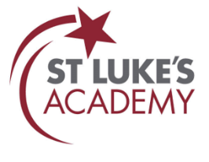
Christmas 2025 Newsletter

Principal’s Message
Well, it seems Term 1 and 2 have whizzed by faster than a rogue Christmas cracker, and suddenly the festive season is upon us! It’s been a wonderfully busy and fulfilling term — Year 11 mocks, interviews, college visits, guest speakers, celebration days, cinema trips… and that’s just the highlight reel. You’ll find all of this (and more!) tucked inside this newsletter, ready to be enjoyed!
As you will be aware, attendance continues to be a major focus for us all. Being in school every day is essential for giving pupils the very best chance to reach their full potential — academically, socially, and in terms of their wellbeing. We are pleased to have seen improvements this term, and with your support we know this will continue. Some simple things that can make a big difference include establishing a regular morning routine, booking appointments outside the school day where possible, and keeping open communication with us if challenges arise.
I would like to extend a heartfelt thank-you to our entire school community for your continued support. A special mention must go to our dedicated staff, whose hard work, humour, and unwavering commitment keep the school running seamlessly.
Finally, I wish you all a wonderful, restful Christmas break. Whether you are spending it travelling, celebrating, or simply enjoying some well-deserved downtime, I hope it brings plenty of joy (and perhaps a quiet moment or two!).
Merry Christmas and a Happy New Year. We look forward to seeing pupils back in school Tuesday the 6th of Janurary.
Mr T Green
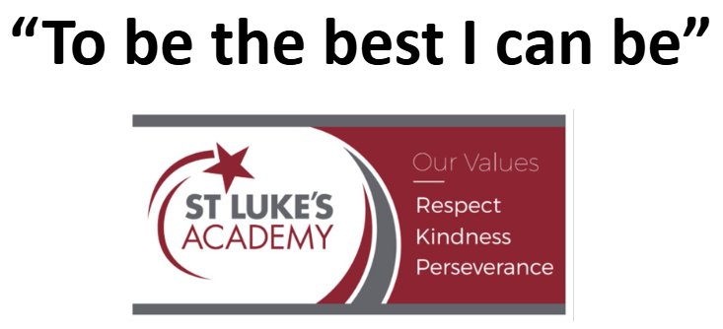
Associate Headteacher



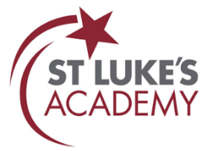

Safeguarding

Online safety:

Digital technologies have advanced more rapidly than any innovation in our history, and is now part of our everyday lives. However, as well as making education more accessible and lives more efficient, giving our young people access to such a vast pool of information can be problematic.

Below are some links to information, advice and guidance to support you in taking steps to ensure that your child’s digital world is being managed carefully. You can also find information on our school website under ‘about us’ – in the safeguarding and online safety sections.

SWGfL provides resources and information to parents and carers such as points to consider and useful links to help understand how to deal with online situations.

- swgfl.org.uk/resources/online-safety-guidance-for-parents/
- Online Safety Guidance for Parents | SWGfL

Parent Zone provides information and advice about the set up and safe use of devices such as gaming consoles, smartphones and tablets, smart watches, smart speakers and connected toys. They also provide guidance about monitoring and setting appropriate boundaries around screen use and screen time.

- https://parentzone.org.uk/article/digital-family-basics-setting-new-tech
- Parent Zone | At the heart of digital family life

Contacts:


If you have any safeguarding concerns during the holiday, please contact:

Monday 22nd – Tuesday 23rd December:
Mr T Green (Associate Principal & DSL)
tgreen@stlukes.swindon.sch.uk / 07719319491

Monday 29th December – Friday 2nd January:
Mr T Green (Associate Principal & DSL)
tgreen@stlukes.swindon.sch.uk / 07719319491

Alternatively, please contact:

Swindon Borough Council Children's Services – Contact Swindon:
contactschildrenandfamilies@swindon.gov.uk / 01793 464646
Office hours - 8.30am to 4.30pm
Out of hours: Contact Swindon Emergency Duty Service: 01793 436699

Police:
Non-emergencies: Call 101; Emergencies: Call 999


Latest news
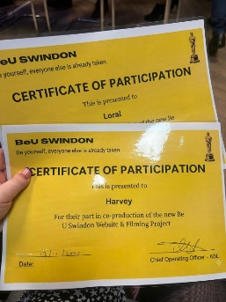
Hollywood Arrives in Swindon!
In July, Harvey and Miss Brodie participated in a filming event for BU Swindon, creating a short video that emphasises the importance of mental health for young people. This video celebrates the idea that being different is something to embrace.
In October, Harvey and Miss Brodie attended a Red-Carpet Celebration, honouring the young people involved in the project. The evening featured recognition, a panel discussion on SEMH (Social, Emotional, and Mental Health) needs, and insights on how schools and services can better support young people.
The key question raised was how to convey this vital message about mental health and self-acceptance to younger generations. It was an inspiring night of celebration, education, and meaningful conversation, highlighting an important cause!

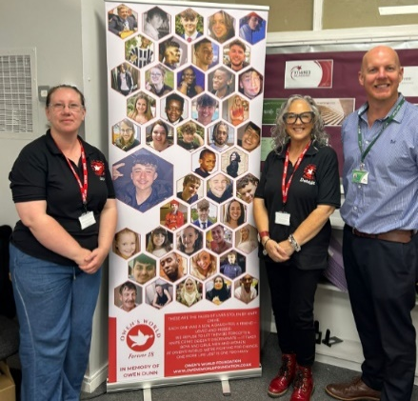
St Luke’s Academy welcomed Owen’s World to deliver a powerful series of knife crime intervention workshops, part of our wider safeguarding and community outreach strategy. These sessions were honest and hard-hitting, designed to open eyes, spark dialogue, and ultimately change lives.
Focusing on early prevention and behaviour change, the workshops addressed key issues surrounding knife-related crime, equipping our pupils with the tools to make safer choices. Through real-life stories, group discussions, and interactive activities, pupils engaged with challenging topics, demonstrating maturity and empathy.
Mr Green, Associate Principal, expressed pride in our pupils’ thoughtful participation, proving that even the hardest topics can lead to essential learning. A huge thank you to Owen’s World for their impactful intervention!

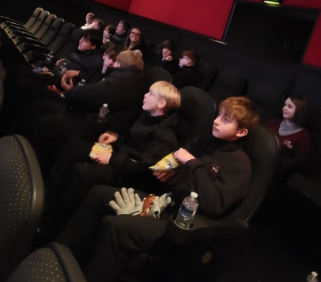
We are thrilled to share that our Years 7 to 11 pupils had a fantastic outing to the Vue cinema, thanks to the wonderful partnership with Into Film. The pupils enjoyed a delightful screening of Zootropolis 2, immersing themselves in the vibrant world of animation and adventure. This trip not only provided a fun break from the classroom but also sparked engaging discussions about themes of friendship and teamwork. A big thank you to all the staff who made this experience possible! We look forward to more exciting events in the future.


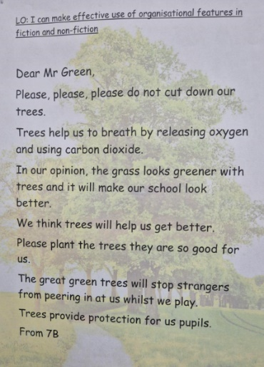
KS3 English
Year 7 pupils have been working hard on closing their gaps in reading, comprehension and writing. During Term 1 they learnt about resilience through reading and exploring various texts. This term we are working on curiosity. What makes people want to know about things, go exploring, and take risks.
Year 8 have excelled this term in exploring a child’s voice during conflict in the book ‘Once’. This book is about a Jewish 10-year-old caught up in Poland during WWII. This scheme has allowed the pupils to be inquisitive, delve deeper and explore how a child’s mind would think, react and speak about war.
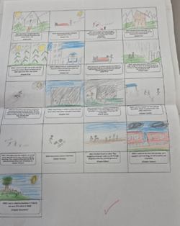
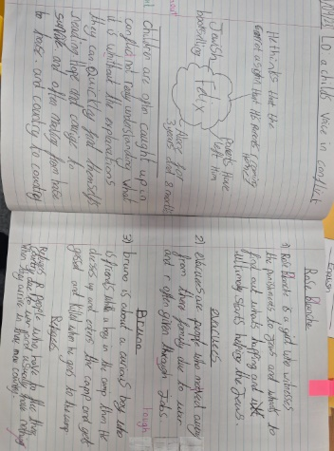
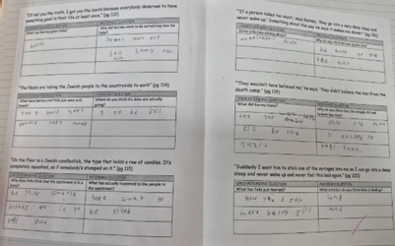



KS4 English
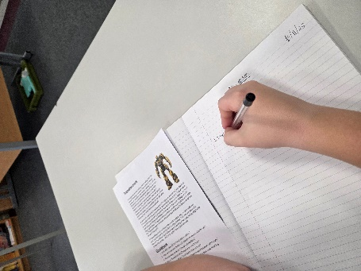
As we reflect on the first two terms of Key Stage 4 English, it’s wonderful to celebrate the achievements of our pupils across all year groups.
Year 11 has shown remarkable dedication as they prepared for and successfully completed their mock exams. Their hard work and commitment are commendable, setting a strong foundation for their upcoming assessments.
In Year 10, pupils embarked on an exciting journey exploring the Voices of Diversity. Their engagement with this topic has led to significant progression, and it’s heartening to see their understanding deepen. Additionally, they tackled their Entry Level 3 mock exams with enthusiasm, showcasing their developing skills.
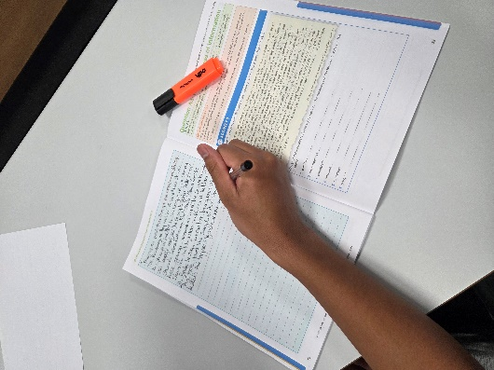
Year 9 pupils delved into the theme of Voices in Protest, producing some truly detailed and thought-provoking work. Their exploration of this topic has not only enhanced their analytical skills but also boosted their confidence in reading for meaning.

Overall, the first two terms have been filled with positivity and progress, and I look forward to seeing what the next terms will bring!


KS3 Mathematics
During Terms 1 and 2, pupils have worked on key KS3 Maths topics including multiples, fractions, types of numbers, mensuration, angles and constructions. They developed number fluency through work on multiples, factors and different types of numbers, and improved their confidence with fractions by simplifying, comparing and calculating with them. In geometry, pupils explored mensuration by calculating perimeter, area and volume, and strengthened their reasoning using angle rules to solve problems. Within constructions, they focused specifically on loci, learning how to use a compass and ruler to create paths and regions that satisfy given conditions, such as points equidistant from a line or a fixed point. Overall, these topics have provided a strong foundation in both number and geometry.


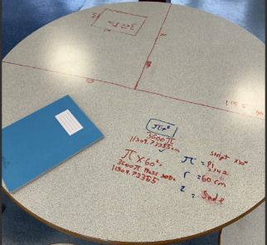
KS4 Mathematics
We would like to extend our heartfelt congratulations to Year 11 for their outstanding performance during the recent GCSE Mock exam series. Their hard work and dedication have truly paid off, and we are proud of their achievements. The hard work still remains as we enter into the final stages of their educational journey.
Across all year groups, we have witnessed positive engagement with some challenging topics, particularly in our focus on Geometry, which included Circles, Angles, and Area, as well as Perimeter and Volume. The enthusiasm shown by pupils in tackling these concepts is commendable and reflects their commitment to mastering the curriculum.
Additionally, we are pleased to announce the successful introduction of Functional Skills within Year 10. Our aim is to ensure that all Year 10 pupils achieve their Functional Skills qualification by the end of Term 3. This initiative is designed to enhance their practical skills and prepare them for future academic and vocational opportunities.
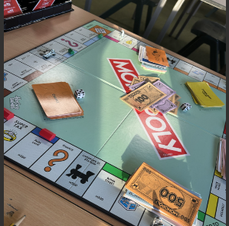
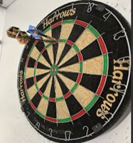
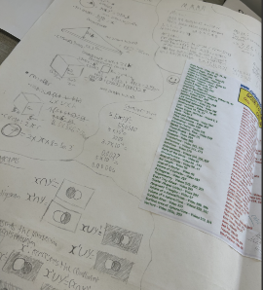




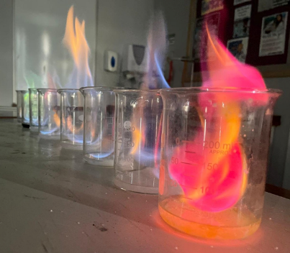
Science
We are delighted to share some exciting updates from our science department! Our youngest pupils have settled into the lab wonderfully, and their enthusiasm has been infectious. Recently, they earned their “Bunsen burner” licenses, a milestone that has sparked a new level of excitement in their experiments. It’s heart-warming to see them demonstrate such great teamwork, helping one another as they explore the fascinating world of science together.
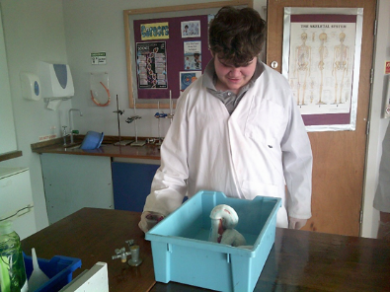
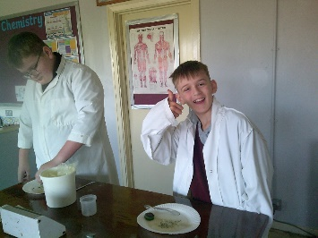
In Years 8 and 9, pupils are building upon their earlier learning with impressive confidence. They are becoming adept at using lab equipment and can explain its purpose with clarity. This growing self-assurance is a joy to witness, as they engage more deeply with the subject matter.
Our older pupils are also making remarkable strides. They are showing increasing independence and confidence in making their own choices to complete their BTEC units. This ability to take ownership of their learning is a testament to their hard work and dedication. We look forward to seeing how all our pupils continue to grow and thrive in their scientific journeys!

Art
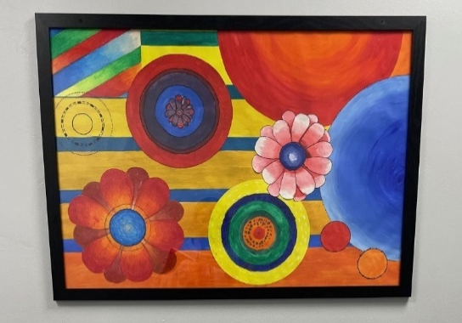
Pupils across the school have been exploring the formal elements of art, such as year 7 exploring colour and using acrylic paint to produce these fantastic colour wheels. In year 8 and 9 the pupils have used the grid method to aid their freehand drawing skill. This has been really successful in helping pupils produce accurate, thoughtful pieces while studying other artists.
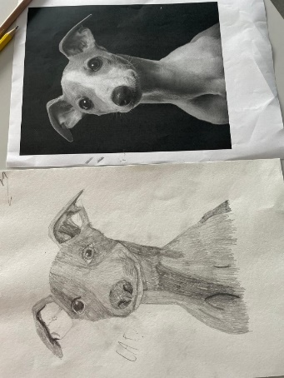
Year 10 pupils have made a fabulous start to their GCSE coursework producing some great pieces based around food and animals. Many pupils have been experimenting with different media such as watercolour paint, coloured pencil, acrylic paint and mixed media. Through GCSE pupils also research other artists as seen in the Louise McNaught and Abby Diamond pieces by a year 10 pupils.
Year 11 pupils continue to impress with their coursework. This dog shows some fab tonal pencil skills.
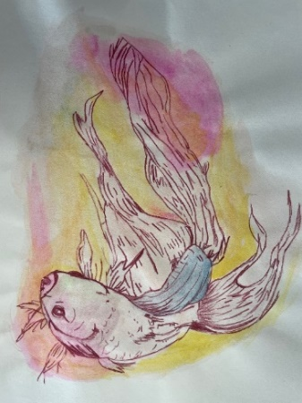
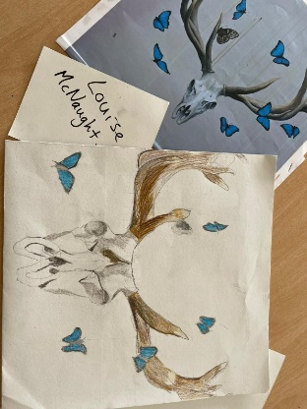
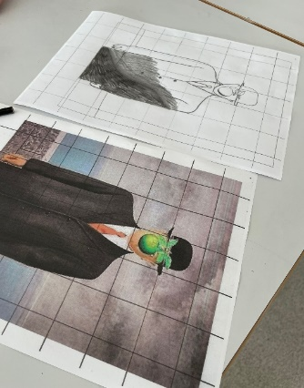
We have also been working collaboratively in the art department with various pupils having an input on large scale display pieces for different areas of the school. These have very different styles but show great use of colour, tone and mark making. Great teamwork artists!


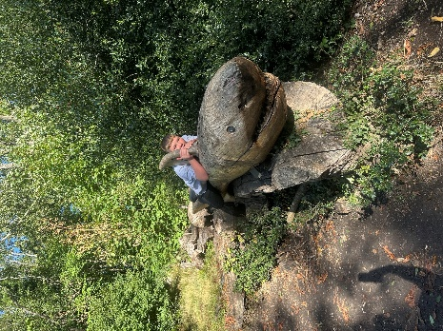
Outdoor Education
This year, our Outdoor Education pupils have excelled in map reading and navigation. The curriculum combines traditional methods with digital tools, equipping them for real-world applications. Pupils focused on interpreting maps, identifying features, understanding scale, and using symbols, which enhanced their spatial awareness and critical thinking. We emphasised online map reading with platforms like Google Maps, expanding their digital navigation skills. They learned to search for locations, calculate distances, and plan routes, crucial in today's tech-driven world. The introduction of GPS technology further enriched their experience. Through practical exercises, pupils became skilled in using GPS devices to navigate unfamiliar terrains, boosting their technical abilities and confidence.
This progress was evident during our recent school expedition, where pupils showcased their skills in practical challenges. Their proficiency in reading maps, using GPS, and adapting to various tools demonstrated their dedication. The advancements in map reading, online navigation, and GPS technology reflect our pupils' commitment to learning and enthusiasm for essential life skills.
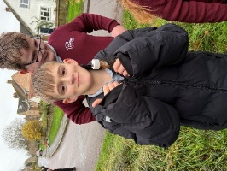
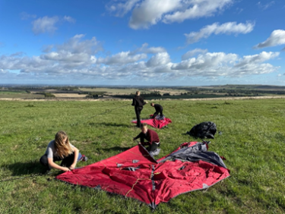
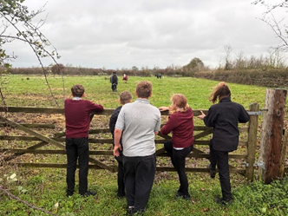

DT
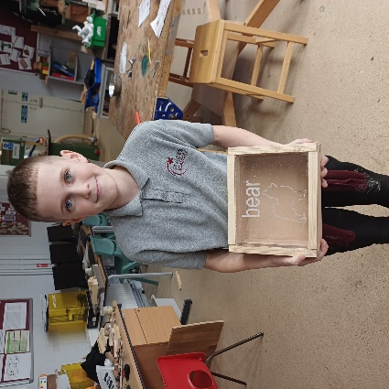
As we reflect on our DT journey so far this year, it’s wonderful to see how our pupils have developed their skills and creativity! In Key Stage 3, learners have been improving their hand skills and the quality of their work, tackling increasingly complex projects. From crafting intricate wooden puzzles to designing exciting marble runs and creating beautiful jewellery boxes, the progress has been remarkable.
Moving into Key Stage 4, we’re thrilled to introduce a new qualification in painting and decorating. Pupils are learning essential techniques, including wall preparation, selecting the right tools and materials, and finishing their projects to a high standard. It’s inspiring to witness their dedication and enthusiasm as they bring their ideas to life. We look forward to seeing even more fantastic creations as the year unfolds!
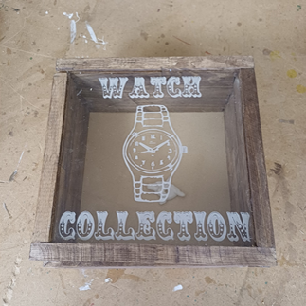
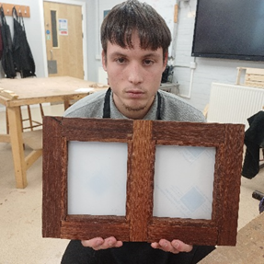
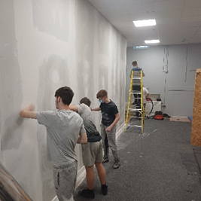


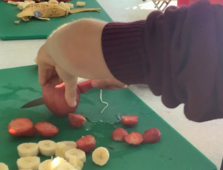
Food Technology
We are thrilled to share the latest happenings in our Food Technology department, where pupils are making incredible strides in their culinary skills!
Year 7 has been busy developing core skill techniques, and it’s wonderful to see them applying these skills in practical sessions. Their enthusiasm for cooking is truly infectious! In Year 8, pupils are diving deep into the world of nutrients, using their knowledge to enhance their theory work. They are learning how to make informed choices about food, which is vital for their health and well-being.
Year 9 pupils benefit from double lessons, allowing them more time to adapt their knowledge and meet the criteria in preparation for their KS4 options. This extended time is fostering a deeper understanding of the subject. As we look ahead to Year 10, pupils are gearing up to take their Level 2 Food Hygiene Certification after Christmas. They are building essential knowledge that will serve them well in their culinary journeys.
Finally, our Year 11 pupils are shining as they apply better time management skills in their practical’s. They are rising to the challenge and creating some fabulous Michelin star meals under pressure!

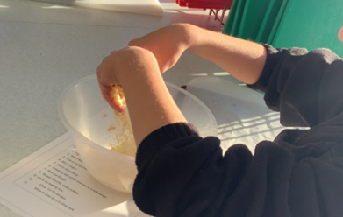
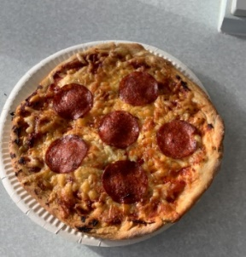
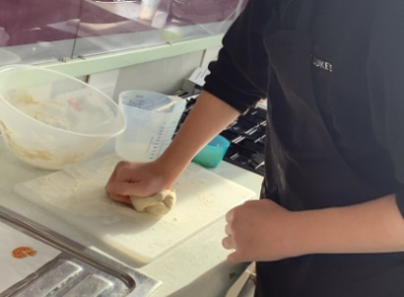

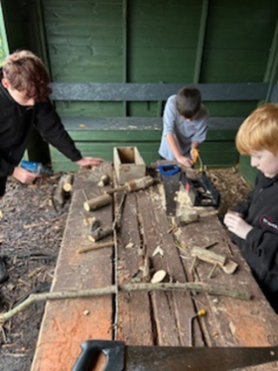
Forest School
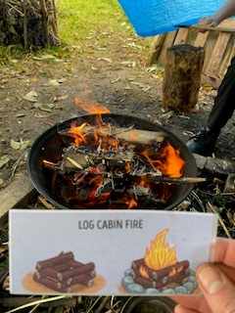
As we approach the end of Term 2, we have some exciting updates to share from our forest school community! 7B pupils have been fantastic when exploring fire-starting methods. They have shown great enthusiasm and perseverance with Ferro rods, which can be tricky when starting out. Meanwhile, our Year 9 pupils have been enjoying delightful outdoor food experiences. They have been experimenting with various recipes, enhancing their culinary skills while appreciating the beauty of nature around them. The bread making session in particular went down well, with the pupils very keen to improve their recipes. As we look forward to the festive season, we are working on some beautiful Christmas decorations to finish off the term. This term year 8’s have been working particularly well on candles for themselves and the Christmas market.
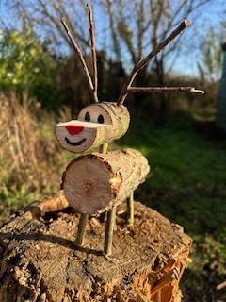
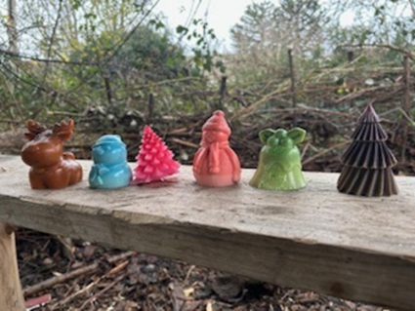
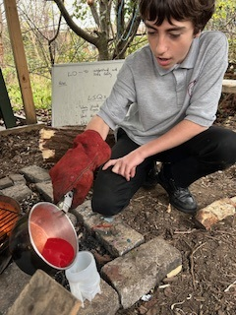

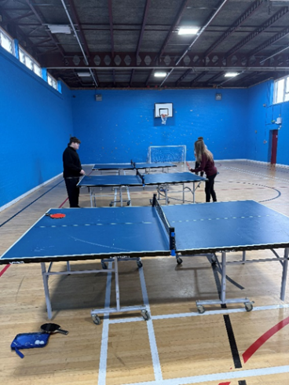
Sport

This term, our pupils have done really well in Physical Education, especially in invasion games. Their engagement in matched play has showcased their understanding of the rules and teamwork. Their enthusiasm and effort have been commendable. A notable achievement is their improvement in hand-eye coordination and control. Whether dribbling a football or using a table tennis ball, pupils have demonstrated significant progress, reflecting their commitment to personal growth. Sportsmanship has also shone through, with pupils consistently supporting one another, celebrating successes, and encouraging peers during challenges. This positive attitude enhances their experience and fosters a sense of community.

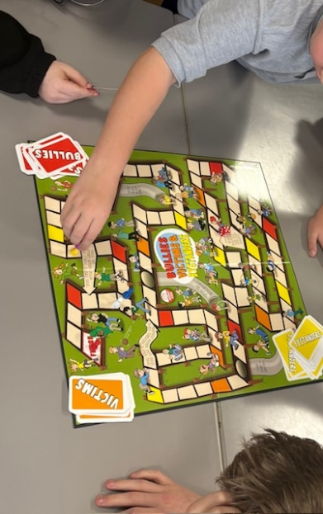

PHSE
So far, this year has been a focus on pupils discovering who they are and who they want to become. We have seen achievements as pupils begin to shape their own identities with confidence. One key topic which has been a focus in Term 2 included anti-bullying in collaboration with anti- bullying week. Pupils completed a range of tasks looking at kindness and supporting one another. Through PSHE, our pupils are developing a strong sense of self-awareness. They are recognising their strengths and talents and what makes them unique.
Equally inspiring is the way our pupils are embracing diversity and respect. They are learning to value different perspectives and cultures, showing empathy and kindness towards others. Within learning about identity pupils have developed recognition in their changes. Adolescence is a time of change, and our pupils are exploring their values, experimenting with new roles, and finding their voices. PSHE provides a safe and supportive environment for this journey, encouraging them to celebrate individuality while learning the importance of collaboration and respect.
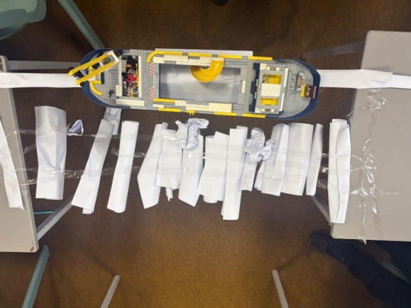
Emotional Intelligence
KS3 pupils have been learning all about self-esteem. They have been looking at how low self-esteem and high self-esteem including anxious, sad, confident and happy can affect their feelings. They have worked well together reframing negative self-talk, such as ‘I can’t do this’ to ‘I can try and do this’.


The pupils have also learnt that their strengths are positive qualities they own and they have more resilience than they thought. The pupils had a resilience challenge by building a bridge made out of paper. They encountered setbacks but overcome these challenges by communicating and working as a team.


Childcare
In Childcare, we have been working on the unit which looks at our values, skills and abilities. Pupils have succeeded in completing this; they needed to create a chart of their skills and how this will impact them in the future and support them with future work. We have practiced interview skills for future careers which pupils achieved very well and tried hard. Pupils have also managed to have excellent discussions around our forest school unit which they completed, Pupils were required to think about how forest school can improve school for younger children and have a positive effect on their school.

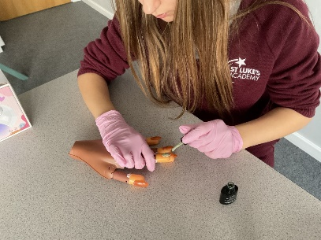
Hair and Beauty
This term, Pupils have been finishing their nail assessments, taking the skills, they have learnt and applying this to their final projects. They carried out a role play consolation where they asked questions to staff as if it was a real appointment. In the assessment, they had to create and design a nail set that they would then create on their models and show it step by step.

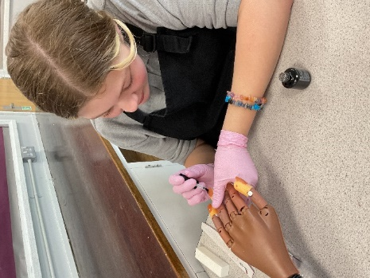
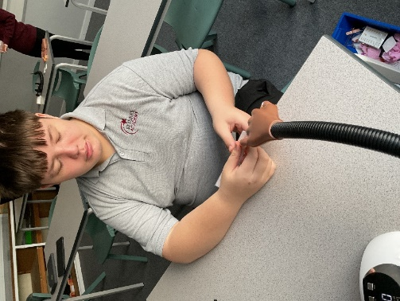
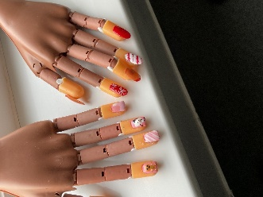


BU Swindon

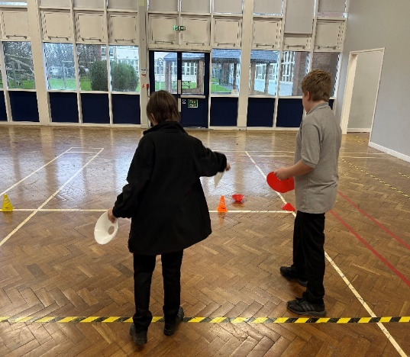
BeU Swindon is a fantastic mental health and wellbeing service dedicated to children, young people, and families in our community. Every week, they visit St Luke’s Academy to provide engaging group interventions for our Year 7 pupils. Through teamwork, games, sport, and art, BeU supports pupils facing health concerns such as anxiety, low mood, and emotional regulation. This innovative approach embeds the mental health team directly within the school, effectively removing barriers like waiting lists and travel difficulties. The focus is on early intervention and prevention, ensuring accessible mental health support for children and young people, as well as their families and carers. The pupils have shown remarkable engagement during these sessions, benefiting greatly from the support provided. It’s heartening to see our young people thrive in a nurturing environment, equipped to tackle their challenges head-on.

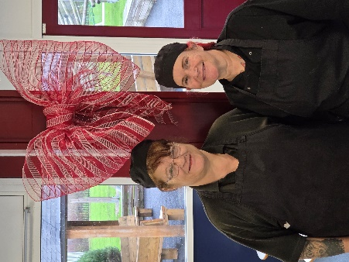
Christmas Cooking Hacks from Pixie and Alison!
- Make a list! Then prepare as much as you can in advance. Braised Red cabbage can be made ahead of time in a slow cooker and it freezes really well!
- Roast potatoes can be par boiled for 5 minutes (longer if using big potatoes). Leave to cool fully, give a good shake to fluff the sides up and add some flour to coat them in a light dusting. These can be frozen and cooked from frozen. Make sure to have the fat nice and hot in the oven trays before adding them.
- For non-Brussel sprout fans, try the recipe included. It’s a gam changer!
- If you are tight for space in the oven, once your turkey is cooked it can be removed from the oven to rest, cover in foil and keep the heat in by wrapping the tray in a couple of large towels, it will keep it hot enough for an hour, giving you room to cook your potatoes!
TRADITIONAL BRAISED RED CABBAGE WITH APPLES
Equipment:  A large casserole with a tight-fitting lid | Additional:  Pre-heat oven to gas mark 2, 300F  Serves 10-12
  Ingredients:  2lb red cabbage  1lb onions  1lb cooking apples, peeled, cored and shopped  1 clove garlic, chopped very small  ¼ whole nutmeg, freshly grated  ¼ level teaspoon of ground cinnamon  ¼ level teaspoon ground cloves  3 level teaspoons brown sugar  3 tablespoons wine vinegar  ½ oz butter | Method:  First discard the tough outer leaves of the cabbage, cut it into quarters and remove the hard stalk.  Shred the rest of the cabbage finely, using your sharpest (although you can shred it in a food processor. Next in a fairly large casserole, arrange a layer of shredded cabbage seasoned with salt and pepper, then a layer of chopped onions and apples with a sprinkling of garlic, spices and sugar. Continue with these alternate layers until everything is in. Now pour in the wine vinegar, lastly add dots of butter on the top.  Put a tight lid on the casserole and let it cook very slowly in the oven for 2-2 ½ hours. Stirring everything around once or twice during the cooking. Red cabbage once cooked, will keep warm without coming to any harm, and it will also re-heat very successfully.



BRILLIANT BRUSSELS
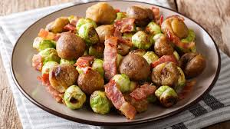  Ingredients:  1 onion  10g bunch of fresh thyme  3 rashers of higher welfare smoked streaky bacon  olive oil  1009 vac-packed chestnuts roasted and peeled (shelled weight)  500g Brussels sprouts  2 large knobs f unsalted butter  table spoon double cream  salt and pepper | Method:  Peel and chop the onions, then pick and finely chop the thyme leaves.  Place a large pan on a high heat to get nice and hot. Slice the bacon into chunky strips and put in the pan with a drizzle of oil, then immediately turn the heat down to medium. Fry for a few minutes, or until lightly golden, then crumble in the chestnuts.  Fry for about 5 minutes, or until deep golden, then add the onions and sage. Turn the heat down to low and cook slowly for about 30 minutes, stirring occasionally.  Meanwhile, trim the Brussels and peel away any tatty outer leaves, halving and larger ones through the core and keep the smaller one’s whole.  Place the Brussels in a large saucepan over a high heat for a couple of minutes, then, once the pan is nice and hot, cover with boiling salted water.  Boil for 5 minutes, or until just tender but with a little bite. Taste to check – they should be slightly undercooked.  Drain the Brussels, then stir through the chestnut mixture, scraping up any lovely sticky bits from the bottom of the pan.  Add the butter and season to perfection, then serve right away, or cover and store in the fridge, reheating in the pan when needed.

We hope that you have enjoyed reading our newsletter.
There is so much more we could have included, but we think that this gives you a flavour of our amazing school!
From all of us at St. Luke’s,
We wish you a very Happy Christmas!
See you on Tuesday the 6th of January 2026.

