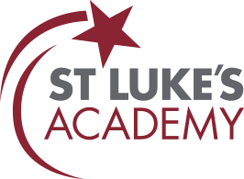


Easter 2026 Newsletter


Principal’s Message
Wow—where has this term gone? It feels like only yesterday we were welcoming everyone back, and now we have a newsletter full of achievements to share.
Attendance continues to be a key focus at St Luke’s Academy, and I am pleased to report that overall attendance is improving, with more pupils achieving 100% attendance. Thank you for your continued support with this—regular attendance really does make a difference to pupils’ learning, confidence and future opportunities. If you have any concerns or need support, please do contact your son or daughter’s tutor.

As the weather begins to improve (slowly but surely!), pupils have enjoyed a range of trips and visits, including the cinema, a Bristol City Football Club match, football tournaments, golf lessons, college visits, Cardo Construction and even a challenge at Ninja Warrior. These experiences are a fantastic way to build confidence, develop social skills and broaden pupils’ understanding of the world around them.
We have also marked a number of important events this term, including Children’s Mental Health Week, Holocaust Memorial Day and Red Nose Day—helping pupils develop awareness, empathy and understanding.
Our Year 11 pupils continue to work incredibly hard towards their qualifications, including Functional Skills, BTECs, NCFEs and GCSEs. The whole school wishes them the very best as the GCSE exam season begins early next term.
I also want to offer my sincere thanks go to our staff for their energy, commitment and determination to provide the very best opportunities for our pupils.
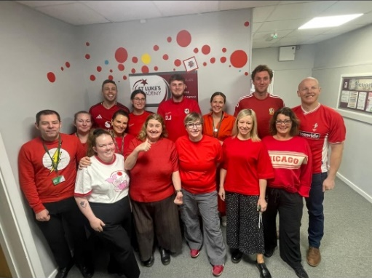
Lastly, I must wish you all a restful Easter break and look forward to welcoming everyone back on Monday 13th April.
Mr T Green
Associate Principal

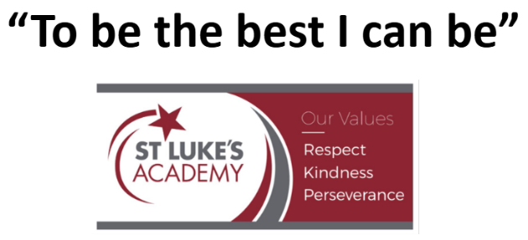

On the 20th of March, staff at St. Luke’s proudly participated in Comic Relief, teaching our pupils the importance of being good local and global citizens. Together, we celebrated compassion and community spirit, fostering a sense of responsibility in our students.

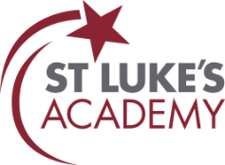
Safeguarding
Each newsletter we would like a share a safeguarding topic to support parents. This term we would like to highlight various types of Child exploitation.
Child Exploitation:
Child exploitation can affect any young person. Teenagers are particularly vulnerable as they seek independence, friendships, relationships, and spend more time online. Exploitation is never the child’s fault.

What Is Child Exploitation? Young people may be:
Sexually exploited – pressured or manipulated into sexual activity
Criminally exploited – forced or coerced into activities such as drug running (“county lines”), carrying weapons, or theft
Exploited online – groomed through social media, gaming, or messaging apps
What Parents Can Do
Keep communication open and calm
Ask about friendships and online contacts
Talk about healthy relationships and consent
Set boundaries around online use
Reassure your child they won’t be in trouble for telling you something
Concerned? Get Support
National Support for Parents
NSPCC – 0808 800 5000 - www.nspcc.org.uk
PACE (Parents Against Child Exploitation) -www.paceuk.info
CEOP
Report online concerns at www.ceop.police.uk

Signs to Look Out For:
- Exploitation often involves manipulation, threats, gifts, money, status, or affection.
- Going missing or staying out late
- Sudden new older friends or boyfriend/girlfriend
- Unexplained money, clothes, phones, or gifts
- Secrecy around online activity
- Mood changes, anxiety, aggression, or withdrawal
- Decline in school attendance or performance
- Carrying multiple phones or being very protective of devices
- If something feels “not quite right,” trust your instincts.

Easter Holiday Contacts:

If you have any safeguarding concerns during the holiday, please contact:

Monday 30th March- Friday 10th April:
Mr T Green (Associate Principal & DSL)
tgreen@stlukes.swindon.sch.uk / 07719319491

Alternatively, please contact:

Swindon Borough Council Children's Services – Contact Swindon:
contactschildrenandfamilies@swindon.gov.uk / 01793 464646
Office hours - 8.30am to 4.30pm
Out of hours: Contact Swindon Emergency Duty Service: 01793 436699
Police:
Non-emergencies: Call 101; Emergencies: Call 999

Latest news
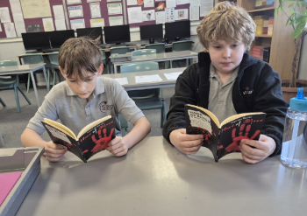
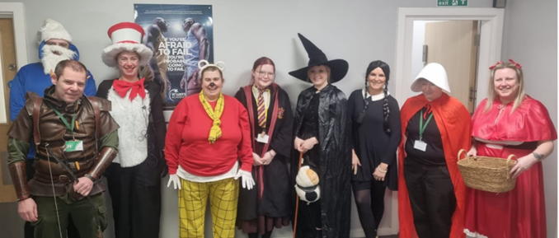
To celebrate World Book Day, our pupils have been exploring the importance of reading for creativity, wellbeing, and stronger literacy skills. Staff joined in the fun by dressing up as their favourite book characters, bringing stories to life throughout the school. Our KS3 pupils enjoyed trips to various outlets to choose new books, discovering genres and authors they might not have tried before. Throughout the day, pupils participated in reading competitions, and tutor groups enjoyed shared reading sessions, fostering confidence and a love of reading within our school community.
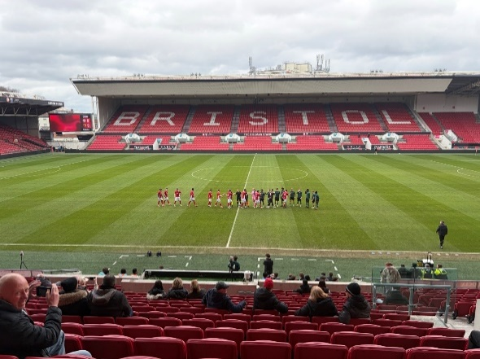
Our pupils had an exhilarating day watching the Bristol City versus Watford match, which ended in a thrilling 2-all draw. The atmosphere was electric, and the excitement was palpable as the teams battled it out on the pitch. We are proud to report that the pupils displayed fantastic behaviour throughout the event, cheering enthusiastically and supporting their team with great spirit. It was a wonderful opportunity for our pupils to engage with the local community and enjoy the beautiful game together!

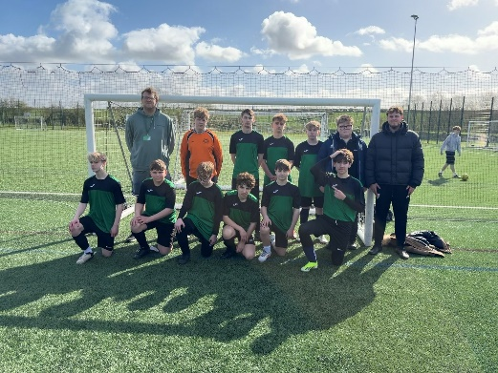
We look forward to more exciting events in the future. We are thrilled to share that 13 of our pupils proudly represented the school at the SEND Football Tournament! They played six exciting matches and achieved an impressive four wins. The spirit of sportsmanship was truly remarkable, with every player showing respect and encouragement to one another. This was our first-ever school football tournament, and we couldn’t be prouder of our team for their dedication and teamwork. Well done, everyone!

We are thrilled to share that our pupils recently had the fantastic opportunity to visit the cinema and enjoy a screening of Bad Guys 2, courtesy of INTOfilm! This engaging outing not only provided a fun day out but also sparked lively discussions about the film’s themes and characters. We believe experiences like these enrich our pupils’ learning and foster a love for storytelling. Thank you, INTOfilm, for making this possible!


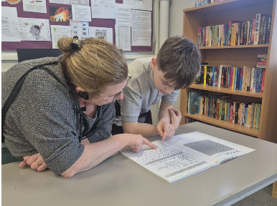
KS3 English
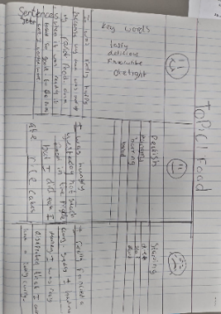
So far in Year 7 English, our focus has been on tolerance—understanding, respecting, and celebrating the differences that make each of us unique. Through reading, discussion, and creative writing, pupils have been exploring how language can help us express empathy and build a kinder school community. Pupils have refreshed key skills such as sentence writing, paragraphing, and expanding vocabulary. They have also been practising using their senses to describe settings and people, helping them create more vivid and detailed writing.
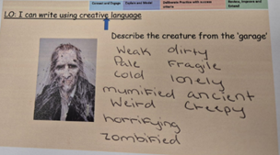
This term, Year 8 have been exploring travel writing and how writers bring places to life for their readers. Pupils have been learning why it’s important to combine:
- Figurative language – to create vivid images and help the reader picture the setting.
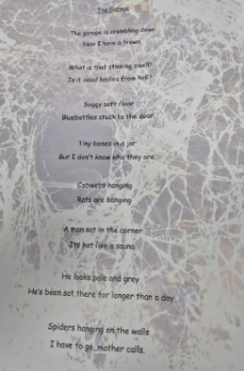
- Emotive descriptive words – to show feelings and make the writing more engaging.
- Facts – to give accuracy, build trust, and ensure the writing is informative.

Alongside this, pupils have also been exploring tone in spoken language, looking at how a speaker’s voice, emphasis, and word choices affect meaning and influence the listener. This helps them understand how tone shapes communication in both speech and writing.

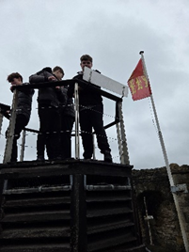
KS4 English
As we approach the end of term, it’s wonderful to reflect on the fantastic achievements across our year groups!
Year 11 have been diligently preparing for their exams, and we are thrilled to announce that many pupils have successfully passed their Functional Skills Level 1. Additionally, several have completed their mock exams, showcasing their hard work and dedication. We are incredibly proud of their efforts and resilience during this crucial time.
In Year 10, pupils have been immersed in the world of Gothic literature. They have explored a range of Gothic texts, delving into the themes and styles that define this intriguing genre. A highlight of their term was the successful visit to Oxford Castle, where they experienced the Gothic aesthetic in a real-life setting. This trip not only enriched their understanding but also sparked their imaginations!
Meanwhile, Year 9 has been exploring the concept of Dystopia. Through various Dystopian stories and real-life examples, pupils have engaged in language analysis, discovering what makes a narrative compelling. Their discussions have been lively and insightful, fostering a deeper appreciation for storytelling.

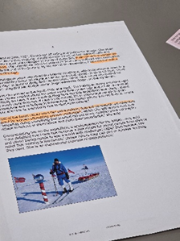
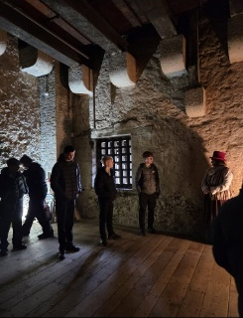
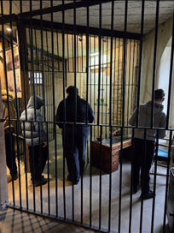
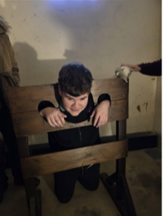

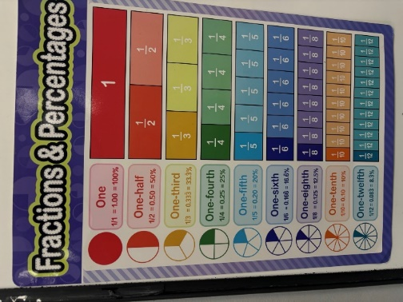
KS3 Mathematics
In KS3 Maths has been both busy and rewarding, with pupils developing key skills across several important topics. We’ve explored fractions, an introduction to algebra, and ratios, building strong foundations for future learning.
In our fraction’s unit, pupils improved their ability to simplify, compare, and calculate with fractions, applying their knowledge to real-life problems. The algebra topic introduced pupils to using letters to represent numbers, simplifying expressions, and solving simple equations—an important step towards more advanced mathematical thinking. Our work on ratios helped pupils understand proportional relationships and apply them to everyday contexts such as recipes, maps, and sharing quantities, linking closely to earlier work on fractions and decimals.
A huge well done to all Year 8 pupils who recently completed their AP1 assessments. The results have been fantastic and reflect the hard work, determination, and progress shown throughout the term. Teachers are incredibly proud of how pupils have approached their studies with enthusiasm and resilience.
Overall, KS3 Maths continues to challenge and inspire pupils, helping them grow in confidence as problem-solvers and independent learners. Congratulations again to Year 8 on a brilliant start to the year—keep up the great work next term!
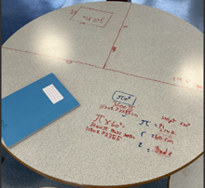
KS4 Mathematics
We would like to extend again another congratulations to Year 11 for their outstanding performance during the recent March GCSE Mock exam series. Their hard work and dedication have truly paid off, and we are proud of their achievements. The hard work still remains as we enter into the final stages of their educational journey.
Across all year groups, we have witnessed positive engagement with some challenging topics, particularly in our focus on Algebra, which included solving equations, and algebraic graphs, as well as coordinates and sequences. The enthusiasm shown by pupils in tackling these concepts is commendable and reflects their commitment to mastering the curriculum.
Additionally, we are pleased to announce the successful introduction of Functional Skills within Year 10. Our aim was to push Year 10 pupils to achieve their Functional Skills qualification by the end of Term 3, however this will now be towards the end of Term 4. This initiative is designed to enhance their practical skills and prepare them for future academic and vocational opportunities.

Looking ahead, we are still firmly focused on growing the curriculum and continue to strive to pinpoint improved ways to ensure effective teaching and learning.
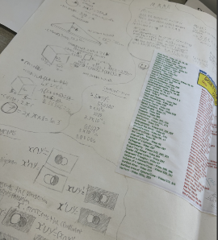
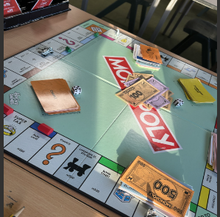
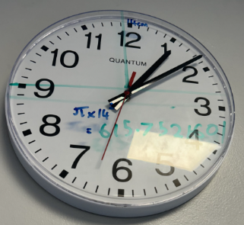
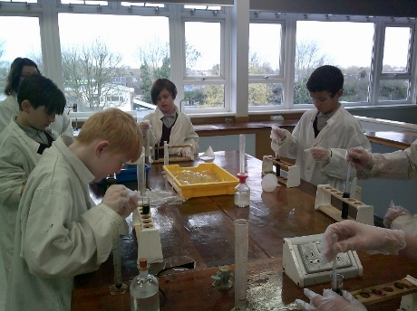
Science
In Science our pupils have been diving into the fascinating world of biology in Key Stage 3, exploring how science helps us understand living things through independent research and practical experiments.
Year 7 pupils have investigated how life forms adapt to their habitats, gaining valuable skills in evaluating the success of different organisms in surviving and appreciating their interdependence. Year 8 pupils have tackled the sometimes-embarrassing topic of human reproduction with remarkable maturity, asking insightful questions that have enriched our discussions. Meanwhile, Year 9 has explored the impact of DNA from previous generations on our appearance and health, confidently predicting inherited traits.
In Key Stage 4, our pupils have been busy completing their BTEC coursework, planning and conducting independent experiments. This hands-on approach has boosted their confidence in making predictions, writing up findings, and presenting their work. Year 10 pupils are currently engaged in forensic science modules, enjoying the thrill of investigating simulated crime scenes and honing their skills in evidence evaluation. Lastly, Year 11 pupils have been delving into physics, applying their knowledge to construct electronic circuits and create useful devices. It’s an exciting time for science at our school!
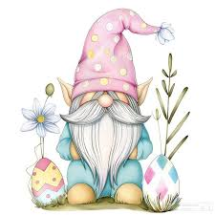

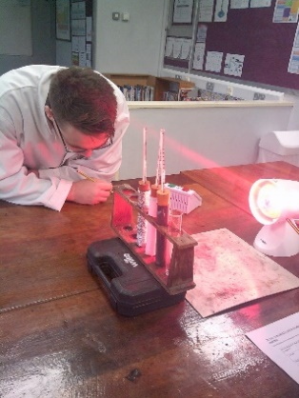
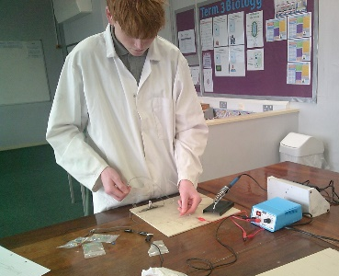
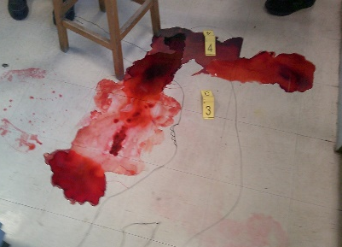
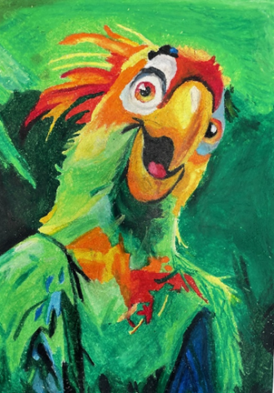
Art
Pupils have continued to impress in the art department over the last two terms with pupils in year 7 creating some fantastic Mexican Day of the Dead skull designs and developing their tonal pencil skills. Year 8 pupils explored the work of Vincent van Gogh creating their own freehand landscapes of local areas. They also had a chance to experiment with oil pastels using a range of mark making.
Year 9 have improved their design and colouring skills creating African inspired mask pieces then using card to create their designs in 3D.
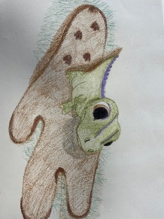

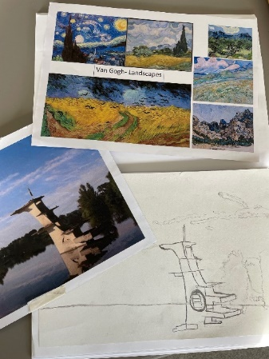
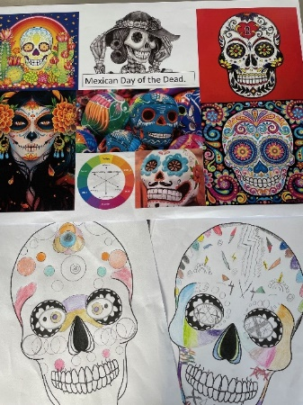
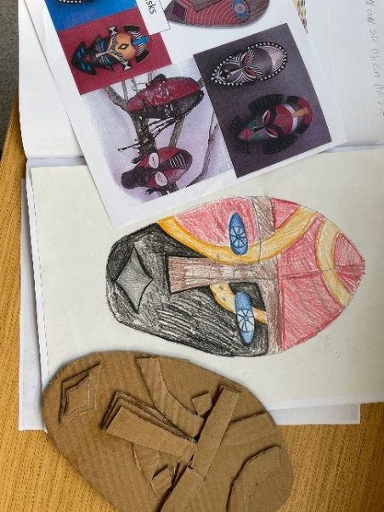
Key Stage 4 have continued to impress with their GCSE coursework. While Year 11 are now working on their externally set projects year 10 have expanded their animal projects in a wide range of media and styles taking inspiration for some fabulous artists.

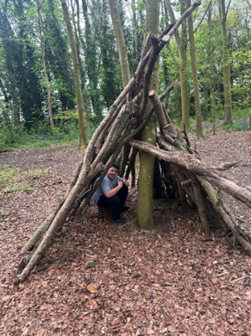
Outdoor Education
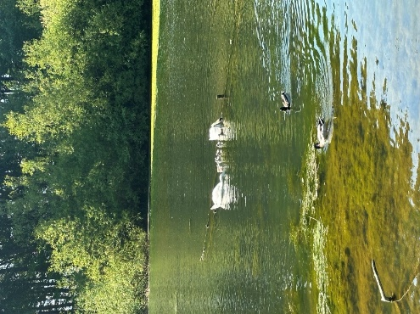
We are proud to say our pupils have embarked on an exciting journey into the world of orienteering! They have explored the use of compasses, learning not only how to navigate but also how to work together as a team. It’s been wonderful to see everyone engage so positively with the activities, demonstrating enthusiasm and a willingness to support one another.
Whether competing in friendly races or collaborating to find hidden markers, the pupils have shown remarkable teamwork and resilience. Their positive attitudes have truly shone through, making each session enjoyable and productive.
We are proud of their achievements and look forward to seeing how these skills will enhance their confidence and cooperation in future challenges. Keep up the fantastic work, everyone!
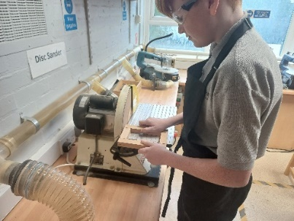
DT
In our Construction (DT) department, we are buzzing with activity! Our Year 8 pupils have just embarked on their electrics section, diving into the world of soldering and designing their very own LED lamps. It’s wonderful to see their creativity shine as they learn these essential skills.
Meanwhile, our Year 9 pupils are taking on a more ambitious project by designing and manufacturing stylish copper pipe household lamps. Their innovative designs are sure to brighten up any room!
As for our Year 10s, they have successfully completed the plumbing section and are now exploring basic household electrics. They are learning how to wire a lighting ring main and a double switch lamp, gaining practical skills that will serve them well in the future.
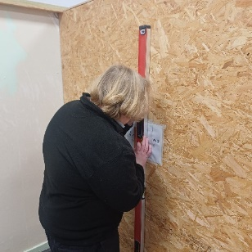
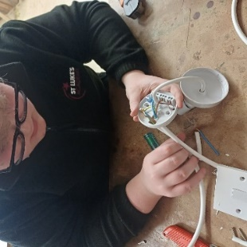
Stay tuned for more updates as our pupils continue to build their knowledge and skills in Construction!
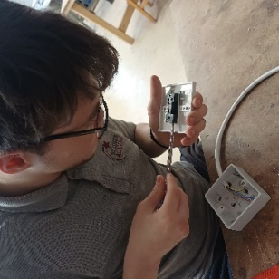



Childcare

In Childcare we have been exploring how science activities support children in their growth and development through a range of activities such as bubbles and melting ice, with the focus being the benefits of certain scientific activities.

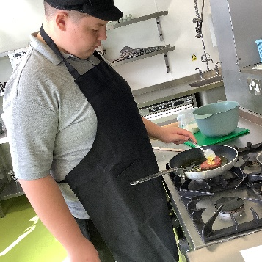
Food Technology
Year 7 have been little scientists learning about the functions of ingredients in recipes. A firm favourite activity is the blind folded crisp challenge using sensory analysis to guess flavours. Kneading and rubbing in method have been a culinary skill we’ve mastered well this term and demonstrate with confidence.
Year 8 have demonstrated a secure understanding of special dietary requirements and have successfully learnt life‑saving skills, including safe EpiPen use for allergic reactions. We have developed great understanding of types of intolerances along with religious and moral beliefs about why people become vegetarians.
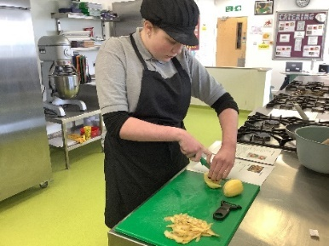
Year 9 have embraced challenges to plan meals on a budget learning vital life skill on using up ingredients to save money. We make some great fake-away meals.
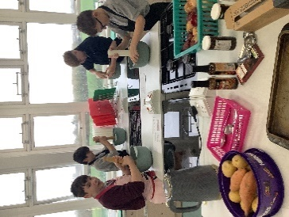
Year 10 pupils worked with determination in Catering this winter term. They have successfully completed the Level 2 Food Hygiene Certificate, applying safe working practices consistently in practical sessions. Their practical repertoire is expanding, with secure progress in techniques such as choux pastry, homemade sauces and aeration, techniques.

Year 11 are making good pace through the NCFE qualification, submitting organised, accurate written evidence and meeting the assessment criteria using their knowledge from their previous food hygiene qualification. Next steps our year 11 pupils have embarked on an exciting journey to master the art of planning a two-course meal within a specified time limit, tailored for a target audience. By engaging in this challenge, pupils are developing their culinary talents while also learning to think critically about the needs and preferences of those they are serving.
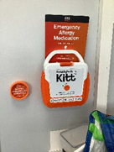
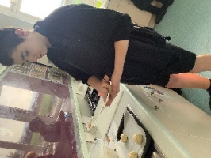
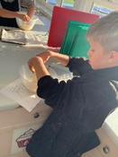
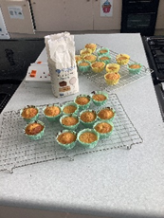

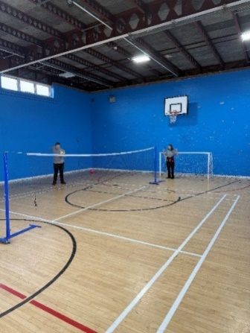
Sport
During Term 3, all secondary year groups took part in units of dodgeball, focusing on developing fundamental physical education skills such as throwing accuracy, catching, dodging, spatial awareness, and teamwork. Pupils showed strong progress in their ability to move strategically around the court, communicate with teammates, and apply tactics during game play. Many groups demonstrated increased confidence when throwing and catching under pressure, and they successfully applied defensive and attacking strategies during matches. Moving into Term 5, pupils are beginning a volleyball unit where they will continue to develop cooperation and communication through structured drills and match play. The focus will be on key skills such as serving, passing, and setting while working together effectively in team situations. To conclude the term, pupils will transition into gym-based activities, where they will explore different methods of recording and analysing performance data, helping them to understand how fitness can be measured and tracked over time.

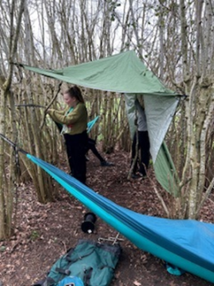
Forest School
We’ve had an amazing time at Forest School lately, and I just wanted to share some highlights from our recent sessions. A huge shout-out to our Year 8 and 9 pupils for their brilliant work in maintaining our forest area. They’ve been using tools like hand saws and loppers to tidy up the space as well as laying new pathways. It’s fantastic to see them taking responsibility and learning valuable skills along the way!
We also had a lovely time building cosy camps. The pupils really got into it, using natural materials to create warm and inviting spaces. It was great to see teamwork in action, with everyone pitching in to help each other.
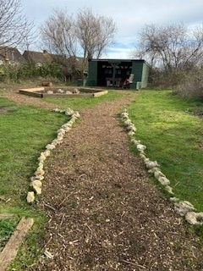
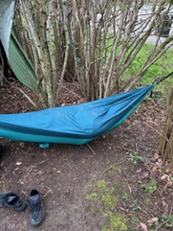
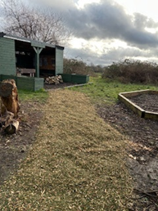
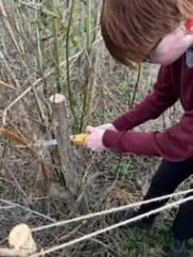

As we move forward, we’re excited to plan more activities that encourage exploration and connection.

PHSE
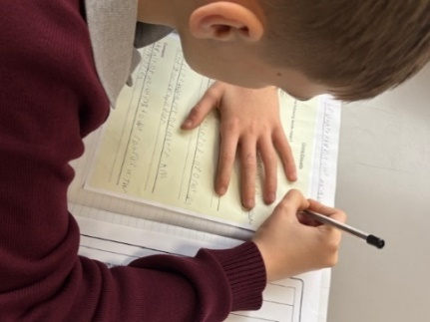
During PSHE lessons, pupils have been engaging in valuable discussions about online safety and respectful relationships. They explored the risks associated with social media and learned how easily personal information can be shared online. Through discussion and reflection, pupils considered the importance of privacy settings and responsible online behaviour. Pupils finished these topics with increased confidence and a better understanding of online safety.

Pupils also explored online etiquette, thinking about how to communicate respectfully and thoughtfully in digital spaces. In addition, they discussed how relationships can change as they grow and learned about the importance of consent. These lessons have provided pupils with important knowledge and skills to help them build safe, respectful and healthy relationships both online and offline. As always, we have focused on key aspects of British values to ensure our pupils are the best Citizens they can be!
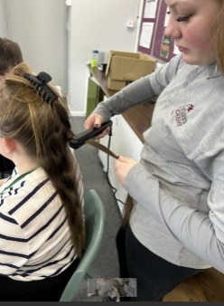
Hair and Beauty
Hair and Beauty pupils have been practicing their hair salon skills and vocabulary, exploring how they would welcome a client and practicing hair techniques on members of staff from their requests. Pupils then treated staff as if they were a client and practiced the service they would provide.


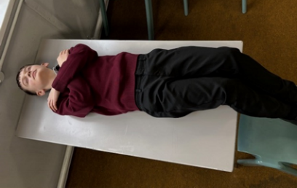
Emotional Intelligence
During EQ lessons, pupils have been learning to recognise body sensations linked to different emotions. They explored how feelings can show up physically, such as butterflies in the stomach when nervous or a faster heartbeat when excited. Pupils also practised different ways to articulate their feelings, helping them build a stronger emotional vocabulary. Through successful discussion and activities, they discovered a range of positive coping strategies to help manage challenging emotions. These lessons support pupils in understanding themselves better and developing healthy ways to respond to their feelings.
Enrichment Opportunities

At St Luke’s Academy, we’re committed to developing not just academic excellence, but confident, well-rounded individuals. That’s why this term, we’ve continued with exciting enrichment sessions in scootering, boxing, and football — giving our pupils the chance to learn new skills, stay active, and grow in confidence.
These sessions are more than just physical activities. They’re carefully designed to build teamwork, resilience, and self-belief, all within a safe, supportive environment. Whether it’s learning control and coordination on a scooter, discipline and focus through boxing, or leadership on the football pitch, each experience helps shape our pupils for the better.
Easter Recipe from Pixie and Alison!
Nests  - 200 g milk chocolate (finely chopped)  - 200 g dark chocolate (finely chopped)  - 100 g unsalted butter  - 100 g golden syrup  - 6-8 Shredded Wheat (full-size)  Topping  - 100-200g Easter chocolates | 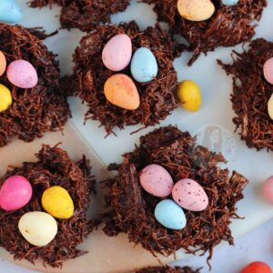  Instructions  - Crush your Shredded Wheat into a large bowl. Leave to the side!  - Add your butter and golden syrup to a pan, and heat gently whilst stiring occasionally until all the butter has melted.  - Take off the heat, and add in the finely chopped chocolates. Stir until the chocolate has melted into the syrup/butter mix.  - Pour over the Shredded Wheat and mix until combined!  - Using spoons, or a cookie/ice cream scoop - scoop onto a lined tray.  - Add on your eggs, I did three per nest, and set in the fridge until solid!  - Enjoy!

We hope that you have enjoyed reading our newsletter.
There is so much more we could have included, but we think that this gives you a flavour of our amazing school!
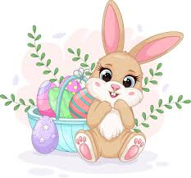
From all of us at St. Luke’s,
We wish you a very Happy Easter!
See you on Monday the 13th of April 2026.

