

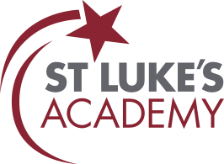
Summer 2026 Newsletter


Principal’s Message
As we reach the end of another academic year at St Luke's Academy, it's hard to believe how quickly the year has flown by. Looking back, it's been a busy, successful and rewarding year for our entire school community—and I think we've all earned a well-deserved break!
To our Year 11 pupils, I want to wish you every success as you take your next steps beyond St Luke's. You have worked hard, overcome challenges and created memories that will stay with you for years to come. Be proud of your journey, proud of your achievements and proud of the people you have become. We can't wait to hear about your future successes.
To all of our pupils, congratulations on completing another fantastic year. It has been wonderful to see so many of you embracing opportunities both in and beyond the classroom. From trips, work experience placements, expeditions, camping, fishing and paddle boarding, to CV writing, interview practice and college visits, there has been something for everyone. Your enthusiasm, resilience and willingness to get involved—even when it meant leaving your comfort zone (or sleeping in a tent!)—has been great to see!
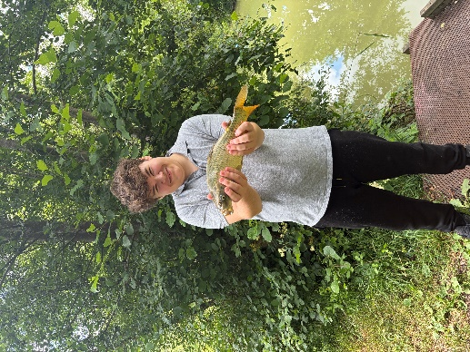
Of course, none of this would be possible without the dedication, commitment and care shown by our incredible staff every single day. Thank you for constantly going the extra mile, supporting our young people and making St Luke's such a special place to learn and work. Quite simply, our pupils are lucky to have you.
As the summer holidays arrive, I hope everyone takes the opportunity to relax, recharge and enjoy some well-earned downtime. Stay safe, have fun, and remember—kindness costs nothing, but it means everything.
We look forward to welcoming you back in September, refreshed and re-energised.
Have a fantastic summer.
Mr T Green
Associate Principal
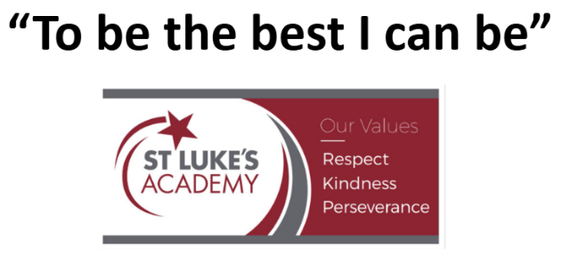


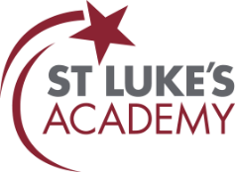
Safeguarding

Each newsletter we would like a share a safeguarding topic to support parents. This term we would like to highlight racism.

Racism:
Working Together to Challenge Racism and Promote Inclusion
We have been working hard to educate our pupils about racism, equality, and the importance of respecting and celebrating each other’s differences. Through lessons, discussions, and wider school activities, we are helping pupils understand the impact of discrimination and empowering them to challenge racism and prejudice whenever they see it. We have also welcomed support from external agencies who bring specialist knowledge and experience to help strengthen our approach. On 08.07.26, we were pleased to welcome the Police into school to deliver a hate crime awareness session, helping pupils understand what hate crime is, how it affects individuals and communities, and the importance of speaking up and reporting concerns.
As part of our ongoing commitment to creating a safe, inclusive, and respectful school environment, we have developed a graduated response procedure for incidents of racism and hate crime. This ensures that concerns are dealt with consistently, fairly, and appropriately, while also providing opportunities for education, reflection, and positive change. We are proud of the work taking place across our school community and will continue to work with pupils, families, and external partners to ensure every pupil feels valued, respected, and included.
Supports victims of hate crime: SARI - Stand Against Racism & Inequality


To report a hate crime, anonymously: Report all Hate Crime - Stop Hate UK

Contacts:

If you have any safeguarding concerns during the holiday, please contact:

Thursday 23th July – Friday 7th August: Elysia Potter
Epotter@stlukes.swindon.sch.uk / 07889209155
Monday 10th August- Friday 14th August: Tom Green
Tgreen@stlukes.swindon.sch.uk / 07719319491
Monday 17th August- Friday 21st August: Paul Holroyd
pholroyd@twhf.org.uk /07564368032
Monday 24th – 28th August: Cat Dougan
Cdougan@stlukes.swindon.sch.uk / 07713669898
Alternatively, please contact:

Swindon Borough Council Children's Services – Contact Swindon:
contactschildrenandfamilies@swindon.gov.uk / 01793 464646
Office hours - 8.30am to 4.30pm
Out of hours: Contact Swindon Emergency Duty Service: 01793 436699
Police:
Non-emergencies: Call 101; Emergencies: Call 999

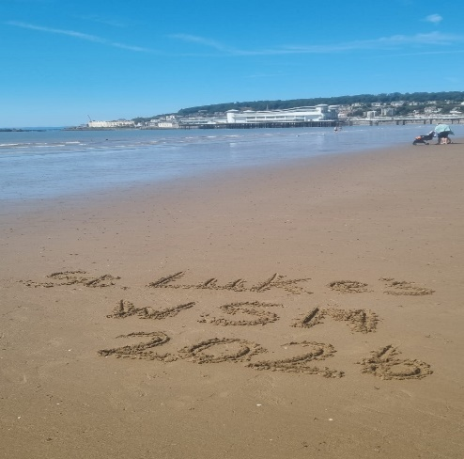
Latest news

Beach Trip
Years 7–9 enjoyed a fantastic trip to Weston-Super-Mare. Pupils spent the day exploring the pier, taking part in activities, and enjoying time together on the beach. The experience provided a great opportunity to build friendships and create lasting memories. The adventure continued back at school, where pupils put their Expedition (Ex Ped) training into practice by setting up camp on the school field and staying overnight. The experience helped develop teamwork, resilience, independence, and confidence, making it a memorable experience for all involved.

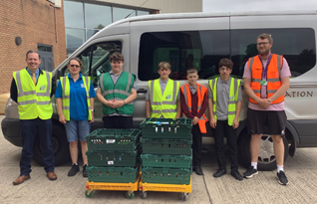
Foodbank
Year 9 and 10 Catering pupils visited Swindon Foodbank to support their vital work within the local community. Pupils worked alongside staff and volunteers, helping to organise donations and gain an understanding of how foodbanks provide support to those in need. The visit gave pupils valuable insight into community service, teamwork, and social responsibility. We were incredibly proud of their positive attitude, hard work, and willingness to help others, making a meaningful contribution during their visit.


Sports Day
The whole school came together for an exciting Sports Day, with Team A and Team B competing in a range of athletic and team events. Pupils demonstrated determination, teamwork, and excellent sportsmanship throughout the day, giving their best effort in every challenge. The atmosphere was fantastic, with plenty of encouragement and support from pupils and staff alike. It was wonderful to see so many pupils getting involved and representing their teams with pride. Congratulations to everyone who took part and helped make the day such a memorable success.
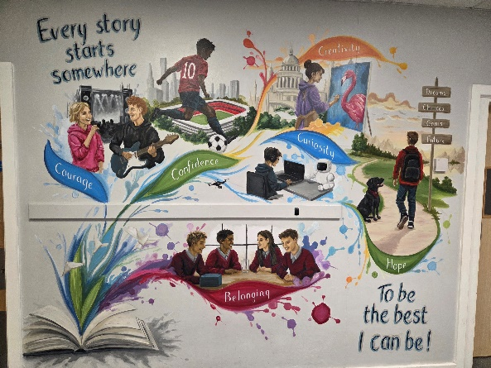
School Mural
We are delighted to unveil our new mural on the ground floor outside the Pastoral area. The vibrant display celebrates our school values and serves as a daily reminder of the qualities we strive to embody as a community. Designed to inspire and encourage all pupils, the mural reflects our commitment to respect, resilience, kindness, and ambition. We hope it will be enjoyed by pupils, staff, and visitors for many years to come.


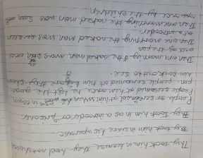
KS3 English
This term, Year 7 pupils explored Global Identities through The Wisp and The Island. These texts helped pupils develop empathy and a deeper understanding of the experiences of refugees. They improved their dialogue writing by learning to use speech punctuation accurately and explored themes of prejudice, acceptance, and diversity. Pupils also strengthened their use of subordinating conjunctions to create more sophisticated writing. We have been impressed by their maturity, compassion, and thoughtful reflections throughout the unit.
This term, Year 8 pupils studied Shakespeare’s A Midsummer Night’s Dream, exploring its plot, themes, and memorable characters. They analysed character motivations, relationships, and the impact of misunderstandings on the story. Through creative and analytical writing, pupils developed confidence in expressing their ideas. A particular highlight was exploring Shakespearean language, including his famous insults, which pupils enjoyed recreating themselves. This study has enhanced their understanding of Shakespeare’s influence on modern English while encouraging creativity, critical thinking, and engagement with classic literature.
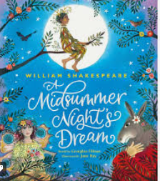
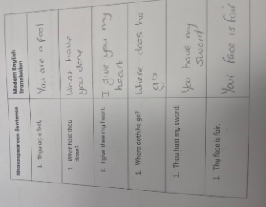
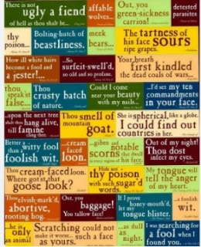
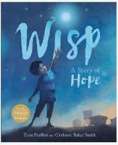



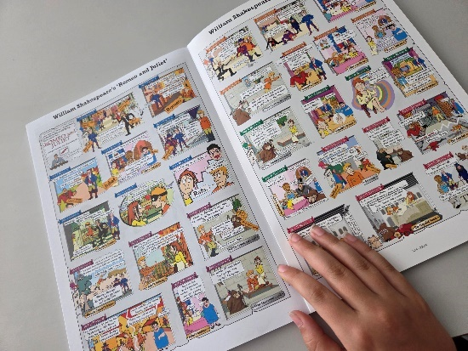
KS4 English
This term, our KS4 English pupils have shown real commitment, enthusiasm and growth across every year group.
Year 9 have been exploring Romeo and Juliet, building a strong understanding of Shakespeare’s time and the main events in the play. They have approached the text with curiosity and confidence, and we are delighted to celebrate their great success with their Entry Level 3 skills. Their hard work and positive attitude have really shone through.
Year 10 have been focusing on Arthur Miller’s A View from the Bridge, developing their Functional Skills at Level 1 and showing excellent focus as they prepared for their GCSE Mock Exam. They have tackled challenging ideas with maturity and determination, and it has been wonderful to see their progress.
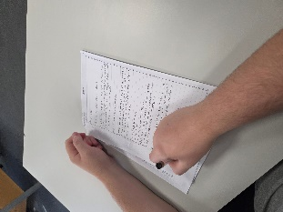
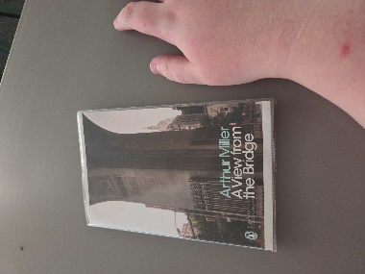
Year 11 have completed a big final push and should be incredibly proud of themselves. They went into the GCSE exam prepared, confident and ready to do their best. Their resilience and dedication throughout the year have been impressive, and we wish them every success for the future.

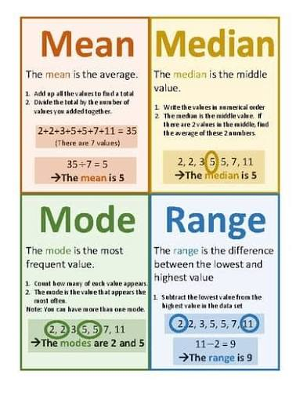
KS3 Mathematics
This term, our KS3 mathematicians have been developing their understanding of statistics by exploring averages, including the mean, median, mode and range. Through a range of engaging practical activities, pupils have strengthened their knowledge of how to calculate the mean and have learned when each type of average is most useful.
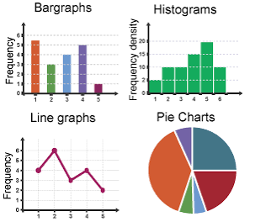
More recently, pupils have begun working with data by creating and interpreting a variety of charts and graphs. They have enjoyed presenting information clearly and using their mathematical skills to analyse and draw conclusions from real-life data.
It has been fantastic to see pupils growing in confidence and applying their statistical knowledge in practical and meaningful ways.


KS4 Mathematics
As we reach the end of another successful academic year, we would like to congratulate all of our pupils for their continued effort, resilience and determination throughout the year.
A huge well done to our Year 11 pupils who recently completed their GCSE Mathematics examinations. They approached each paper with confidence, positivity and maturity, and we are incredibly proud of the commitment they have shown throughout their final year.
This year has also seen fantastic success with our Functional Skills programme. Many pupils achieved their Entry Level 3 (E3) Functional Skills Maths qualification, providing them with an excellent foundation as they now aim to progress onto Level 1 Functional Skills next academic year.
Thank you for your continued support throughout the year. We wish all of our pupils and families a safe, relaxing and enjoyable summer break, and we look forward to welcoming everyone back in the new academic year.

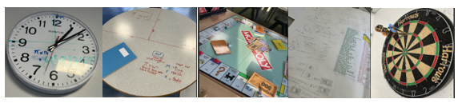

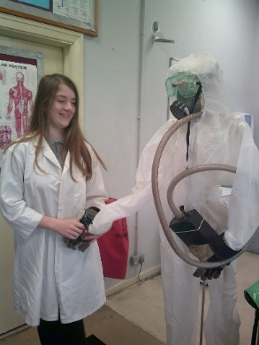
Science
This term, the pupils have been focusing on physics in Key Stage 3, this has enabled the pupils to explore ways of using science to understand energy and forces such as gravity and radiations, Through independent research and practical experiments.
Year7 have taken their first steps in exploring physics and are showing understanding of how things we can’t see affect us in everyday life. Their skills in analyzing and explaining what is happening in situations has grown remarkably.
Year 8 Are building their skills from last year and are much more confidently performing experiments and using scientific words in their work.
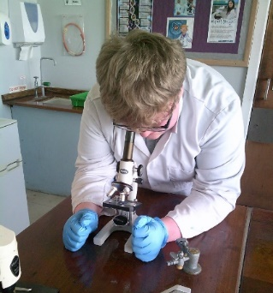
Year 9 The level of independence in this group has grown a lot and will help them be prepared for moving on to BTEC coursework in year 10.
The level of curiosity about science has increased in our younger pupils, Often, they seek me out at social times with questions about things they have seen or heard in everyday life.

KS4 pupils are confidently applying the skills learnt in previous years. They have shown that drive to design their own experiments and the resilience to modify them when things don’t turn out as they expected.
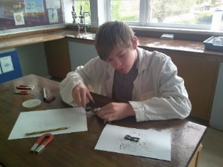
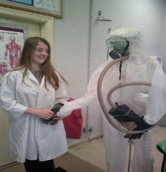
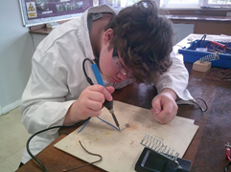

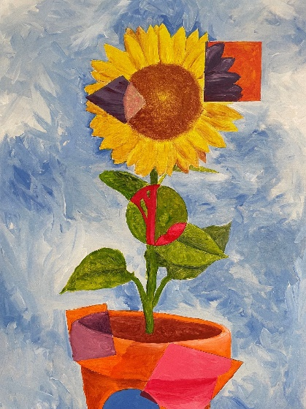
Art
The Spring/ Summer has been a busy time in the art department as 5 year 11 pupils completed their 10-hour GCSE Art and Design exam creating an exciting variety of pieces with great care and skills. Year 10 pupils have also been working towards their GCSE qualification completing pieces for their coursework. There is now a wonderful display of some of these pieces in the art room.
In key stage 3 pupils have looked at a wide range of inspirations such as Aboriginal art, looking at patterns, and Tinga Tinga art, which is bold and colourful and they practiced their colour mixing and painting skills. They have also been influenced by the work of Beatriz Milhazes who creates bold vibrant coloured pieces with patterns and natural forms, and the work of Ian Cook who uses remote control cars to make paintings of cars. The pupils loved painting their favourite cars.
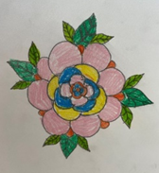

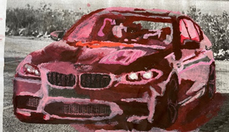
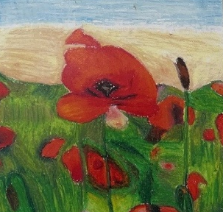
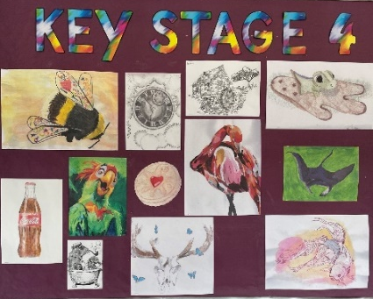
A year 9 pupil has created this fantastic surreal flower piece on A2 board. This will be part of an exciting display in the school next year!

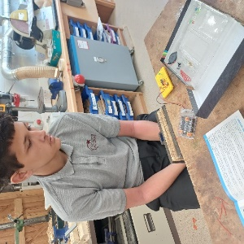
DT
This term, KS3 pupils have been working on a free design-and-make project, giving them the opportunity to apply the skills they have developed throughout the year to create their own unique products. Pupils demonstrated creativity, problem-solving, and practical making skills as they designed, planned, and manufactured their individual projects.
Year 9 pupils have successfully transitioned into their option groups and have made an excellent start to their courses. Construction pupils have been developing and refining their hand-tool skills, building confidence and accuracy in a range of practical tasks. Engineering pupils have begun exploring electronic circuit building, learning key principles and gaining valuable hands-on experience with electrical components.

Year 10 pupils have enjoyed an exciting collaboration with CARDO, working alongside members of their building team. This valuable experience allowed pupils to develop their teamwork, communication, and practical construction skills while gaining insight into the building industry. We are incredibly proud of the enthusiasm, resilience, and determination shown by all pupils this term.
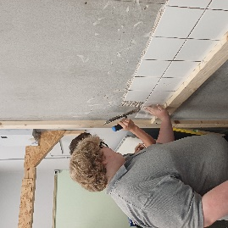
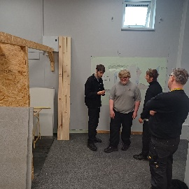
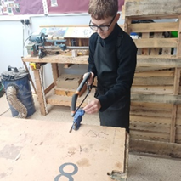
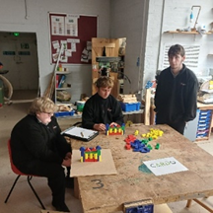
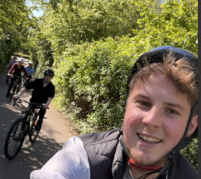
Outdoor Education
This term, our pupils have taken part in a fantastic programme of outdoor education, designed to support their personal development in meaningful and memorable ways. By stepping outside the classroom, they have embraced new experiences, built confidence and shown a willingness to rise to fresh challenges.
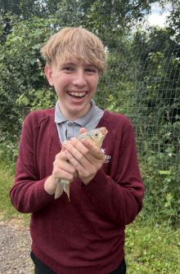
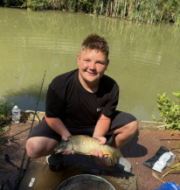
Across the programme, pupils have had the opportunity to try a range of activities, including fishing, scootering, mountain biking and golf. Each activity has offered something different: patience and focus through fishing, balance and control through scootering, resilience and determination through mountain biking, and concentration and precision through golf. These experiences have helped pupils develop important life skills while discovering strengths they may not have known they had.
It has been inspiring to see how positively they have approached each new environment. Their teamwork, encouragement of one another and growing independence have been a credit to them. Outdoor education continues to provide a powerful way for our young people to learn, achieve and flourish.
Work Experience
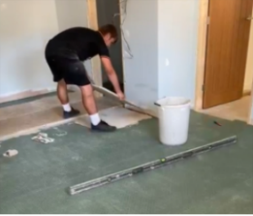
Year 10 pupils have excelled during their work experience placements, demonstrating enthusiasm, maturity and determination throughout. Working in a variety of settings, including supermarkets, construction sites, cafés, hair and beauty salons, and energy plants, they gained valuable insight into the world of work and potential career pathways. Employers praised their professionalism, confidence and willingness to learn, while pupils developed key skills such as teamwork, communication, problem-solving and reliability. We are especially proud that several pupils performed so well they have already secured future job opportunities. Well done, Year 10 – you have made the whole school community proud!

Food Technology
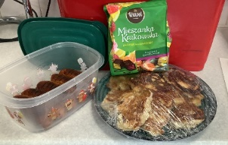
This term, Year 7 pupils have explored foods from around the world, developing their practical cooking skills while gaining a greater appreciation of different cultures. A highlight was pupils sharing their own cultural traditions, including a pupil who introduced a traditional Polish delicacy, celebrating the diversity within our school community. Year 8 pupils have enjoyed adding creative twists to traditional recipes, experimenting with new flavours and ingredients. This has helped them develop their culinary skills, creativity, and problem-solving abilities while learning about the cultural influences behind food. Their enthusiasm and positive feedback have been fantastic to see. Year 9 pupils have now selected their options and are enjoying the opportunity to cook in our fully equipped commercial kitchen, proudly wearing their chef whites and hats.

Our catering pupils also visited the local food bank, working alongside the CEO and learning about the importance of supporting the community. Thank you to everyone who contributed donations. Finally, we are delighted that Year 11 NCFE Catering portfolios have been recognised as exemplary work and will be used to support future pupils, following praise from the external verifier.
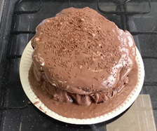
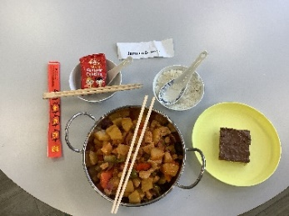
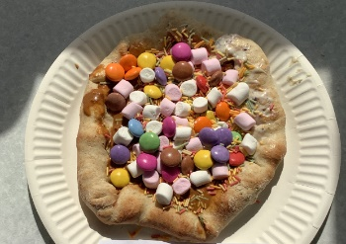
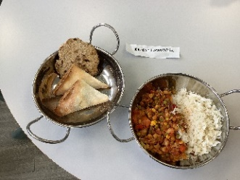
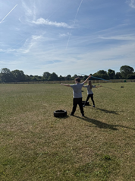
Sport
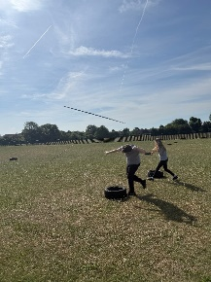
During Term 5, pupils enjoyed developing their skills in cricket and rounders. Throughout the term, the focus was on teamwork, communication, and improving individual techniques such as throwing, catching, batting, and fielding. In cricket, pupils worked hard to develop their batting accuracy, bowling control, and fielding skills through a range of fun games and challenges. They demonstrated excellent perseverance, supporting one another and celebrating each other's successes, no matter the outcome. Rounders provided plenty of opportunities for pupils to build confidence while learning the rules of the game and working together as a team.
This term, pupils have been developing their athletic skills through a range of track and field events, including short-distance sprinting, long-distance running, long jump, and javelin. Throughout each lesson, pupils have focused on improving their technique, building stamina, and striving to achieve their personal best.

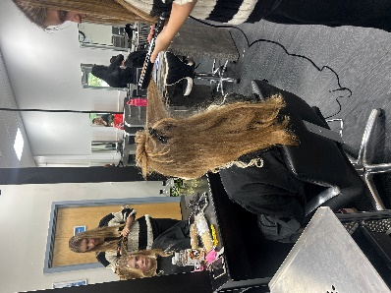
Hair and Beauty
Hair and beauty pupils have been focusing on hair styling and techniques. We had a visit to NorthStar college where we got to use the facilities and practice the skills we have learnt. We also had a demonstration from some level 4 pupils on hair washing techniques.

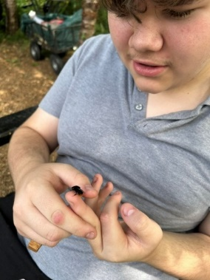
Forest School
Forest School has been full of exciting learning and achievements this term. Troy proudly carved a beautiful wooden ring, showing excellent patience and craftsmanship, while our Year 11 pupils completed their impressive final practical projects. Expedition Skills pupils have been developing their camp-building, teamwork and outdoor survival skills.

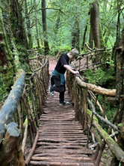
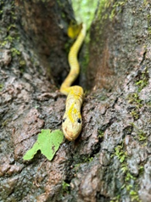
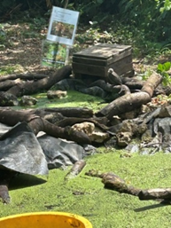
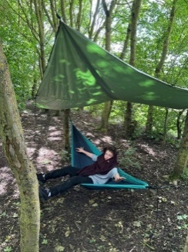
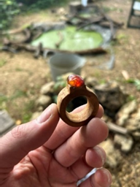
We were delighted to discover frogs thriving in our very own pond, highlighting the success of our conservation work. Pupils also enjoyed unforgettable educational visits to Puzzlewood and the Living Rainforest, where they explored a variety of habitats, discovered fascinating wildlife, and learned more about the importance of protecting our natural environment


PHSE

We are proud to support a safe and inclusive environment for all our pupils. As part of our commitment to the Equality Act 2010, we celebrate diversity. Alongside this we continue to promote British Values. These values help our children become caring and responsible members of society. Pupils also learnt basic first aid skills, including how to respond in an emergency, treat minor injuries, and understand when to seek help. These invaluable life skills help build confidence and responsibility.
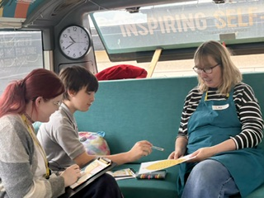
Emotional Intelligence
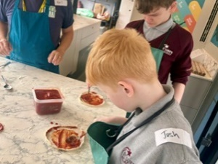
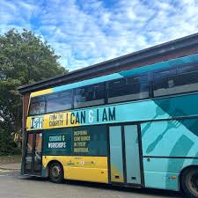
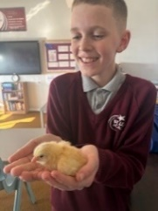
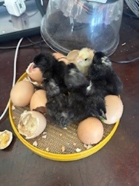

We had the privilege of watching, caring for, and learning about our six eggs as they made their way into the world. Five hatched into chicks, giving the children a wonderful hands-on opportunity to observe, care for, and learn about the life cycle. They have now gone to a loving home, where we look forward to visiting them in the future. Also, we were delighted to welcome I Can & I Am, a UK charity that helps young people build resilience, confidence and self-belief. Year 7 and 8 pupils enjoyed a unique experience aboard the charity’s double-decker bus. In the kitchen, they worked together to make and bake pizzas, developing teamwork skills and a sense of achievement. They also took part in an interactive workshop exploring practical ways to build confidence and resilience. The session ended with the charity’s memorable ‘balloon’ analogy, encouraging pupils to maintain a positive mindset and support their wellbeing. The visit was a great success, with plans for the bus to return in the new academic year.


Pastoral support at St Luke’s Academy
Pastoral support provides care, guidance, and emotional support to pupils throughout their time at school. Alongside academic progress, we focus on social, emotional, behavioural, and mental wellbeing, helping pupils overcome barriers, build resilience, and achieve success.


How Does Pastoral Support Help Pupils?
Pastoral support helps pupils by:
- Providing a trusted adult to talk to.
- Supporting emotional wellbeing and regulation.
- Spending time with Willow, our school therapy dog.
- Encouraging positive behaviour and relationships.
- Building confidence and resilience.
- Improving attendance and engagement.
- Supporting transitions and periods of change.
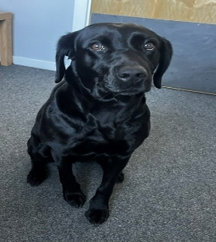
- Working with families and external agencies when needed.

The Role of the Pastoral Team
The pastoral team provides:
- One-to-one support.
- Daily check-ins and mentoring.
- Behaviour and wellbeing support.
- Attendance support.
- Family communication.
- Support during difficult circumstances.
- Guidance on friendships and personal development.
Through strong relationships and consistent support, we help pupils feel valued, safe, and connected to their school community. By working closely with pupils, families, staff, and external professionals, we ensure every pupil receives the support they need to thrive. Our aim is for every pupil to leave St Luke's with the confidence, resilience, and skills to make positive choices and succeed in the future.
We hope that you have enjoyed reading our newsletter.
There is so much more we could have included, but we think that this gives you a flavour of our amazing school!
From all of us at St. Luke’s,
We wish you a very Happy Summer!
Inset Days:  Tuesday 1st Sept  Wednesday 2nd Sept | Year 7 and 11  Thursday 3rd Sept  Friday 4th Sept | Whole School Return  Monday 7th Sept

