Thursday 26th May 2022

Dear Parent / Carer,

We would like to say a massive well done to our Year 6 and Year 2 students as they have worked so hard on their exams over the past couple of weeks. Half term is now quickly approaching and we hope that you all get to have a well-deserved rest. School will close at 3.30pm on Thursday 26th May and will reopen for all students on Tuesday 7th June. Have a lovely week off!

Attendance

September 2021-May 2022

Target attendance | 96%
Reception | 92.3%
Year 1 | 91.3%
Year 2 | 94.9%
Year 3 | 92.9%
Year 4 | 92.3%
Year 5 | 93.3%
Year 6 | 95.5%
School Total | 93.2%

Attendance is highly important for children to achieve the best opportunities in life and to maintain friendships. Children should be attending school each day and arriving to school on time. If your child is late you must bring them to the office and fill out the late form.

New Late System
If your child is late for school an adult must bring them to the office to fill out a late form that they will need to sign and date.

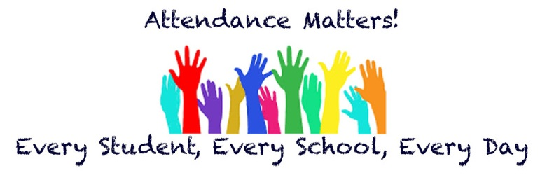

Pupil Voice

A message from our Headboy and Headgirl:

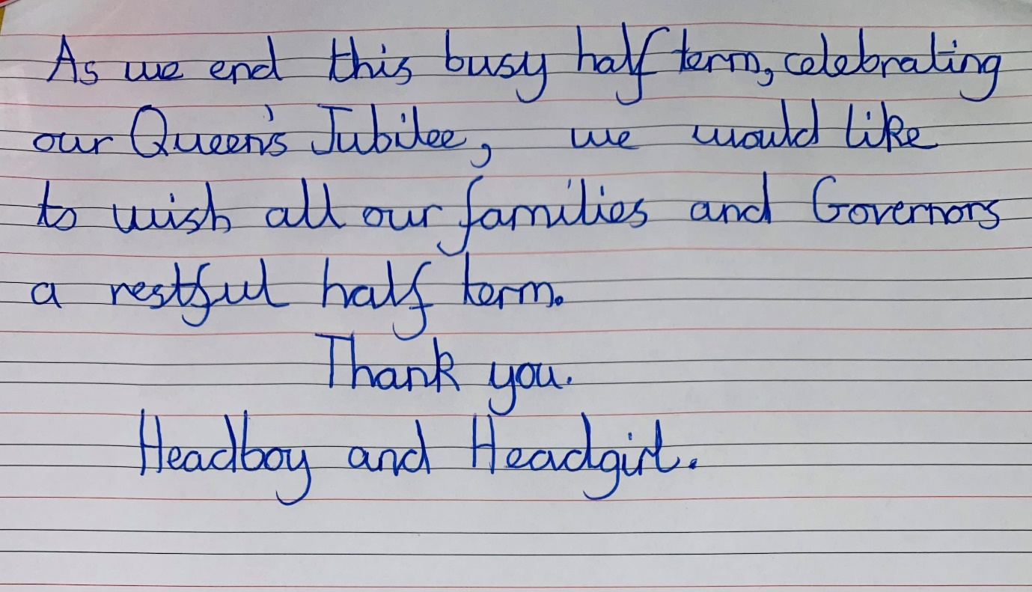

Uniform

We are seeing an increase in the amount of children coming into school wearing incorrect uniform.
Please send children into school wearing Black School shoes - no trainers, white polo shirts and red cardigan/ jumper or a red summer dress.

Leggings can be worn for PE days- However, please be reminded that these MUST be plain black with no writing.

Correct Uniform
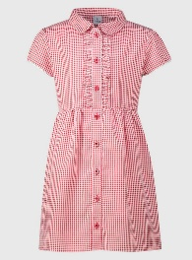
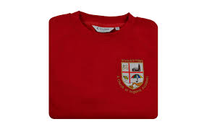
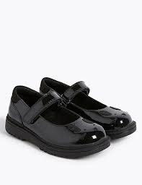
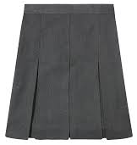
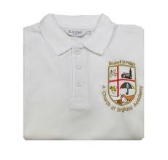

Correct PE kit
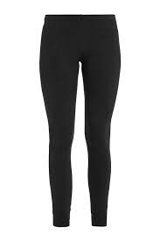
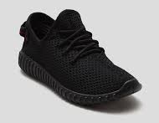
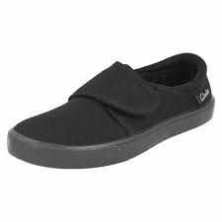

St Luke’s Church Street Party

On Friday 3rd June St Luke’s Church will be hosting a Queen’s Platinum Jubilee party at Blackburn Baptist Church, the party will be from 4pm until 6pm. There will be lots of different things going on like tea, cake, live music and plenty of other fun for all the family at no cost!

Queen’s Jubilee Celebration

On Thursday 26th May we hosted a Jubilee party for all of the children from 1:30pm till 3:00pm. There were lots of different activities going on throughout the afternoon like afternoon tea, face painting, royal bingo and musical thrones.

Clubs

There has been a slight change to clubs for next half term, Key Stage 2 will now have a club on Monday’s instead of Wednesday’s as Reception now have the opportunity to try out a club on a Wednesday afternoon. Here are the clubs for the half term:

School Dinners

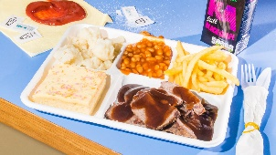
From September you will see that there will be an increase to the price of school dinners. At the moment school dinners cost £2.00 per dinner but they will be rising to £2.20. We have not had to make an increase in price for many years now but as you will have noticed the cost of living has become more expensive meaning food prices have gone up.
Parent/Carers Courses in School

ESOL (English classes)

These will begin on Thursday 9th June 2022 at 9.30am - 11.30am. We have had lots of parents and carers showing lots of interest. If you would like a place just send me an email or pop into the office and they will put your name down.

Fussy Eaters

We are still awaiting a date from the BWD Adult learning team. The resources have still not arrived so hopefully this session will be added to the diary very soon. Please keep a lookout on all our social media pages and posts up around school.

HENRY

We will be starting a group in September for 0 - 5 years. When I have a date I will again post on all our social media and posts around school.

The worship theme for the new half term is:

