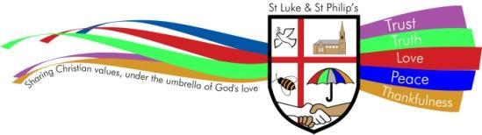

EARLY YEARS AND FOUNDATION STAGE POLICY

**ST. LUKE & ST. PHILIP’S PRIMARY,** A CHURCH OF ENGLAND ACADEMY

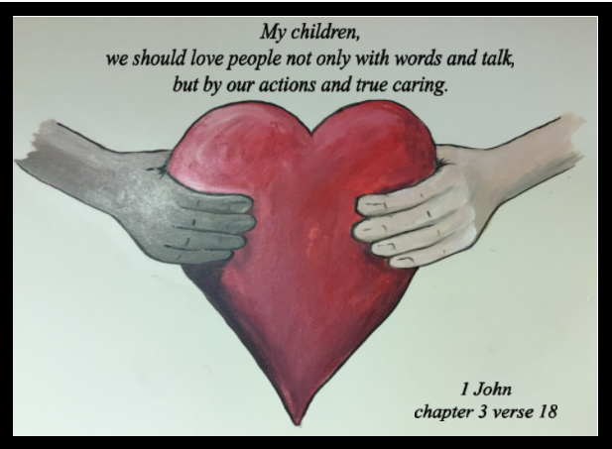

***VISION STATEMENT***

***‘The family of St Luke and St Philip’s will ensure excellence is encouraged, minds are opened, diversity is embraced, respect is expected and talents are nurtured under the umbrella of God’s love.’***

**ETHOS**

Our school provides grounding in the Christian Faith for all its children with emphasis on collective worship as part of its daily life. Our Christian values of trust, truth, love, peace and thankfulness are built into the ethos and teaching of our school with the support of all Governors and staff for its Christian foundation. We also seek to encourage an understanding and respect for other world faiths.

**CHRISTIAN SCHOOL VALUES**

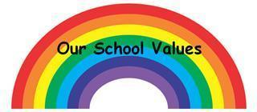



PURPOSE

This policy reflects the values, ethos and Mission Statement of St. Luke and St Philip’s Primary School, a Church of England Academy in relation to the curriculum. It is consistent with the school’s agreed aims and objectives and sets out a framework within which teaching and support staff can operate.

**AUDIENCE**

This document is intended to give a clear outline of the school’s approach to the curriculum to all staff, Governors, Cidari and parents. It is also intended for the use of the School’s Advisory Service when assisting the development of the school’s curriculum and for any authorised inspector. Copies of this document are provided for all teaching staff and are available when necessary to support staff, members of the School’s Governing Committee and Cidari members. A copy of this document is available for the use of parents.

**Intent**

Our Early Years Curriculum is based on the requirements set out in the statutory framework for the Early Years Foundation Stage for 2024. We aim to create a supportive, nurturing and inclusive environment where independence is promoted. Reception and KS1 staff work together to ensure a successful transition into YR1.

**Curriculum**

The EYFS framework includes 7 areas of learning and development that are equally important and inter-connected. 3 areas, known as the prime areas, are seen as particularly important for igniting curiosity and enthusiasm for learning, and for building children’s capacity to learn, form relationships and thrive.

The prime areas are:

* Communication and language
* Physical development
* Personal, social and emotional development

The prime areas are strengthened and applied through 4 specific areas:

* Literacy
* Mathematics
* Understanding the world
* Expressive arts and design

We use the half termly objectives from Focus Education to inform our planning to ensure progression of the early learning goals in all seven areas.

We place a heavy emphasis on communication and ensure that ‘children’s spoken language underpins all seven areas of learning and development’ (EYFS Framework 2023). Children have daily opportunities to listen to stories and role play through ‘Three books a day’, use of the school library and learning nursery rhymes. We assess communication and language using the WellComm programme and plan interventions to close the gaps.

Children's health is an integral part of their emotional, mental, social, environmental and spiritual well being. We promote healthy snacks and offer foods from different cultures to develop their taste preferences. Activities relating to the food cycle are interwoven in planning e.g. harvest preparations, planting seeds, gathering, preparing and eating. We ensure that children have access to quiet areas indoors and outdoors where they can relax alongside space for vigorous free movements.

We promote good oral health, as well as good health in general. We teach the children about the importance of eating healthy and exercise. We talk to them about the effects of eating too many sweet things and the importance of brushing their teeth. We teach the children how to brush their teeth through daily supervised tooth brushing. We follow Public Health England

guidance on supervised toothbrushing to make sure that it is evidence-based and safe.

We assess the children’s Fundamental Movement Skills and plan activities so they can practise these key skills throughout the year. We have a specialist PE teacher who takes groups of children to develop their FMS on a weekly basis.

Children’s mental wellbeing is developed where they are taught to understand their own feelings and we teach them strategies to manage their feelings. They have daily opportunities to talk about how they are feeling. We have introduced the programme ‘My Happy Mind’ and these sessions are taught in EYFS. The sessions aim to develop a resilient, balanced and happy mind.

Mathematics is taught daily using White Rose Maths and NCETM Mastering Number and Literacy using Read, Write Inc. We use the Jigsaw programme to teach PSHEC.

**Supporting Learning**

Routines are an important way that children feel secure and can make sense of all the opportunities offered throughout their time at St Luke and St Philip's Primary School. This includes snack time, small group time and whole group phonics, story, circle times and PE. Children use continuous provision throughout their day and are supported through adult led activities.

**Inclusive Practise**

All children and their families are valued at St Luke and St Philip's Primary School. Children are treated as individuals and have equal access to all provisions available. We give our children every opportunity to achieve their best. We do this by taking into account our children's range of life experiences when planning for their learning.

We plan to meet the needs of different genders, children with special educational needs, children who are more able, children with disabilities, children from all social and cultural backgrounds, children of different ethnic groups and those from diverse linguistic backgrounds. We liaise closely with all relevant professionals in order to provide early support for those children and their families who need it.

**Assessment**

At St Luke and St Philip’s, ongoing assessment is an integral part of learning and development. Data is analysed to identify the children’s level of achievement, interests, learning styles and to inform future planning. Within the first 6 weeks that a child starts reception, staff will administer the Reception Baseline Assessment (RBA). At the end of the EYFS, staff complete the EYFS profile for each child. Pupils are assessed against the 17 early learning goals, indicating whether they are: Meeting expected levels of development. Not yet reaching expected levels (‘emerging’). The profile reflects ongoing observations, and discussions with parents and/or carers. The results of the profile are shared with parents and/or carers for their child. EYFS profile data is submitted to the local authority upon request.

Children’s progress is tracked using the statements on Sonar. The results are discussed half termly at Pupil Progress Meetings. Phonic and Fundamental Movement Skills assessments are carried out each half term and children are regrouped accordingly.

We use a Speech and Language toolkit ***“Wellcomm***” to track children’s speech, language and communication needs throughout the Early Years and Foundation Stage. Once a profile has been drawn up for each child, The Big Book of Ideas provides focused teaching and intervention activities to meet individual needs.

Assessments also take into account contributions from a range of perspectives to ensure that any child with potential special educational needs is identified at the earliest possible opportunity. Concerns are always discussed with parents/carers at an early stage and the schools Inclusion manager is called upon for further information and advice. Appropriate steps are taken in accordance with the school's Inclusion policy for SEN.

**Positive Relationships**

At St Luke and St Philip's Primary School we recognise that children learn to be strong and independent through forming secure relationships. We aim to develop caring, respectful, professional relationships with the children and their families.

**Parents/Carers as Partners**

We recognise that parents/carers are children's first and most enduring educators and we highly value the contribution that parents make. We recognise the role that parents have played and their future role in supporting their child/ren's education and development. We do this through:

* Talking to parents about their child before they start in our school
* The children having the opportunity to spend time with their teacher(s) prior to starting school during transition sessions
* Support children through their transition from pre-school to Reception class with the children having a staggered start to ensure they have the opportunity to explore their new environment with a small group. This is also to further support staff and parents in getting to know each other as well as the children; Inviting all parents to an induction meeting during the term before their child starts school and again during the first half term of the child's Reception year in order to detail how we aim to work with their child particularly in relation to reading and phonics;
* Offering parents regular opportunities to talk about their child's development and progress and allowing free access to their children's online Class Dojo profiles and class work books.
* Encouraging parents to talk to the child's teacher if there are any concerns. There is a formal meeting for parents three times a year at which the teacher and the parent discuss the child's progress in private with the teacher. The parents of children in EYFS have additional meetings throughout the year to share children’s progress and next steps. Parents receive a report on their child's attainment and progress during the school year; Offering various activities throughout the year that involve parents/carers in the life of St Luke and St Philip's e.g. church services and events, fairs and assemblies. Providing parents with opportunities to celebrate their child's learning and development by completing "wow" moments which inform planning and provision; Written contact through home reading books as well as the acknowledgement that parents can ring/ message school to contact staff.
* Supporting parents/carers whose first language is one other than English Supporting parents/carers who have a child with special educational needs.

**Safeguarding and Welfare**

At St Luke and St Philip's Primary School we understand that we are legally required to comply with certain welfare requirements as stated in the Statutory Framework for Early Years Foundation Stage 2024. We understand that we are required to:

* Promote the welfare and safeguarding of children;
* Promote good health, preventing the spread of infection and taking appropriate action when children are ill;
* Manage behaviour effectively in a manner appropriate for the children's stage of development and individual needs;
* Ensure all adults who look after the children or who have unsupervised access to them are suitable to do so;
* Ensure that the premises, furniture and equipment is safe and suitable for purpose; Ensure that every child receives enjoyable and challenging learning and development experiences tailored to meet their needs;
* Maintain records, policies and procedures required for safe efficient management of the setting and to meet the needs of the children.

**Key Person**

At St Luke and St Philip's Primary School, each child has a key person (Class teacher or Teaching Assistant). The key person builds confidence, gives children opportunities to express their thinking and use their initiative. We believe children learn and develop effectively when the key person provides:

* First hand experiences
* Individual and collaborative learning experiences
* An environment where children can take risks
* Innovative delivery
* Clear expectations
* Opportunities to review and reflect
* Thinking time
* Thorough preparation and organisation
* Activities building on prior learning
* Open ended, thought provoking challenging questions
* Support for children with differing needs
* Support for parent/carers

**Enabling Environments**

We aim to create an attractive and stimulating learning environment where children feel confident, secure and challenged. The children have daily access to an indoor and outdoor environment that is set up in discrete areas of learning with planned continuous provision. These are areas where the children can be active, be quiet and rest. The environment is organised into continuous provision areas, where children are able to find and locate equipment and resources independently. Our outdoor provision offers opportunities for doing things in different ways and on different scales than when indoors.

**The Wider Context**

At St Luke and St Philip's Primary School, we recognise that children's social, emotional and educational needs are central to any transition from home to school, from Reception to Year 1 and from one Early Years setting to another. We communicate with local nurseries, day care centres, private providers and Children's Centres as well as with parents and carers to ensure that children's needs are met. Information is shared in order that there is continuity in their learning and development. We have good links with local nurseries and visits are undertaken by either the Class teacher and Pupil Wellbeing Lead to meet with the children prior to them starting at school in September. These visits provide the opportunity to discuss individual needs and to meet the children.

Early Years Foundation Stage staff work together across local authority services in order to achieve the best for all children. This may involve working with multi agency professionals.

# Statutory policies and procedures for the EYFS

| Statutory policy or procedure for the EYFS | Policies |
| --- | --- |
| Safeguarding policy and procedures | See child protection and safeguarding policy |
| Procedure for responding to illness | See health and safety policy |
| Administering medicines policy | See supporting pupils with medical conditions policy |
| Emergency evacuation procedure | See health and safety policy |
| Procedure for checking the identity of visitors | See child protection and safeguarding policy |
| Procedures for a parent failing to collect a child and for missing children | See child protection and safeguarding policy |
| Procedure for dealing with concerns and complaints | See complaints policy |

***Policy reviewed :*** November 2024

**Policy reviewed by** : Mrs B Patel

**Next review date** : November 2026