FIRE SAFETY POLICY

ST. LUKE & ST. PHILIP’S PRIMARY, A CHURCH OF ENGLAND ACADEMY

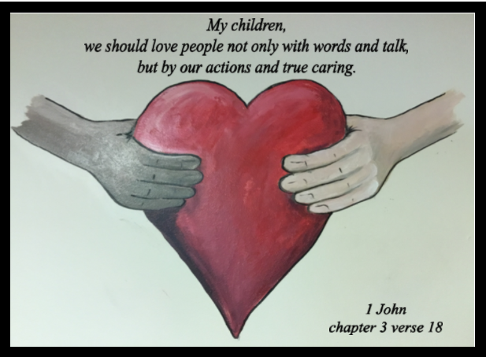

VISION STATEMENT
‘The family of St Luke and St Philip’s will ensure excellence is encouraged, minds are opened, diversity is embraced, respect is expected and talents are nurtured under the umbrella of God’s love.’

ETHOS
Our school provides grounding in the Christian Faith for all its children with emphasis on collective worship as part of its daily life. Our Christian values of trust, truth, love, peace and thankfulness are built into the ethos and teaching of our school with the support of all Governors and staff for its Christian foundation. We also seek to encourage an understanding and respect for other world faiths.

CHRISTIAN SCHOOL VALUES

PURPOSE

This policy reflects the values, ethos and Mission Statement of St. Luke and St Philip’s C.E. Primary Academy in relation to the curriculum. It is consistent with the school’s agreed aims and objectives and sets out a framework within which teaching and support staff can operate.

AUDIENCE
This document is intended to give a clear outline of the school’s approach to the curriculum to all staff, governors, Cidari and parents. It is also intended for the use of the School’s Advisory Service when assisting the development of the school’s curriculum and for any authorised inspector. Copies of this document are provided for all teaching staff and are available when necessary to support staff, members of the School’s Governing Committee and Cidari members. A copy of this document is available for the use of parents.

Fire Safety Duties
The following persons have fire safety responsibility within the school:-
Head Teacher — will ensure there is a Fire Safety Risk assessment and that preventive and protective measures are in place.
Administration Manager — will ensure that Fire Safety Risk assessments and preventive and protective measures are monitored at regular intervals.
Site Supervisor — will during the course of her duties ensure that fire safety measures are in place. Teachers — will take charge of pupils to ensure their class evacuates the building in an emergency.
- will actively ensure that the means of escape in their classroom is never obstructed or blocked.
All other staff — will cooperate in the emergency procedures in event of a fire.

Employees
Employees will be provided with clear and relevant information on the risks to them identified by the fire risk assessment, about the measures to be taken to prevent fires, and how these measures will protect them if a fire breaks out.
The school will consult employees (or their elected representatives) about nominating people to carry out particular roles in connection with fire safety and about proposals for improving the fire precautions.

Employment of children
Before the employment of a child the Young Employee risk assessment, as detailed in the School Health & Safety Policy and Procedures Manual, will include the risk from fire and the measures taken to control the risk.

Non-Employees
The school will inform non-employees, such as students and temporary or contract workers, of the relevant risks to them, and provide them with information about the fire safety procedures for the premises. The information will include any part they will be expected to play in the evacuation of pupils from the premises.
Shared Premises
Other organisations using the premises will be issued with a copy of the schools emergency procedures and will be expected to cooperate with the preventative measures put in place by the school.
Details of the Schools Emergency Plan
How people will be warned if there is a fire:
• The fire alarm units installed in all areas of the building will sound and in some cases flash with a red light.
What staff should do if they discover a fire:
• Staff should break the nearest break glass point on their way out of the building and report the location of the fire to the Administration Manager as soon as possible after ensuring pupils in their care have evacuated to the school field.
• Staff should not attempt to tackle a fire unless it is safe to do so, and they are confident they have received sufficient instruction to use fire fighting equipment safely.
• Staff should evacuate the building by the nearest available fire exit.
• Staff should not stop to collect personal belongings on their way out.
• Under no circumstances should anyone attempt to re-enter the building until told to do so by the Administration Manager.
What pupils or visitors should do if they discover a fire:
• Pupils should inform the nearest adult of the location. The adult should then break the nearest break glass point and leave the building with their class by the nearest exit.
Visitors should exit the building by the nearest exit, informing the nearest member of staff on the way out of the location of the fire.
How the evacuation of the premises should be carried out:
- All occupiers of the premises should exit by the nearest available fire exit.
• Staff responsible for pupils should ensure that all pupils in the class have left the room before exiting themselves. i.e. the last person out of an area should be an adult.
Staff should take their fire registers with them and staff should close the door behind them on leaving the room.
• Staff and pupils should move quickly and quietly but do not run.
• The office staff will take the staff & visitors log to the assembly points.
• All pupils, staff and visitors will go immediately to the assembly points. If the emergency evacuation occurs at the end of the school day or lunchtime, people will still report to the assembly points.
• Leave by the nearest exit, do not stop to collect belongings, move quickly and quietly but do not run, make your way to the designated assembly point.
Procedure for checking the premises have been evacuated:
Identification of key escape routes and how they are accessed to escape to a place of safety:•All classes have exits through joined 'quiet areas'. Most classes also have their own fire exit doors. Children in the hall exit via the fire door that leads outside. People in the library should exit via the main infant entrance.
• In the Juniors Miss Flannery will check toilets and corridors after instructing children to exit via the nearest door. In the Infants this role is taken by Mrs Rain.
Where people should assemble after leaving the premises:
All children line up on the school all weather pitch facing the school building.
• Once classes are assembled on the all weather pitch, roll calls will be made by class teachers against the fire register.
Arrangements for fighting fire:
• Only staff who have undergone Fire Safety Training should attempt to fight a fire if they can do so without risk to themselves or others and they feel they are competent to do so. The general rule is that all should evacuate the building should leave firefighting to the Fire Service.
Fire Extinguisher Type Use:
Water: Combustible materials such as wood, paper, cardboard.
Do not use on fires involving electrical equipment
Short circuits caused by water in electrical apparatus could expose the operator to the risk of electric shock. Do not use on flammable liquids.
Dry Powder: Flammable liquids, Electrical fires
Carbon Dioxide (C02): Electrical fires and small fires involving flammable liquids Foam: Flammable liquids and combustible materials
Fire Blanket: Deep fat fryers and frying pans etc.
Do not attempt to fight the fire unless there are exceptional circumstances such as in order to escape, if the fire is already contained, such as a small amount of burning material in a waste bin, use a fire blanket for a cooking or clothing fire.
The duties and identity of staff who have specific responsibilities if there is a fire:
- Admin staff — telephone the fire service and take registers and contact details to the assembly point
- Kitchen staff —turn off cooking appliances before leaving kitchen
- Caretakers — shut off any machinery in use when alarm sounds.
- Designated staff check toilets and general shared areas for evacuation
- First aiders will check both yard areas.

Arrangements for evacuation of people especially at risk
Children with severe mobility difficulties will be assisted by the Teaching Assistant assigned to them.
Any appliances or power supplies that have to be isolated if there is a fire - Kitchen equipment
Specific arrangements for high risk areas
Kitchens — cooking appliances will be isolated
Boiler House — keep flammable materials to a minimum
Contingency Plans for when safety systems are out of order:
In the event of the fire detection system being out of order, a hand bell will be rung (located in Caretakers office).
How rescue services will be called and who is responsible for this
- Once the fire alarm has been activated a call will be sent to the monitoring company who will telephone the school to ascertain whether it is a genuine call or false alarm. The Administration Manager will confirm either way.
- The Site Supervisor will check the fire control panel situated at the front door to ascertain the area in which the alarm has been raised. This information will need to be passed on to the emergency services on their arrival.

Procedure for meeting rescue services on their arrival and notifying them of any special risks:
- The Administration Manager or Site Supervisor will liaise with the emergency services on their arrival.
- Depending upon the site of the fire the Administration Manager or Site Supervisor will meet the fire services at the main entrance to the main building.
What training employees need and the arrangements for ensuring that this training is given:
- Fire drills will be held every term.
- The emergency procedure will be shared with staff, including the induction of new staff.
- Fire fighting equipment training will comprise of
- which extinguisher to use
- the location of the nearest appliance to relevant workplace
- information on how to operate the extinguishers
- instruction to keep themselves between the fire and the exit.
Plans for dealing with people once they have left the premises:
If the premises cannot be re-occupied within a reasonable time the school will alert parents to collect pupils
Contact details will be available in the event that the building cannot be reoccupied.

Policy Reviewed: March 2021
Policy Reviewed By : Mrs M Rain
Approved by Governors:
Next Review Date: March 2023

