SPECIAL EDUCATIONAL NEEDS AND DISABILITIES (SEND) POLICY
ST. LUKE & ST. PHILIP’S PRIMARY, A CHURCH OF ENGLAND ACADEMY

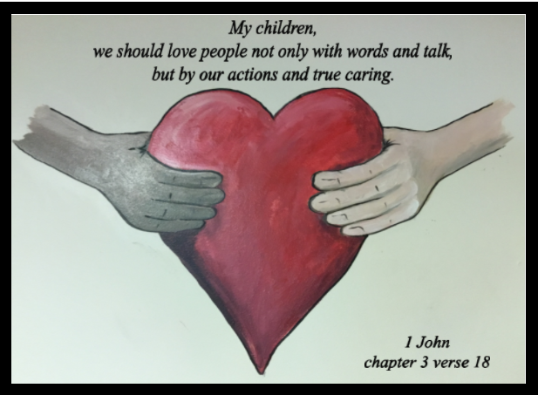

VISION STATEMENT
‘The family of St Luke and St Philip’s will ensure excellence is encouraged, minds are opened, diversity is embraced, respect is expected and talents are nurtured under the umbrella of God’s love.’
ETHOS
Our school provides grounding in the Christian Faith for all its children with emphasis on collective worship as part of its daily life. Our Christian values of trust, truth, love, peace and thankfulness are built into the ethos and teaching of our school with the support of all Governors and staff for its Christian foundation. We also seek to encourage an understanding and respect for other world faiths.

CHRISTIAN SCHOOL VALUES

DOCUMENT PURPOSE
This policy reflects the values, philosophy and Mission Statement of St. Luke and St. Philip’s Primary School in relation to the teaching of children with special educational needs and disabilities. It is consistent with the school’s agreed aims and objectives and sets out a framework within which teaching and support staff can operate.

AUDIENCE
This document is intended to give a clear outline of the School’s approach towards the teaching of pupils with special educational needs to all staff, governors and parents. Copies of this document are provided for all teaching staff and support staff and members of the Local Governing Committee. The Multi Academy trust in co-operation with the Local Governing Committee and Head Teacher determines and monitors the Academy’s policy and approach to the provision for children with Special Educational Needs, establishes the appropriate staff and funding arrangements and maintains a monitoring oversight of the school’s work. The Trust will have regard to the SEN Code of Practice 2014 and Equality Act 2010. The Head Teacher has strategic responsibility for overseeing the provision for children with SEND and keeping the governing body fully informed.
A copy of this document is available for the use of parents.

AIMS AND OBJECTIVES
As a Christian school we believe that all individuals are unique and of equal value, whatever their abilities, background, physique and experiences.

We aim to:
- Ensure all children are given access to a broad, balanced and well-structured curriculum suitable to their needs;
- Provide all children with opportunities to experience success;
- Be considerate of special educational needs and disabilities across all curricular areas;
- Ensure special provision relates to the needs of the individual pupil;
- Inform and involve pupils and parents/carers where possible to provide a more effective special educational provision;
- Identify, as early as possible, the individual needs of all pupils and make appropriate provision;
- Provide personal plans for pupils with special educational needs and disabilities with targets that are additional to and different from their peer group.

Objectives of this policy
All governors, teaching and non-teaching staff, pupils and parents should have an understanding of the teaching of children with special educational needs and disabilities.
All governors, teaching and non-teaching staff should know what the school policy is on the teaching of pupils with SEND.
All parents should know what the school policy is on the teaching of pupils with SEND.

EDUCATIONAL INCLUSION
Through appropriate curricular provision, we respect the fact that children:
- Have different educational, behavioural and emotional needs and aspirations;
- Require different strategies for learning;
- Acquire, assimilate and communicate information at different rates;
- Need a range of different teaching approaches and experiences.

Teachers respond to children’s needs by:
- Providing support for children who need help with communication, language and literacy and all areas of the curriculum;
- Planning to develop children’s understanding through the use of all available senses and experiences;
- Planning for children’s full participation in learning and in physical and practical activities;
- Using in class support staff appropriately to assist with the teaching and learning of SEND pupils;
- Helping children to manage their behaviour and to take part in learning effectively and safely;
- Helping individuals to manage their social development and emotions, particularly trauma or stress, and to take an active part in learning.

INCLUSION AND EQUALITY
Teachers set high expectations for all pupils. Appropriate assessments are used to plan challenging work for all groups, including:
- More able pupils
- Pupils with low prior attainment
- Pupils from disadvantaged backgrounds
- Pupils with SEN
- Pupils with English as an additional language (EAL)
Teachers plan lessons so that pupils with SEN and/or disabilities can study every National Curriculum subject, wherever possible, and ensure that there are no barriers so every pupil achieves.
Teachers also take account of the needs of pupils whose first language is not English. Lessons are planned so that teaching opportunities help pupils to develop their English, and support pupils to take part in all subjects. Class trips and visits linking to Special Educational Needs are planned to ensure they are inclusive for all.

We believe all our children are entitled to benefit from equal access to work and equipment regardless of race, gender, intellectual and physical ability, in line with the nine protected characteristics. Classroom management will take into account such issues and Special Educational Needs materials free from bias will be positively sought.

To ensure equality for all, teachers are committed to planning lessons that:
- Eliminate discrimination, harassment and victimisation;
- Promote equality of access and opportunity within our school and within our wider community;
- Promote positive attitudes to difference and good relationships between people with different backgrounds, genders, cultures, faiths, abilities and ethnic origins.

SPIRITUAL, MORAL, SOCIAL, CULTURAL DEVELOPMENT AND BRITISH VALUES
The school sets out to plan a provision for Spiritual, Moral, Social and Cultural development, but it is also expected that many unplanned opportunities will occur (especially for spiritual development) and staff are encouraged to "seize the moment" when appropriate. Such moments may have a profound effect on individuals.
The promotion of the ‘British Values’ of
- Democracy
- The rule of law
- Individual liberty
- Mutual respect
- Tolerance of those of different faiths and beliefs
is central to our education as British Values have their origin in the Christian values of our nation.

CODE OF PRACTICE 2014
The school follows the Special Educational Needs and Disability Code of Practice and uses the same definition of special educational needs and disability as defined in the Code of Practice.

‘A child or young person has SEN if they have a learning difficulty or disability which calls for special educational provision to be made for him or her.
A child of compulsory school age or a young person has a learning difficulty or disability if he or she:
- has a significantly greater difficulty in learning than the majority of others of the same age, or
- has a disability which prevents or hinders him or her from making use of facilities of a kind generally provided for others of the same age in mainstream schools.’
Many children and young people who have SEN may have a disability under the Equality Act 2010 – that is ‘…a physical or mental impairment which has a long-term and substantial adverse effect on their ability to carry out normal day-to-day activities’.

In line with the Code of Practice, the school considers the four following areas of SEN:
- Communication and Interaction
- Cognition and Learning
- Social, emotional and mental health
- Sensory and/or physical

A child must not be regarded as having a learning difficulty solely because the language or form of language of the home is different from the language in which he/she is or will be taught.

Special Educational provision means:
Educational provision which is additional to, or otherwise different from, the educational provision made generally for children of the child’s age in maintained schools other than special schools in the area.

PERSONAL TARGETS
High quality teaching, differentiated for individual pupils, is the first step in responding to pupils who have or may have SEND. The school’s system for tracking and assessing the progress of individual children will provide information about areas where a child is not progressing as expected. Where there are concerns a child is not progressing as expected, or is demonstrating social, emotional and mental difficulties, information needs to be gathered to identify the child’s barriers to learning. This will include an internal referral made to the Inclusion Manager by the class teacher and early discussions with parents and carers to develop a good understanding of the pupil’s areas of strength and difficulty, the parents’ concerns, the agreed outcomes sought for the child and the next steps. The purpose of this early action is to help the pupil achieve the identified outcomes and remove any barriers to learning.
In some cases outside professionals such as Educational Psychologists, the SEND Support Service, SALT and social services may already be involved with the child. Where these professionals have not already been working with the school staff, the Inclusion Manager may contact them if the parent agrees.

Where it is decided that a pupil does have special educational needs, the decision should be recorded in the school records and the pupil’s parents formally informed by the Inclusion Manager that special educational provision is being made. The child will be given personal targets, and a copy given to parents. The targets will be reviewed termly by the class teacher, Inclusion Manager and any support staff involved. Parents will be invited into school to meet the Inclusion Manager to discuss the reviewed and new targets given.
All targets need to be SMART -
S – Specific
M – Measurable
A - Achievable
R - Realistic and relevant
T - Time-limited

Targets that are non academic will be on a laminated target sheet with their targets written in child friendly speak. This gives the child ownership of their targets, and feeds back into reviews. Foundation stage teachers should keep a tracker sheet for each child with personal targets.

GRADUATED APPROACH
This SEND support should take the form of a four-part cycle known as the graduated approach – Assess, Plan, Do, Review (Please see appendix for the flow chart).

Assess

The class teacher and Inclusion Manager will look at teacher’s assessments and experience of the pupil, their progress, attainment and behaviour in comparison to their peers and national data, the views and experience of parents, the pupil’s own views and, if relevant, advice from external support services. This will help ensure that support and intervention are matched to the child’s need, and barriers to learning are identified and overcome.

Plan

The teacher and the Inclusion Manager should agree in consultation with the parent and the pupil the adjustments, interventions and support to be put in place, as well as the expected impact on progress, development or behaviour, along with a clear date for review.
All teachers and support staff who work with the pupil should be made aware of the child’s needs, the outcomes sought, the support provided and any teaching strategies or approaches that are required.
Parents should be fully aware of the planned support and interventions and, where appropriate, plans should seek parental involvement to reinforce or contribute to progress at home.
Do
The class or subject teacher should remain responsible for working with the child on a daily basis. Where the interventions involve group or one-to-one teaching away from the main class or subject teacher, they should still retain responsibility for the pupil. They should work closely with any teaching assistants or specialist staff involved, to plan and assess the impact of support and interventions and how they can be linked to classroom teaching.
The Inclusion Manager should support the class or subject teacher in the further assessment of the child’s particular strengths and weaknesses, in problem solving and advising on the effective implementation of support.
Review
The effectiveness of the support and interventions and their impact on the pupil’s progress will be reviewed in line with the agreed date set in the planning stage. The impact and quality of the support and interventions will be evaluated, along with the views of the pupil and their parents.
The class teacher, working with the Inclusion Manager, will revise the support in light of the pupil’s progress and development, deciding on any changes to the support and outcomes in consultation with the parent and pupil. Parents should have clear information about the impact of the support and interventions provided, enabling them to be involved in planning next steps.
This support may include:
- Different learning materials or special equipment;
- Some group or individual support;
- Extra adult time to devise the nature of the planned intervention and to monitor its effectiveness;
- Staff development and training to introduce more effective strategies;
- Access to external support services for one-off or occasional advice strategies or equipment.

Some pupils will receive support in the classroom and a small number will be withdrawn for more individual help. We ensure that our pupils’ Special Educational Needs are known to other schools to which they may transfer.

Where a pupil is receiving SEND support, staff should meet parents at least three times each year. (Two meetings through parent-teacher meetings, and a review meeting with the Inclusion Manager through the graduated approach.) Parents are welcome to discuss their child’s progress at anytime.

Where suitable, the views of the pupil should be included in these discussions. This could be through involving the pupil in all or part of the discussion itself, or gathering their views as part of the preparation.

EDUCATION, HEALTH AND CARE NEEDS ASSESSMENT AND PLANS
Where, despite the school having taken relevant and purposeful action to identify, assess and meet the special educational needs of the child, expected progress has still not been made, the school or parents should consider requesting an Education, Health and Care needs assessment. The local authority will look at evidence of the action taken by the school as part of SEND support in order to decide whether it is necessary for to make provision in accordance with an EHC plan.
The purpose of an EHC plan is to make special educational provision to meet the special educational needs of the child or young person, to secure the best possible outcomes for them across education, health and social care and, as they get older, prepare them for adulthood.

EHC plans should be forward-looking documents that help raise aspirations and outline the provision required to meet assessed needs to support the child or young person in achieving their ambitions. EHC plans should specify how services will be delivered as part of a whole package and explain how best to achieve the outcomes sought across education, health and social care for the child or young person.

EHC plans should show how education, health and care provision will be co-ordinated wherever possible to support the child or young person to achieve their outcomes. The plan should also show how the different types of provision contribute to specific outcomes.

IMPLEMENTATION AND RESPONSIBILITIES
The implementation of the SEND policy is the responsibility of all staff in school. The Inclusion Manager has the responsibility for the day-to-day operation of the policy.

The role of the Inclusion Manager is to:
- Oversee the day to day operation of the SEND policy
- Monitor the effectiveness of the policy
- Liaise with and advise fellow teachers
- Liaise with parents
- Manage any SSA support
- Hold half termly meetings with support staff
- Co-ordinate the provision for pupils with SEND and monitor the effectiveness
- Track the progress of pupils with SEND
- Oversee the records on all pupils with SEND
- Contribute to and arrange in-service and external training of staff
- Liaise with external agencies
- Monitor effective use of any SEND funding in conjunction with the Head teacher
- Purchase appropriate resources
- Liaise with High Schools on the transfer of pupils with SEND
- Administer diagnostic tests as required
- Represent the interests of pupils with SEND
- Keep the Head teacher regularly informed about SEND provision in school

The role of class teachers
All teachers are special educational needs teachers. It is the responsibility of each class teacher to consider the kinds of options and variety of activities available within the class setting to enable all children to access the National Curriculum.
Teacher’s plans should be flexible in order to recognise the needs of all children as individuals and to ensure progression, relevance and differentiation. The statutory National Curriculum Inclusion Statement emphasises the importance of providing effective learning opportunities for all pupils and states three key principles for inclusion.
- Setting suitable learning challenges
- Responding to pupil’s diverse needs
- Overcoming potential barriers to learning and assessment for individuals and groups of pupils

The role of Special Support Assistants
SSAs are employed to work specifically with children with IPRAs, Statements and EHC plans and play a vital role in the school’s provision for children with SEN and disabilities. Their role is to work closely with the class teachers concerned to support the implementation of the personal targets and to facilitate the child’s access to the curriculum and inclusion in the life of the school. Each SSA completes a half termly evaluation for children with IPRAs, Statements or EHC plans, linked to personal targets and monitored by the Inclusion Manager. The SSA is also expected to attend any reviews/meetings when required for the child they support.

The role of Learning Support Assistants
Learning Support Assistants (LSA) will, from time to time, be asked to work specifically with children who are experiencing learning difficulties. They will be involved in supporting the class teacher, implementing the personal targets and therefore, play an important role in the SEND process.

MONITORING
The Inclusion Manager regularly monitors the movement of children within the SEND system in school and there is regular movement on and off register. The Inclusion Manager and the Head teacher hold regular meetings to review the work of the school in this area. SSAs are also monitored on their work by the Inclusion Manager on a regular basis.

RESOURCE ALLOCATION
The Head teacher and Inclusion Manager organise and plan the amount of additional in-class and external specialist support required by pupils identified as needing SEND support and those with an IPRA, Statement or EHC plan. Pupils on the SEND register are covered from within the school’s existing budget and may receive extra learning support from support staff. All mainstream schools are provided with resources to support those with additional needs, including pupils with SEN and disabilities. The local authority should provide additional top-up funding where the cost of the special educational provision required to meet the needs of an individual pupil exceeds the nationally prescribed threshold.

SPECIFIC RESOURCES
Staff have access to a wide range of SEND resources catalogued and located in the KS1 resource area cupboards. ICT offers great benefits for children with learning and behaviour difficulties. It is also used to support the Inclusion Manager’s work. We have a range of software to support pupils with SEND.

INVOLVING PARENTS/CARERS
The effectiveness of any assessment and intervention will be influenced by the involvement and interest of the child and his/her parents. Both the parents and the child have important and relevant information to offer and if the pupil is consulted then his/her self-esteem and confidence often benefit. Successful education is dependent on the active and positive participation of parents/pupil/teacher, supported when and where appropriate by other specific professionals and agencies.
All parents/carers are welcome to contact the Inclusion Manager or Head teacher if they have concerns about the educational provision being made for their child. Parents/carers are also strongly encouraged to keep in regular contact with the school regarding their child’s progress.
The Home School Agreement encourages parental partnership; Parents’ Meetings provide opportunities for discussion.

RECORD KEEPING
Each teacher has a class SEND file that contains personal targets, relevant information and suggested strategies and assessments from external professionals for children with special educational needs and disabilities in their class.
In addition, the Inclusion Manager holds individual files for all children on the SEN and Disability register in the SEND room.
The Inclusion Manager keeps a record of all interventions across school, which children are involved, the impact and effectiveness of the interventions and the progress made by the children.

TRANSFER PROCEDURE
At the review in year 5 for children with an IPRA, Statement or EHC plan, the aim should be to give clear recommendations as to the type of provision the child would require at the secondary stage. This may involve an early review to allow a reasonable time-scale for schools to be visited and a smooth transfer to occur.

On transfer to High School, a child’s SEND records together with his/her personal targets will be passed on to the relevant High School. The Inclusion Manager liaises with the SENCOs of the High School to discuss any children transferring. This helps to ensure continuity of provision between the two phases. Where necessary, individual transition plans are drawn up between both schools, providing additional visits to help the child feel confident and supported when moving on to High School.
The High School SENCOs are also invited to the Y6 Annual Review when choice of High School has been confirmed.

PROFESSIONAL DEVELOPMENT
The professional development of all staff is encouraged. Staff are kept fully informed about LA, national and regional training courses and seminars that relate to SEND. Whole school training on a variety of special educational needs and disabilities is delivered through staff meetings, INSET days and in-house training. Where necessary, individual staff members attend training pertinent to the child they are supporting.
Staff attending any courses disseminate and share their knowledge with other staff within the school at staff meetings. The Inclusion Manager has completed the National SENCO Award and attends regular meetings for SENCOs organised by the LA.

LEGISLATION

This policy reflects the requirements for academies to provide a broad and balanced curriculum as per the Academies Act 2010, and the National Curriculum programmes of study which we have chosen to follow.
It also reflects requirements for inclusion and equality as set out in the Special Educational Needs and Disability Code of Practice 2014 and Equality Act 2010, and refers to curriculum-related expectations of governing boards set out in the Department for Education’s Governance Handbook. In addition, this policy acknowledges the requirements for promoting the learning and development of children set out in the Early Years Foundation Stage (EYFS) statutory framework.

OTHER RELATED POLICIES
All subject policies should indicate their contribution to the SEND Policy in school. Including:
- Accessibility Plan
- Behaviour Policy
- Intimate care Policy
- Medical Policy
- EYFS
- Equal Opportunities
- Inclusion
- SMSC and British Values
- Online safety
- Assessment, recording and reporting
- Marking and Feedback Policy
- Presentation

Appendix
Assess-Plan-Do-Review (Graduated Response) provided by the SENDSS.
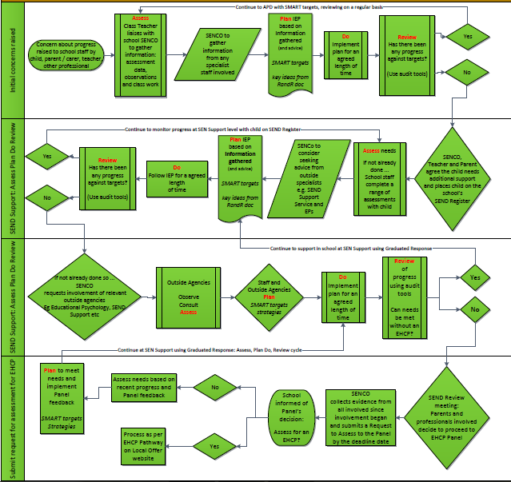

Policy reviewed: June 2020

Agreed by governors: ______________

Next review date: June 2022

