Wednesday 30th March 2022

Dear Parent / Carer,

We would like to thank you all for your continued support throughout the School Year.
We hope you all have a well deserved break and remember to stay safe.

Attendance

Reception | 93.24%
Year 1 | 92.32%
Year 2 | 94.12%
Year 3 | 92.57%
Year 4 | 94.92%
Year 5 | 92.96%
Year 6 | 95.52%
School Total | 93.61%
Target attendance 96%

Attendance is highly important for children, to achieve the best opportunities in life and to maintain friendships. Children should be attending school each day and arriving to school on time.

Staff Updates
We are saying our goodbyes to Miss Hall this week as she starts her role in a new school in April. Thank you for everything you have done throughout your time with us.
We wish you all the best for the future and you will be missed by everyone!
Year 1 will be covered by Miss Waka, who has been with us previously in Reception and Year 4.

Miss Noblett has had a healthy baby boy and they are both doing well.
Miss Maher starts her maternity leave this week. We would like to say a big Congratulations and good luck!

Pupil Voice

A message from our Headboy and Headgirl:

After School Clubs

Please see our list of After School Clubs for the Summer Term. We would appreciate payment for all clubs to be made on the day.

Tuesday | Multi Skills | Year 1 & 2
Wednesday | Cricket | Year 3, 4, 5 & 6
Thursday | Olympic Games | Year 1 & 2
Friday | Team Games | Year 3 , 4 , 5 & 6

You can sign up for clubs on Class Dojo, by replying to the message posted on Tuesday 29th March

Easter Bonnet Parade
We will be holding our parade on Friday 1st April in school from
1:00pm- 1.45pm.
We are looking forward to seeing our children’s “eggciting” entries.
Please come and join us!

Family Learning 2022

We would like to say a really big thank you to all the parents/carers that attended the HENRY and ESOL courses. It was a great success, thank you for your positive feedback and we hope to see you again on future courses.

New Courses

Please look out for our new courses which will begin in May 2022. We also have a day course called “Fussy eaters” on Wednesday 27th April 2022 in school. Miss Dean will be sending you all invitations through Class dojo and Facebook with instructions on how to sign up.

Uniform

We are seeing an increase in the amount of children coming into school wearing incorrect uniform.
Please send children into school wearing Black School shoes - no trainers, white polo shirts and red cardigan/ jumper.

Leggings can be worn for PE days- However, please be reminded that these MUST be plain black with no writing.

Correct Uniform

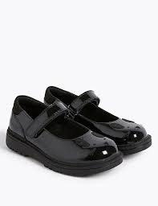
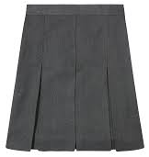
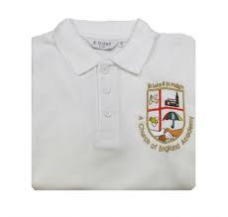
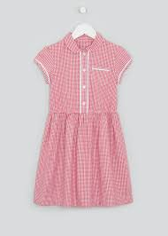

Correct PE kit
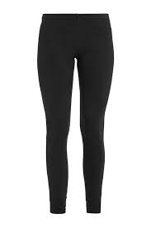
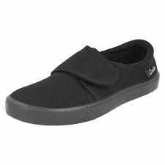

Winmarleigh Residential Trip 2023

We have provisionally booked the dates for our Year 6 trip to Winmarleigh for 2023 – 2nd 3rd and 4th November 2022
The children all had a fantastic time on our latest trip, please ask them what they enjoyed and reserve your place. Letters will be coming home after the Easter holiday.

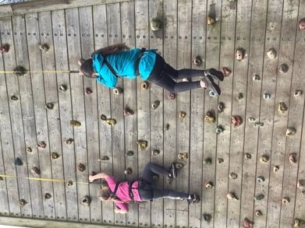

Keeping our School clean and tidy

Please help us to keep our School area looking clean. Please be vigilant with litter and remember to throw all rubbish in bins. Please also let us know if you see anyone littering around our School grounds.

Easter Holidays
Please note- Children are to be collected from school at 2:00pm on Friday 1st April for the holidays.

School reopens on Tuesday 19th April with Breakfast Club starting at 7:50am.

Juniors will be able to enjoy a “grab and go” Bagel as they arrive in to class each day after Easter.

Please remember

Tuesday 19th April – School Re-opens
Monday 2nd May- School Closed for Bank Holiday

