Tuesday 25th January

Dear Parent / Carer,

Welcome to 2022. It is lovely to have all our children back in school and working hard. We are looking forward to seeing what the rest of the year will bring.

Attendance
Year group | Attendance
Reception | 92.1%
Year 1 | 93.3%
Year 2 | 93.8%
Year 3 | 92.3%
Year 4 | 94.1%
Year 5 | 93.2%
Year 6 | 94.9%

Our target is 96% so we are not quite reaching target! We need your help to improve attendance for our school. You can help by coming to school every day and on time.

After School Clubs for Spring.

Day | Club | Year group | Cost
Tuesday | Multi – skills | Year 1 / 2 | £2 per session
Wednesday | Library Club | Year 3 / 4 / 5 / 6 | No charge
Wednesday | Dodgeball | Year 3 / 4 / 5 / 6 | £2 Per session
Thursday | Invasion Games | Year 1 / 2 | £2 Per session
Friday | Jag Tag | Year 3 / 4 / 5 / 6 | £2 Per session
Please ensure payment is made on the day of each session.

Our Worship Theme for this term is:

Truthfulness

“Rather than love, than money, than fame, give me truth”. Henry David Thoreau

Admissions

Please be reminded- September 2022 admissions should have been completed by January 15th 2022. If you have or know of a child who is due to start school in September 2022 and an application has not been completed, please contact school.

A message from our Head Boy and Head Girl :

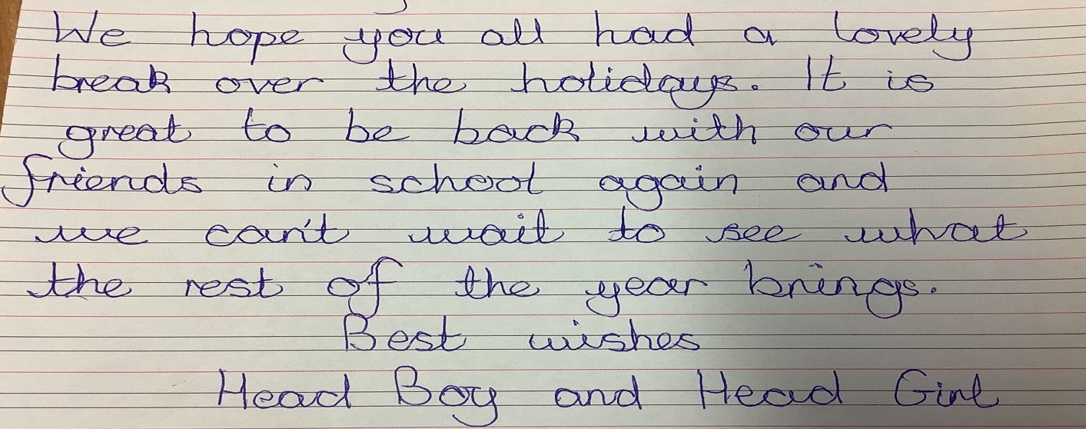

Breakfast Club

Our Breakfast Club is currently open every day for all children from 7:50am. Please contact the office if you would like your child to attend.
The cost of this is £1 per session or 50p if your child is entitled to Free School Meals.

Smart Watches

Please can we remind all parents that the use of Smart Watches by children is not appropriate in school due to the risk of loss, damage and misuse, in the same way as mobile phones or tablets.

School Uniform

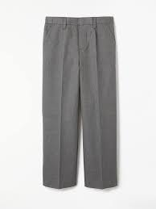
We would like to remind you of our school uniform rules as it has been noted that several children are not wearing the correct uniform for the school. Below is a reminder of the uniform and expectations for all children.
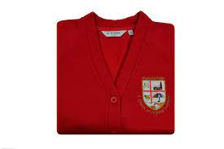
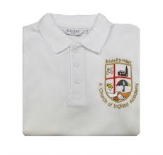
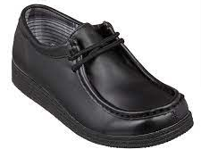
Uniform:
-Black school shoes (not trainers).
- Red school jumper
- White polo shirt
- Grey pants / skirt.
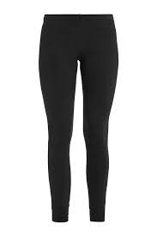
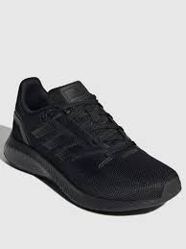
PE Kit :
-Plain white t-shirt
-Black trainers
-Black joggers / leggings

Parent Governor vacancy

Unfortunately we have had to say goodbye to one of our Parent Governors , Hina Suleman. Thank you for all your support and valuable opinions. Best of luck with your future career.
Miss O’Connell and all the Governors of St Luke’s.

Due to this we are looking for a passionate parent to join us on our Governing Committee. Please contact the office for further information.

Free School Meal vouchers

Free School Meal vouchers will be available from school from Wednesday 2nd February for the ½ term holiday if you are entitled to Free School Meals- Not Universal Free School Meals.

Dates for the Diary

Chinese New Year - Reception assembly - Tuesday 1st February – This will be recorded and available online for parents to watch.

Valentines Disco - Wear red - Thursday 10th February

Half term - Your children will finish on Thursday 10th February at 3:30pm due to a staff inset day on Friday 11th February

School Re-opens - Monday 21st February with Breakfast club opening at 7:50am.

