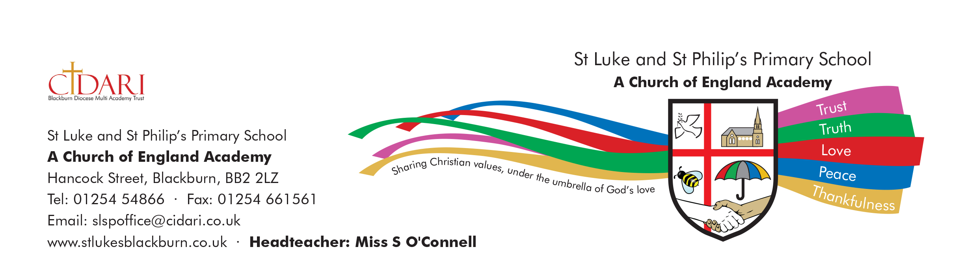
St Luke and St Philip’s Church of England Primary Academy
Admissions Policy

This policy sets out the admission arrangements for St Luke and St Philip’s C of E Primary Academy in 2022/2023. It applies to applications to start in Reception in September 2022 as well as “In Year” applications; it also includes details of the over subscription criteria, waiting lists and the appeals process.

