Timetable of school day – Reception (school finishes at 3:30)
 | 8:55 | 9:05 | 9:30 | 11:00 | 11:30 | 11:45 | 12:45 | 1:00 | 1:30 | 3:00
Mon | Register | Dough disco and phonics | Independent learning time | Maths key worker  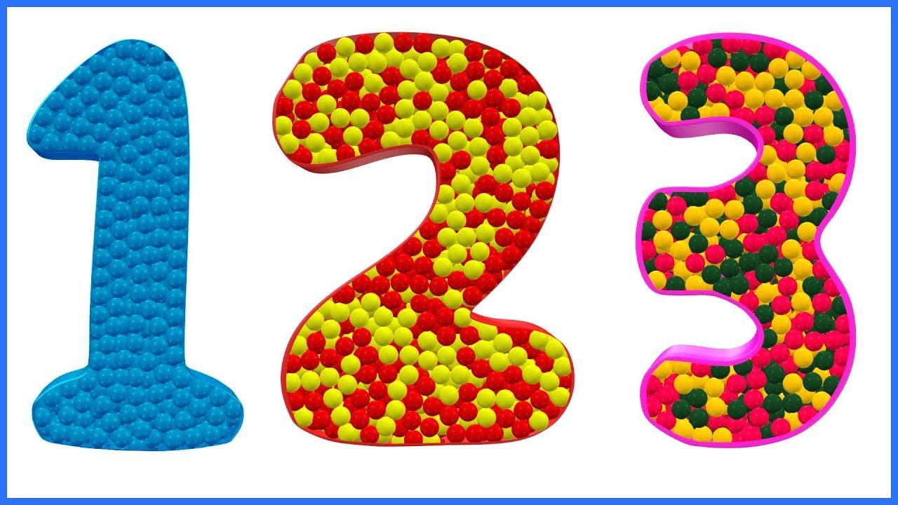  groups | wash hands | Lunch | Register and topic / key worker groups. |  | Gymnastics  (1.45)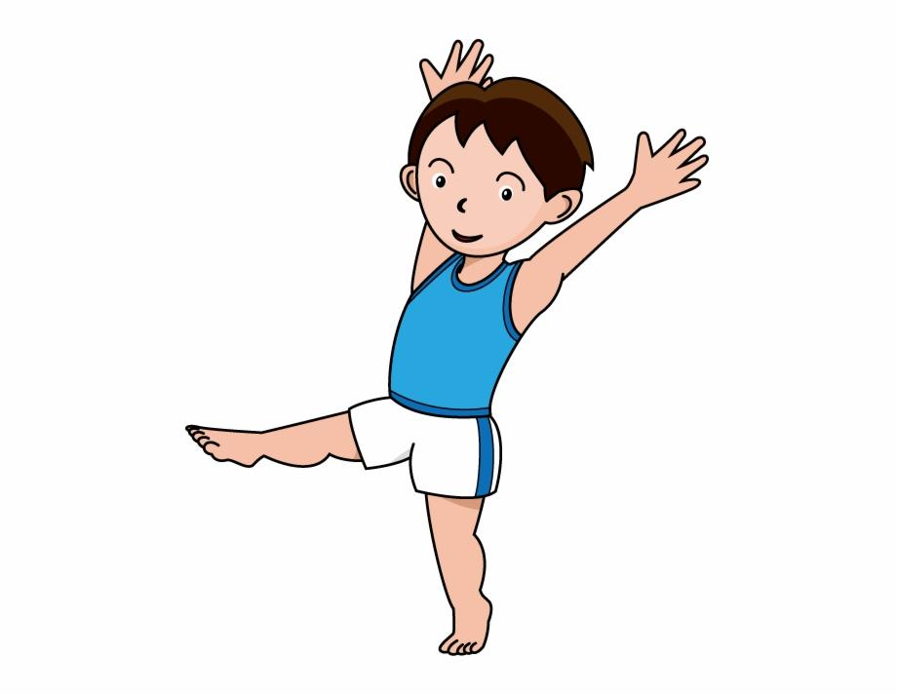 | Story
Tues | Register | Dough disco and phonics | Independent learning time | Maths key worker  groups | wash hands |  | Register and topic / key worker groups. | Independent learning time |  | Story
Wed | Register | Dough disco and phonics | Independent learning time | Maths key worker  Groups | wash hands |  | Register and music  (1.20 – 1.50) |  | Independent learning time | Story
Thurs | Register | Dough disco and phonics | Independent learning time | Maths key worker  groups | wash hands |  | Register and topic / PSHE | Independent learning time |  | Story
Fri  Celebration assembly | Register | Assembly | Independent learning time | Dough disco and phonics | wash hands |  | Register and R.E | Independent learning time |  | Story

