Friday 10th September

Dear Parent / Carer,
A BIG welcome to our new parents and welcome to our SCHOOL FAMILY! It’s always a nervous time sending your child to school for the first time but by all accounts they seem to have settled into school life well and are having lots of fun!
Uniform
Please make sure all children are coming into school wearing the correct uniform. We have noticed a few children wearing trainers instead of school shoes. Following phone calls home teachers will be asking children to change into either their own or school pumps if we see this happen on more than one occasion.
School uniform : red school jumper, white t-shirt, grey trousers or skirt and black school shoes (not trainers).
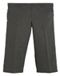
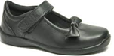
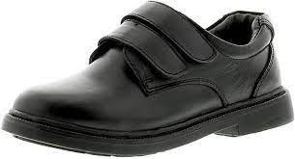

PE days
Following the same system as last year children in Years 3,4,5 and 6 will come into school wearing their school PE kit on the days they have PE. Following our school uniform we are asking children to wear dark trainers and black leggings or tracksuit bottoms with a white t-shirt and their school jumper on these days.
Monday Multi Sports KS1 (Year 1 & 2 ) | £1 Per session
Tuesday Multi sport KS2 (Year 3, 4, 5 & 6) | £1 Per session
Wednesday Drama club KS2 (Year 3,4,5,6) | £1 Per session
Wednesday Netball club (Year 5 & 6) | £1 Per session
Wednesday Football club KS2 (Year 3,4,5 & 6) | £2 Per session
Thursday JagTag club KS1 (Year 1 & 2) | £2 Per session

Payments for all After School Clubs are due weekly and if you can use Parentpay we appreciate it. If you have difficulties using Parentpay please talk to our school office where they are always ready to help.

New to you
Do you have any school uniform that is in good condition that you would like to donate?
We hope to arrange a ‘NEW TO YOU’ shop in the near future so welcome any unwanted school items. Melissa and Morag in the school office will very kindly take these off your hands.

School photos
Its photo time at St Lukes on Wednesday 15th September. Individual, class and family photos will be taken on this occasion so please make sure all children are looking SPICK and SPAN ! If there are younger siblings you wish to join in the photos please contact the office for further information.

Do you fancy a slice of cake and a brew?
Derian House remains our school charity and we will be holding our first charity event for Derian House on Friday 24th September. Come and join us from 2.30pm in our school hall to help us to raise money for this worthwhile charity. Any cake donations will be gratefully appreciated and given to the school office on Friday 24th am.
Walk & Bike to school day
Does your child have a bike or scooter? If so,please join us on Wednesday 6th October for Bike to school day. Your child can ride their bike or scooter for the day. Please remember to bring a helmet!
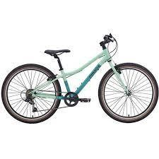
All bikes and scooters will be kept safe in school throughout the day.

Pupil Voice
Please say a huge hello to our new Headboy and Headgirl - Lily G and Taahaa. They are looking forward to writing in our newsletters informing you of our school life here at St Luke and St Philip’s. Take a look at what they have written since returning to school.

School Council and Worship Team
We would like to say a big well done and congratulations to our new School Council members and Worship team members!
Let's meet our school council team : Year 2 - Harvey & Adeeba Year 3 - Zuzanna & Martin
Year 4 - Alicja & Mark Year 5 - Abdullah M & Vanesa Year 6 - Angela & Eduard.
Let's welcome our Worship team: Year 2 - Mine Year 3 - Lexus Year 4 - Amanda Year 5 - Jan Year 6 - Skye.

Our Worship theme for this term is:
Thankfulness

Dates for the Diary
Tempest Photography – Wednesday 15th September
Derian House Coffee & Cake Event – Friday 24th September
Bike to School Day – Wednesday 6th October
Bedtime Stories- Thursday 14th October - More information will follow shortly.
Harvest Festival – Friday 15th October in school
Parent Meetings - Tuesday 19th October at 1.00pm -3.30pm
- Wednesday 20th October at 3.30pm – 6.30pm
Half Term Holiday - Friday 22nd October - Friday 29th October

