26th March Newsletter.
St Luke and St Philip’s Primary School, A Church of England Academy,
Hancock St, Blackburn BB2 2LZ.
Phone: 01254 54866.
Dear Parent/Guardian,
We would like to say a big thank you for all of your support since the children have returned to School. Luckily we have not had to close any of our classrooms. We can help to keep it this way by being extra vigilant. If your child is showing any symptoms of Covid, please get them tested. If anyone in your household tests positive or is waiting for a test result then please follow the isolation guidelines. For any other concerns regarding Covid, please contact the office.
Reception attendance | 97.23%
Year 1 attendance | 97.16%
Year 2 attendance | 97.21%
Year 3 attendance | 92.44%
Year 4 attendance | 96.86%
Year 5 attendance | 98.49%
Year 6 attendance | 92.25%
Attendance Target attendance 96% Overall attendance 96.52%

End of Term.
School will close for the Easter holidays on Friday 26th March. There will be a staggered finishing time.
Please see the timetable below. Collection from normal school gates.
Class | Collection time.
Reception, Year 2 and Year 6. | 1:40PM
Year 1 and Year 5. | 1:50PM
Year 3 and Year 4. | 2:00PM
Start of Term.
All children will return to school on Monday 12th April. Please see the timetable below.
Breakfast club for those already attending starts at 7:50am prompt.
After School Clubs.
Our current After School Clubs will continue after the Easter holidays. These will run up to and including Friday 30th April.
We will keep parents informed of all new and upcoming clubs on Class Dojo and Facebook.
PE days.
Class | Class PE day.
Reception | Monday & Friday
Year 1 | Tuesday & Thursday
Year 2 | Wednesday & Thursday
Year 3 | Monday & Friday
Year 4 | Monday & Friday
Year 5 | Tuesday & Friday
Year 6 | Tuesday & Friday
Please send your child to school in the correct clothing each day. If your child has After School Club, they are able to come to school in their PE kit on the day. Please see details below.

Parents meeting.
Thank you to all parents who took part in the recent Virtual Parent Evening appointments. We hope you all found it beneficial in these difficult times. It was great to see 85% of parents signing up for an appointment. For anyone who had technical issues, we are arranging another evening for Thursday 15th April and will send out further details over Facebook and Class Dojo.

Money raised from our recent raffles.
Thank you for all your kind donations towards Red Nose Day and the chocolate raffle.
Red Nose Day raised a huge £296.69.
Our Chocolate Raffle raised a massive sum of £224.80.

Fly-Tipping.
As you may be aware of the issues we are having with fly tipping outside School, we are asking for parents to contact the Environmental Services or Police over anything suspicious.
This will be greatly appreciated and will help to keep our school grounds looking clean and tidy.

Free school Meal vouchers.
These will be given out to parents who are entitled to Free School Meals - (not Universal Free School Meals) throughout this week. £30 of vouchers to use on Blackburn Market. Please collect at the office.
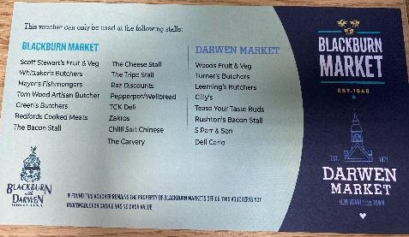
Holiday Club.
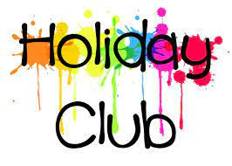
Would you like your child to join a holiday club? We have decided to look into a holiday club to help with childcare over the school holidays. This would possibly be for May half term and possibly the summer holidays.
This would be charged at £11 per child per day and would be run by Edstart(who are currently running one of our much loved after school clubs- Jag Tag)
Miss Hall will be providing parents with a questionnaire after the Easter holidays to gauge peoples interest and decide if this is a viable option.
Pupil voice.
Easter is a time to remember about how Jesus let us start a new beginning and taught us about being a better person.
We hope you have a lovely Easter holiday and we can’t wait to see you back in school on April 12th. (Remember not to eat too many Easter eggs).
Aysha and Daniel.
Head boy and Head girl.

Our Worship Theme for next term is:
Trust
Dates for the Diary.
End of term: Friday 26th March.
Return to school: Monday 12th April.
We hope you all have a lovely Easter and remember to stay safe.

