3rd February Newsletter.
St Luke and St Philip’s Primary School, A Church of England Academy,
Hancock St, Blackburn BB2 2LZ.
Phone: 01254 54866.
Dear Parents/Carers.
We are incredibly happy to welcome back all our children on Monday 8th March 2021 and we are looking forward to getting to some form of normality and face to face teaching. Thank you all for your enormous efforts in keeping your children’s learning going at home.
Of course things will continue to look a bit different due to Covid restrictions and social distancing, but rest assured we continue to work really hard to keep everyone safe.
Below is a reminder of what you can expect in school.

Reopening of school.
As you may be aware, with the recent Covid updates, ALL children WILL be returning to school on Monday 8th March 2021. The arrangements will be the same as the autumn term, with staggered start and finishing times.

Class | Dropping off/Collecting time. | Location
Reception | 8:40 – 3:10 | Reception gate to infant entrance.
Year 1 | 8:50 – 3:20 | Reception gate to class fire entrance.
Year 2 | 8:40 – 3:10 | Main gate to infant door.
Year 3 | 9:00 – 3:30 | Reception gate to class fire door.
Year 4 | 9:00 – 3:30 | Galligreaves gate to class fire door.
Year 5 | 8:50 – 3:20 | Galligreaves gate to class fire door.
Year 6 | 8:40 – 3:10 | Galligreaves gate to class fire door.

Please could we ask that parents continue with the use of face masks and also remember to socially distance to help keep everyone safe.
Breakfast Club.
We have made the decision to reopen from Monday 8th March from 7.50am. This will remain at limited capacity and is there for those parents who may need help with childcare due to work.
This will start at 7:50am promptly, and there is a charge of £1, or 50p for those on Free school meals. This is to be paid through Parentpay.
We have contacted all parents and carers who used Breakfast Club during the Autumn Term. If you require a place, please contact the school office.

After School Clubs.
Year 3 – Multi Sports. Monday £1
Year 4 – Drama Club. Wednesday £1
Year 2 – Jag Tag. Thursday £2
Year 6 – Gymnastics. Friday £1
All afterschool clubs finish at 4:30pm and are chargeable at £1/£2 on ParentPay.
All clubs will begin week commencing 8th March and run for 7 weeks. If you wish your child to attend a club please ring the school.

Red Nose Day.
As you may know, Red Nose Day falls on Friday 19th March. We will be selling red noses in school noses in school if you would like your child to take part. The noses are new and updated being 100% plastic free.
More details to follow.

Dress down day.
We will be having a non-uniform day on the 12th March. Children are able to come to school in their own clothes for the day. It would be greatly appreciated if chocolates could be donated towards the raffle prizes.

Devices.
As all children will be returning to school, please could any borrowed devices be returned to the school office as soon as possible. We ask that all devices are returned in the same condition in which they left school and these will be checked on return.
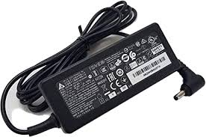

School dinners.
All children in school will have the option of hot school dinners one week, and sandwiches the following week, as we still have to follow social distancing measures within school. Please see the school website for our lunch menus.

Uniform.
We ask for all children wear their full school uniform, except for PE days where children should come to school in their outdoor PE kit. Please check with your class teacher for your PE day
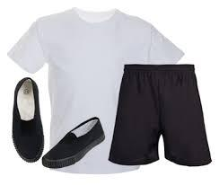
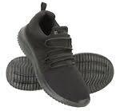

Pupil Voice.
We would like to say that home learning has been very different for all of us but we will be going back to school very soon. Everyone has been working extremely hard at home and the teachers have done a great job too! I hope everyone is excited to come back to school as much as we are.
From Head Boy and Head Girl.

The Worship theme for this half term is: Forgiveness.

Friday 5th March - World book day
Friday 12th March- Non uniform day
Friday 19th March – Red Nose day
School closes on Easter Friday – 26th March at 2.00pm.

