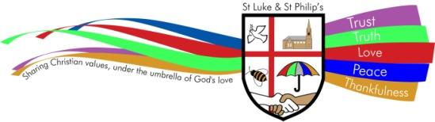

CURRICULUM POLICY

ST. LUKE & ST. PHILIP’S PRIMARY, A CHURCH OF ENGLAND ACADEMY

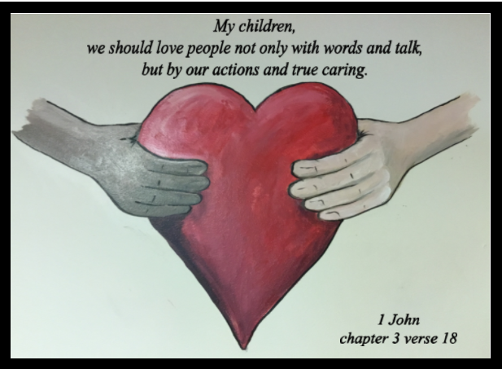

VISION STATEMENT
‘The family of St Luke and St Philip’s will ensure excellence is encouraged, minds are opened, diversity is embraced, respect is expected and talents are nurtured under the umbrella of God’s love.’

ETHOS
Our school provides grounding in the Christian Faith for all its children with emphasis on collective worship as part of its daily life. Our Christian values of trust, truth, love, peace and thankfulness are built into the ethos and teaching of our school with the support of all Governors and staff for its Christian foundation. We also seek to encourage an understanding and respect for other world faiths.

CHRISTIAN SCHOOL VALUES

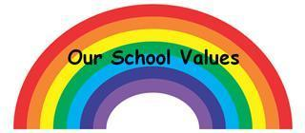

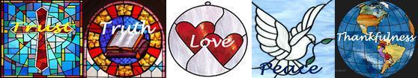

PURPOSE

This policy reflects the values, ethos and Mission Statement of St. Luke and St Philip’s C.E. Primary Academy in relation to the curriculum. It is consistent with the school’s agreed aims and objectives and sets out a framework within which teaching and support staff can operate.

AUDIENCE
This document is intended to give a clear outline of the school’s approach to the curriculum to all staff, governors, Cidari and parents. It is also intended for the use of the School’s Advisory Service when assisting the development of the school’s curriculum and for any authorised inspector. Copies of this document are provided for all teaching staff and are available when necessary to support staff, members of the School’s Governing Committee and Cidari members. A copy of this document is available for the use of parents.

AIMS AND OBJECTIVES

At St Luke and St Philips, we aim to foster a lifelong love of learning, through adopting a highly practical and cross curricular approach to learning. Being a Church of England school, we aim to fulfil all the requirements of the National Curriculum and the Diocesan Syllabus for Religious Education.

We are proud of being a Church academy at the heart of our local community – a place where everyone is valued, respected and encouraged to develop resilience and confidence. Our strong ethos strives to ensure that each pupil achieves their very best.

Academically – through a knowledge rich, focussed and sequenced curriculum.

Culturally – through an extensive programme of extra curricular activities and visits.

Spiritually – through an ethos of interdependence that flows through the life of both the academy and the wider community.
Our exciting and enquiry based curriculum is designed to both engage and challenge our pupils to develop creative and independent thinking through strong oracy skills. We endeavour to nurture a thirst for learning in all our pupils.
The broad content of the curriculum is enriched by covering a wide range of subjects, talents and future careers. We realise that in order for our pupils to lead in tomorrow’s world they will need to demonstrate compassion, understanding, empathy and innovation.
Success, progress and celebration are very much at the heart of what we do.

CURRICULUM INTENT

The curriculum -
- follows the National Curriculum as its foundation,
- has been personalised to meet the needs of our pupils, ensuring learning is meaningful and in context with our pupils’ lives,
- follows a sequence that builds on knowledge and skills throughout and across the key stages,
- is designed to be inclusive for all pupils, including boys and girls, those with SEND, socially disadvantaged backgrounds, different cultures and religions,
- ensures knowledge is retained through the high quality teaching of a broad vocabulary, and through making meaningful links with other topics,
- prepares pupils for their future learning by ensuring all necessary knowledge and skills are taught in preparation for the following learning phase, and by developing the key cognitive skills of independence, creativity, problem solving, analysis and evaluation,
- creates an air of excitement and a love for learning.

IMPLEMENTATION

- The curriculum is taught through discrete teaching of English, Maths, RE, PE and French, however where an English unit fits with a curriculum topic, teachers will deliver the lessons during the same half term. Cross curricular Maths and English is taught through topics.
- Our curriculum aims to make tangible links between the subjects Geography, History, DT and Art. Each term starts with Geography first - looking at the ‘here and now’ and follows with History, ensuring Geographical knowledge can be used through the History unit.
- Science, PSHE and Music are also taught discretely however if there are tangible links with a curriculum topic, teachers will deliver these topics in the same half term.
- All computing skills are taught through the curriculum subjects of Geography and History, apart from Coding, which is discrete.
- Topic boxes from the Library Service are loaned each term to ensure there is a wide range of age appropriate books matching topics, promoting reading within the curriculum.
- Whole school themed days/events will occur on a regular basis to promote a particular curricular area, in accordance with the School Improvement Plan and key priorities.
- Homework is given linking to the curriculum to consolidate learning, encourage research and promote creativity.
Ensuring effective learning -
- Pre-Teach Vocabulary strategies are used whole class to teach topic specific vocabulary and also additional sessions are delivered to further embed the vocabulary for identified pupils. Vocabulary games are embedded throughout lessons to encourage children to make conceptual links, in turn aiding memory and making knowledge stick.
- Each topic is enriched with a ‘wow’ experience; through either a class trip, visit to a local area of interest within the community or a special visitor coming into school. Parents and members of the local community are invited into school where fits a topic. Where possible, lessons are practical and use interactive resources and artefacts, and visual and auditory stimuli. Outdoor learning is encouraged.
- At the beginning of every topic, pupils complete a pre-topic assessment activity to evaluate prior knowledge and inform planning, followed by a post-topic assessment activity to evaluate the learning.
- Knowledge organisers are used for every Geography, History and Science lesson, providing subject specific vocabulary and sticky knowledge.
- Oracy techniques are incorporated throughout daily lessons to develop confidence and clarity of thought and speech using quality vocabulary.
- Kagan structures are incorporated throughout daily lessons to encourage positive interdependence, individual accountability, equal participation and simultaneous interaction.
- Problem-solving activities are actively incorporated within topics, allowing the children to use and apply learnt knowledge, further embedding it. This also develops and enhances the key cognitive skills of independence, creativity, problem solving analysis and evaluation.
- Children know what they are going to learn and why. (Objective)
- Children know what they need to do to be successful. (Steps to Success)
- Expectations should be high and spontaneity should be encouraged.
- Children should have time to reflect and review their learning.
- The learning environment should be well-organised, attractive, stimulating and positive.
- Displays celebrate children’s work - at all levels - as well as key vocabulary and knowledge for the topic.
- Children are encouraged to be active and responsible for their own learning and progress.

IMPACT

- Pupils’ books are marked in accordance with the Marking and Feedback policy, noting where objectives have been achieved independently or with support, and giving next steps to further the learning. Class teachers track the progress and attainment using an internal assessment system of ‘working towards’, ‘working at’ and ‘greater depth’.
- Subject Leads analyse the data to monitor the progress and attainment of their subject across school, giving feedback and support where necessary.
- Pupils’ learning and the impact of teaching and learning is monitored by Subject Leads, Senior Lead Team and external advisors in accordance with the Monitoring and Evaluation policy. This involves quality assurance of books and planning, observations of lessons, drop-ins, Teaching and Learning audits and pupil interviews.
- Staff share good practice through ‘Standards Meetings’ where books, plans, resources and ideas are shared.

PLANNING

- The yearly curriculum overview shows the topics to be covered by each year group and is progressive, ensuring knowledge builds over and across key stages. Where it is fitting, the curriculum promotes learning that incorporates a deeper understanding of the history and present times of the local area and important people within it.
- A long term skills overview for each year group has been produced ensuring progression of skills in each subject in accordance with the National Curriculum and is used alongside the yearly curriculum overview.
- Teachers create Medium Term Plans using the two documents mentioned above. Additional resources also provide schemes of work with detailed Medium Term Plans for teachers to use. (e.g. Kent Science SOW, the Royal Geographical Society and Oddizzi Geography resources and Key Stage History.)
- Daily plans are noted in each teacher’s individual Primary Teacher Planner book and are shared every Monday morning with all relevant members of staff working within a class.

EYFS
The Early Years Foundation Stage profile sets out the prime and specific areas of learning as a precursor to the curriculum, with an aim of all children meeting the relevant Early Learning Goals by the end of the year, in preparation for the National Curriculum.

THE ROLE OF THE CURRICULUM LEAD

- Take the lead in policy development;
- Monitor the effectiveness of the curriculum through regular quality assurance checks, feeding back to Subject Leads and class teachers;
- Ensure progression, continuity and consistency throughout the school;
- Support colleagues in their development of planning, implementing and assessing the curriculum;
- Keep up-to-date with developments in curriculum education and disseminate information to colleagues as appropriate;
- Collaborate with individual Subject Leads to
- ensure appropriate resources are in place to deliver a rich and challenging curriculum,
- identify clear links with other subjects to ensure knowledge is transferrable and sequential;
- promote the curriculum and champion all subjects with colleagues and pupils.

RESPONSIBILITIES
- All relevant staff will ensure that the school curriculum is implemented in accordance with this policy;
- The Head teacher is responsible for ensuring that this policy is adhered to;
- Cidari Multi Academy Trust and the governing committee will monitor the effectiveness of this policy and hold the Head teacher to account for its implementation.

INCLUSION AND EQUALITY
Teachers set high expectations for all pupils. Appropriate assessments are used to plan challenging work for all groups, including:
- More able pupils
- Pupils with low prior attainment
- Pupils from disadvantaged backgrounds
- Pupils with SEN
- Pupils with English as an additional language (EAL)
Teachers plan lessons so that pupils with SEN and/or disabilities can study every National Curriculum subject, wherever possible, and ensure that there are no barriers to every pupil achieving.
Teachers also take account of the needs of pupils whose first language is not English. Lessons are planned so that teaching opportunities help pupils to develop their English, and support pupils to take part in all subjects. Class trips and visits linking to subjects are planned to ensure they are inclusive for all.

To ensure equality for all, teachers are committed to planning lessons that:
- Eliminate discrimination, harassment and victimisation;
- Promote equality of access and opportunity within our school and within our wider community;
- Promote positive attitudes to difference and good relationships between people with different backgrounds, genders, cultures, faiths, abilities and ethnic origins.

SPIRITUAL, MORAL, SOCIAL, CULTURAL DEVELOPMENT AND BRITISH VALUES
The school sets out to plan a provision for Spiritual, Moral, Social and Cultural development, but it is also expected that many unplanned opportunities will occur (especially for spiritual development) and staff are encouraged to "seize the moment" when appropriate. Such moments may have a profound effect on individuals.
The promotion of the ‘British Values’ of
- Democracy
- The rule of law
- Individual liberty
- Mutual respect
- Tolerance of those of different faiths and beliefs
is central to our education as British Values have their origin in the Christian values of our nation.

LEGISLATION

This policy reflects the requirements for academies to provide a broad and balanced curriculum as per the Academies Act 2010, and the National Curriculum programmes of study which we have chosen to follow.
It also reflects requirements for inclusion and equality as set out in the Special Educational Needs and Disability Code of Practice 2014 and Equality Act 2010, and refers to curriculum-related expectations of governing boards set out in the Department for Education’s Governance Handbook. In addition, this policy acknowledges the requirements for promoting the learning and development of children set out in the Early Years Foundation Stage (EYFS) statutory framework.

RELATED POLICIES

- EYFS
- Equal Opportunities
- Inclusion
- Special Educational Needs and Disabilities
- SMSC and British Values
- Online safety
- Assessment, recording and reporting
- Marking and Feedback Policy
- Presentation
- Individual subject policies

Policy reviewed: November 2019

Agreed by Governors: ______________

Next review date: November 2021

