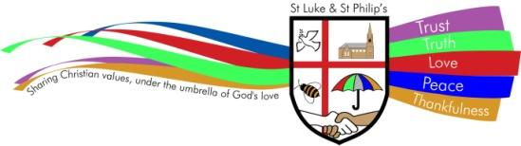

SOCIAL MEDIA POLICY

ST. LUKE & ST. PHILIP’S PRIMARY, A CHURCH OF ENGLAND ACADEMY

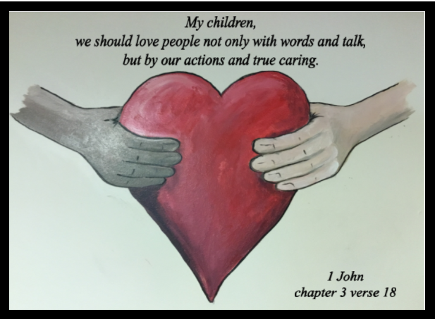

VISION STATEMENT
‘The family of St Luke and St Philip’s will ensure excellence is encouraged, minds are opened, diversity is embraced, respect is expected and talents are nurtured under the umbrella of God’s love.’

ETHOS
Our school provides grounding in the Christian Faith for all its children with emphasis on collective worship as part of its daily life. Our Christian values of trust, truth, love, peace and thankfulness are built into the ethos and teaching of our school with the support of all Governors and staff for its Christian foundation. We also seek to encourage an understanding and respect for other world faiths.

CHRISTIAN SCHOOL VALUES

PURPOSE

This policy reflects the values, ethos and Mission Statement of St. Luke and St Philip’s C.E. Primary Academy in relation to the curriculum. It is consistent with the school’s agreed aims and objectives and sets out a framework within which teaching and support staff can operate.

AUDIENCE
This document is intended to give a clear outline of the school’s approach to the curriculum to all staff, governors, Cidari and parents. It is also intended for the use of the School’s Advisory Service when assisting the development of the school’s curriculum and for any authorised inspector. Copies of this document are provided for all teaching staff and are available when necessary to support staff, members of the School’s Governing Committee and Cidari members. A copy of this document is available for the use of parents.

AIMS AND OBJECTIVES

At St Luke and St Philip’s, we aim to foster a lifelong love of learning, through adopting a highly practical and cross curricular approach to learning. Being a Church of England school, we aim to fulfil all the requirements of the National Curriculum and the Diocesan Syllabus for Religious Education.

We are proud of being a Church academy at the heart of our local community – a place where everyone is valued, respected and encouraged to develop resilience and confidence. Our strong ethos strives to ensure that each pupil achieves their very best.

Academically – through a knowledge rich, focussed and sequenced curriculum.

Culturally – through an extensive programme of extra curricular activities and visits.

Spiritually – through an ethos of interdependence that flows through the life of both the academy and the wider community.
Our exciting and enquiry based curriculum is designed to both engage and challenge our pupils to develop creative and independent thinking through strong oracy skills. We endeavour to nurture a thirst for learning in all our pupils.
The broad content of the curriculum is enriched by covering a wide range of subjects, talents and future careers. We realise that in order for our pupils to lead in tomorrow’s world they will need to demonstrate compassion, understanding, empathy and innovation.
Success, progress and celebration are very much at the heart of what we do.

INTENT

At St Luke and St Philip’s Church of England Academy, our intent is to use social media as one of the many ways to connect and communicate with the members of our school community. We use Facebook and Twitter to engage with our school community on an informal and day-to-day basis. A high percentage of parents and carers are already on Facebook and for the school to be on there too with its own Page, not profile, makes the work of the school easier to access, value, engage with and show the added value of the experiences provided. The page is also an avenue for personal communication and an alternative way of making us aware of any concerns.

OUR CODE OF CONDUCT

All users interacting with our Social Media pages, either by liking or commenting on posts, must do so using an account that clearly identifies them by their real name. People under the age of 13 years are prohibited by Twitter’s and Facebook’s Terms and Conditions from creating an account, therefore the pages are forums for adults to communicate and demonstrate appropriate and positive online behaviour.
The Pages are monitored by the school. All updates and comments are archived and reported on each month in order to demonstrate the reach and topics of conversation in the community. The Facebook and Twitter walls are configured to not allow posting of photographs or videos by parents. It has a profanity filter set to 'high' in place though there is no reason to expect issues from inappropriate content from parents; these are precautionary measures only. The school will add additional words as the need arises. Language use on the page will be more relaxed in tone from the school but will at all times be professional and uphold the school’s reputation and good name. If a person not known to the school or otherwise joins the Page and the school is unhappy or uncertain about the risk associated with them they can be blocked from engaging the Page with immediate effect.
Children’s first names and class can be stated in posts when we wish to acknowledge someone’s great work or community contribution. We wish our Facebook page to be used in building our community. Parents and carers will have agreed to these details being used. Pupils without photographic consent will not be included on any Social Media site.
All teachers operate under a Department of Education Code of Conduct that states that they are to maintain a professional relationship with students and parents, and must refrain from social interaction.

OTHER RELATED POLICIES

Policy reviewed:

Agreed by Governors: ______________

Next review date:

