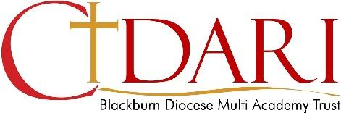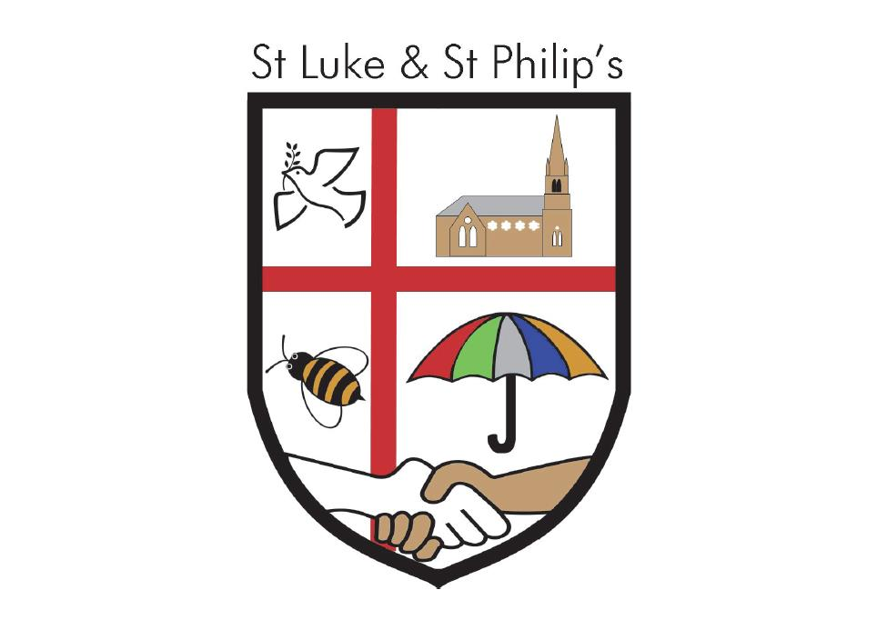

St Luke and St Philip’s
Remote Learning Statement

From the beginning of the Coronavirus pandemic, across Cidari Multi Academy Trust we have been working hard to support our pupils, parents and staff through these unprecedented times - whilst acknowledging that individuals will be living through their own very different experiences.

Some aspects of our education system will be permanently changed by this pandemic, but to navigate the uncertainty generated by the challenges and ensure that learning is continued, irrespective of lockdown or self-isolation, each of our academies has a Remote Learning Policy and each has produced a bespoke and personalised Remote Learning Plan. Each of our academies plans offer remote learning opportunities whilst also acknowledging that some households have limited access to devices and would require hard copies of work and resources. We will endeavour to provide a quality blended learning approach with pupils educated in-academy and for those at home.

All our academies use a common technology framework and an agreed platform for sharing and collaboration. We have chosen to use the Google G-suite and Google Classroom. Our Google infrastructure was already very well embedded in all our academies and is now supported by additional Google plugins and academy wide resources such as Learning by Questions. Wherever possible, we will endeavour to ensure that pupils have access to devices to use at home if needed. We have distributed Chromebooks and laptops and data SIM cards also. We continue to liaise with the Department for Education to secure further devices and internet accessibility.

Each of our school’s Remote Learning Plans will be applied in the following instances:
- A pupil or a household member needs to isolate because someone in their household is symptomatic or tests positive.
- A whole bubble (class of pupils) is self-isolating because of a positive case of coronavirus.
- For all pupils who remain at home for the duration of the national lockdown

Each plan complies with the expectations and principles in the DfE document Guidance for Full Opening of Schools and is geared to providing the mandatory daily remote learning offer of 3-4 hrs at primary level and 5 hrs at secondary level.

Each of our school’s plans aim to mitigate the effect of extended school closure on pupils’ learning and support parents to navigate the challenges of home education. They also support teachers to share resources and collaborate remotely, helping to reduce individual workload and pressure.

To find out more about how your child’s school is delivering remote learning, please have a look on their academy website. You can expect to find the personalised plan for your school along with any support and guidance. In addition, Cidari have a set of remote learning protocols and an Acceptable Use of Remote Learning Policy designed to keep all pupils safe.

January 2021

Please refer to the documents in the Remote Learning Folder:

Remote Learning Policy
Acceptable Use of Remote Learning Policy
Remote Learning FlowChart
Parent Home Learning Booklets

