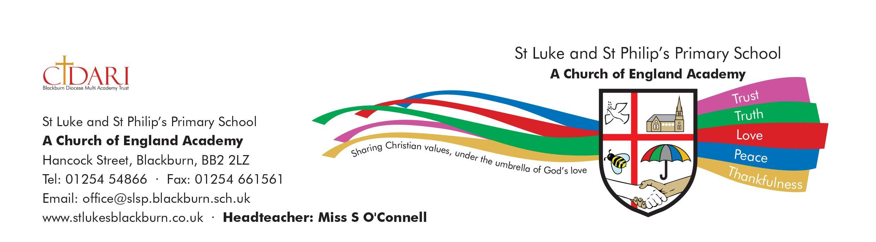
HOLIDAYS 2021 / 2022

AUTUMN TERM 2021

School Re-opens Thursday 2nd September 2021
Half Term Friday 22nd October to Friday 29th October 2021 (inc)
School Re-opens Monday 1st November 2021
Christmas Holidays School closes for Christmas Holidays on Friday 17th December
2021 at 2pm

SPRING TERM 2022

School Re-opens Tuesday 4th January 2022
Half Term Friday 11th February to Friday 18th February 2022 (inc)
School Re-opens Monday 21st February 2022
Easter Holidays School closes for Easter Holidays on Friday 1st April 2022 at
2pm

SUMMER TERM 2022

School Re-opens Tuesday 19th April 2022
May Day Closure Monday 2nd May 2022
Half Term Friday 27th May to Monday 6th June 2022 (inc)
School Re-opens Tuesday 7th June 2022
Summer Holidays School closes for Summer Holidays on Thursday 21st July 2022 at
2pm

INSET DAYS

Wednesday 1st September 2021
Friday 22nd October 2021
Friday 11th February 2022
Monday 6th June 2022
Friday 22nd July 2022

