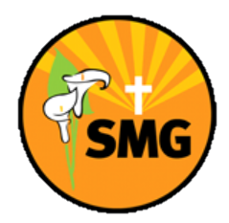
A
20 books to read in 2022/23
KS1: Can you read one of each type of book this year? In the box, write the title of the book you read!
A book with magic

A book with a main female character

A book written about a different country

A funny book

A magazine or comic

A book where a character uses a school value

A book a family member loves

A book with a villain

A book set in the past

A non-fiction book

A poetry book

A book written from before you were born

A wordless picture book

A fairy tale

A book with an animal character

A book with an exciting front cover

A book you would recommend to your teacher

A
20 books to read in 2022/23
KS2: Can you read one of each type of book this year? In the box, write the title of the book you read!
A book you like the front cover of

A book with a main female character

A graphic novel

A funny book

A fantasy book

A book where a character uses a school value

A book a family member loves

A book with a villain

A book set in the past

A non-fiction book

A poetry book

A book written from before you were born

A wordless picture book

A book and its sequel

A book with a one word title

A book set in the future

A book you would recommend to your teacher

