Mental Maths Mondays! – 22nd March 2021

- What is 4 x3 = 4 x 30 = 4 x 300 =
- How many more do I add to 43 to make 100?
- What is the value of the 4 in 432?
-  Write the name of this 3D shape.
- 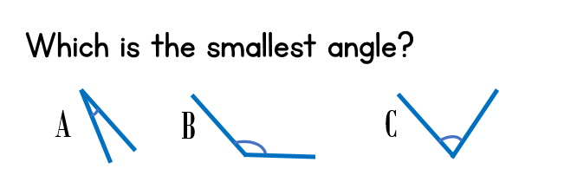
- What is 345 + 100 =

- 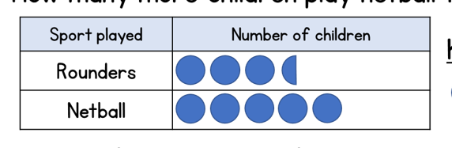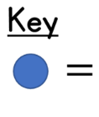
4
How many more children play netball than rounders?
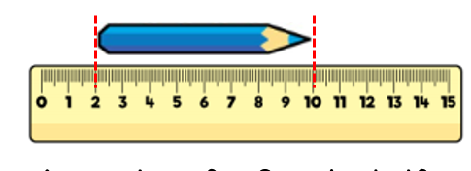
How long is the pencil? _______cm _________mm

- Measure the line below.
_____________________________________________

The line is _______cm _____mm




