Mental Maths Mondays! – 23rd November

- What is 3 x 9 ? What is 30 x 9?

- What is the value of the underlined digit - 965
- Continue the sequence – 105, 100, 95, ___, ___, _____
- How many minutes are there in ½ hour? 2 ½ hours?
- I am thinking of a number. I add 5 and then take away ten my answer is 30. What number did I start with?
- 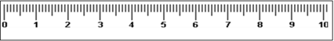
What measurement is the arrow pointing to?
- _ + 8 -= 10 _ + 18 = 20 38 +___ = 100
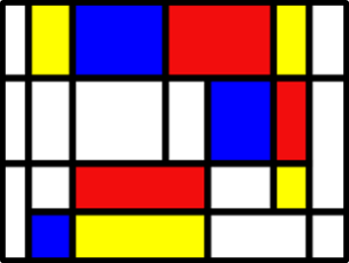How many horizontal and vertical lines can you spot?
- 