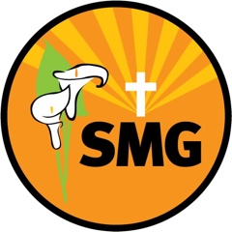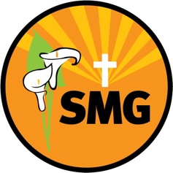
Summer term RE overview

 | Summer 1  20th April – 22nd May | Summer 2  1st June – 17th July
EYFS | To the Ends of the Earth  The Holy Spirit at Pentecost | Dialogue and Encounter  Friends of Jesus
Year 1 | To the Ends of the Earth  Road to Emmaus, Ascension and Pentecost | Dialogue and Encounter  Our Parish/Jewish beliefs
Year 2 | To the Ends of the Earth  How people are changed by the Holy Spirit | Dialogue and Encounter  How Jews live out the beliefs of the Torah
Year 3 | To the Ends of the Earth  How Mass today mirrors Mass of the first disciples | Dialogue and Encounter  Feast of Passover
Year 4 | To the Ends of the Earth  Explore the Apostles | Dialogue and Encounter  The five pillars of Islam
Year 5 | To the Ends of the Earth  The Sacrament of Confirmation | Dialogue and Encounter  The Bible
Year 6 | To the Ends of the Earth  The Sacrament of Confirmation | Dialogue and Encounter  The Bible

