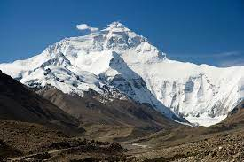
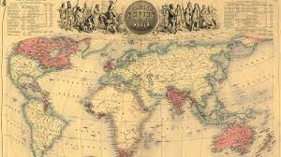
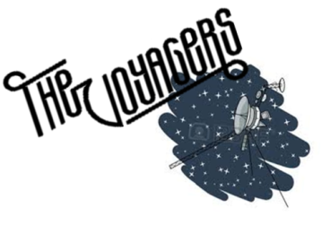
Home Learning Tasks (Voyagers)
The Early British Empire and Mountains
Date due: W/C 06.01.2026
  Be a Regular Reader!  Please read every day. Read a range of books. Make sure that you read aloud too as this is a different skill. You will need to make a note of what you have read under each day in your diaries. Remember when you have finished a book, write a review or tell us about it. | Be a Word Whizz!  Practise the spellings you are given every Friday. You will need to look at these several times a week. We will test on the following Fridays (as a dictation). | Be a Mathematician!  Log on to TIMES TABLE ROCK STARS or TACKLING TABLES and answer a minimum of 100 questions a week. We will check this on a Friday along with your average accuracy score. We will be looking for this to be above 90%. If you have trouble accessing this at home, you can use an iPad at break or lunch times.
Vocabulary quizzes
Voyagers will be having regular quizzes throughout the term to see if they have retained what they have been taught. Please revise the vocabulary on the back of this sheet and their definitions regulary ready for the quizzes!
UK mountains  Draw, print out or save a blank map of the UK and colour where the main mountain ranges are in yellow and brown. Identify and label the peaks using a triangle symbol. | Make a volcano  Make a ‘working’ model of a volcano. Label or explain the key parts and record a video/take pictures of it working.  https://www.youtube.com/watch?v=9b_gltKtERY | Mountain peaks  Research the height of the highest mountain peak in each continent and make a graph to compare their heights.
Be a researcher  Find out about James Wolfe and write down at least seven facts about him. | The Battle of Quebec  Draw a comic strip showing what happened during Britain’s victory at the Battle of Quebec. | The British Empire  Research the countries that were once ruled by Britain and locate them on a world map.
e
The homework grid should be completed within the half term. The compulsory tasks ( ) must be completed each week. You then need to complete at least one additional task from each coloured column by the end of the half term.
- All work needs to be completed in your homework books, photos should be taken and stuck in or drawings and explanations written of models etc.
- Work can be handed in for marking as and when it is completed or by Friday 9th January at the latest.

The Early British Empire and Mountains key vocabulary
The Early British Empire |  | Mountains
Empire | an empire is a group of countries ruled over by a single monarch  or ruler | Peak | the highest point of a mountain
Imperial | belonging or relating to an empire | Range | a group of mountains connected by high ground
Trade | buying, selling or exchanging goods between people, companies  or countries | Erosion | the process of something being worn down or destroyed over time
Colony | a country or area controlled by another country that is often far  away | Topography | the study of the surface of the earth: topography can look at the shape of the land, hills, mountains, valleys,  rivers etc
Slave | a person who is considered to be owned by another person and has  to obey them | Plate boundary | scientists believe the earth’s crust is split into plates, and where these plates meet (at a plate boundary)  there can be mountain ranges formed
Slave |  | Machu Picchu | a famous Inca city built on top of a mountain in the Andes
Slave |  | Mount Kilimanjaro | the tallest mountain in Africa
Merchant | a person involved in trading goods | Mount Kilimanjaro | the tallest mountain in Africa

