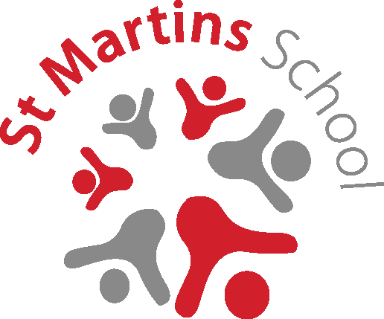
Is your child eligible for Free School Meals?

How do I find out?
Your child might be able to get free school meals if you get any of
the following:
- Income Support
- income-based Jobseeker’s Allowance
- income-related Employment and Support Allowance
- support under Part VI of the Immigration and Asylum Act 1999
- the guaranteed element of Pension Credit
- Child Tax Credit (provided you’re not also entitled to Working Tax Credit and have an annual gross income of no more than £16,190)
- Working Tax Credit run-on - paid for 4 weeks after you stop qualifying for Working Tax Credit
- Universal Credit
How do I apply?
If your application for Free School Meals is successful, St Martins School will also receive extra funding from the Government to use in support of teaching and learning for your child (Pupil Premium).

Parents / Carers can apply online at https://www.cloudforedu.org.uk/ofsm/link2ict or by completing a form
at Reception.

Alternatively, please make an appointment with our Family Support Worker, Marie Chadwick, for help with completing your application.
What if my child already receives Free School Meals?
St Martins are changing the way Parents / Carers apply for Free School Meals – you may be asked to complete a new Free School Meals form to give school permission to apply online on your behalf before your eligibility period finishes.
If you are not sure about any of the above, please come and ask us
in school.
In accordance with the EU General Data Protection Regulation 2018 (GDPR) all data is kept securely and only shared with organisations in order to process your application, please see our school website or the school office for further information on where/how long your data is kept for.

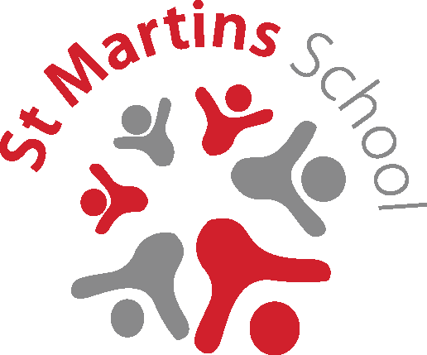
ST MARTINS SCHOOL

APPLICATION FOR PUPIL PREMIUM & FREE SCHOOL MEALS (one application per student)

Details of PARENT / CARER in receipt of Benefit Claim:
Title: Mrs Ms Miss Mr Other
First Names:
Surname:
Address:
Post Code

National Insurance / Asylum Seeker Number:
Date of Birth (Parent/Carer): //

STUDENT DETAILS:
First Names:
Surname:
Date of Birth (Student): //

Declaration
- I understand that my entitlement to free school meals will only continue as long as I receive one of the relevant Support Payments (see over).
- I will inform you immediately if my entitlement to any of the Support Payments is terminated.
- I will inform you immediately if I change my address.
- I declare that I am legally responsible for the child/children I am claiming for
- I give permission for school to apply on my behalf using the online FSM system.
I certify that the above statement and information given by me on this form is complete and true and I authorise St Martins School to take such steps, as they consider necessary to verify the same.
Parent/Carer Signature: | Date:
For Office Use:
Date application received
Date authorised
Reference Number:
Pease return completed form to:
The School Office
St Martins School
The Derwent Campus
Bracknell Drive
Alvaston
Derby DE24 0BT

