Reception Curriculum Overview 2024- 2025

 | Reception
 |  | Term 1  Potential Theme:  Homes/ starting school and Harvest | Term 2  Potential Theme: Autumn and Christmas |  | Term 3  Potential Theme: Winter Potential Theme  Potential Theme: Transport |  | Term 4  Potential Theme:  Journeys and maps/woodlands |  | Term 5  Potential Theme: plants and growing |  | Term 6  Potential Theme: Bees  Potential Theme: Africa
Literacy | Talk4Writing Text Focus | Nursery Rhymes (2 weeks)  Owl Babies (3 weeks)  Little Red Hen 3 weeks | The Leaf Thief  The Gingerbread Man  Stick Man |  | Lost & Found,  Naughty Bus |  | Little Red Riding Hood  The Gruffalo |  | Jack and the Beanstalk  The Extraordinary Gardener |  | Betsy Buglove Saves the Bees. (3 weeks)  Bee (non-fiction)  2xweek  We’re Going on a Lion Hunt – 3 weeks
 |  | 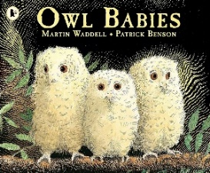  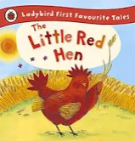  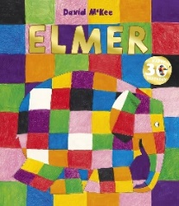 | 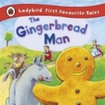  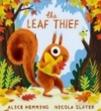  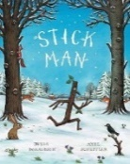  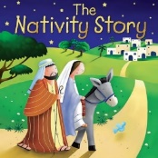 |  | 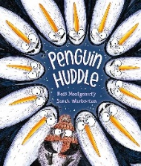  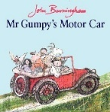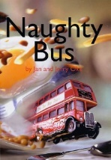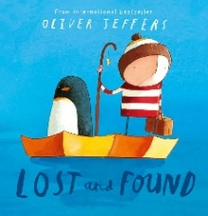 |  | 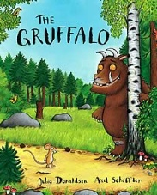  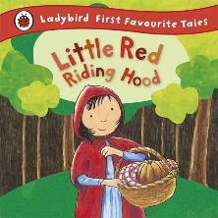 |  | 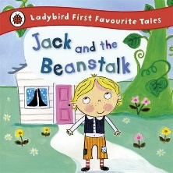  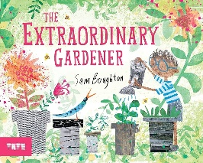 |  | 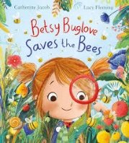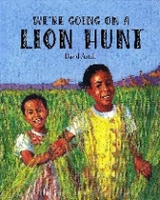  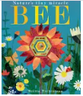
 | Writing focus | Orally retell a story  Write initial sounds | Orally retell the story using story map  Write words / label  Write a list |  | Orally retell the story a using story map  Write a sentence |  | Orally retell the story a using story map  Write a description |  | Orally retell the story a using story map  Recount the story |  | Orally retell the story a using story map  Recount and  Innovate the story
Maths | Number | Numbers to 5 | Numbers to 5/10 |  | Numbers to 8/10 |  | Numbers to 10 |  | Numbers to 10 |  | Numbers to 15/20
 |  | Subitising – dice patterns  5 Frames  Finger patterns 1 – 5  Numberblocks  Number and Place Value  Reading and Writing Numerals  Numicon  Comparing and Ordering Numbers  Oral Counting  Object Counting  Talk Pictures  Addition and Subtraction | Subitising – non-standard dot patterns  10 Frames  Finger patterns 1 – 10  Numberblocks  Number and Place Value  Reading and Writing Numerals  Numicon  Comparing and Ordering Numbers  Oral Counting  Object Counting  Talk Pictures  Addition and Subtraction |  | Subitising – non-standard dot patterns  10 Frames  Finger patterns 0 – 10  Numberblocks  Number and Place Value  Reading and Writing Numerals  Numicon  Comparing and Ordering Numbers  Oral Counting  Object Counting  Talk Pictures  Addition and Subtraction |  | Subitising – dot talk  10 Frames  Finger patterns 0 – 10  Numberblocks  Number and Place Value  Reading and Writing Numerals  Numicon  Comparing and Ordering Numbers  Oral Counting  Object Counting  Talk Pictures  Addition and Subtraction |  | Subitising – non-standard patterns  10 Frames  Finger patterns 0 – 10  Numberblocks  Number and Place Value  Reading and Writing Numerals  Numicon  Comparing and Ordering Numbers  Oral Counting  Object Counting  Talk Pictures  Addition and Subtraction  Multiplication and Division (Doubling and Halving) |  | 10 Frames  Quantities from 0 -20  Numberblocks  Number and Place Value  Reading and Writing Numerals  Numicon  Comparing and Ordering Numbers  Oral Counting  Object Counting  Talk Pictures  Addition and Subtraction  Multiplication and Division (Doubling and Halving)
 | SSM | Spatial Reasoning Aspect 1: Understanding Relationships  Spatial Reasoning Aspect 2: Language  Spatial Reasoning Aspect 3: Spatial Memory  Spatial Reasoning Aspect 4: Sense of Direction  Spatial Reasoning Aspect 5: Spatial Representations
 |  | Measure  Pattern | Measure  Pattern |  | Measure  Pattern |  | Measure  Pattern |  | Measure  Pattern |  | Measure  Pattern
UTW | Science  (Units are interchangeable) | Weather and Seasons  Animals  Food  Forces  Health and Safety  Insects and Invertebrates  Machines  Materials  Our Body  Plants  The Senses
 | History | Peek into the Past  Adventures Through Time
 | Geography | Exploring Maps  Outdoor Adventures  Around the World
RE | Time to Celebrate | What makes us special? |  | What are special times? |  | Why are some places special? |  | What makes the world special? |  | Why are some things special? |  | Why are some stories special?
EAD | Art | Mark Making using a variety of media  Painting and Mixed Media  Sculpture and 3D  Cutting, Threading and Joining
 | Crafts | Autumn Wreath |  | Salt Dough Decoration |  | Threaded Snowflake |  | Egg Threading |  | Suncatcher |  | Salt Painting
 | Design and Technology | Structures  Cooking and Nutrition  Textiles
 | Crafts | Hibernation box |  | Sliding picture |  | Flower threading |  | Hanging decoration |  | Designing a rainbow salad |  | Making a rainbow salad
Music | Singing, moving and playing, using a variety of known and new songs, simple songs for accurate pitching and an eclectic mix of recorded music to listen, move and play instruments to, connecting to curriculum themes
PE | Fundamental Movements  Walking, Skipping, Hopping, Jumping, Side Stepping | Basic Ball Work  Throwing, Catching,  Rolling  Coordination |  | Gymnastics  Balance  Movements  Jumping |  | Team Games  Learning basic rules  Working as a team |  | Social Awareness  Moving safely  Moving Confident  Changing different directions |  | Gymnastics  Develop balance  Develop agility  Develop coordination
PSHE | Jigsaw | Friendships |  | Mental Health |  | Healthy Lifestyles |  | Families and Close Positive Relationships |  | Shared Responsibilities |  | Communities
Festivals/Celebrations |  | Harvest  Diwali |  | Harvest Festival  Diwali  Christmas  Bonfire night |  | Easter  Shrove Tuesday  Holi  Lunar New Year |  | Easter  Shrove Tuesday  Holi |  |  |  | Graduation  Transition
Experiences |  | Welly Walks  Walk around the school |  | Welly Walk  Walk around the school field |  | Welly Walk  Walk around the local area  Dentist |  | Welly Walk  Walk around the local area  Pizza Express |  | Welly walk |  | Caterpillars  Farm Visit

