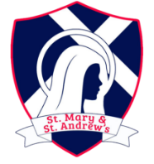
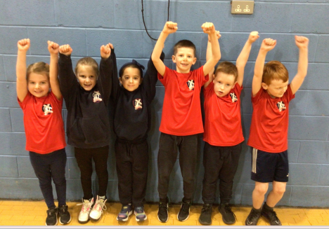
SMSA SPORTING NEWS | ISSUE NO:1 | FEBRUARY - 2024
THANK YOU to our wonderful SMSA family community for all of your encouragement and support not to mention the invaluable logistical contributions on competition days.

A HUGE well done to Robins multi-skills team who could not have done a better job representing school. They showed super sport -ship and won FIRST PLACE. What a way to kick off the year. Thank you Emmy, Ronnie, Emily, George, Kaitlyn and Arron
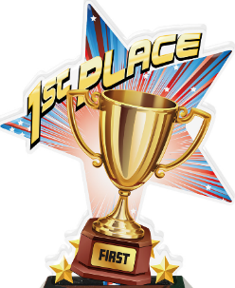

Congratulations to biathlon medal winners Isabel (Eagles) and Lexie (Owls). What an impressive achievement to score so highly competing against all North-West schools. We await news of the National Finals. Good Luck!

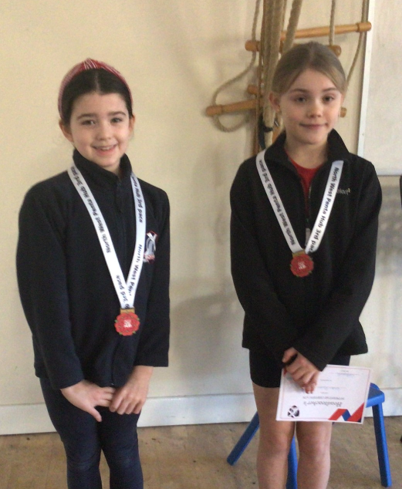

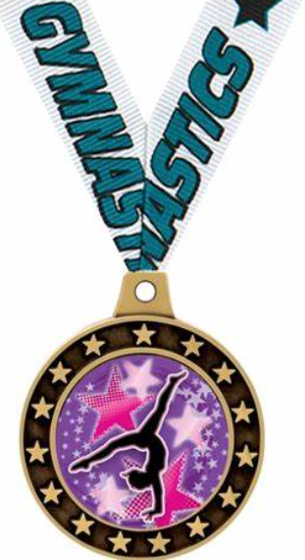
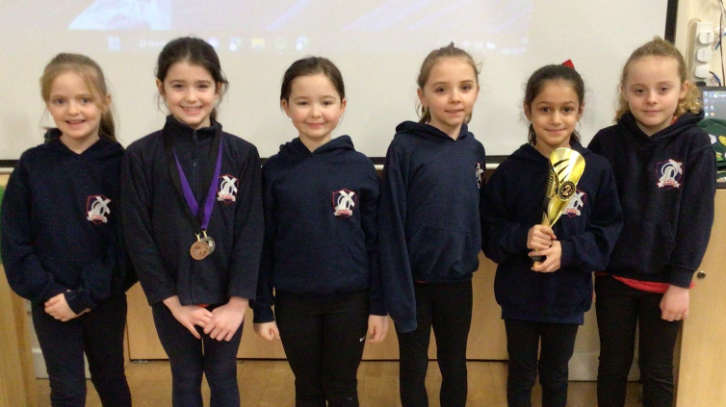
Mr Arrowsmith, lots of love and best wishes to you as you embark on new opportunities. We are eternally grateful and your sporting legacy will live on!

Owls Class gymnastic team certainly lived up to our school motto ‘Above and Beyond’ this week. The team volunteered to enter the competition at the last minute and spent time at home and during break times practicing set routines. Their hard work and dedication earned them a wonderful second place. Lexie, Poppy, Unaisah, Sofia, Lexie, Evie-Leigh and Alexandra
Kurling
Our team have been training hard. Ironically the competition in January was cancelled due to the snow and icy weather. Luckily, a new date has been scheduled for April. Good luck Declan, Vanessa, Thomas and Lola.

