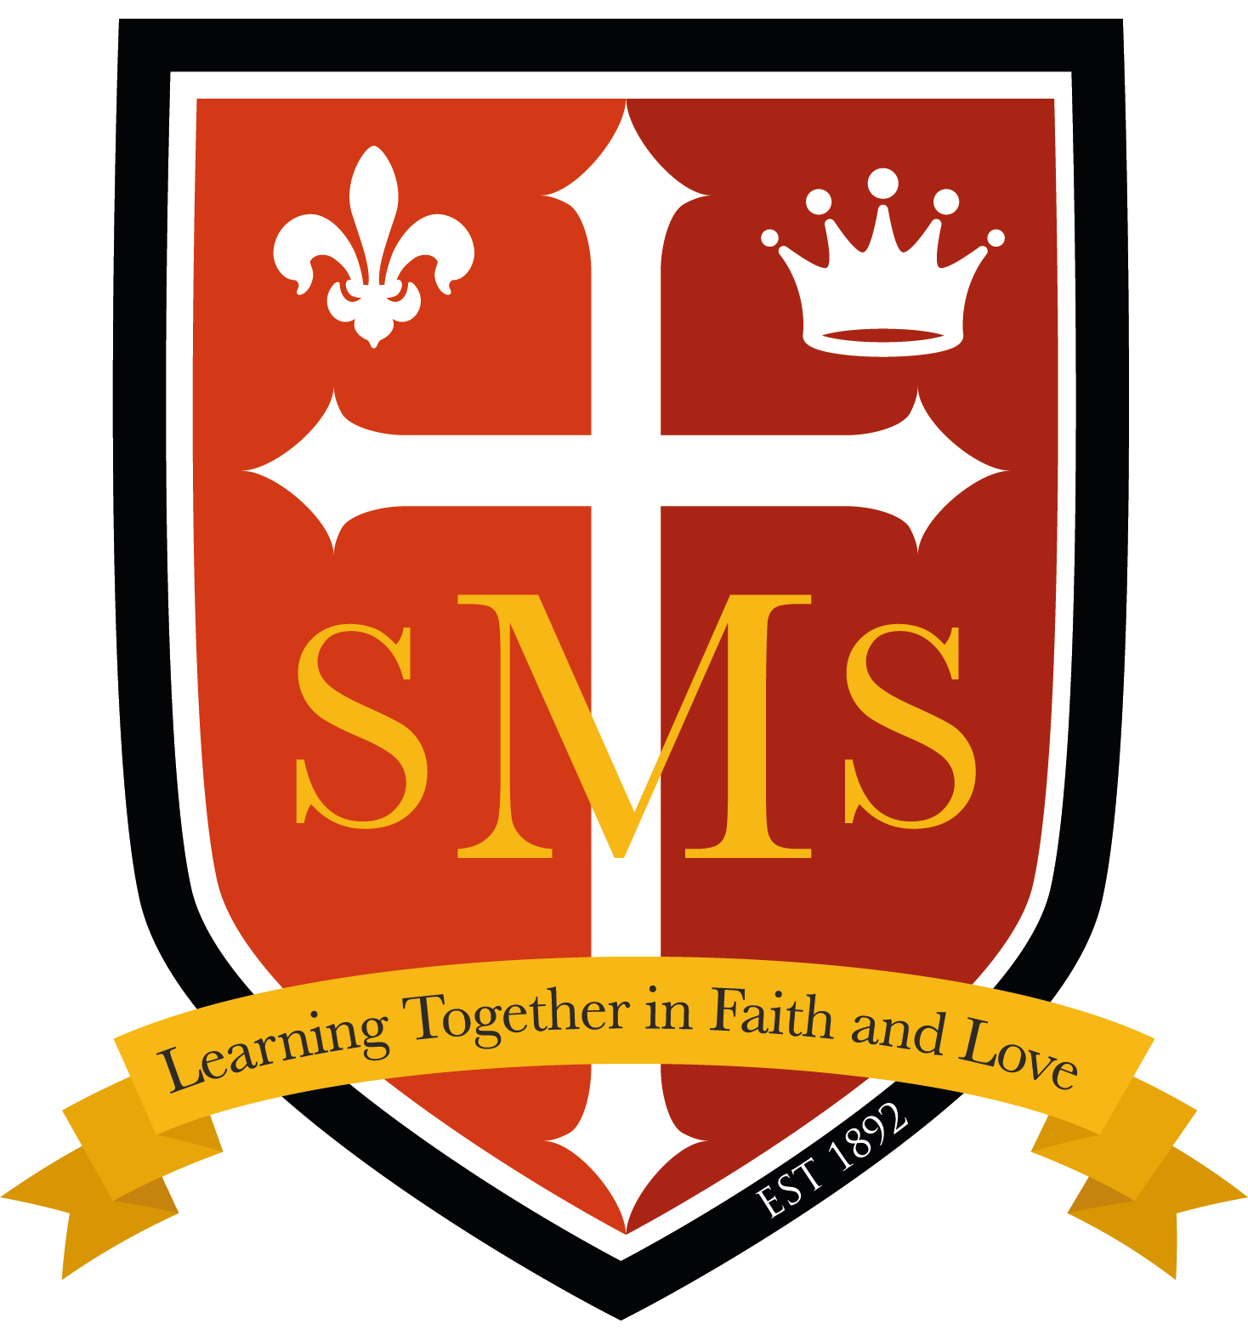
Nursery Autumn Term Newsletter 2026

Dear Parents/Carers,
We’ve had a lovely start to the new term in our nursery class! The children are beginning to settle into their new routines and are becoming familiar with our classroom, making new friends and exploring their surroundings. It has been wonderful to welcome some familiar faces back and see their excitement at being together again. Everyone is settling in beautifully and starting to find their feet as they discover all that nursery has to offer. We are looking forward to a happy, exciting and busy term ahead, filled with lots of fun, learning and new experiences together!
Literacy  In Literacy this term our themes are ‘All about me’ and ‘Winter wonderland’.  Our focus for Writing  -Mark making with meaning.  -Recognising own name and some familiar print.  -Makes marks and talks about them to others.    -Joining in with repeated phrases.  Our key texts  -The Colour Monster  -One Happy Tiger  -Brown Bear, Brown Bear  -Owl Babies    -It was a Cold Dark Night  -Gruffalo  -The Christmas Pine  -The Nativity | Maths  In Maths we are following the White Rose scheme and below will be our topics this term through a variety of different hands-on activities.  Comparison  Shape, space and measure  Patterns  Counting  Subitising  More than, fewer than, same as  Explore and build with shapes and objects    Explore and join in with repeats  Hear and say number names  Begin to order number names  Explore position and space |  | Phonics  This term we are continuing to have daily phonics lessons first thing in the morning. Early phonetic knowledge and understanding will help children prepare for reading and writing opportunities in school. In nursery class this is called Rhyme Time.  This term in ‘Rhyme Time’ we are focussing on  One, Two, Buckle my Shoe,  Round and Round the Garden  Pat a Cake  Row, Row, Row Your Boat  Twinkle, Twinkle Little Star  Ring-a-Ring-a-Roses  Wind the Bobbin up  The Grand Old Duke of York.
RE  In RE children will be learning Branches 1 and 2 and will be listening to the following stories about Jesus.  Branch 1 Creation and Covenant. Through the lenses of Hear, Believe, Celebrate and Live pupils will explore how God made the World and everything in it.  Branch 2- Prophecy and Promise. Through the lenses of Hear, Believe, Celebrate and Live pupils will explore aspects of the Christmas Story. | PE  This term children will be focussing on the following skills.  Movements Moving bodies, speed and directions. Using gross motor skills for climbing, jumping, running, throwing and kicking  Movements & Ball Skills Throwing, catching, dribbling, kicking, striking  In addition to these skills, children are also taught how to play alongside others in a team, solving problems and negotiating roles. |  | Other areas of development  In Nursery children will also be learning through teacher led and child initiated activities. This term all children will also be learning how to spell their name correctly, forming their letters and using a capital letter for the first letter of their name. Children are also engaging in activities to promote their communication and language skills and we have regular carpet sessions to promote this area of development.  In addition to academic learning we have a focus on children’s PSED. Ensuring all children are happy and are able to build respectful friendships with others is a crucial development stage this term. We are focussing on broadening our friendships and showing kindness to others in our classroom.

Important dates
PE every Thursday. Cooking on Fridays, £1 OR 50p donations welcomed. Nursery children to bring in a piece of fruit each day.
Our School Behaviour Policy
St. Mary’s is committed to fostering calm, constructive, and positive learning environments across the school. Below is a reminder of our school-wide behaviour policy.
