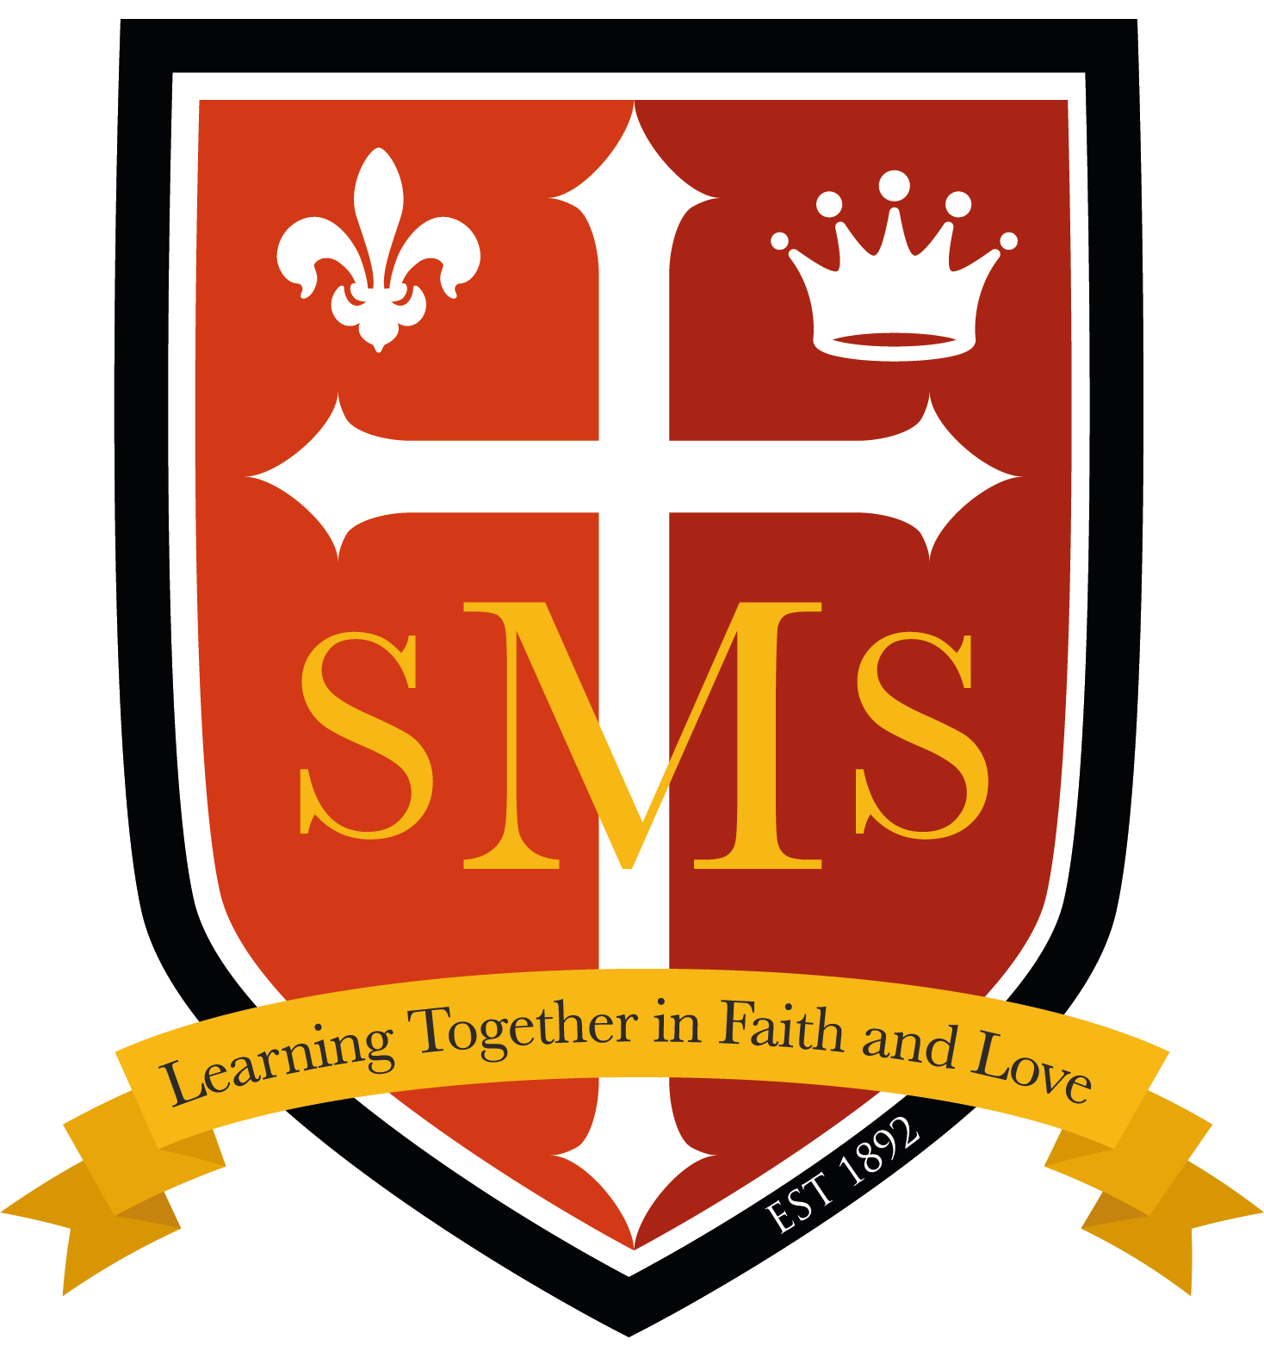
Reception Spring Term Newsletter 2026
Dear Parents/Carers,

A very warm welcome to all our new Reception children and families and children from our Nursery! We are so excited to begin a new school year together and look forward to getting to know each and every one of the children as they begin this exciting new chapter. The first term in Reception is all about settling in, building friendships and developing confidence and independence. We will be helping the children become familiar with their new routines, classroom environment and expectations, while encouraging them to explore, ask questions and develop a love of learning.
We are looking forward to a wonderful term filled with fun, discovery, new friendships and lots of learning!
Thank you, as always, for your continued support and for working in partnership with us to help your child have the very best start to their school journey.
Literacy  In Literacy this term our themes are ‘All about me’ and ‘Winter wonderland’  Writing  We will have a focus on- Writing their name and simple labels  -Identify initial sound on a sound mat  -Describe a character  -Write simple word labels or phrases on a story map  -Writing a caption  -Introduce sentence writing using capital “I”  Our keys texts are  -Colour Monster  -Augustus and his smile  -We’re going on a bear hunt  -Our class is a family  -Dark, dark tale  -The Gingerbread Man  -The Jolly Christmas Postman  -Stickman  -The Nativity story | Maths  In Maths we are following the White Rose scheme and below will be our topics this term through a variety of different hands-on activities.    Our topics are  -Getting to know you  -Match, sort and compare  -Talk about measure and patterns  - Numbers 1, 2, 3, 4, 5  -Circles and triangles  -Shapes with 4 sides |  | Phonics  This term we will be learning phase 2 sounds and learning to segment and blend to read simple CVC words and captions. Tricky words will be introduced.  -We will be looking at how to use a sound mat  -How to recognise simple tricky words  -Phonics workshops for parents  -Introducing reading books that include sounds taught
RE  In RE children will be learning Branches 1 and 2 and will be listening to the following stories about Jesus.  Branch 1 Creation and Covenant  The words and actions of the sign of the cross.  Understand God created the world and made each one of us. (Genesis 1:31).  God loves us (Laudato Si’ 84–88). Baptism.  Branch 2 Prophecy and Promise  The annunciation (Lk 1:26 – 31, 38)  The Nativity (Lk 2:4-7)  The shepherds visit the manger. (Lk 2:8-20)  Shepherds were told by angels to visit baby Jesus. | PE  This term children will be focussing on the following skills.  Movements- Moving bodies with more skill and precision, speed and directions. Spatial awareness. Gross motor skills for balancing, jumping, running, throwing and kicking.  In addition to these skills, children are also taught how to play alongside others in a team, solving problems and negotiating roles.  Movements & Ball Skills- Throwing, catching, dribbling, kicking, striking |  | Other areas of development  This term, we are excited to explore the wonderful world of animals and their habitats, learning about where they live and how they survive. We will also be using interactive maps to investigate our local area, making connections between what we see and where we live. In science, we’ll be observing the amazing changes that happen as the seasons change and how they affect the world around us. Alongside this, we will be reflecting on our own behaviours, thinking about how our choices impact ourselves and others. It’s going to be a fantastic term of discovery and learning!

Important dates
PE every Thursday. Cooking on Fridays, 50p/£1 donations welcomed.
Our School Behaviour Policy
St. Mary’s is committed to fostering calm, constructive, and positive learning environments across the school. Below is a reminder of our school-wide behaviour policy.
