
St Mary’s Catholic Primary School
Lunch Menu 1
 | Monday | Tuesday | Wednesday | Thursday | Friday
Hot Main Dish | 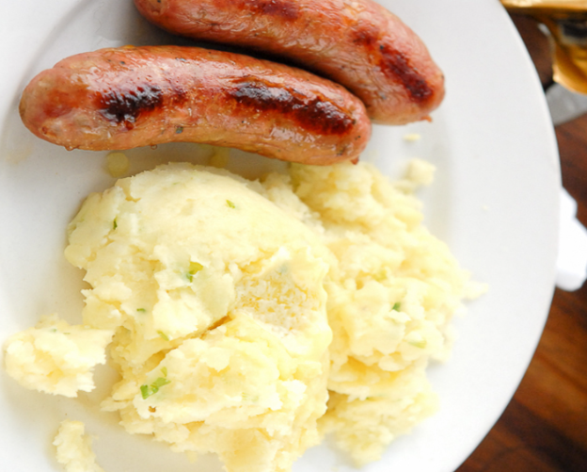  Sausage and Mash Potatoe | 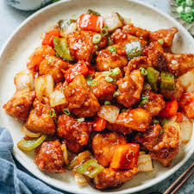  Sweet & Sour Chicken | 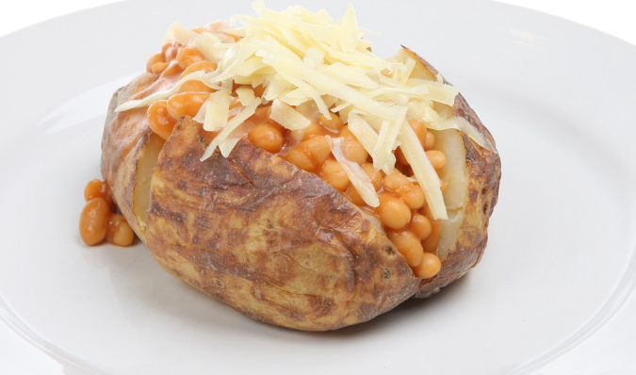  Jacket Potatoes/Baked Bean/Cheese Tuna | 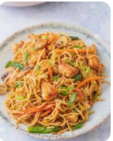  Chicken Chow Mein | 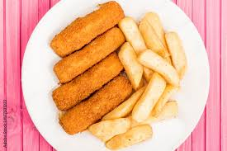  Fish Fingers & Chips
Hot Vegetarian Dish | 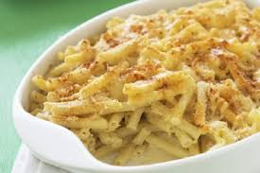  Macaroni Cheese | 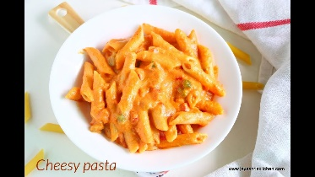  Cheesy Pasta | 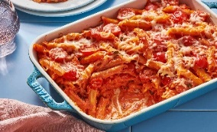  Pasta Bake | 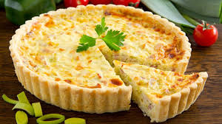  Quiche | 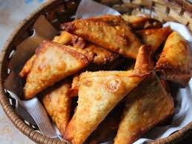Vegetarian Samos
Salads | Bean Salad | Mixed Green salad | Sliced peppers, cucumbers & carrot sticks | Mixed Green Salad | Sliced peppers, cucumbers/ carrot sticks & Coleslaw
Vegetables | Beans | Sweet Corn | Green beans | Mixed vegetables | Baked Beans
Desserts | Carrot Cake  Vanilla Custard  Fresh Fruit: sliced apple and oranges | Rice Pudding  Fresh Fruit: sliced apple and oranges | Yogurt  Fresh Fruit: sliced apple and oranges | Sponge Cake  Fresh Fruit: sliced apple and oranges | Strawberry Jelly  Fresh Fruit: sliced apple and oranges
Cool Water, Fresh Seasonal Fruit, Fresh Vegetables and Wholegrain Bread served daily
(All dishes are subject to delivery and may vary from time to time)Lunch Menu

