
St Mary’s Catholic Primary School
Lunch Menu 2
 | Monday | Tuesday | Wednesday | Thursday | Friday
Hot Main Dish | 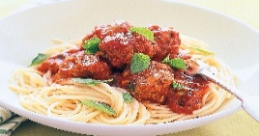  Meatball Spaghetti | 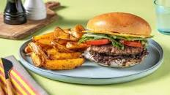  Beef Burger & Wedges | 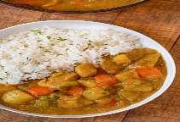  Chicken Curry & Rice | 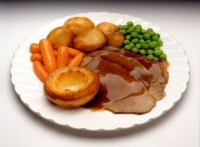  Roast Turkey & Roast Potatoes | 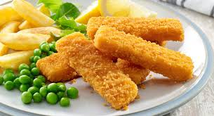  Fish Fingers  French Fries
Hot Vegetarian Dish | 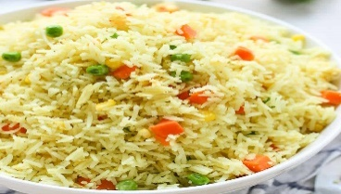  Vegetarian Rice | 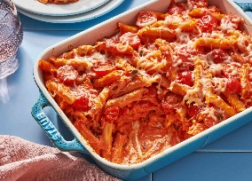  Pasta Bake | 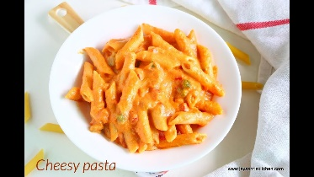  Cheesy Pasta | 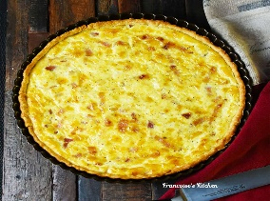  Quiche | 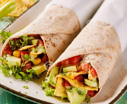  Vegetarian Tortilla Wrap
Salads | Bean Salad | Mixed Green salad | Sliced peppers, cucumbers &carrot sticks | Mixed Green Salad | Sliced peppers, cucumbers/ carrot sticks & Coleslaw
Vegetables | Peas | Green Beans | Sweet Corn | Mixed vegetables | Baked Beans
Desserts | Carrot Cake  Vanilla Custard  Fresh Fruit: sliced apple and oranges | Rice Pudding  Fresh Fruit: sliced apple and oranges | Yogurt  Fresh Fruit: sliced apple and oranges | Sponge Cake  Fresh Fruit: sliced apple and oranges | Ice cream  Fresh Fruit: sliced apple and oranges
Cool Water, Fresh Seasonal Fruit, Fresh Vegetables and Wholegrain Bread served daily
(All dishes are subject to delivery and may vary from time to time)

