
St Mary’s Catholic Primary School
Lunch Menu 3
 | Monday | Tuesday | Wednesday | Thursday | Friday
Hot Main Dish | 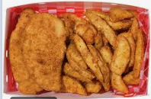  Breaded Chicken Potatoes Wedges and Garlic Bread | 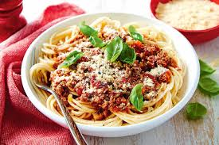  Spaghetti Bolognese | 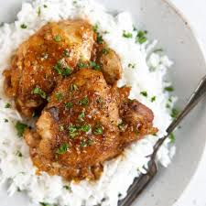  Roast Chicken  n Thigh & Rice | 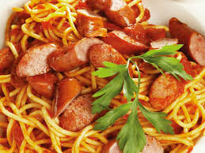  Spaghetti Sausages in Tomato Sauce | 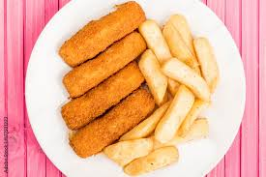  Fish & Chips
Hot Vegetarian Dish | 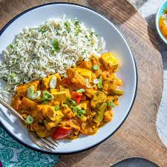  Vegetable Curry Rice | 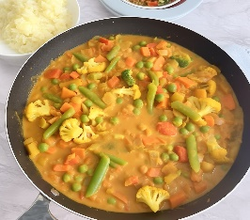  Vegetarian Curry | 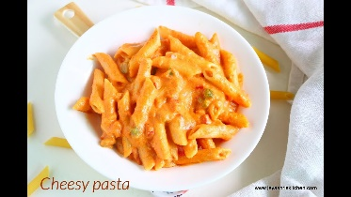  Cheesy Pasta | 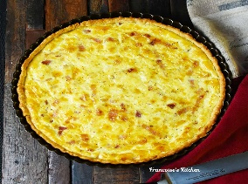  Quiche | 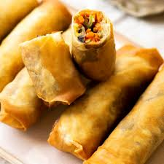Vegetarian Spring Rolls
Salads | Bean Salad | Mixed Green salad | Sliced peppers, cucumbers &carrot sticks | Mixed Green Salad | Sliced peppers, cucumbers/ carrot sticks & Coleslaw
Vegetables | Peas | Mix Vegetables | Sweet Corn | Green Beans | Baked Beans
Desserts | Carrot Cake  Vanilla Custard  Fresh Fruit: sliced apple and oranges | Rice Pudding  Fresh Fruit: sliced apple and oranges | Yogurt  Fresh Fruit: sliced apple and oranges | Sponge Cake  Fresh Fruit: sliced apple and oranges | Strawberry Jelly  Fresh Fruit: sliced apple and oranges
Cool Water, Fresh Seasonal Fruit, Fresh Vegetables and Wholegrain Bread served daily
(All dishes are subject to delivery and may vary from time to time)

