Issue 1 of the School Newsletter 11th September 2026

Welcome Back to a New School Year!

A very warm welcome back to all our families. We hope that everyone has enjoyed a restful and happy summer, and we are delighted to have our children back with us, ready for another year of learning, friendship, growth and discovery.

A new school year brings new opportunities, new experiences and new beginnings.
We are looking forward to working closely with you throughout the year to ensure that every child feels safe, valued, included and inspired to achieve their very best.

Our school values of Kindness, Tolerance, Respect, Responsibility, Co-operation and Honesty will continue to be at the heart of our school community, helping our children to understand not only how we learn together, but how we live together.

Our Uniform – A Sense of Belonging
Our school uniform is an important part of our identity. Wearing our uniform with pride helps children feel that they belong to something special – our St Mary’s community. It promotes equality, pride and a sense of belonging, while reminding us that we are all part of a shared school family.
We are also very conscious of the increasing cost of living and want to support our families wherever we can. We are therefore developing a pre-loved uniform collection, where good-quality, clean and gently used uniform can be made available to families who may find this helpful.
If your child has outgrown any school uniform that is still in good condition, we would be very grateful if you would consider donating it to school. Your generosity could make a real difference to another family, while also helping us to reduce waste and encourage a more sustainable approach to school uniform.
Thank you in advance for your engagement with this.

Every Day Counts – The Importance of Attendance
We would also like to remind families of the importance of regular and punctual attendance. Being in school every day and arriving on time gives children the very best opportunity to learn, develop friendships, build confidence and make the most of everything that school has to offer.
Every school day matters. Even occasional absence can mean that children miss important teaching, experiences and opportunities to develop their knowledge and skills. Arriving on time is equally important, as it allows children to settle calmly, begin their learning with their classmates and start the day feeling confident and ready.

We know that sometimes children are unwell or families experience circumstances that make attendance difficult, and we will always work with families to provide support where needed.

Our shared aim is simple: to help every child attend school regularly, arrive on time and make the most of every precious day of learning.

Thank you, as always, for your continued support and partnership. We are very excited about the year ahead and all that we will achieve together.

Here’s to a wonderful new school year at St Mary’s – a year filled with learning, friendship, kindness, faith and opportunity!

With very best wishes,

Magdalena Tusting
Head of School

Catholic Life and Mission of the school

Yesterday, on Thursday 10th September, we attended the Holy Mass in our parish church to celebrate the beginning of the new school year.
Father Damian delivered a beautiful sermon about God seeing and listening to us like a parent does through a baby monitor.
Our children displayed excellent behaviour, great listening and reflection and sang beautifully. All the readers read clearly and reverently. We would like to thank them as well as the two altar servers who served really well.

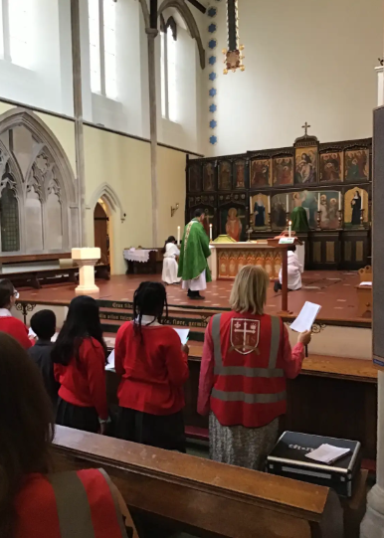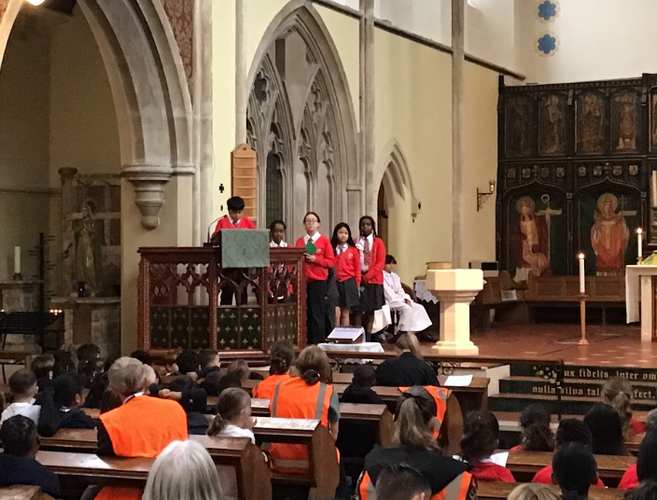

Our School Value for this half term is Responsibility and the matching Catholic Social Teaching Principle is Stewardship – Caring for our Common Home. We will be exploring thinking about how each and every one of us can show responsibility in caring for and protecting our planet.



Safeguarding and Wake up Wednesdays



This week we look at: What parents and staff need to know about: What Parents & Educators Need to Know about What's Real Online

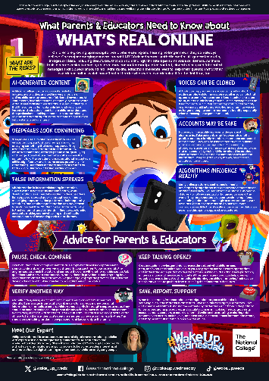

Please click on the link below to read the #WakeupWednesday guide on What Parents & Educators Need to Know about What's Real Online:
Click this link

For more information on how to keep you child safe online, please click on the link to our website page.
Click here

New Parental Control Videos
Internet Matters have uploaded 3 new short videos onto YouTube, each focussing on parental controls for YouTube, Roblox and TikTok, the links are:
- YouTube parental controls top features.
- The top 3 parental controls to use on Roblox.
- The top 3 parental controls to use on TikTok.

Google Family Link
For children with Android devices, Google Family Link is a great way for parents to set restrictions. Internet Matters have released a brand-new YouTube video showing how to set up Google Family Link to customise content and screen time restrictions.
Click to Set Up Google Family Link

We encourage families to engage with these resources and to work in partnership with us to promote safe, respectful and responsible online behaviour, in line with our Catholic values of care, dignity and responsibility.

We would like to share some important dates for the Autumn Term with you. We will also be adding some more dates and will share them with you soon, so please keep checking the Newsletter and the Parents’ Information Board on the front gate.

Important dates:
September 2026
Friday 11th September | Year 5 Class Meeting at 3.45pm
Tuesday 15th September | Year 1& 2 Class Meeting at 3.30pm
Week beg 21st September | Year 6 Into University workshops and trips
Tuesday 22nd September | Show Racism a Red Card Day
Wednesday 23rd September | Secondary Transfer Meeting for Y6 at 3.45pm
Friday 25th September | McMillan Coffee Morning, Cake sale after school
October 2025 | Black History Month
Thursday 1st October | School Census Day
Thursday 1st October | First PTA meeting – all welcome
Thursday 1st October | National Poetry Day, Theme: Wonder
Monday 19th October | Year 5 visit to see Bayeux Tapestry at British Museum
Tuesday 20th September | Parent Consultation Meetings 3.45pm to 6.00pm
Thursday 22nd September | Parent Consultation Meetings 3.45pm to 6.00pm
Thursday 23rd October | Grandparents’ Afternoon Tea and Concert 2.00 pm
Half term holiday: Monday 26th October to Friday 30th October.
November 2025
Monday 2nd November | Staff INSET Day – school closed for children
Tuesday 3rd November | Back to school after half term

We will share dates for Class Assembly soon.

PE Days:
Please remember that children can come to school in their PE kits on PE days. Please refer to our guidance on school uniform and ensure your child has the correct PE kit. If for any reason they are not able to come in the correct kit, we require an email or phone call from home to explain the circumstances.

Thursdays – EYFS, Year 1 & 2, Year 4 and Year 5
Fridays - Year 3 and Year 6

Monday 2nd November is Staff Training Day and the school will be closed to children.
Schools resumes on Tuesday 3rd November.

Term Dates 2026 – 2027
Autumn Term – 2026
First Half Term
Staff Training –Tuesday 1st September – Inset Day (no pupils)
Staff Training –Wednesday 2nd September – Inset Day (no pupils)
First Day of School – Thursday 3rd September
Last Day of School – Friday 23rd October
Half Term – Monday 26th – Friday 30th October
Second Half Term
Staff Training- Monday 2nd November- Inset Day (no pupils)
First Day of School – Tuesday 3rd November
Last Day of School – Friday 18th December - School Closes at 1.30pm
Christmas Holiday – Monday 21st December 2026 – Friday 1st January 2027

Spring Term - 2027
First Half Term
Staff Training – Monday 4th January- Inset Day (no pupils)
First Day of School-Tuesday 5th January
Last Day of School – Friday 12th February
Half Term – Monday 15th – Friday 19th February
Second Half Term
First Day of School – Monday 22nd February
Last Day of School – Thursday 25th March - School Closes at 1.30pm
Easter Holiday – Monday 29th March – Friday 9th April

Summer Term – 2027
First Half Term
First Day of School – Monday 12th April
Last Day of School – Thursday 27th May
Staff Training – Friday 28th May – Inset Day (no pupils)
Bank Holiday – Monday 3rd May (no pupils)
Half Term – Monday 31st May– Friday 4th June
Second Half Term
First Day of School – Monday 7th June
Last Day of School – Wednesday 21st July - School Closes at 1.30pm

