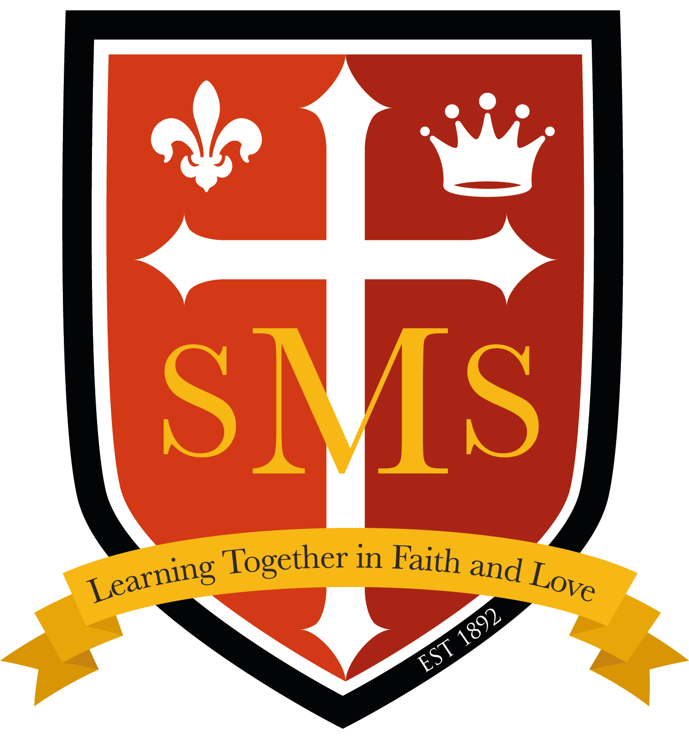
Termly Newsletter Autumn 2026
Year 1 & 2

Welcome back!

I hope you all had a wonderful summer break and enjoyed some special time together.

I am delighted to welcome both you and your children to Year 1 and Year 2. It has been lovely to see the children back at school, and they have already made a fantastic start to the new academic year!

This year, we are excited to introduce a newly merged Year 1 and Year 2 format. The children will have the opportunity to learn and explore together through a range of exciting shared topics and learning experiences, while continuing to follow the curriculum appropriate to their individual year groups. We are really looking forward to seeing the benefits of the children learning alongside one another and sharing their ideas and experiences.

This information will give you an insight into some of the exciting curriculum areas we will be covering in the lead-up to Christmas. I also hope it will provide some helpful ideas for supporting and extending your child's learning at home.

I am really looking forward to the exciting term ahead and all the wonderful learning and experiences we will share together!

  English-Writing  This term, our English learning will be inspired by a wonderful selection of class texts:  - Man on the Moon – A Day in the Life of Bob  - The Lighthouse Keeper’s Lunch  - The Snowman  - The Nativity Story  Through these engaging stories, the children will develop their reading, writing and spoken language skills. Drama, discussion and role play will play an important part in our learning, helping the children to explore characters, settings and events before developing their ideas through writing.  Year 1  Year 1 children will develop their confidence in composing and writing sentences. They will learn to sequence their ideas to create simple narratives and use basic punctuation, conjunctions and descriptive language in their writing. The children will also be encouraged to re-read their work and check that it makes sense.  Year 2  Year 2 children will build upon their existing writing skills by planning and developing their ideas into longer, more detailed pieces of writing. They will explore a wider range of vocabulary and sentence structures, while developing their use of punctuation and learning to evaluate and edit their own work.  Through our class texts, the children will have regular opportunities to develop their creativity, imagination and confidence as writers. | English-Spelling  Spelling activities will be closely linked to the children’s learning in class.  Year 1  Year 1 children will focus primarily on revising previously learned sounds and applying newly taught phonics knowledge to their reading and writing. They will also practise reading and spelling high-frequency and tricky words.  Year 2  Year 2 children will build upon their phonics knowledge while developing their understanding of a range of spelling patterns and rules. They will also continue to practise high-frequency and tricky words to support accuracy and confidence in their writing.  Spelling Homework  Spelling homework will be closely linked to what your child has been learning in class that week. Year 1 homework will focus on the sounds and phonics they have been practising, while Year 2 homework will focus more on the spelling patterns and rules they have been learning.  This will give you an opportunity to see what your child has been working on and to help them practise and reinforce their learning at home. A little practice each week can make a big difference!  English – Reading  Reading is at the heart of so much of our learning, and we are looking forward to sharing lots of wonderful stories and texts with the children this term.  We follow the Little Wandle Letters and Sounds Revised phonics programme. The children will take part in daily phonics sessions, helping them to develop their confidence in recognising sounds and applying their phonics knowledge when reading and writing. They will also take part in three guided reading sessions each week, where they will develop their reading fluency, comprehension and understanding through a range of engaging texts and activities.  Year 1 children will focus on developing their phonics knowledge and using this to read unfamiliar words. They will also develop their understanding of what they have read by discussing characters, settings and events, making simple predictions and answering questions about the text.  Year 2 children will continue to build upon their existing phonics knowledge while developing greater fluency and confidence in their reading. They will explore a wider range of texts and develop their understanding by discussing vocabulary, retrieving information, making predictions and beginning to make inferences using clues from the text.  Reading at Home  Your child's home reading book will be sent home each Monday and will be carefully matched to their individual reading ability. Please ensure that their book is returned to school each Friday.  We encourage children to read the same book at least three times throughout the week. Re-reading a familiar book is incredibly valuable and helps children to build confidence, develop fluency and improve their understanding of what they are reading.  You can support your child further by talking about the story, discussing any new or unfamiliar words and asking questions about what they have read. Most importantly, we hope that reading at home becomes an enjoyable and positive experience for both you and your child!   |   Maths  In our mixed Year 1 and Year 2 class, we follow the White Rose Maths approach. The children will often learn together through practical and engaging activities, while working towards the objectives that are appropriate for their own year group.  Year 1  This term, Year 1 children will be building their confidence with numbers within 100 and developing a strong foundation in key mathematical skills. They will explore place value, use practical resources and number lines to support their addition and subtraction, and enjoy exploring and describing a range of 2D and 3D shapes.  Year 2  Year 2 children will build upon their previous learning and develop greater confidence when working with numbers up to 100. They will explore place value in more detail and develop their addition and subtraction skills, including calculations that involve crossing a ten. They will also continue to develop their understanding of number bonds and explore the properties of 2D and 3D shapes.  Throughout their learning, all children will be encouraged to talk about their mathematical thinking, solve problems and develop confidence when explaining how they have found an answer.
Science  This term, our science topics will be Living Things and Their Habitats and Seasonal Changes.  The children will explore the world around them through practical activities, observations and discussions.  Living Things and Their Habitats  - Identifying things that are alive, once alive and never alive  - Exploring different habitats and microhabitats  - Understanding how plants and animals depend on one another  - Learning about simple food chains  Seasonal Changes  - Observing and exploring the changes that take place throughout the seasons  - Identifying how the weather and environment change over time |   History  This term our topic in History is:  Significant Queens  This term, our History topic is Significant Queens. The children will learn about the lives and achievements of three important queens from British history: Queen Elizabeth I, Queen Victoria and Queen Elizabeth II.  They will explore why these queens are significant and learn about their impact on Britain during different periods in history. The children will also have opportunities to compare the lives and reigns of these three remarkable women. | 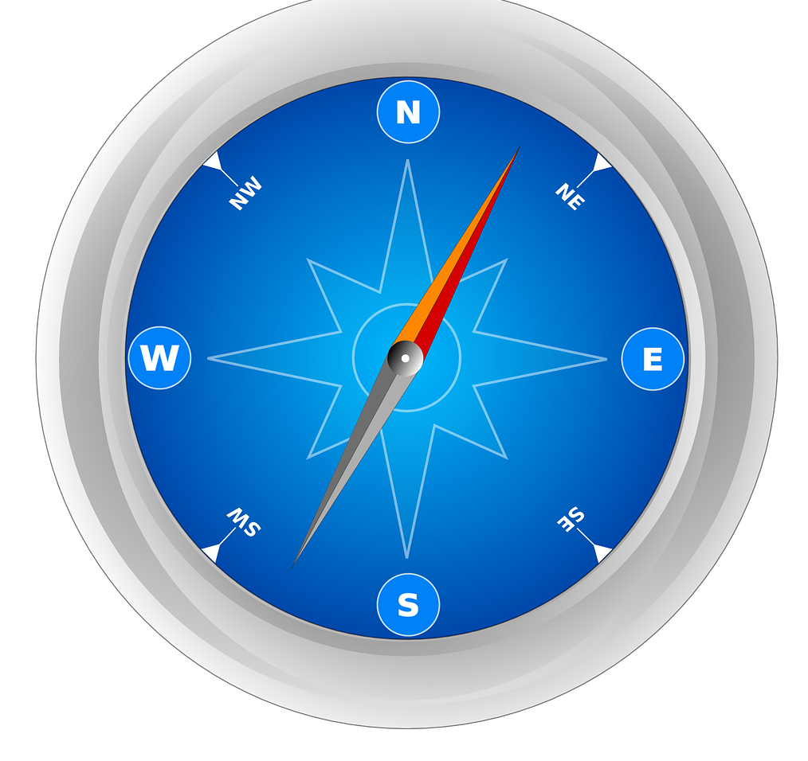  Geography  This term, our Geography topic is Where Do I Live? The children will explore where they live and develop their understanding of the wider world around them.  They will learn about:  - Where they live within the UK  - The countries that make up the UK  - What a capital city is and the capital cities of the UK  - How to use an atlas to investigate different places  - How maps can be used to represent places, including our school and its local area
RE  In RE, we will be following the new RED curriculum. This term, the children will explore the following topics:  - Creation and Covenant – learning about God’s creation and the special relationship between God and His people.  - Prophecy and Promise – exploring the messages and promises of God and preparing for the celebration of Christmas. | 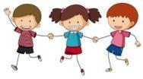  PHSE/RSE  Our PHSE Topics this term are:  - Health and Wellbeing:  - Living in the Wider World  In RSE:  - Created and loved by God  - Created and loved by God |   Computing  In computing our topics are:  Online safety  - Safety rules - understanding the AUP  - What happens when I post online?  - How do I keep my things safe online?  Computer Systems and Networks  - computer parts  - inputs  - real-world role play
PE-  Movements / Ball Skills  - Throwing, catching, dribbling, kicking, striking ball  Team Games  - Further understanding of working in small teams and playing games by the rules  - Developing skills such as throwing and catching with a teammate. | Music  Year 1  Exploring Pulse and Tempo 1:  Feel the Beat. Change the Tempo  Exploring Rhythm 1:  Playing and Copying. Perform their own rhythm patterns  Year 2  Exploring Pulse and Tempo 2:  - Feel the Strong Beat. Speed of music  Autumn Term 2: Exploring Rhythm 2:  - Stick Notation.  - Note values: (crotchets, quavers and crotchets rests) | Home Learning  Children will receive homework every FRIDAY and it is to be returned on a WEDNESDAY.
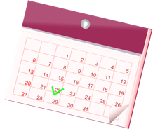
Important dates

