Termly Newsletter Autumn 2026
Year 3

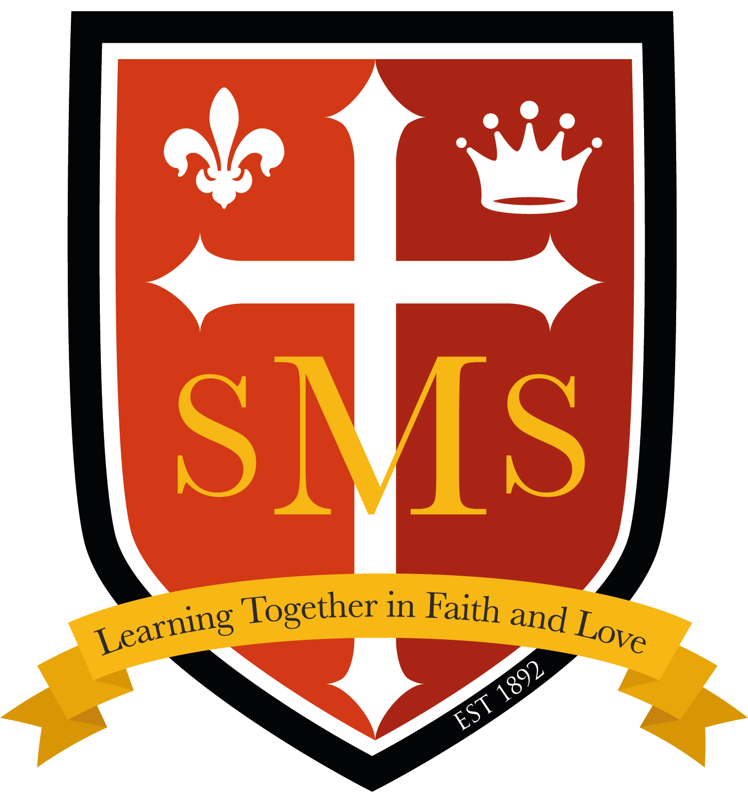

Welcome back - I hope you had a lovely Summer break! I am delighted to welcome the children to Year 3 where the class have already had a great start to the year. Below, you will find an outline of the topics that your child will be learning about in class over the coming term. In addition to providing you with an insight into the curriculum areas that will be covered in the lead up to Christmas, I hope that this information will also assist in supporting and extending your child’s learning at home. In our teaching team this year we have Ms Carolan, Ms Marta and new St Mary’s member, Ms Hanan. We are all looking forward to a fabulous year ahead!

Best wishes,
Miss Flashman

English-Writing  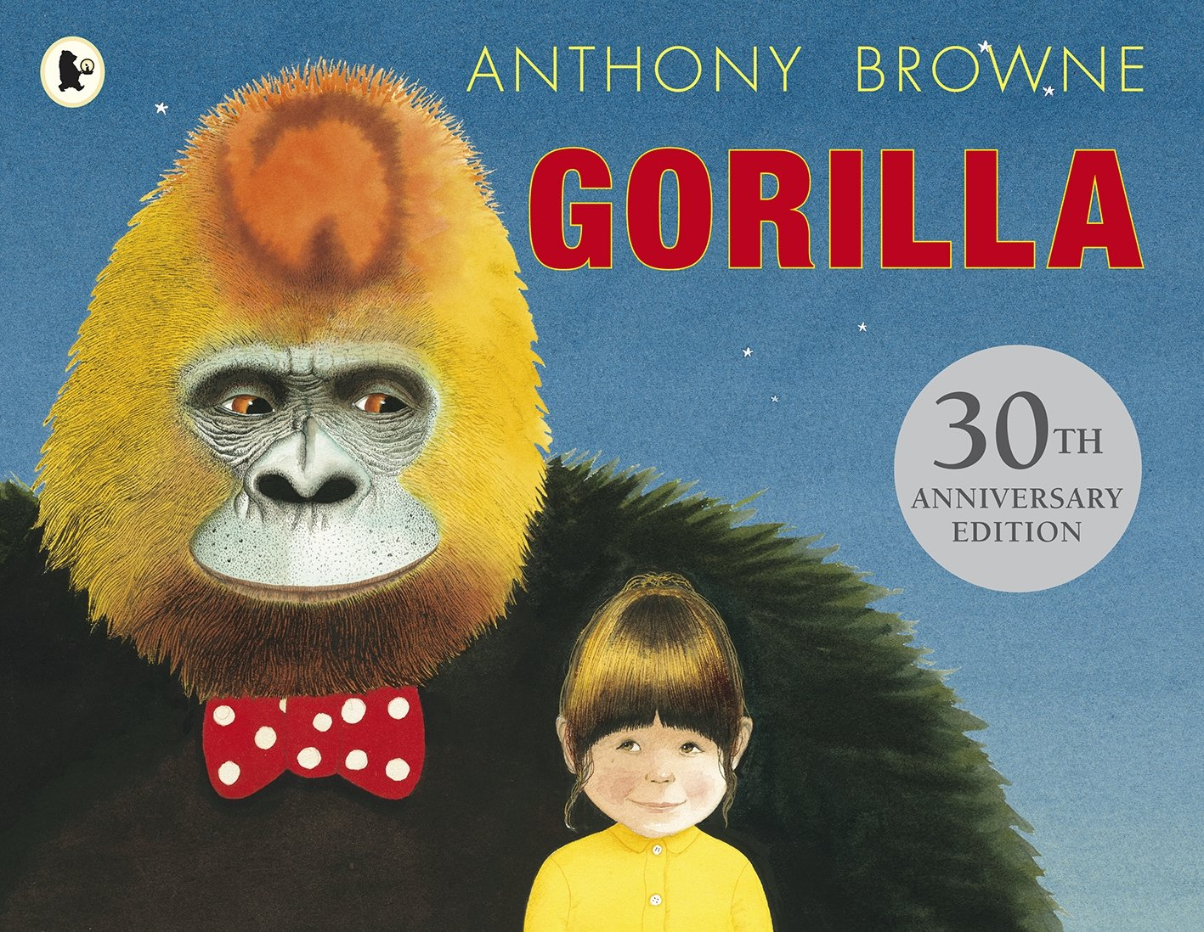  In English this term, our writing will include a selection of fiction and non-fiction pieces based around the class texts.  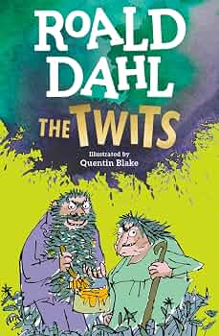  - Character descriptions  - Third person narratives  - Reports  - Instructional Writing    In grammar, we will be studying: Identifying and sorting nouns, prefixes, specifically “un-”, inverted commas for direct speech, punctuation in spoken sentences and synonyms for “said”.  Our class texts we will be focusing our learning around will be Gorilla by Anthony Browne and The Twits by Roald Dahl. | English-Spelling  Spelling lists will be given out on Fridays along with other homework. Spelling tests from the previous week will also be on Fridays. The spelling patterns we will be looking at are: Words where ‘ou’ makes an /ow/ sound, words where ‘ou’ makes a /u/ sound, words where ‘y’ makes an /i/ sound, words ending in ‘-sure’, words ending in ‘-ture’, words with the prefix ’re-’.    English-Reading  Just as in KS1, a great emphasis will be placed on daily reading, both at home and at school. Reading will be taught in both guided and independent sessions. |  | Maths  This term we are continuing to use the White Rose curriculum scheme and we will be studying the following topics:  - Place value.  - Addition and subtraction.  - Multiplication and division.  We will also be working on learning and consolidating our Multiplication and Division facts and number bonds up to and within 100.
  Science  To kick off science this term, we will first be learning about Forces and Magnets. A force is a push or pull, and surfaces can either help or hinder how an object moves. Magnets attract magnetic materials such as iron and nickel, and their strongest parts are the north and south poles. Like poles repel each other, while unlike poles attract each other.  Year 3 will then move on to studying Animals Including Humans as our second topic. Animals need to eat food to get the nutrients they need, unlike plants which can make their own food. Nutrients include carbohydrates, protein, vitamins, minerals, fats, water and fibre, which help keep the body healthy. Humans and some other animals have skeletons and muscles that provide support, protection and help them move. |   History (Autumn 2)  In History this term, we will be exploring Early life in Britain - from the Stone Age to the Iron Age. The children will learn about the major discoveries that shaped life in prehistoric Britain - including fire, farming, bronze, and iron - and how each one helped people live more safely and build stronger communities. Our enquiry question at the centre of our learning is ‘What was the most significant discovery in early Britain?’. |  | 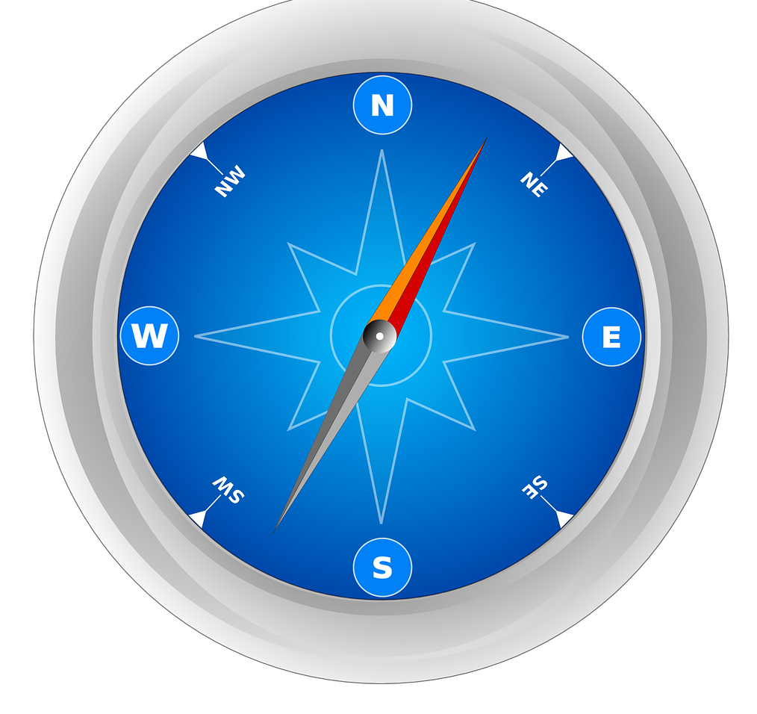  Geography (Autumn 1)  Beginning this term with geography, we will be learning about the Countries of the World, including continents, capital cities and key geographical features around the world. At the conclusion of the unit, the children will have a deeper grasp on key facts, and similarities and differences of different areas around the world.  
RE  In RE this term we will be studying:  - Creation and Covenant; The Creation Story  - Prophecy and Promise: Eucharist and the Early Church.  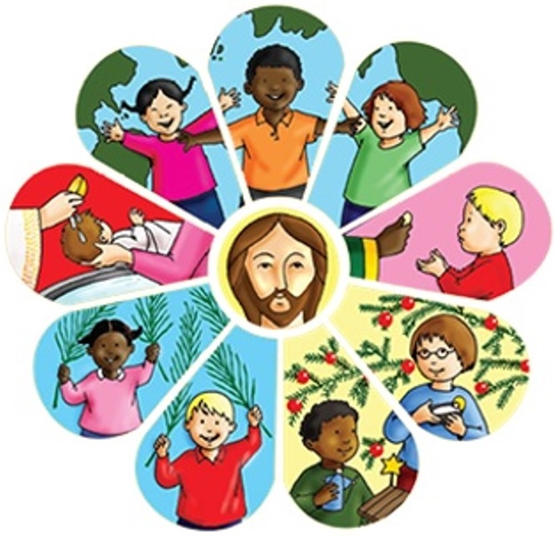 | 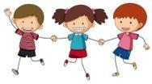  PHSE/RSE  Our PHSE Topics this term are:  Emotions and Feelings  Being Safe, Mental Wellbeing  In RSE we will be looking at the module ‘Created and Loved by God’ in our Ten Ten programme. |  |   Computing  In computing for the Autumn term we will be looking at Online safety and Computing systems and networks.
PE  Sending and Receiving  Invasion games  Passing techniques such as bounce, chest, pop.  How to receive a pass.  Different hand positions  Tracking and getting in line with the ball.  Pass with control whilst moving.  Keeping Possession  Develop passing techniques  Use different equipment to keep  possession.  Start to learn about passing and moving into a space to receive a ball. | Music  Autumn Term 1: Reading Notation 1: Rhythm and Tempo. Crotchets and Paired Quavers  Autumn Term 2: Exploring Notation 1: High and Low   |  | Home Learning  Home Learning is a consolidation of the subjects taught during the week. It is given out weekly on a Friday to be completed by Thursday. It will be based on areas covered that week. Spelling tests will also be on Friday.
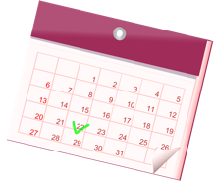
Important dates
10/09 - Whole School Mass & Year 3 Meet the Teacher Afternoon at 3:45 pm
22/09 - Show Racism the Red Card day
01/10 - School Census day & National Poetry Day
12/10 - 16/10 - Assessment Week
20/10 & 22/10 - Parent Consultation Meetings (3:45 - 6:30pm)
21/10 - Grandparents afternoon tea at 2 pm
23/10 - Final Day of Autumn 1
24/10 - 02/11 - HALF TERM BREAK
02/11 - Staff inset day (school closed to students)
03/11 - Autumn 2 begins!
16/11 - Antibullying week commences
20/11 - Odd Socks Day
03/12 - Whole school Advent Mass
10/12 - School Christmas lunch and Christmas Jumper Day! (Gold coin donation)
16/12 - KS2 Christmas Carol Concert at 2pm
18/12 - Last day of Autumn Term!

Our School Behaviour Policy
St. Mary’s is committed to fostering calm, constructive, and positive learning environments across the school. Below is a reminder of our school-wide behaviour policy.
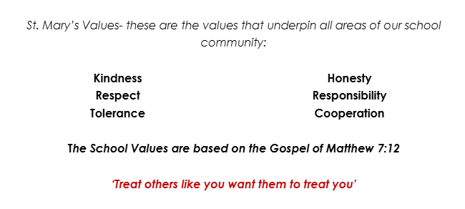  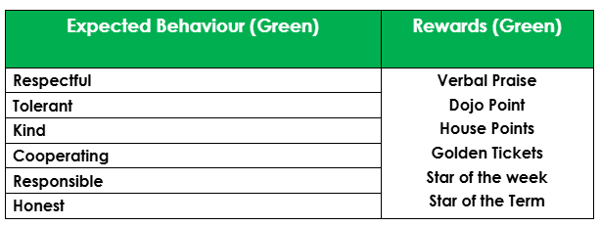 |  | 