Termly Newsletter Summer 2026
Year 3

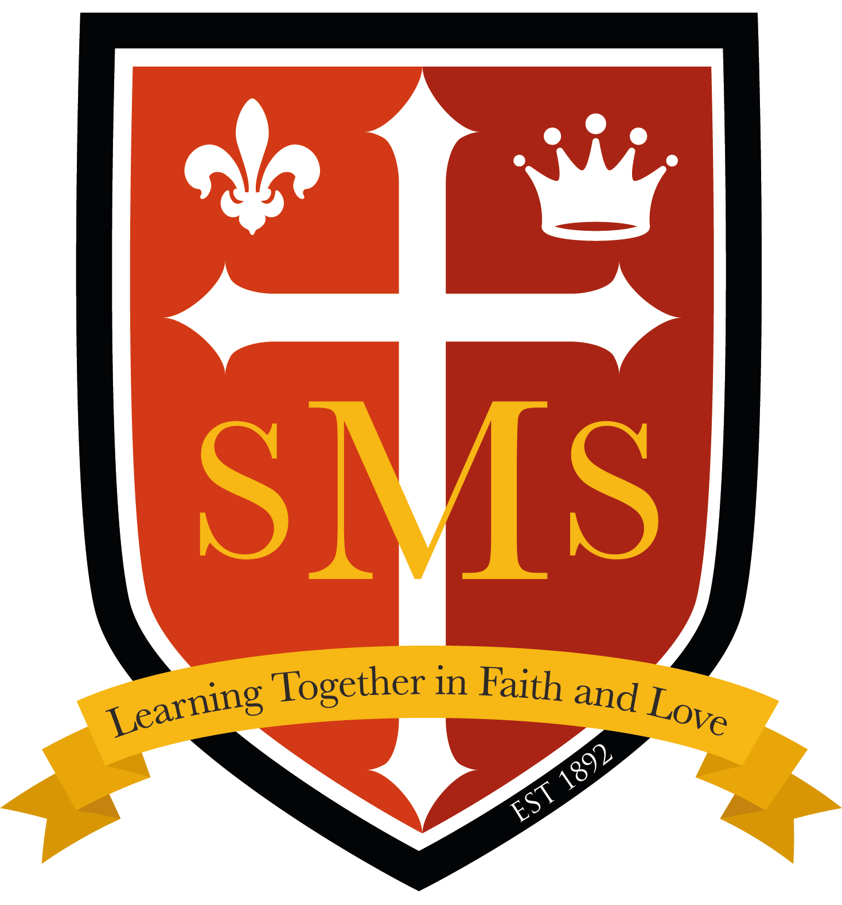


Welcome back to school!
As we embark on this exciting new term, I am glad to share that, while there have been some instances where ties have been left at home, Year 3 pupils are improving in coming to school in the correct, full school uniform. We do have spare ties available at school, but these should be returned at the end of the day and ideally only used in extreme circumstances. Please ensure your child wears their tie to school every day.
In addition to this uniform reminder, please make sure homework is completed and returned every Friday. If there are any concerns or queries, I am happy to discuss these with the children or find time to help during the school day if needed.
Reading records should be signed at home and brought in every day so that children can change their reading books and staff can keep track of improvements and reading levels. If a reading record or levelled reading book is lost, please ask your child to inform me as soon as possible so that they can receive a new reading record. Lost reading books must be replaced, and these cost £5.
Below, you will find an overview of our curriculum and what we will be learning in each subject this term. If you have any questions, please contact me at the gate or via the school office.
Thank you for your ongoing support,
Miss Hickey
English-Writing  In English this term we are reading The Wolves in the Walls by Neil Gaiman, Walk with a Wolf by Janni Howket, Fox by Margaret Wild and The Ice Palace by Robert Swindells.  - The Wolves in the Walls (fiction) and Walk with a Wolf (non-fiction) - Sequel to story, using similar sentence structures in the story to create their own animal in the walls story and a non-chronological report about wolves.  - Fox - Retell of the story.  - The Ice Palace - Narrative retell of story, character description, creating own ending for the story. | English-Spelling  - Words ending with the suffix '-er'  - Words where the digraph 'ch' makes a /k/ sound  - Words ending in '-gue' and '-que'  - Words where the digraph 'sc' makes a /s/ sound    - Words that are homophones  English-Reading  - Class texts to be read throughout the term.  - 1:1 reading at school with me or another staff  member.  - 1:1 reading at home with a family member.  - Fluent in Five at school for fluency. |  | Maths  This term we will be working on:  - Mass and capacity  - Fractions (part 2)  - Money  - Time  - Shape  - Statistics  Year 3 also now has access to TT Rockstars so time will be allocated during the week for times tables practice.
  Science  This term we will be finishing off learning about Rocks, Soil and Fossils and starting a new unit about Light.  Light  - Understanding light is needed to see  - Understanding darkness is an absence of light  - Light reflection  - Understand what a shadow is  - Observing patterns in changing shadows  - Dangers of light from the sun |   History (Summer 1)  The Industrial Revolution  - How did people live and work before machines?  - Why did people start using machines instead of hand tools?  - Which invention changed life most during the Industrial Revolution?  - What was it like to work in a Victorian factory?  - How did the Industrial Revolution change people’s lives? |  |   Geography (Summer 2)  Our Local Area  - Identify our local area on a map  - Give directions  - Physical and human features of our local area  - Collect and record evidence
RE  RED Branch 5 - To the Ends of the Earth  - The Ascension  - Pentecost  - How the Holy Spirit empowers us  - The role of the Church in sharing the Gospel  RED Branch 6 - Dialogue and Encounter  - Understanding the Church’s relationship with other faiths and worldviews  - The importance of discussing different perspectives  - Respectful studying of other religions  - Comparing and making links between Christianity/Catholicism and Judaism | 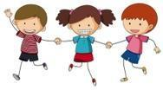  PHSE/RSE  Our PHSE Topics this term are:  Basic First Aid  Mental well being & Basic first aid  Keeping Safe  Being safe, Mental wellbeing & Health and prevention  Aspirations  Economic well being & Careers  In RSE we are exploring:  Ten Ten Module 3: Created to love others  Unit 1: Religious Understanding  Ten Ten Module 3: Created to love others  Unit 3: keeping Safe |  |   Computing  Programming  Kapow - Programming Scratch  - Tinkering with Scratch  - Using loops  - Making an animation  - Programming a game  Online safety  Kapow - Online Safety  - When being online makes me upset  - Sharing of information  - Rules of social media platforms
PE-  Swimming  Creating and Modifying Games  - Cricket  - Rounders  Athletics  - Travelling, throwing and jumping techniques  Our PE day is Friday. Please only come in PE kit that day, unless otherwise instructed. Changes of clothes should be brought for clubs and changed into after school. | Music  Exploring Musical Theatre:  Forte and Piano  Developing into Musicians 1:  - Dynamics and Tempo |  | Home Learning  - Daily reading at school and at home  - 10 spelling words  - Consolidating work from English and Maths lessons previously learnt  - TT Rockstars times table practise

Important dates
Thursday 21st May - World Cultural Day Friday 12th June - Green for Grenfell
Monday 1st June - INSET day Friday 3rd July - Summer Fair
17th July - School closes for the year at 1:30pm Thursday 9th July - Sports day
Spanish
My School
This unit builds on children’s prior knowledge of numbers 0–12, briefly revisiting them at the start. It reinforces their understanding of asking and answering questions about age, as well as the use of gendered indefinite articles ‘un’ and ‘una’. The unit highlights cultural differences by comparing the educational experiences of Spanish-speaking children with their own, while introducing ‘soy’ and ‘estoy’ for “I am.” Children also learn colours and classroom items, enabling them to recognise, describe, and request items using numbers, colours, and polite expressions.

Times and Dates
In this unit, children learn the months, days, and how to talk about birthdays in Spanish, including asking and answering when a birthday is and singing “happy birthday.” They explore Spanish festivals and traditions, both familiar (like Easter and Valentine’s Day) and less familiar, while strengthening their knowledge of numbers (0–32) and spelling. A Spanish story, El lobo que quería cambiar de color, is used to reinforce days of the week and revisit colours. The unit also introduces cultural figures such as Pablo Picasso, Shakira, Antoni Gaudí, and Alejandro Garnacho, while developing understanding of Spanish date structure and possessive grammar.

Our School Behaviour Policy
St. Mary’s is committed to fostering calm, constructive, and positive learning environments across the school. Below is a reminder of our school-wide behaviour policy.
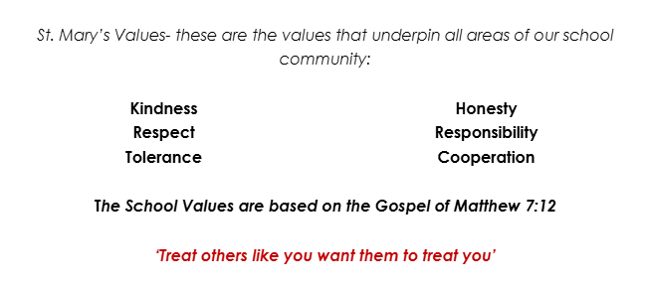  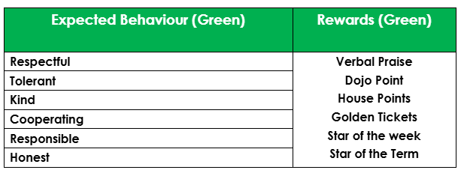 |  | 