Termly Newsletter Autumn 2026
Year 4

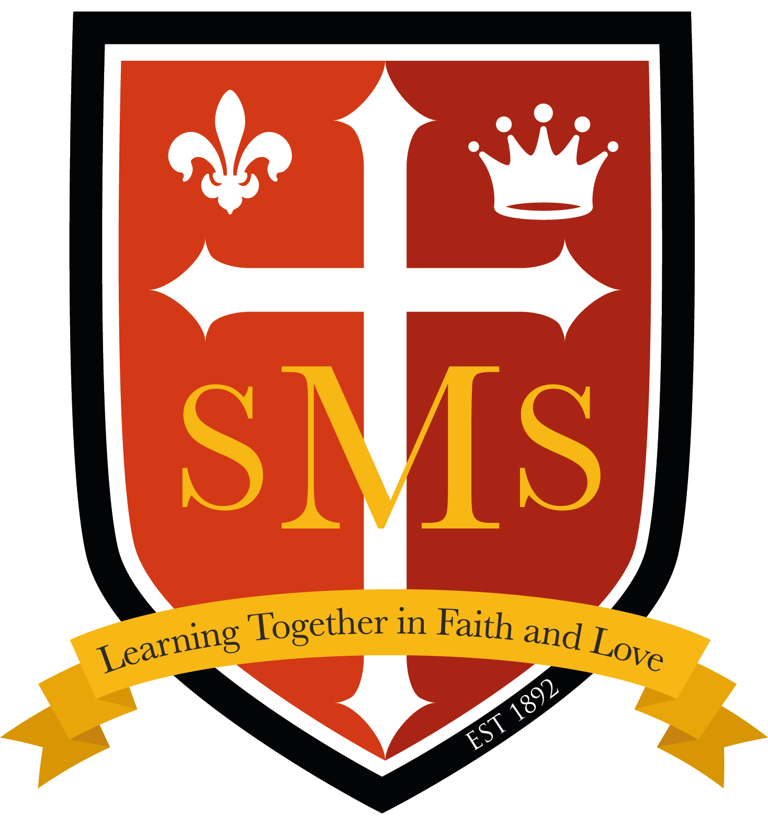

Welcome back - I hope you had a lovely Summer break. I am delighted to welcome your child to Year 4 where the children have already had a great start to the year. It has been wonderful to see the children wearing their correct full school uniform every day, including formal school shoes and a tie; please keep it up! Children also get Dojo points for coming in the correct uniform each day.
PE is on Thursdays and the children can come to school in their PE gear. Please ensure it is the correct school uniform PE gear and not a tracksuit or their own clothing. If your child doesn’t own the correct uniform, please speak to Ms Tusting or Ms Hampton.
Children must wear trainers to go on the new playground, play on the pitch and play champ. Toys are not permitted at school according to our school rules. Please remind your child not to bring toys to school or they may be confiscated and returned at the end of the term. Children should not bring pencil cases or stationery equipment - we provide everything that is needed!

Below, you will find an outline of the topics that your child will be learning about in class over the coming term. In addition to providing you with an insight into the curriculum areas that will be covered in the lead up to Christmas, I hope that this information will also assist in supporting and extending your child’s learning at home.
Please make sure your child practices her or his times tables every day.

Thank you for your ongoing support,
Mr Whear

English-Writing  In English this term our writing will be inspired by “Krindlekrax” and “The Iron Man”.  Krindlekrax - the children will write a character description of Ruskin, a diary entry and a Letter of Complaint.    The Iron Man - the children will write a Narrative Retelling and Instructions on how to build your own metal giant.  We will finish the term with some Christmas poetry. |   English-Spelling  Spelling will form part of our weekly grammar lesson. Spellings will be tested on Fridays and it is essential that the children learn - through practice at home - their spellings every week.  English-Reading  Reading is arguably the most important part of your child’s learning. It is evident in children’s writing when they read regularly. Thus, to best support your child, please ensure they read at home each  day and record this in their reading records. We read daily in class, with the aim that each child reads with an adult in class weekly. |  | Maths  In Year 4 we extend the mathematical operations to numbers up to 10,000. This term we will be covering the following units:  Place Value Addition and Subtraction    Measurement Multiplication and Division
  Science  We will be studying States of Matter. This will include observing and classifying solids, liquids and gases, observing and measuring changes in states of matter change and learning about the water cycle.  In the second part of the Autumn term we will start our unit on Animals, including Humans by looking at the digestive system. The science skills we will be developing will be “Observing and classifying”, “Comparative and Fair Testing”, “Pattern Seeking”, “Observation over Time” and “Secondary Sources”. |   History (Autumn 2)  Our inquiry question is “What were the main achievements of the Ancient Greeks?” The children will investigate what life was like in Ancient Greece, look at their beliefs and achievements - including the Olympic Games and democracy. |  | 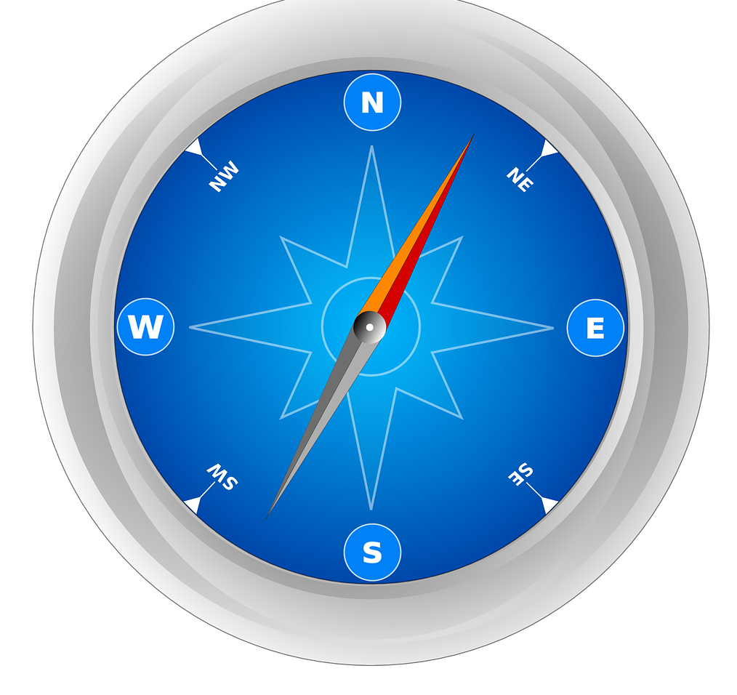  Geography (Autumn 1)  The class will be learning about “Our European Neighbours". We will look at where Europe is in the world and some of its physical features. The children will then learn about the countries in Europe, consider the major capital cities and compare two of them. Finally, we will find out about the physical and human features of a European city.
RE  In Autumn one, we will study Branch 1: Creation and Covenant of the curriculum. This will include an in-depth consideration of Abraham and how his decisions (and those of Joseph) were defined by the virtues of faith, hope and love.  Branch 2: Prophecy and Promise will be studied in Autumn 2. In this unit, the children will continue, from the previous year, their understanding of John The Baptist, making links to Elijah and Isaiah. Finally we will look at the Solemnity of Christ the KIng and the Jesse tree. | 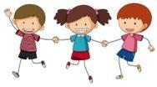  PHSE/RSE  Our PHSE Topics this term are:  Health and Well-being - mental health  Internet safety  Media influence  In RSE we will be understanding that God created us as individuals. |  |   Computing  In computing we will be exploring a range of collaborative tools (in Google) in Autumn 1.  In Autumn 2, our unit will be on e-safety.
PE  In Autumn 1, the children will be learning about Sending and Receiving Invasion games. By the end of the unit, they should be able to:  send different types of passes whilst moving and catching and receiving more consistently; keep control of a ball, start to understand when to run and pass.  Keeping Possession will be the Autumn 2 focus. This will include:  developing skills such as passing whilst moving; controlling a ball with different parts of our bodies including feet and moving into space when receiving a ball. | Music  Autumn Term 1: Reading Notation 2:  Sequences of 2, 3, 4 beat phrases. Minims and Rests  Autumn Term 2: Exploring Staff Notation 2:  Follow the Score.   |  | Home Learning  Home learning will be set on Monday and is to be returned on Friday. It will comprise:  -Daily reading (recorded in the reading record)  -10 spelling words, to be practiced regularly and sentences written to support understanding.  -maths activity  -Times tables to practise daily  -Sometimes a grammar activity
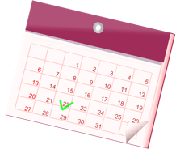
Important dates
Assessment Week: 12th October
Parents Evening: 20th and 22nd October

Our School Behaviour Policy
St. Mary’s is committed to fostering calm, constructive, and positive learning environments across the school. Below is a reminder of our school-wide behaviour policy.
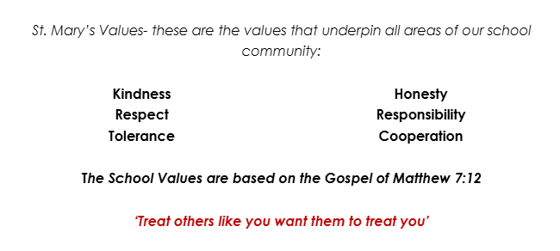  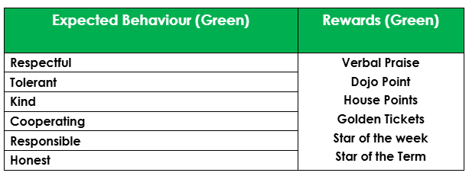 |  | 