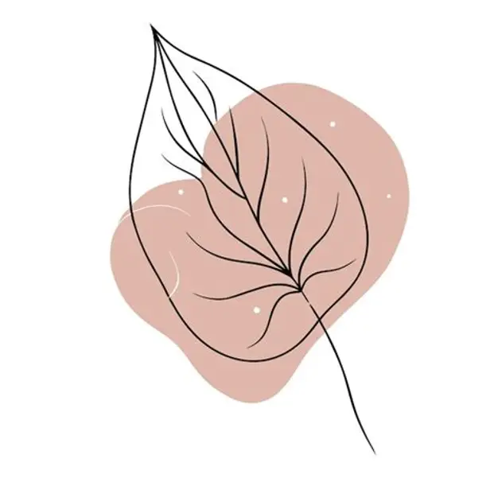
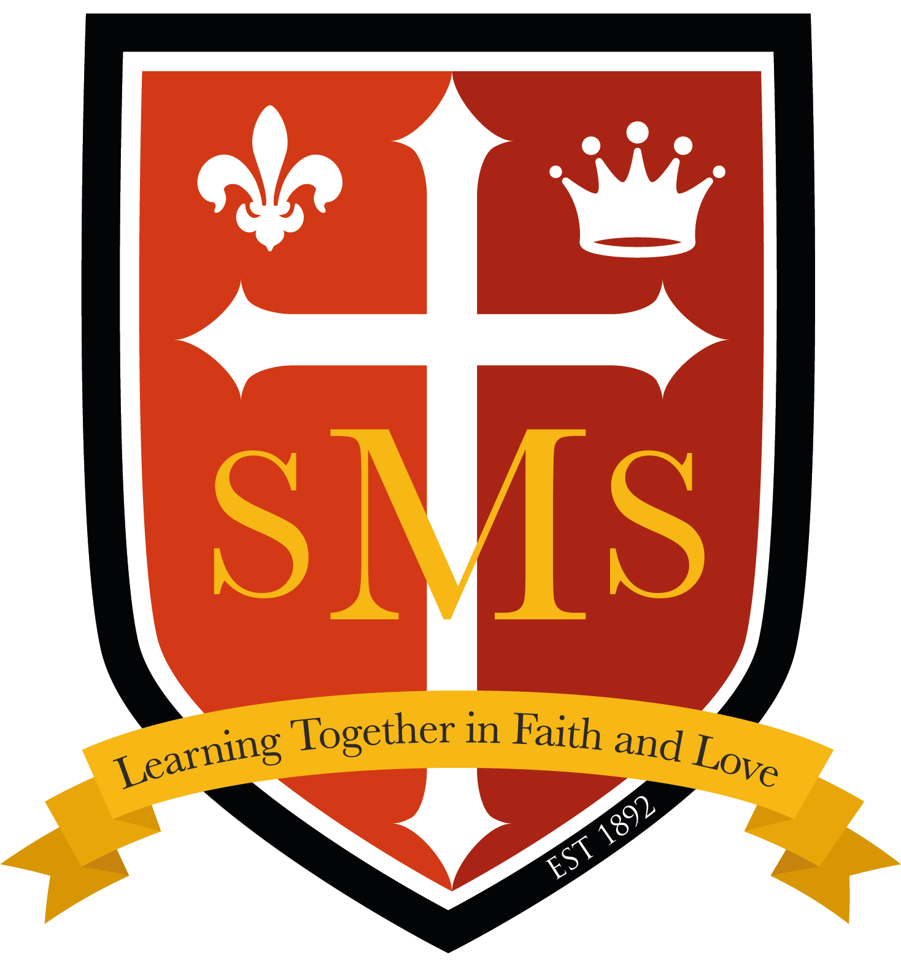
ST. MARY’S CATHOLIC PRIMARY SCHOOL
Termly Curriculum Newsletter - Autumn 2026
Year 6

I hope you have had a lovely Summer break and I am delighted to welcome you and your child to Year 6. Below, you will find an outline of the topics that your child will be learning about in class over the coming term. In addition to providing you with an insight into the curriculum areas that will be covered in the lead up to Christmas, I hope that this information will also assist in supporting and extending your child’s learning at home.
  English-Writing  In English this term we will be focusing on a variety of genres including: Narratives, Literary and Science texts as well as Michael Morpurgo’s War Horse. We will also focus keenly on the audience and purpose of our writing, as well as prediction, selection of appropriate form, proofing and important editing skills. Children will draw on a variety of readings and research to develop their own ideas and improve their writing. | English-Spelling  Spelling continues to be an important part of  your child’s learning. We will particularly focus on  spelling rules and patterns. Weekly spellings will  be set as homework and tested during the week.  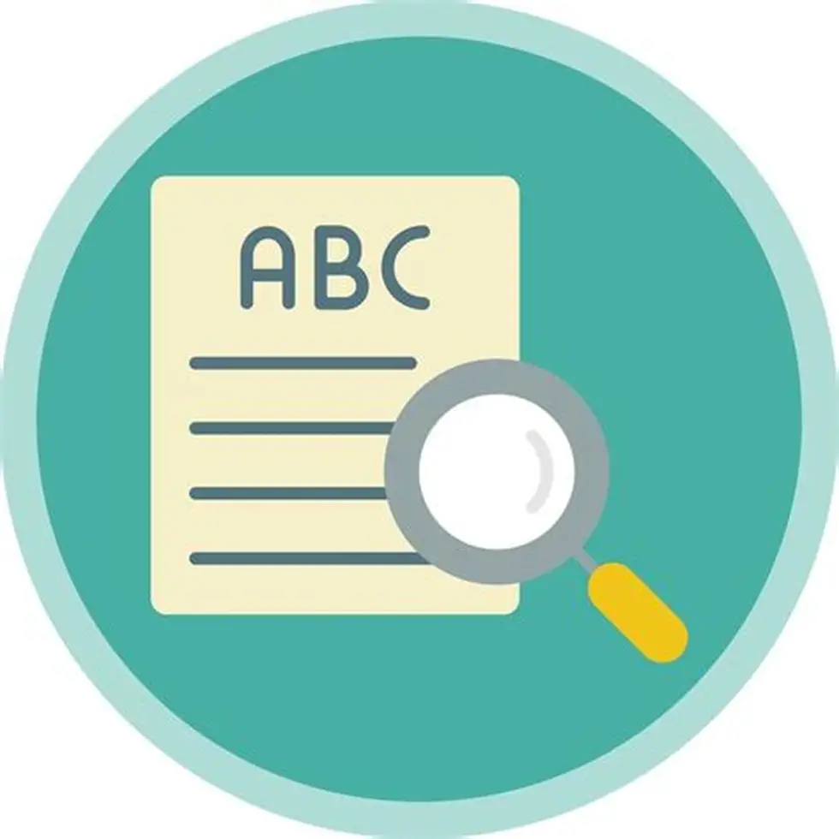  English-Reading  Reading remains a vital aspect of your child’s  Education. as It becomes very evident in children’s  writing when they read regularly. Thus, to best support  your child, please ensure they read at home each  day and record this in their reading journals. This can  be from a variety of texts but should include a novel or  a chapter book with an appropriate level of challenge. |  | Maths  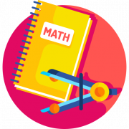  This term Year 6 will be covering the following maths topics.  - Place Value  - Addition, subtraction, multiplication and division  - Fractions  - Converting Units
  Science  In Science this term, we will be focusing on the topics of Electricity and Light.  Electricity  - Make a complete circuit.  - Use recognised symbols to draw a circuit diagram  - Know which materials are good conductors of electricity.  - Understand how changes in a circuit affects the brightness of a bulb.  - Know how my electrical knowledge applies to daily life.  Light  - To know that objects are seen because they give out or reflect light into our eyes.  - To know how the eye receives light and functions.  - To know that the ray model of light, explains the size of shadows.  - To know that the path of reflected light, from a mirror or shiny object can be predicted.  - To understand that white light is made up of different colours. |   History  Year 6 will explore the following topic:  How has the power of the monarchy changed over time?  In this unit, pupils explore how the power of the monarchy in Britain has changed from the medieval period to the present day.  They will learn about key turning points — from the Magna Carta and the English Civil War to the Victorian era and the modern constitutional monarchy.  Pupils investigate how monarchs gained and lost power, how Parliament grew in influence, and how democracy developed. |  | 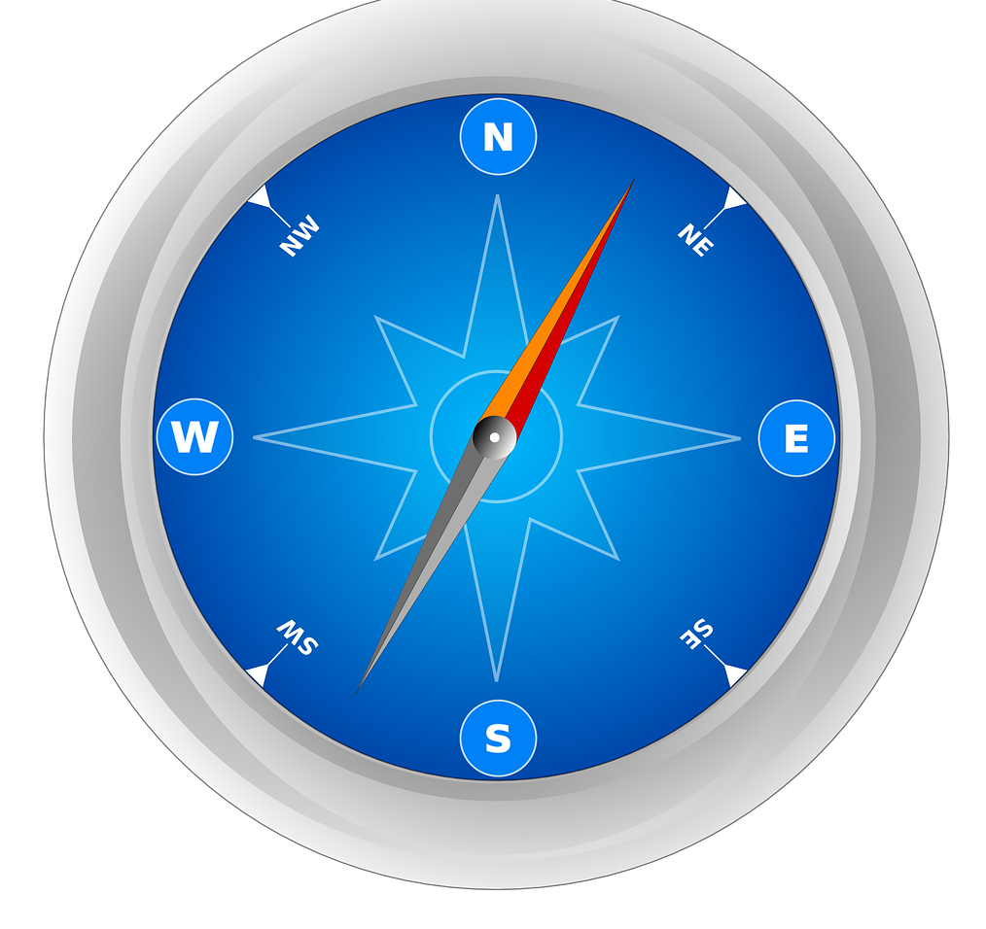  Geography  The class will be focusing on various weather phenomena and their effects on our planet.  Extreme Earth  - To find out about the Earth’s climate and areas of extreme temperatures.  - To find out about the water cycle and the distribution of water across the world.  - To find out about extreme weather conditions across the world.  - To find out about earthquakes and what causes them.  - To find out about tsunamis and how they are caused.  - To find out what volcanoes are and how they are formed.
RE  Creation&Covenant  The second account of Creation  (Genesis 2:5-10, 15-23, 3:1-7,9-13, 17-19)  Jn1:1-5,16-18  Prophecy & Promise  Old Testament passages that show the importance of women in salvation history, e.g:  Genesis 18:1-15; 21:1-7: Sarah  Exodus 1:8-22; 2:1-10: Miriam  Judges 4:4-11; 5:7-15: Deborah  1 Samuel 1:5, 9-11, 26-28: Hannah  Esther 2:4, 15-17; 3:1-6, 12-13; 4:1-4, 8a-17; 5:1-8; 7:1-6, 9-10; 8:3-12 (Purim): Esther  Lk 1: 26-56: Mary as the fulfilment of Old Testament promises | 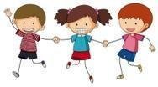  PHSE/RSE  STEREOTYPES AND DIVERSITY  Respectful Relationships  - Understanding that differences and similarities between people arise from a number of factors, including family, cultural, ethnic, racial and religious diversity, age, sex, gender identity, sexual orientation, and disability.  - Stereotypes and how they can negatively influence behaviour and attitudes towards others.  - Appreciating the range of national, regional, religious and ethnic identities in the United Kingdom.  - Provision of strategies to challenge these stereotypes. |  |   Computing  In computing Year 6 will be exploring the following topics:  Computing Systems and Networks  Creating Media - Webpage Creation
PE-Gymnastics & Dance  ● Leading group warmups that develop strength and flexibility.  ● Demonstrating accuracy, consistency and clarity of movement.  ● Working independently and in small groups to make up sequences.  ● Arranging apparatus to enhance work and vary compositional ideas.  ● Using dramatic expression in dance movements.  ● Modifying elements of a sequence | Music  Autumn Term 1: Reading Notation 4:  Rhythm Ensemble  Autumn Term 2: Developing Sight-Reading Skills 2:  Notes names and Durations  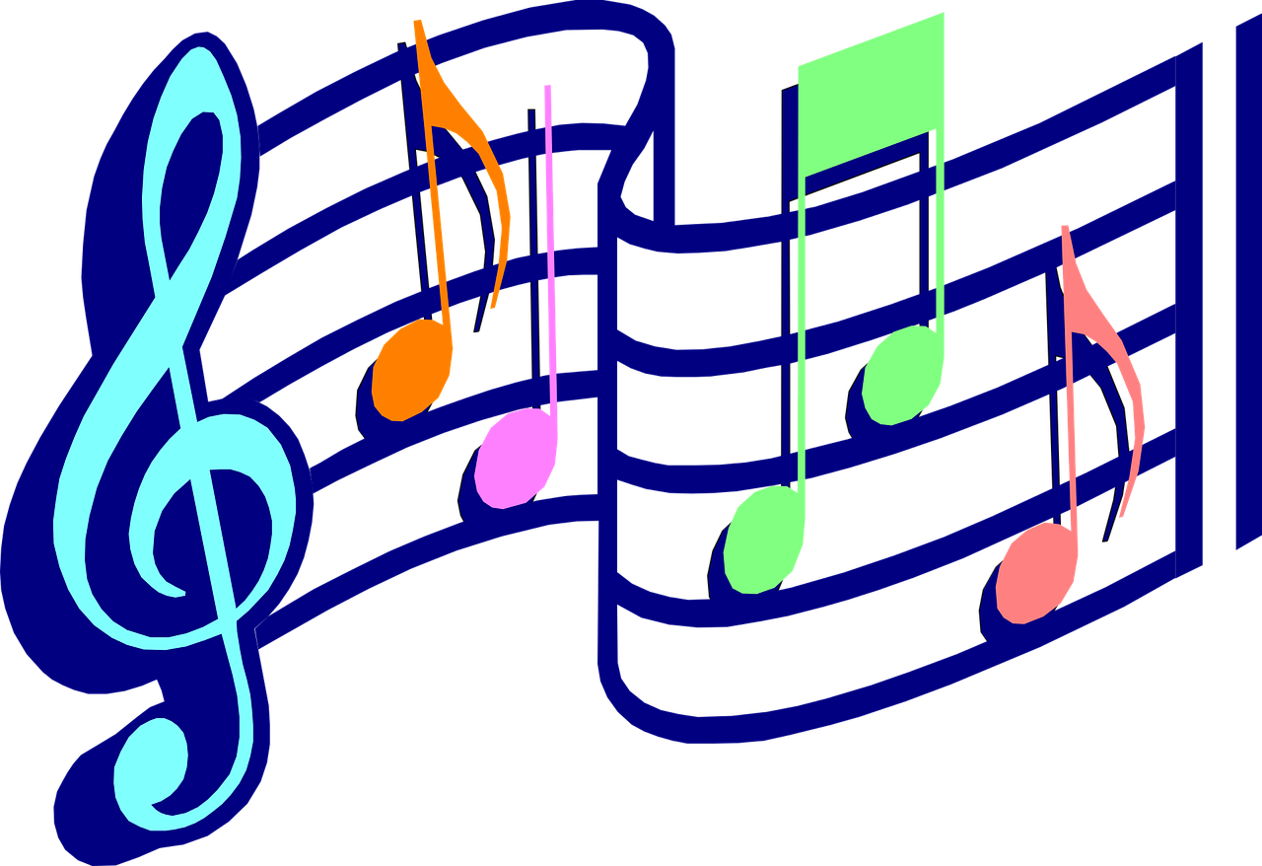 |  | Home Learning  Your child will be told how to access their homework. In addition to set homework, children will be asked to complete any unfinished class work at home. As we approach SATs, children will also be expected to complete revision at home with your assistance. This additional support will be crucial in order to help your child prepare for their end of key stage assessment. Children will receive Spellings to learn each week which they will be tested on the following Monday.
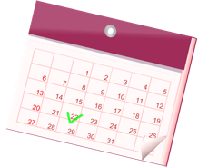
Important dates

21-25.09.2026 Into University Focus Week 08.09.26 Parent Consultation Meetings
23.09.2026 Secondary Transfer Meeting 25.09.26 UK Parliament Week – visit to Parliament
Our School Behaviour Policy
St. Mary’s is committed to fostering calm, constructive, and positive learning environments across the school. Below is a reminder of our school-wide behaviour policy.
