  ST. MARY’S CATHOLIC PRIMARY SCHOOL
  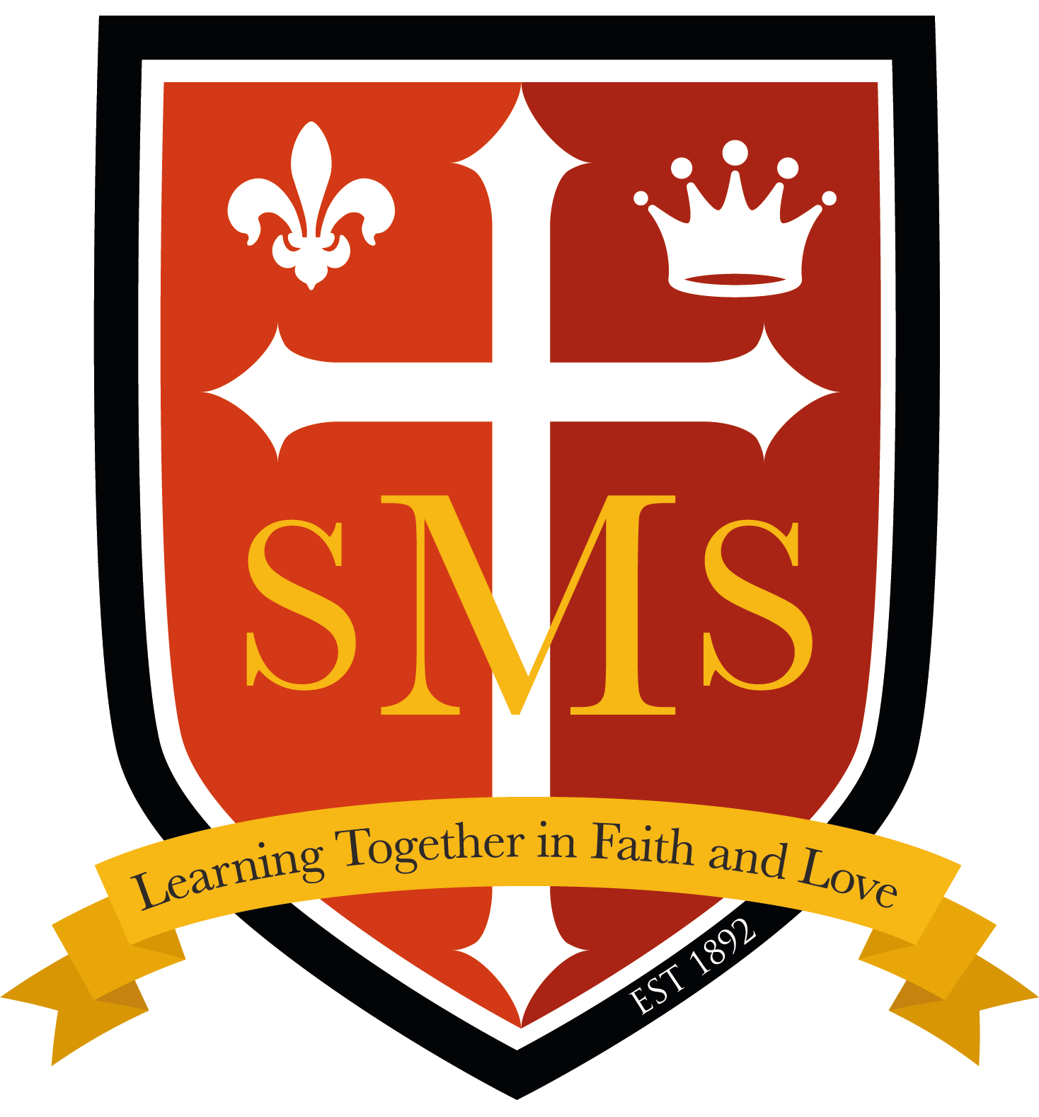
  East Row North Kensington London W10 5AW
  Telephone: 020 8969 0321 Fax: 020 8964 3122
  E-mail: info@st-marys.rbkc.sch.uk
  Website: www.st-marys.rbkc.sch.uk
  Head Teacher: Ms Ann Slavin
  ST. MARY’S CATHOLIC PRIMARY SCHOOL
  East Row North Kensington London W10 5AW
  Telephone: 020 8969 0321 Fax: 020 8964 3122
  E-mail: info@st-marys.rbkc.sch.uk
  Website: www.st-marys.rbkc.sch.uk
  Head Teacher: Miss Joan Harte
Supplementary Information Form (SIF) 2021-2022

Child’s Details
Child’s surname:
Child’s Christian or other names:
Home Address: | Date of Birth:
 | Postcode:

Parent/Carer Details
Parent(s)/Carer(’s) name:
Address:
Telephone number:
Email address:
Alternative contact details
Address:
Telephone number:
Email address:

Details of Religion
Religion of child:  (Please tick) | Catholic | Other Christian (name of denomination e.g. Baptist) | Other faith
Catholic Parish you live in:
Church where child was baptised and date of baptism: (baptism certificate required)
Church you currently attend:
Name and position of priest providing certificate of Catholic Practice or religious leader supplying letter confirming membership: where appropriate)
Name of brothers or sisters at this school: |  | Name Class or Year Group
Is your child ‘looked after’ by the Local Authority adopted having previously been ‘looked after’ or subject to child arrangements or special guardianship orders? (Please circle your response) |  | YES NO
Does your child have exceptional medical, pastoral or social needs that can only be met by attendance at this school? Please circle. (Professional evidence will be required.)

YES NO
I confirm that I have read and understood the Admissions Policy and that the information I have provided is correct. I understand that I must notify the school immediately if there is any change to these details and that should any information I have given prove to be inaccurate that the governors may withdraw any offer of a place even if the child has already started school.

Signed……………………………………… Date…..…………………

Please note:
- Parents can obtain a Certificate of Catholic Practice from the parish where the family normally worships.
- Applicants from other Christian denominations and other faiths may attach a letter confirming membership from their minister or religious leader.

- You must complete the Local Authority’s Online Application Form by the closing date. If you do not do this you will not be offered a place.
Checklist:
Have you enclosed? Copy of baptism certificate
Certificate of Catholic Practice (where necessary)
Evidence of exceptional need (where appropriate)

Have you completed your local authority’s Online Application form?

