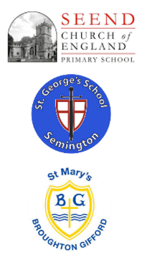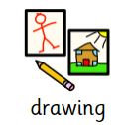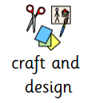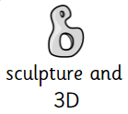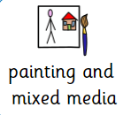

Art and Design at ‘The Three Schools’

**Curriculum Implementation**

Our Art and Design Curriculum at Seend, St George’s and St Mary’s is based on the National Curriculum. The progression of knowledge and skills is mapped out in our progression of skills document and long-term plan.

The curriculum is designed so that children are involved in the evaluation, dialogue and decision making about the quality of their outcomes and the improvements they need to make. By taking part in regular discussions and decision-making processes, children will not only know facts and key information about art, but they will be able to talk confidently about their own learning journey, have higher metacognitive skills and have a growing understanding of how to improve.

**Curriculum Intent**

At Seend, St George’s and St Mary’s, we value Art and Design as an important part of the children’s entitlement to a broad and balanced curriculum. We deliver Art and Design lessons that engage, inspire and challenge pupils, equipping them with the **knowledge, vocabulary, understanding** and **skills** to experiment, invent and create their own works of art.

These areas have been sequenced in each year group ensuring they are progressive and everyone understands the intended end-points.

As pupils progress, they will be able to think critically, using skills and knowledge from prior learning, and develop a more rigorous understanding of Art. We aim to inspire pupils and develop their confidence to experiment and invent their own works of art. We give all pupils the opportunity to develop their ability, nurture their talents and interests, express their ideas and thoughts about the world, as well as learning about rich heritage and cultures of the British Isles and beyond.

**Curriculum Impact**

Pupils should leave primary school equipped with a range of techniques and the confidence and creativity to form a strong foundation for their Art and Design learning at Key Stage 3 and beyond.

Children will:

* Produce creative work, exploring and recording their ideas and

experiences.

* Be proficient in drawing, painting, sculpture and other art, craft and design techniques.
* Evaluate and analyse creative works using subject-specific language.
* Know about great artists and the historical and cultural development of their art.
* Meet the end of key stage expectations outlined in the national

curriculum for Art and design.