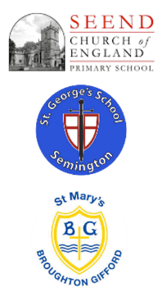

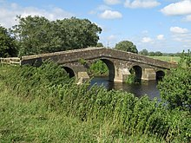

**Curriculum Implementation**

Starting in the Early Years, the children explore their immediate locality, developing a sense of place through their Understanding of the World. In Key Stages 1 and 2, bi-termly themes develop geographical knowledge and skills. These themes focus on particular localities relevant to the children as well as geographical features such as mountains, volcanoes, rivers and islands. Trips and visitors also help to enhance this learning. Children are required to learn relevant geographical facts and develop key geographical skills in a progressive manner. Key to their understanding is the idea that geography is about people, places and environments and the links between these.

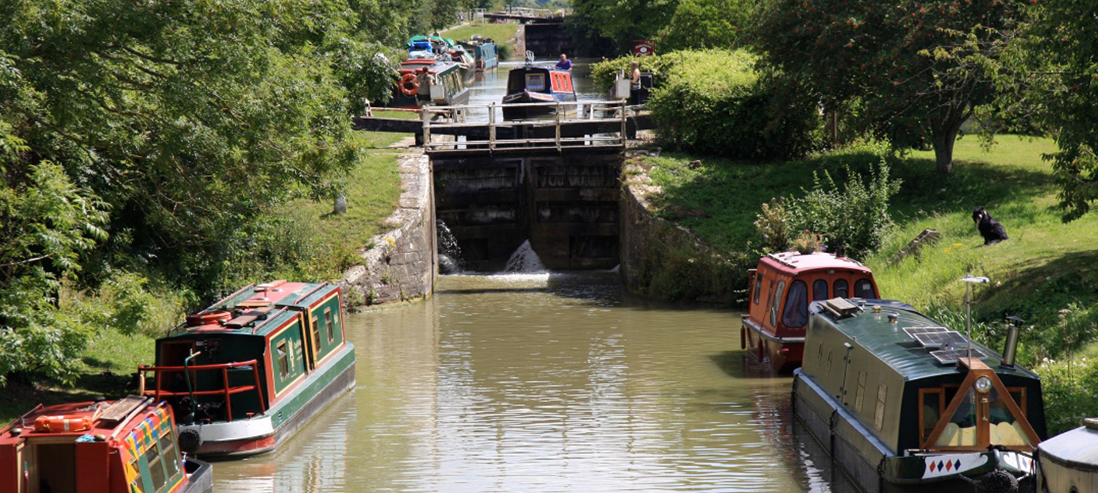 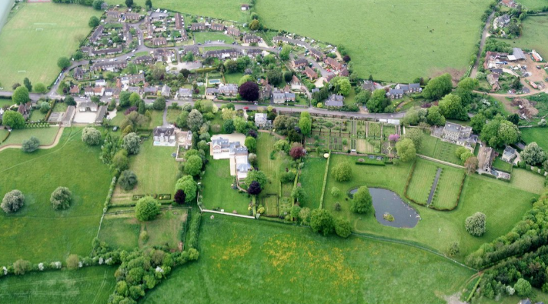

Geography at ‘The Three Schools’

**Curriculum Impact**

The implementation of this curriculum ensures that when all children leave Seend, St George’s and St Mary’s, they have gained a rich understanding of Primary Geography that they can draw upon in future learning. In addition, they will also be able to:

* Have a real sense of curiosity to find out about the world and the people who live there.
* Have an excellent base of geographical knowledge and vocabulary.
* Be confident using fieldwork and other geographical skills and techniques.
* Have the ability to express well-balanced opinions, rooted in very good knowledge and understanding.

**Curriculum Intent**

At Seend, St George’s and St Mary’s, our Geography curriculum is designed to inspire a lifelong curiosity and fascination about the world and its people. Rooted in our Christian values and rural setting, we aim to equip our children with the knowledge, skills, and understanding to appreciate the diversity of places, people, and environments—both locally and globally. Our Geography curriculum allows children to explore the physical and human environment on a spatial scale and the patterns and relationships between them. The children encounter both opportunities and challenges linked to geography, with a range of local, national and global themes.